The Family Chronicle
No. 193 October 2, 2010
____________________________________________________________________

Black River Photos

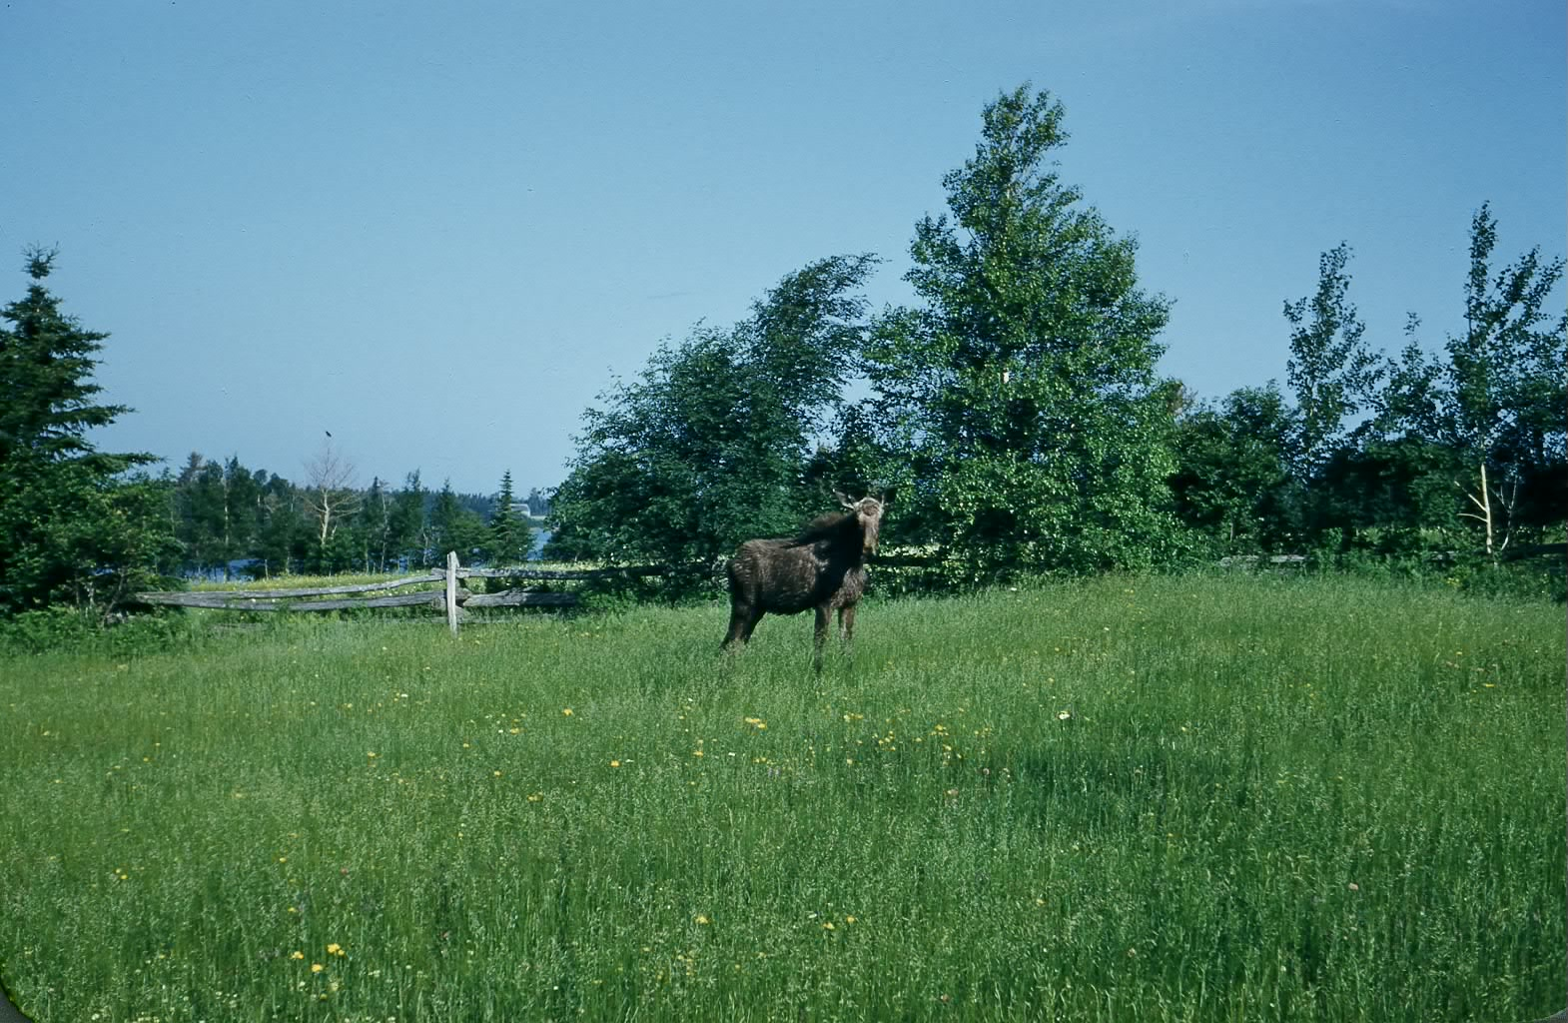
Moose in Jim Adams’ yard, probably early 1950’s


Rainbow over Black River

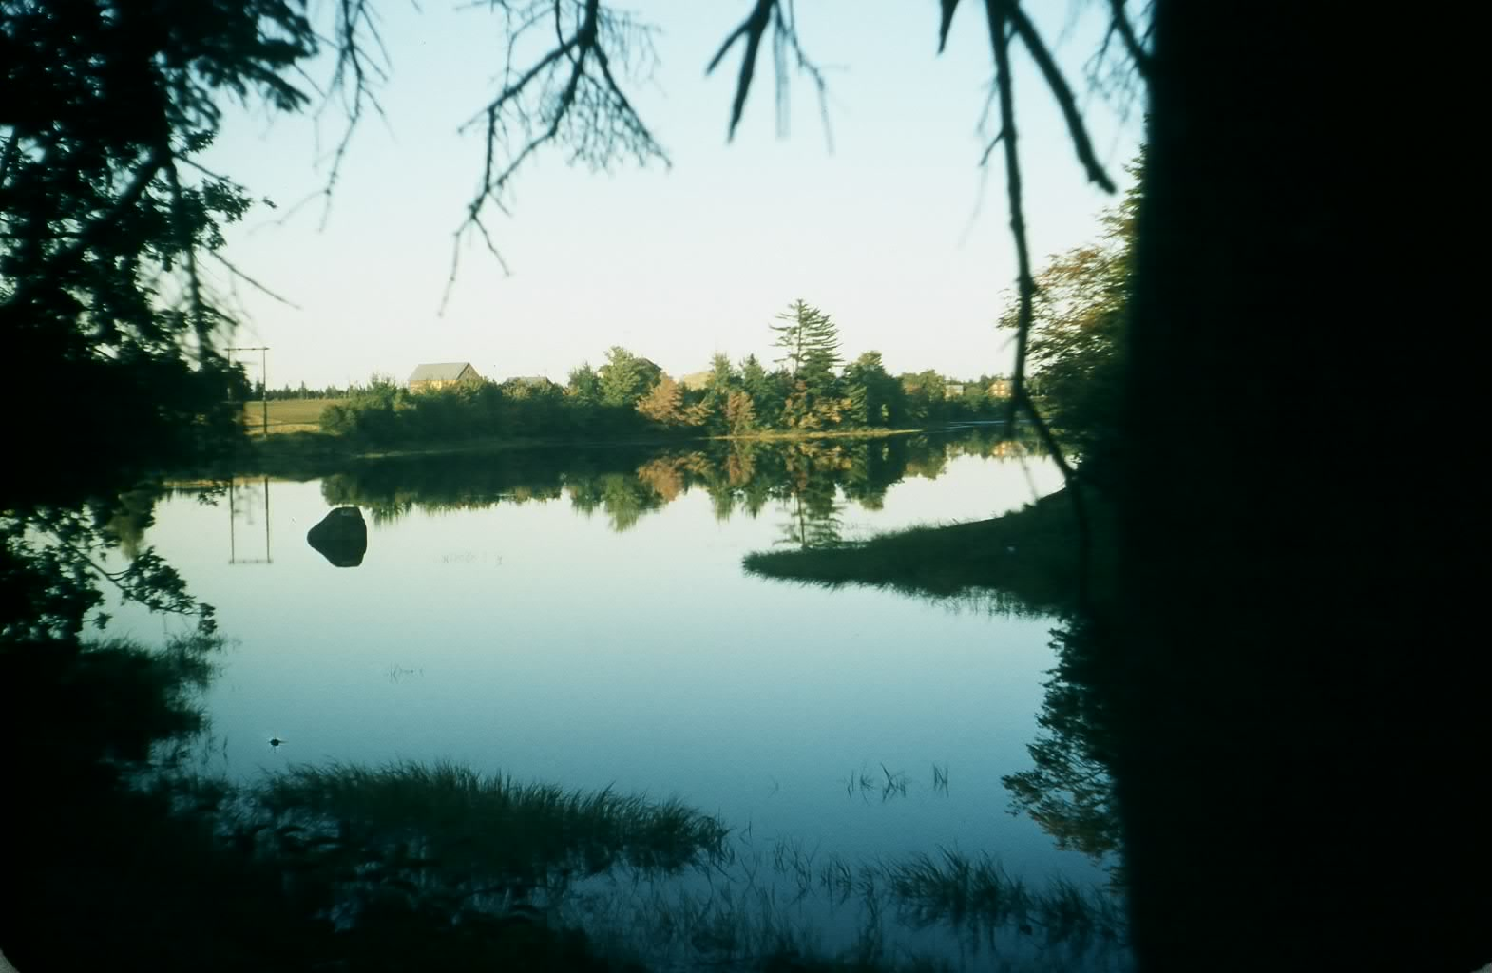
Little Branch River taken from school yard

Road work

This has been a busy summer for road construction on PEI, mostly rebuilding, widening, intersections, paving and some bridge repair. Watching the heavy equipment made me think of road construction in Black River before WW2. In particular, I recall:

- Gravel, mostly shale from one of pits (MacDougall pit in Hexham, Finno pit near Little Branch Bridge, Harry’s Hill on the north side of the Little Branch.) Also there was a large pit on the McKnight Road, a pit in Finno’s bank used when gravel was hauled on the ice for rebuilding the Little Branch Bridge. In talking with Brother Ken, we think that there was a gravel pit at John W. MacNaughton’s and one above the Moncton Highway on the North Side of Black River but cannot recall them.
- Gravel was loosened with a pick and shoveled by hand on to wagons and carts. I know there were ramps where horses could travel up a ramp pulling a scoop, and empty the gravel into a dump cart or on to a wagon but I cannot remember one in Black River. Drivers did not shovel gravel; they pulled into the pit and waited while others loaded their wagons.
- For hauling gravel, truck wagons were fitted with a flat bottom made from small straight poles or 2x4’s. The side of the gravel box was a six or eight inch plank in its edge. The box also had both a front board and a tailgate. When the wagon reached the point where the gravel was needed, front and rear gates were removed and planks and poles were lifted so that the gravel dropped to the road. The box of a dump cart, as their name implies, simply tipped to allow the gravel to spill out. Gravel was spread by men with shovels.
- In 1930, A. W. MacDougall was paid $1.50 a load for delivering gravel to the Black River Community Hall; it appears that a person could deliver three loads each day.
- Adult members of the community paid a poll taxes or head tax. Property owners paid a property tax. In addition, each property owner was, by statue, expected to contribute time to the maintenance of roads. Statute labor, or stated labour, could include cutting trees or brush, digging ditches, repairing culverts, loading gravel, etc. While I am not sure of the actual allocation of time, the number of days varied if the labour was provided by a person with a shovel or axe, versus person who hauled gravel with a horse and dump cart. Even fewer days were required of a person with a wagon and team of horses.
- Occasionally a district would be provided with a road scraper, much like the road graders of today, except pulled by a two or four horse team.
- Bridges and culverts were built of wood. The crib for the Millers Bridge at Little Branch, for example, was probably typical and consisted of large log crib, probably “cedar” 8-12 inches in diameter; the length of the log depended on the width of the road. The crib was filled with rock.
- Culverts or bridges leading into properties were also boxes constructed of cedar, about 4x4 as I recall, forming an opening perhaps 18 x 24 inches

Dogs and porcupine quills

A confrontation between a dog and a porcupine usually ended up with the dog getting a face full of porcupine quills. Obviously, they had to be removed; it was a painful process. Porcupine quills have a barb, something like a fish hook, so that they would not pull out easily. I never did see them being removed but recall the yelps from the dog during such an operation. Ken remembers two men holding our dog while Dad removed the quills with a pair of pliers.

Time to Celebrate

Regular readers may recall that Family Chronicle No 27 included a list of original land grants along the Black River including the Little (Branch) Black River. June 3, 2012 will mark the 200th anniversary. Lots granted that day included both sides of the Little Branch (Black) River and the main river as far as Church or Gunn’s Point. It is likely that a number of settlers were living on their grants for a number of years before the grant was actually made.

A 200th anniversary deserves a special celebration, a parade, a dinner, genealogy presentations, church service, unveiling of a memorial, a history tour, school reunions and more. Planning needs to start now; two years will slip by very quickly.

The Family Chronicle (Copyright©) is an occasional newsletter published by Don Glendenning and posted on the family website. It is intended to share information about my family, community and the times in which I grew up. While every effort is made to be accurate, errors are likely to occur. Comments, enquiries and information may be sent to 62 Queen Elizabeth Drive, Charlottetown, PEI, C1A 3A9. Tel: 902 892 5859. Email: don@glendenning.net Web: www.glendenning.net/don

