The Family Chronicle
No.30 November 17, 2002
__________

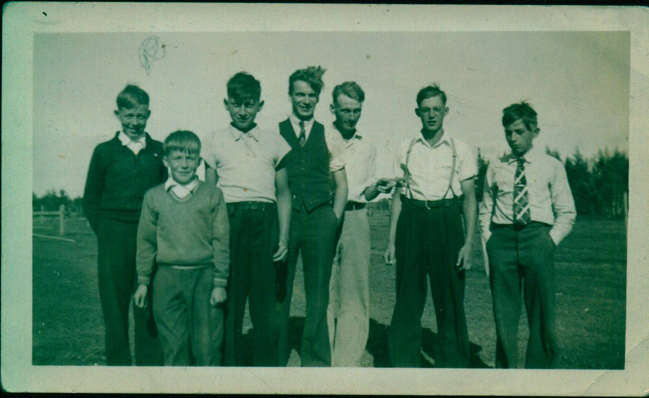

From left to Right: Roy Watling, George Watling, Norman Glendenning, Unknown. Walter Glendenning, Winfield Watling, Kenneth Glendenning

Teachers

During a recent visit to the Miramichi, Venetia, Ken and I were trying to recall our teachers at the Little Branch School. The following is a preliminary list:

Margerite Bell (Mrs. George MacDonald)
Katie (MacNaughton) Neilson
Annie Ellis – 1925?
Jeni Oleskevis
Charles Spencer – 2 years
Donald MacLean – 2 years
Rilma Tracy
Mary (Godfrey) Williston – at least three years
Bertie MacLean – 1938?
Marion Smith
Venetia Russell – 1955-1958
Mrs. Freddie Fowlie

We know there are others. Please help.

Point Aux Carr Trappers

Ken stayed with Venetia and Cam during the winter of 1937-38 and attended the Point Aux Carr school. One weekend, Norman went to visit. He crossed the ice at McKnight’s Point and walked out the Point Aux Carr Road. Ken walked in and met him about half-way.

Ken and Fowlie Gillis had been catching a few rabbits. On Saturday morning, Ken and Fowlie went out early to the snares taking a couple of rabbits caught the day before. Into one of the snares they put two rabbits.

Later in the morning, Norm and Mac Gillis were invited along when they went to “fish” their snares. Imagine the excitement of Norm and Mac when they found two rabbits in one snare.

The Muddy Trail

I was born in Old Black River
Over sixty years ago.
It was a Sunday night and it was dark
My neighbour told me so.
It was the eleventh day of May
In nineteen hundred and eight.
When a neighbour went for a stork.
They say her name was Kate.
He had about four miles to go
Through deep ruts in the mud
And some places on the south side.
The wagon steps they drug.
That night I came into this world.
The stork was waiting there.
She had just arrived five minutes before.
There was no time to spare.
This lady took me in her arms.
She laid me on the “bug’
And when I opened my blue eyes
The first thing I saw was mud.
As time went on and years rolled by.
Eventually I grew.
So I got long and slinky
And now I’m six foot two.
I haven’t got no learning
For I never went to school.
I never learned about Tom’s dog.
Or was taught the golden rule.
I take great delight in wild life.
For I hunted all my life.
But the women wouldn’t look at me.
That’s why I have no wife.
I trapped all kinds of animals
From a weasel to a bear.
I’ve shot all kinds of venison.
From a bull moose down to a hare.
I never wandered far from home.
I’m still here on the “bug”.
For every time I made a move
I was spinning in the mud.
I walk this side road twice a week
To buy something to eat.
But I never feel the worse of it.
For it’s soft and easy on my feet.
Now there isn’t much traffic on this side.
For it is a soopy trail.
For every mile you have to stop
To wash your lights and bail.
You can’t be in a hurry
For a spray goes o’er your hood.
If a walker chances to meet a car.
He’s got to take the woods.
They call it just a dump hole
And I believe it’s true.

For every few yards in the ditch
There’s a garbage bag or two.
It was this side road that started mini-skirts.
They didn’t start before the flood.
For if they wore their skirts down to their knees.
They’d be dropping in the mud.
We would like to have this side road built.
Or the people they’ll soon raz.
For if the mud gets any deeper.
They’ll need mud flaps on their bras.
You go along the side of it
And pick your way across.
But we know someone who will pave our road.
Our old stand by Jack Frost
They promised to fix this road.
For as long as I can mind.
They say we have it on our list.
But it’s on the bottom line.
They brought one load of gravel.
About two years ago;
They didn’t spread it on the road.
For it would make an awful show.
They hauled it up and down the road.
Looked in every little nook.
They seen no place that needed it.
Dumped it o’er the bank of Wells’ Brook.
They came again with mud stone.
And as they worked past the gate.
They spread it just about as thick
As frosting on a cake.
They worked on both ends of it.
With mud-stone mixed with ground.
They had to be very careful
To have enough to go around.
We had all kinds of members.
Enough to form a ring
And when it comes to governments
It didn’t mean a thing.
If Larry Gorman was living now
I’m sure he’d write a song.
He’d take the weight of everything.
And it wouldn’t take him long.
Now some folk when they read this poem.
May think that I’m a goof.

But when they sum the whole thing up.
You’ll find that it’s the truth.

An old tax-payer
Stuck here in the mud

Note: I found this among my papers; the source, writer and date are not known -- Editor

