The Family Chronicle
No.36 March 3, 2003
________________

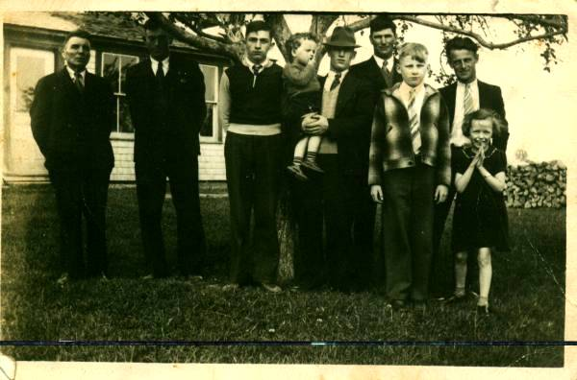
From Left to Right: John R. Godfrey (Uncle Jack), John Glendenning, Kenneth Glendenning, Earl Taylor holding Gerald, Cameron Russell, Don Glendenning, Sterling Williston and Joan Williston. Photo taken at Glendenning home at Little Branch. (Undated but probably taken in 1941) Notice the pile of wood on the left. Furnace wood cut and split in two foot lengths served as a fence ____________________________________________________________________________________________

Follow-up

In the last issue, I mentioned our Aladdin lamp. I was reminded by Donald Edge just how different a light it provided. It was both much brighter and much whiter, presumably because of the use of a mantle. It was obvious when passing a house at night which ones had an Aladdin lamp. Tina Newton tells me that she and her sister used to play Flinch with her Grandfather, my Uncle George Watling.

Family Profiles

As part of my family tree activity, I am preparing profiles of each of my siblings. These profiles when completed will appear in future issues.

The Family Chronicle

Off and on for 50 years, I have been gathering
information about my ancestors. There is not much point in having information unless you share it. The
Family Chronicle is the result. The early issues were very family oriented. More recently, I have begun to reminisce about Black River as I recall it. Obviously, the notes reflect my family and my era. I make no apology for the focus but, in view of the wider distribution, thought it deserved a comment. Articles are not researched but simply presented as I recall them. I sit at my computer and you get what ever occurs to me at that moment. Remember, all memory is selective; some items may even be repeated. Others may contain errors.

The Family Chronicle is available in Email only and readership has now reached 34.

By the way, I am very interested in receiving information, including photos, about Black River, its people and events. The more information I gather the more I realize that most any resident of Black River is likely to be a relative. Some day I will write a note about family relationships.

Truck

In reminiscing about family vehicles, I forgot to mention the 1944(?) Dodge or Fargo 21/2-ton truck, which John bought from Hubert Matchett (I think). It
was khaki colour and used for hauling wood, Christmas trees, gravel, etc. I never drove it. One day, however, Ken asked me to take the truck to pick up Jack Gibson to butcher a cow or pig. I was prepared to go but, on learning that I had not driven the truck before, Ken decided to go himself. He was stopped by the RCMP near Alex MacDonald’s. Fortunately, Ken had a driver’s license; I did not. I am not sure what the fine was for driving without a license.

Driving License

Like most young fellows, I drove for a number of years without a driver’s license. In 1949 I went with
Norm when he went to pick up his new truck. While waiting for the truck to be serviced, Norm asked me if I had a license. I didn’t. He suggested I get one. I asked what one did to get a license. The license bureau was on Water Street near Hachey’s corner. I went down and picked up an application. It required someone to certify that I could drive. Norm suggested that I ask Glenn McTavish to sign. I asked, “Who is Glenn MacTavish” Norman took me to the door of Lounsbury’s garage and pointed him out. He was the service foreman. I went over to Glenn, identified myself and told him what I wanted. He asked if I could drive. I said yes. He signed my application and I got my first drivers license. As I recall, it cost me $2.00.

Blacksmith Shop

Sinclair Williston was a blacksmith. He lived in a long lane just above the Hexham corner. The blacksmith shop was between his house and the road. We went there to have horses shod or shoes sharpened (usually for winter work). I can only remember going there in the summer and, it seems to me, that the horses were shod outside although I am sure that they could have stepped into the shop in bad weather. Sinclair could not only shoe horses, he could make or repair wagon rims, sled shoes, chains, etc. He could make rings and hooks for sleds or wagons, and many other things. He also had a contraption (a sling) to use when shoeing horses that would not stand still when being shod.

Sinclair would lift the horses hoof and hold it between his knees when cleaning and shaping a hoof and again when nailing on a shoe. Each shoe required 8 nails – a square, tapered nail also used for making darts. Then he would put the horse’s hoof on a tripod while shaping the hoof around the new shoe. One had to be careful when cleaning a horse’s hoof in order not to cut the “quick” and lame the horse.

A blacksmith shop was a special place with its distinctive smell, the sound of hammer striking the metal on the anvil, the forge and bellows, the sparks, etc.

Sinclair was a warm and friendly man. I remember once when I was walking somewhere he stopped and gave me a drive. In fact, he let me sit on his knee and steer the car. I am not sure what kind of car he had but I think it was a Chevrolet. I know that it was not a Ford. Sinclair died quite young. I remember also going to Sinclair’s when his house burned; it was engulfed in flames by the time we arrived.

Earning Money

I do not remember having an allowance when I was very young but do remember money to buy candy or ice cream. When I was a teenager, I remember Norm, Ken or John giving me money if I was going in town, going to a dance or going to a movie on Saturday night. One could get along without much cash. One time I went to Chatham with Uncle Jim by horse and wagon via Richibucto Road before it was paved. We usually traveled via Loggieville and stopped at Aunt Tines. Before we left town, Uncle Jim treated me to ice cream at Gray’s Ice Cream Parlour which was, as I recall, across the street but not far from Ben’s Canteen.

To earn money, sometimes we bought packages of flower and vegetable seeds from Steele Briggs Company (?) and peddled them to neighbours. Also we bought and sold cards – Valentines and Easter cards, I think, but probably Christmas cards as well.

The Chronicle is an occasional electronic newsletter published by Don Glendenning It is intended to solicit and provide information about family tree matters. Comments, enquiries and information may be sent to 62 Queen Elizabeth Drive, Charlottetown, PEI, C1A 3A9. Tel: 902-892-5859 Email: dglende @attglobal.net. Feel free to make and pass along copies of this newsletter.

