The Family Chronicle
No. 73 June 18, 2004
__________________________________________________________________________________

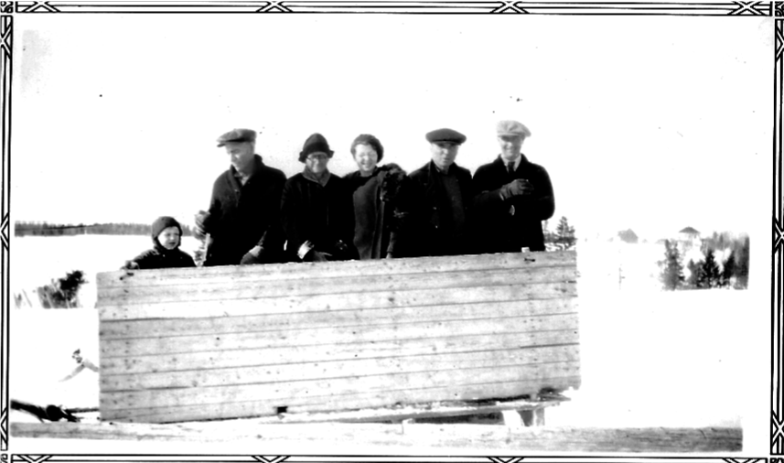

Believed to be Don Glendenning, Jane Glendenning, Grace Godfrey, John R. Godfrey and Cameron Russell at Little Branch. The school would be directly behind the group. To the left, is the tree in the schoolyard leaning out into the cove. To the right can be seen the Finno home, the Little Branch Bridge is just out of sight to the right of the trees. Sometimes we coasted down a short but steep hill through the trees on the right.

Guy Wellington Glendenning

The Herald Advocate of February 24, 1967 carried the following:

Guy W. Glendenning, 77, Died February 8 after an extended illness.

He was born in Canobie, New Brunswick, Canada and was a Canadian Veteran of World War l. He came to Bowling Green in 1930 from Peru where he was affiliated with the Masonic Lodge in 1921, serving as Worshipful Master a few years later.

He was Past Master of Bowling Green Lodge 121 and Past Patron of Bowling Green Chapter 23, Order of the Eastern Star, a Scottish Rite Mason, and a member of the Wauchula Elks Lodge.

Survivors are his widow, Hazel Stultz Glendenning; a son Robert Glendenning of Chesterton, Md.; a daughter, Cornelia Farrell, Huntington Station, Long Island, N. Y.; one brother, Ray Glendenning of Canobie, New Brunswick, Canada and four grandchildren.
Funeral services were held February 13 at the Bowling Green Methodist Church with the Rev. E. J. Halter officiating. Burial was in the Bowling Green Cemetery.

Hazel Glendenning

The Herald Advocate (I forgot to record the date, carried the following:

Hazel Glendenning, 85, a resident of Huntington, N.Y. and former resident of Bowling Green for 46 years passed away Wednesday, July 4 in New York. She was born in Brooklyn, N.Y. She was a member of O.E.S.

She is survived by one daughter, Cornelia Traetta of Huntington, N.Y; one son, Robert W. Glendenning of Chesterton, Md., and four grandchildren.

Graveside services were held Saturday, July 7, with interment in Bowling Green Cemetery. Rev. John Springer officiated.

Wedding

St. Stephen's Presbyterian Church annual report for 1910 includes the following:

"GLENDENNING-WATLING - At the home of the bride's parents, on October 18, Alton Elmer Glendenning of Bathurst and Jane Elizabeth Watling of Little Branch".

It is interesting that Dad’s name sometimes appears as Alton Elmer and other times as Elmer Alton Glendenning. Although I have not seen a birth certificate, my earliest references are to Elmer Alton Glendenning.

Mission Bands

Mission Bands were church groups for children. Statistics for St. Stephen’s in 1915 show five Mission Bands: Grenfell, McMillan, Robb, Star of the East and King Edward

Sleds and Sleighs

The above photo reminded me of the different kinds of sleds around home. Every home had a box sled, shown in photo, which was drawn by one horse and was the “working sled” of the family. The height of the box varied but, as I recall, ours was about 30 inches tall and it would have two or three benches for seats. A box sled would haul a half a ton of smelts, a half a cord of wood, a pig to be bred, results of one’s shopping in Loggieville and friends and family to church. Norman, and likely Kenneth, hauled fellow students to school in the Bay du Vin church and later to the Miramichi High School. He would carry hay for the horse and Goymer Williston or Harrison Smith let him stable the horse while at school for the day.

On long trips or cold days, hay or straw would be placed in the bottom and we would cover ourselves with blankets, a buffalo robe or even the horse blankets to keep warm. Sometimes stones would be heated to help keep us warm. If one got too cold, one got off and walked. On a stormy day, the driver still had to stand in the cold.

We also had a set of bobsleds hauled by a team of horses although there were light bobsleds pulled by one horse as well. Bobsleds were two sleds. The trailing sled was hooked to the leading sled by crossed chains – that is the right front of the trailing sled was hooked to the left rear of the leading sled and the left front to the right rear. The rear sled was like a trailer. Both sleds had bunks with the one on the front able to swivel thus allowing the leading sled to turn.

Bobsleds were used for hauling logs and firewood in long lengths. (Firewood was cut into firewood length at the house) wood to the river for the spring drive or, later, in hauling to the side of a road to be picked up by a truck. When used commercially for hauling logs, extra long bunks were used so that larger loads could be hauled.

Sleighs came in many shapes and sizes and were hauled by one horse. Some were fancy while others, like the one in the last issue of the Family Chronicle were quite utilitarian. Sleighs, if you had one, were used for funerals and courting.

In the summer we had a drag sled sometimes know, I believe, as a stone boat. Drag sleds were hauled by a horse and were used to haul heavy objects short distances such as few bags of grain from the grain shed to the barn, stones to the side of the field, etc.

Finally, there were hand sleds that, as the name implies, were pulled by hand. We had two, a small one and one known as “John’s sled”. I wonder if John made that sled the year he took the course in Newcastle? Hand sleds were used for light hauling around the farm such as to pick up the groceries at the corner when Ken arrived home on the bus, haul wood from the pile to the door.

Of course, the fun use was for coasting which we did on the hill towards the school. On cold, crisp, moonlight nights, I often think of George and I coasting on the hill. I mentioned in an earlier letter that the Little Branch school did not have a pump therefore water was carried in a pail from our house to the school. Usually two students were assigned the task each day. I recall filling a pail at our place, putting it between us on the handsled and coasting down the hill and into the school yard. Whatever water was left, we carried into the school.

The Chronicle is an occasional newsletter prepared by Don Glendenning and posted on the family website. It is designed to share information about my family, community and the times in which I grew up. While every effort is made to be accurate, errors are likely to occur. Comments, enquiries and information may be sent to 62 Queen Elizabeth Drive, Charlottetown, PEI, C1A 3A9. Tel: 902-892-5859 Email: don@glendenning.net Web: www.glendenning.net

