The Family Chronicle
No. 79 September 5, 2004
________________

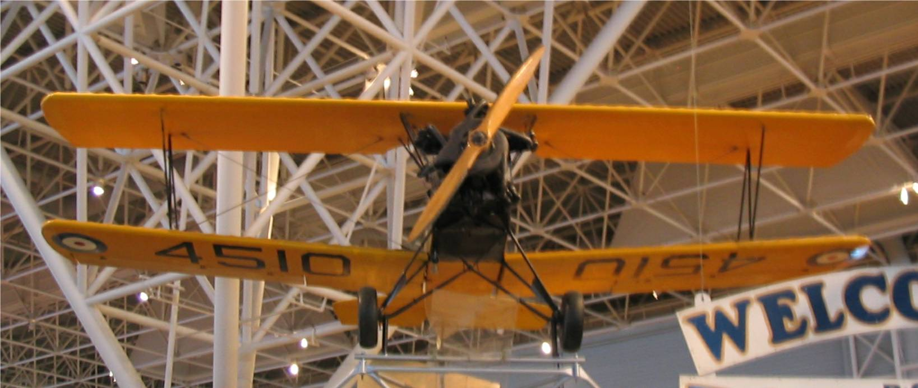

No. 31 Elementary Flying Training School (EFTS) at Chatham used the Fleet Finch for training purposes during World War Two. The above photo of a Fleet Finch was taken recently at the air museum in Ottawa. As I understand it, after some basic flight training given elsewhere, pilots then came to the Chatham air base because it was designated a low flying area. In fact, a number of planes were forced to land or crashed while on training missions. As I recall, there was only one life lost in a plane crash in the Black River area and that was in the crash at Alf MacLean’s shore..

A counting rhyme:

Jennie Foley (we are both descended from John Peters and Jane (Sealey) Peters) reminded me of the following rhyme usually triggered when spotting one or more crows:

One crow sorrow, Two crows joy
Three crows a wedding, Four crows a boy
Five crows silver, Six crows gold
Seven crows a secret, Never to be told.

It is amazing how quickly nursery rhymes drop from view. I was at a family gathering recently and none of the younger generation had ever heard this rhyme.

Lodges

While looking through papers recently, I came across a certificate from Hadattah Lodge No. 117, Independent Order of Odd Fellows which reads s follows:

Portland, Me. , Oct 21st, 1901
This Certifies that Bro. Elmer A. Glendenning
Was this evening admitted to membership in this lodge.
John Steward N.G
Henry G. Milliken Sec’y

In a Masonic Text Book, in Dad’s handwriting, is the following inscription:

I was made a Master Mason the last Saturday night in 1911 at Ocoee Lodge No. 212, Benton, Tennessee, E.A.Glendenning

And in another Masonic Book in Dad’s handwriting:

Presented to E. A. Glendenning
By James Cortey of
Knoxville, Tennessee

Dad and Mum set up housekeeping in Parksville, Tennessee on April 11, 1911 and their first child, Grace was born there. Dad worked on the construction of Ocoee No. 1, a dam at Parksville. Later they moved a few miles up river where a second dam, Ocoee #2, was built. Mum returned to NB for Walter’s birth in 1913. Dad may or may not have accompanied her but they were both in NB in 1914.

St. Stephen’s Church, Black River

The Commercial of February 26 , 1924 carried the following:

That little white church on the Island,
Surrounded by beauties supreme,
Over and over provides inspiration;
So one need not go begging a theme.

When the dew it lies damp on the clover,
And the birds in the branches sing high,
And the sheen on the flowing Black River,
Reflects the rare gliut (glint?) of the sky.

In the quiet still hours of the morning,
As nature, her gay garb doth assume,
And our thoughts dwell on the Creator;
And our hearts are with Him in tune.

Our lives have been filled with his mercies,
Our spirits partake of His grace,
Just here we pause, and adore him
For providing so hallowed a place.

A place that is crammed with rich memories
That in our hearts must forever burn bright,
As we wander through the “God’s Acre”,
And think of those now, gone from sight

They have passed through the grave’s dark portal
To a land supernal and blest,
And we know with a perfect assurance
Again we’ll meet; when we enter our rest.

We love thee, white church on the Island,
With your tower pointing clear to the sky;
In language, though low, still convincing,
That our home is not here, but on high.

We wish thee well, little white church on the Island
Our hearts forever around thee shall twine,
And practice the lessons there taught us
By “precept,” and line upon line.

The Rev. Dr. Harrison

Dr. Harrison was Minister at St. Stephen’s
Presbyterian Church and St. Stephens
United Church during the period 1919 to 1926.

Follow-up

Donald Edge wrote “As usual, I enjoyed your articles, now these on milking and the separator. I never did get the hang of milking, but I enjoyed Eliot Cail's accuracy when he shot a stream straight into the mouth of one of the barn cats. ]There's a whole other article--the house tabby versus the semi-wild barn ratters/mousers.] I especially liked your very clear description of the seperator, since I never understood how the thing worked. I do remember that cleaning the parts was so critical that the task was never assigned to males of any age. I look foward (I hope) to an article on the butter churn. Ours was a barrel-type operated by both hand and foot, and in my mind I still feel the thump-da-thump that let us know the cream was now butter.

The Chronicle is an occasional newsletter prepared by Don Glendenning and posted on the family website. It is designed to share information about my family, community and the times in which I grew up. While every effort is made to be accurate, errors are likely to occur. Comments, enquiries and information may be sent to 62 Queen Elizabeth Drive, Charlottetown, PEI, C1A 3A9. Tel: 902-892-5859 Email: dglende@auracom.com Web: www.glendenning.net

