The Family Chronicle
No. 86 December 9, 2004
____________________________________________________________________

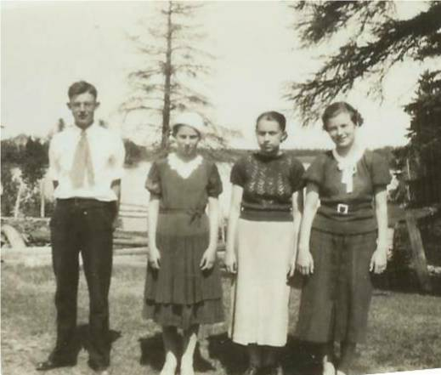

From left: Winfield Watling, Catherine (MacLean) Newton, Elinor (Glendenning) Taylor and Unknown ? Photo taken in the Little Branch schoolyard.

A “shunt” from the West

Thanks to Jennie Foley for this story about her grandfather, Robert Henry Peters.

Farmers sometimes bought horses shipped from the west. Horses were rounded up, loaded into boxcars and shipped east to be used on farms. The ones in the middle of the car were called shunts and often died on route from the battering received when rail cars were being shunted on to sidings.

Robert Henry Peters was blind and had a “shunt” horse called “Pete”. With his daughter, Eva’s help, he would plough the first furrow. Thereafter, he continued to plough by keeping one foot in the furrow.

Pete was used as a bear alarm on frequent trips to collect blueberries. He would give the alarm if he scented a bear and his neighs

would call the children back to the wagon if they became lost in the bushes.

Once a heavy winter storm came up and Eva, Jennie’s mother, started home alone from school walking backwards into the heavy wind and snow. In the meantime, her father hitched Pete to come looking for her. Her father did not see the child on the road but the horse stopped and would go no further even though Robert used the whip. The horse refused to move forward and simply stamped its feet. Just then, Eva, backed into the horse’s chest. The horse knew she was there and refused to step on her.

Home for Christmas

Mildred (Glendenning) Beattie recorded this story in her recollections.

“Uncle Frank settled in Portland, Maine. … One year he decided to pay us (his brother, Chipman Glendenning in Canobie) a surprise visit at Christmas and experience once more his memories of winter on the farm, but – the surprise was as much his as ours. Uncle Frank said, “This is not like winter on the farm! Why, after doing the necessary chores, we all huddled close to the old Star cook stove in the kitchen, moving only far enough away to eat and do necessary indoor jobs. Bricks or stones were heated in the oven until bedtime for each person, wrapped in and old garment and put into bed, mostly two together, which helped to keep each other warm. Now your whole house is as comfortably heated as ours is the States is! The hardwood in the furnace really holds the heat at night – no getting up in the freezing cold. - water frozen in the kitchen and so on. Lil and Bertha won’t believe me when I tell them how cozy you are here. I’ve been talking for years about what it was like growing up on the farm. Now, they’ll think that I was stringing them along all this time.”

According to my sister Lillian:

- An earthquake was felt in Black River in 1925
- The person who put on the fire in the Little Branch school received $8.00 for the year
- Sleds often carried a lantern hanging on the side so that they could be spotted by other drivers, especially during stormy weather.
- Fred Fowlie was the first person to have a car in Black River and Harrison Smith was the first in Bayside. Malcolm MacNaughton also had a car about the same time.
- Dr. MacKenzie was the first one around to have a snowmobile; it was built out of a car and had runners on it.
- If someone needed a doctor, and they knew that Dr. MacKenzie was down river, they would hang a lantern at their gate so that the doctor would know to stop in.
- Dad would drive through to Bathurst when there was grass showing in the center of the road
- Dad would take the kids down to “Bay du Vin” night at Bernie Williston’s Beach where there would be dancing, fireworks and treats.
- Dad used to resole the children’s shoes
- Dad and John W. MacNaughton had a “rosser” (for peeling pulpwood)

- Cows were allowed to graze along the roads
- A cyclone struck Black River in 1932 and blew the roof off Jimmy Major’s barn and also moved the Victoria Bridge on its piers
- She was paid one cent for every hundred potato bugs she picked
- Uncle Jim Watling had a “Star” car; he sold a device that was supposed to increase gas mileage in cars
- Dad had his celluloid collars done at a Chinese laundry in Chatham
- Grace taught herself to play the violin
- Dad used to work in the canteen when there were dances in the Little Branch school
- One year there were 53 children in the Branch school with one teacher
- Dad hunted geese at the Finno field and the family had goose for Thanksgiving dinner
- Dad and Harry Glendenning first met at a Farmers and Dairymen Convention in Woodstock, NB. (Uncle Harry lived in Shediac and, although not related, we visisted back and forth regularly – Ed.)
- One of the older children used to walk part way to meet Mum and her siblings when returning from school at the Meadows because of the bears
- There was a favourite watering hole for horses along the McKnight road
- The Black River hall burned in 1932

The Chronicle is an occasional newsletter published by Don Glendenning and posted on the family website. It is intended to share information about my family, community and the times in which I grew up. While every effort is made to be accurate, errors are likely to occur. Comments, enquiries and information may be sent to 62 Queen Elizabeth Drive, Charlottetown, PEI, C1A 3A9. Tel:902 892 5859. Email: dglende@auracom.com Web: www.glendenning.net

