The Family Chronicle
No. 95 June 2, 2005
____________________________________________________________________

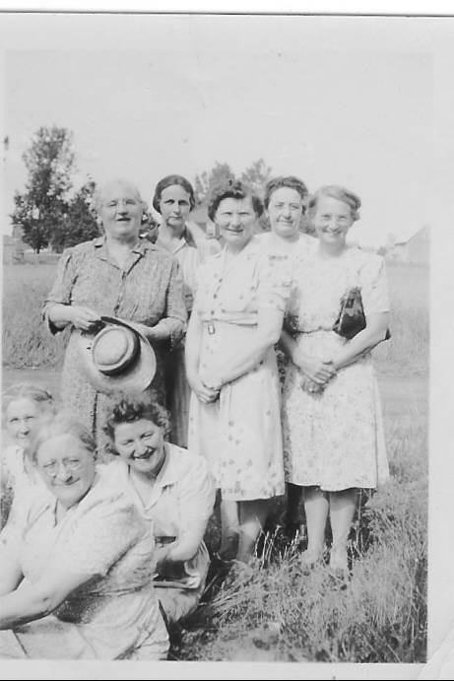

Front: Janet Godfrey, Jane Glendenning, ? Standing: Bioney MacDougall, ?, Alice Watling, ?, Marion MacLean, ? .

Stoppage Settled

The long delay since the last Newsletter results from a labour dispute between the editor and publisher. Negotiations dragged on for months. The dispute is now settled and the Family Chronicle should appear with its usual and regular irregularity. Thank you for your patience

Sgd: Chairman of the Bored

James A. Watling

An undated clipping believed to be from the Moncton Times, reported:

"J. A. Watling

BLACK RIVER BRIDGE (Special) - James A. Watling, 95, died Friday at Hotel Dieu Hospital, Chatham, after a lengthy illness.
Born in Black River Bridge, he was the son of the late Jubal and Grace (MacDonald) Watling. He had been a farmer and, for 42 years was a smelt buyer for W. S. Loggie Co. of Chatham. He was also the first leader of the 4H Club in the area, a charter member and board member of the former Newcastle creamery, now Northumberland Co-Op. He was also a member of St. Paul's Presbyterian Church, Black River Bridge, an elder of the church for 62 years and treasurer of the presbytery for a time. His wife, the former Katherine Mills, died in 1965.
He is survived by a daughter, Mrs. Alvin Young (Marjorie) of Loggieville; four sons, Winfield, Roy and George, all of Moncton, and Neil Watling with whom he resided; 16 grandchildren, and by 9 great-grandchildren.
The body will be at Adams Funeral Home, Chatham, after 7 p.m. today. The funeral service will be held at 2 p.m. Monday at St. Paul’s Presbyterian Church. Interment will be in the Black River Cemetery."

What’s a “buckety wade?

I am not sure of the word or it’s spelling but didn’t we call a teeter-totter a buckety wade? Seems that we made ours with a 2x6 plank over a fence or gate, or perhaps a sawhorse. (A 2x4 was not strong enough.) In order to balance the plank, the lighter person would move a bit closer to the end of the plank. A great demonstration of one of the laws of physics.

Fowlie’s Mill

Among my notes, I found a clipping entitled “150 years ago - 1828”. Presumably it was from a Miramichi paper.

“Foul play suspected

The grist and saw mills of Little Black River owned by Mrs. Fowlie, were totally consumed by fire on the 10th Feb. There was a large quantity of wheat, flour and oatmeal in the mill at the time, which was all consumed, together with everything on the premises.
From all the information we are able to glean, there is every reason to apprehend that it was the work of an incendiary. The fire in the stove was carefully put out early the preceding evening, and when the fire was discovered the next morning, the flames were issuing from the opposite end of the building to where the stove stood.
The loss of property will be from 800 pounds to 1000 pounds.”

Quality

People with farm roots may enjoy the following:

“If you wasn’t nice, clean oats, you must pay a fair price; however if you can be satisfied with oats that have already come through the horse – that comes a little cheaper!!”

Ironing clothes

Clothes were not wrinkle free; they had to be ironed or pressed by hand and, as I recall, sheets and pillowcases, dresses, shirts and most other clothes were ironed every time they were washed.

Irons were heated on the wood stove, the main source of all heat - same one used for cooking, warming the house and heating water. Once plans were made to iron, the irons would be moved to the front of the stove. Irons usually came in sets of three with a handle that could be easily switched from one to the other; two would be heating while one was being used. One had to be sure that there was no dirt on the iron otherwise the item would have to be washed again – and always by hand.

Walter courted Agnes, as I recall, practically every night of the week. This meant a fresh shirt both washed and ironed – and he always wore a white shirt.

If clothes were too dry, a bit of water would be sprinkled on them. A water sprinkler was made from a vanilla bottle. Holes were punched with a nail in the metal cap, water was put in the bottle, and the clothes were sprinkled as needed.

Men’s pants had to be pressed regularly. The pants were laid on the ironing board. A piece of damp cloth was laid over the inside of the leg. The dampness helped set the crease in the pants. Ironing without using a damp cloth, I was told, caused pants to become shiny.

Prior to 1919, my Mum and Dad lived and worked in the USA and, because many of his projects involved hydroelectric dams, they usually had electricity. Among Mother’s possessions, was an electric iron. It sat in a box well hidden in a closet. Electricity came to Little Branch in, I believe, October 1948. The electric iron was brought from storage, plugged in and, a major labour saving device sprang to life.

The Chronicle is an occasional newsletter published by Don Glendenning and posted on the family website. It is intended to share information about my family, community and the times in which I grew up. While every effort is made to be accurate, errors are likely to occur. Comments, enquiries and information may be sent to 62 Queen Elizabeth Drive, Charlottetown, PEI, C1A 3A9. Tel:902 892 5859. Email: dglende@auracom.com Web: www.glendenning.net

