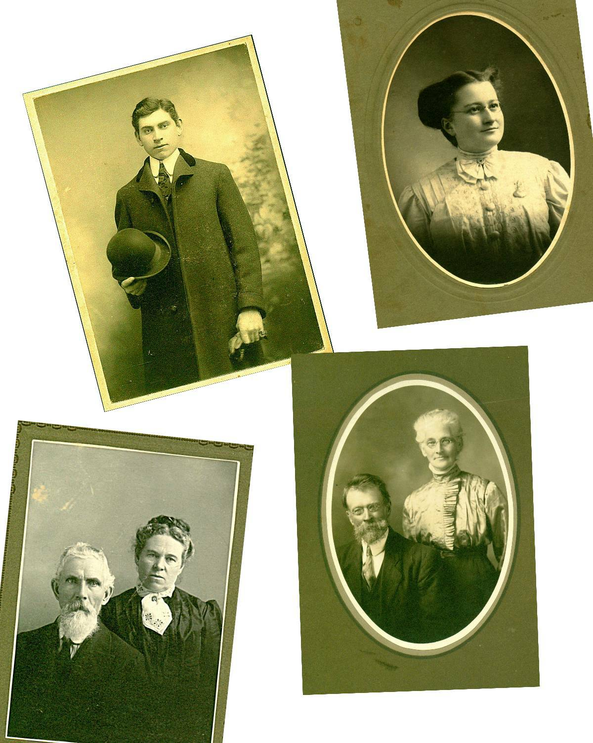

Top left: Elmer Alton Glendenning
Top right: Jane Elizabeth Jardine Watling
Bottom left: Walter and Elizabeth (Peters) Glendenning
Bottom Right: Jubal and Grace (MacDonald) Watling

From the Collection of Jane Elizabeth Jardine (Watling) Glendenning

