Little Branch School Register – 1933-1934

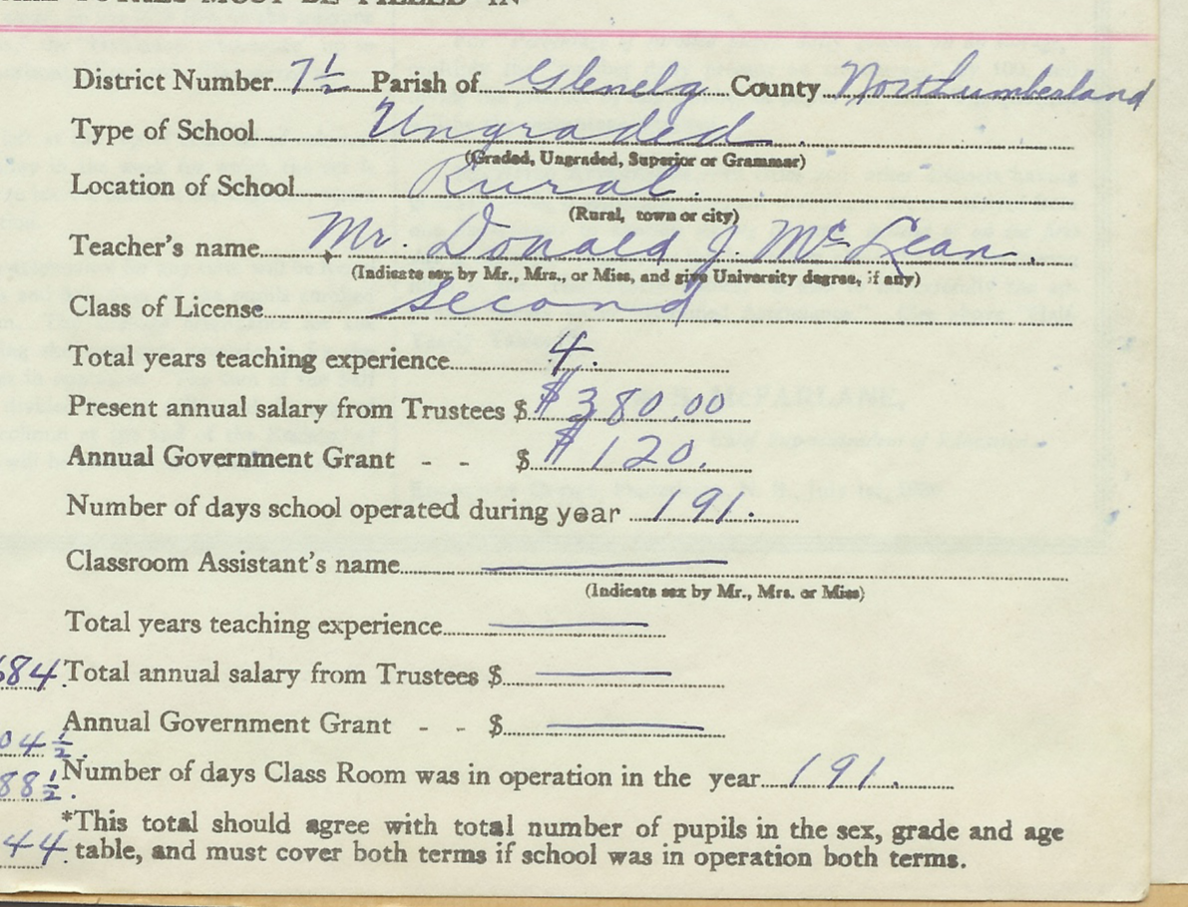
Merry Christmas

Little Branch School Register – 1933-1934

Merry Christmas

