PLATE 14: Dumfrieshire, Scotland

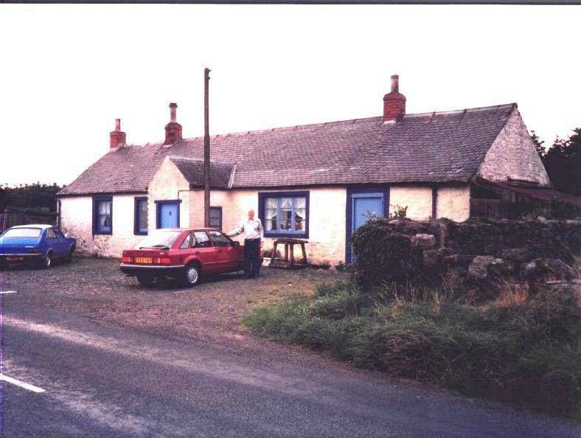
Callister Hall

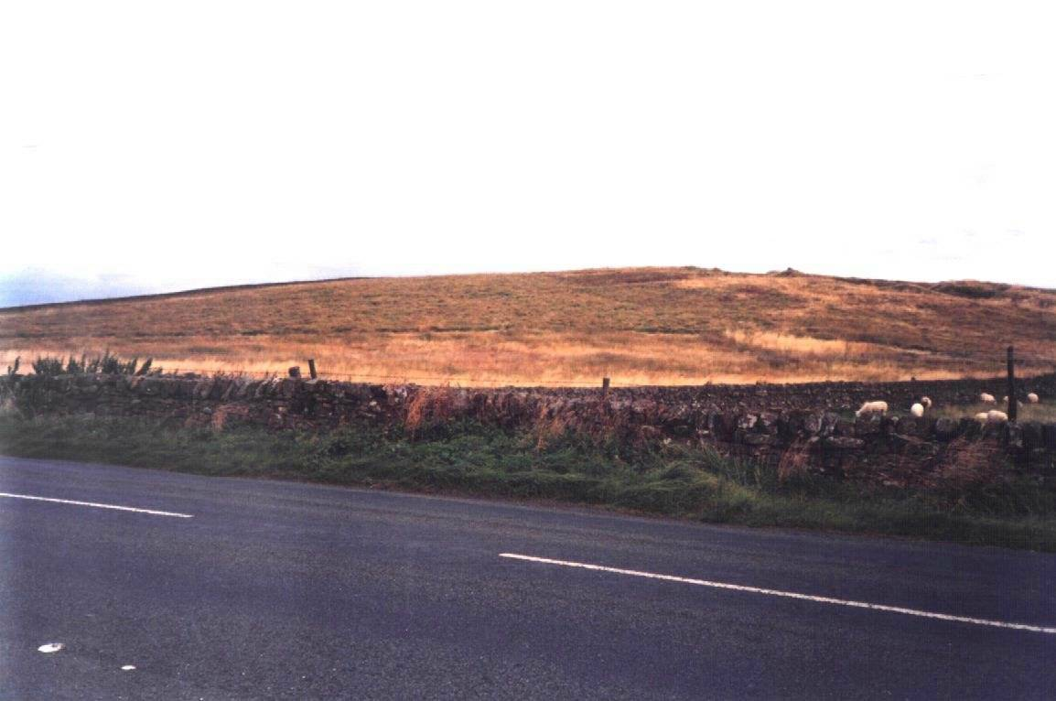
Across from Callister Hall

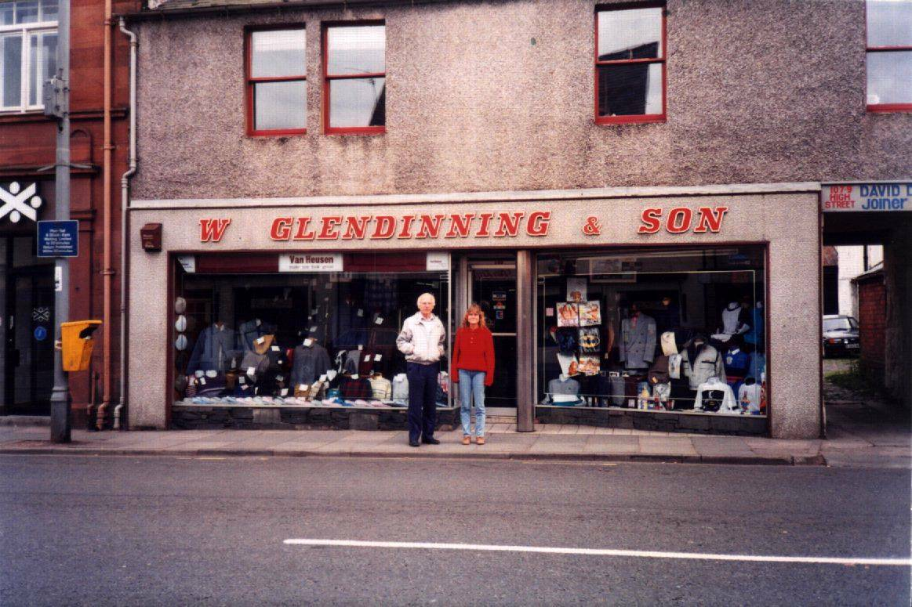

Main Street, Annan

