ST. PAUL’S PRESBYTERIAN CHURCH

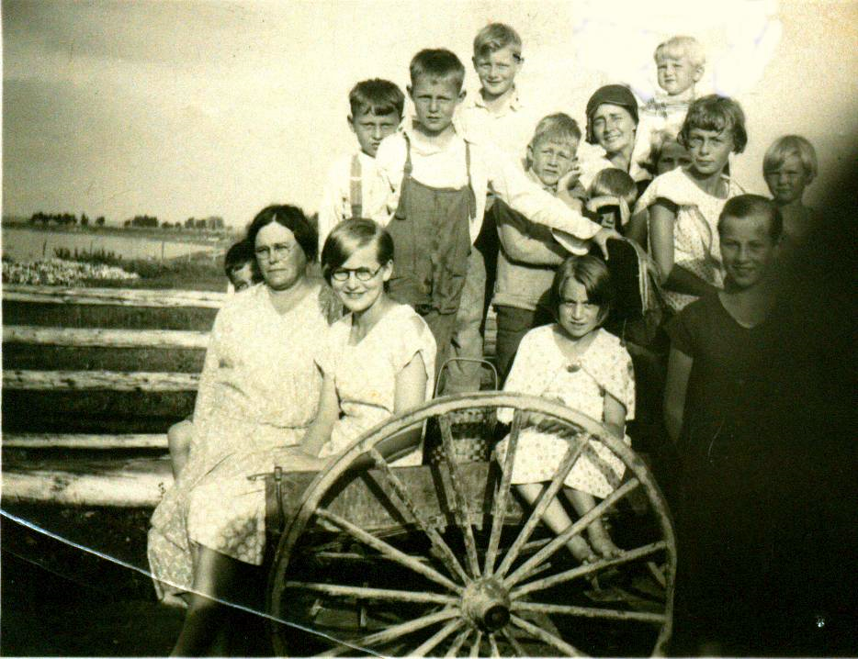
On the way to church picnic at Bayside

From the left: Unknown, Janie Cameron, Iona Cameron, Unknown, Unknown, Roy Watling George Watling, Elinor Glendenning, , Kate Watling, Don Glendenning Marjorie Watling, Unknown, Unknown

Glendenning collection

