PLATE 3: Elmer’s Siblings

Photo not available

Venetia Emily Glendenning
1872-1960

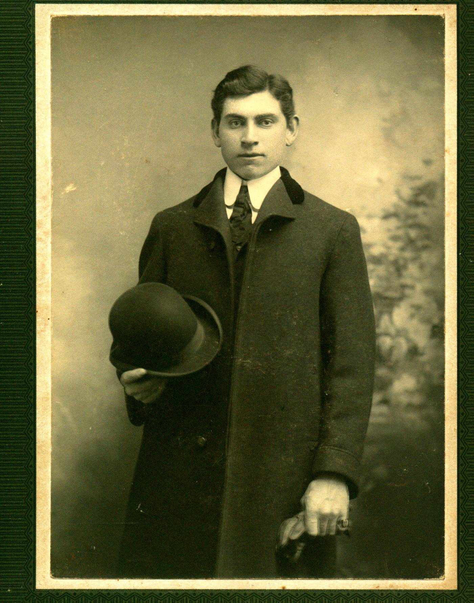
Elmer Alton Glendenning
1875-1938

Photo not available

John Franklin Glendenning
1876-1937

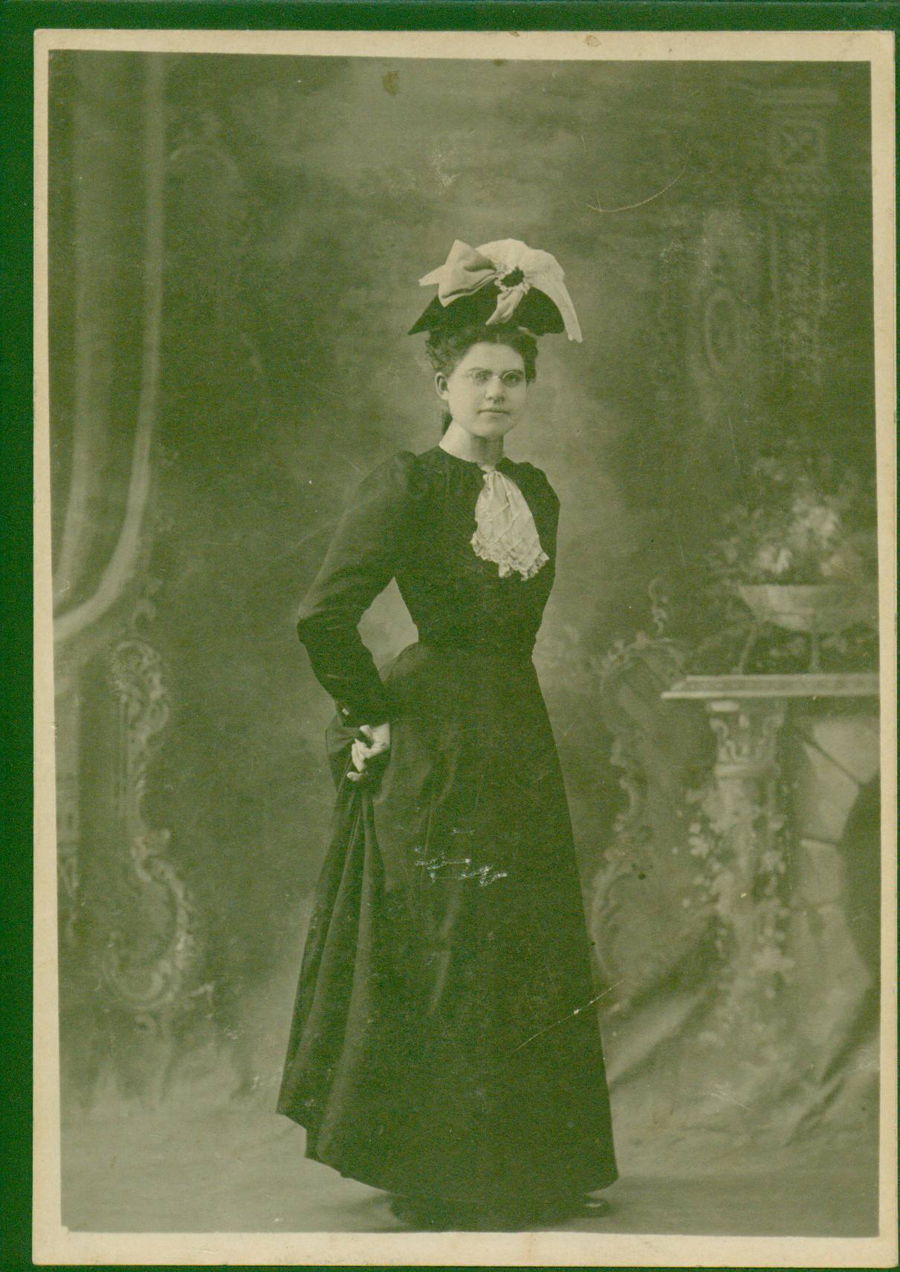
Mary Ann May Glendenning
1879-1955
Photo not available

Leonard Garfield Glendenning
1881-1958

Photo not available

Alda Jane Maud Glendenning
1883-1957
Photo not available

George Raymond Glendenning
1885 - 1970
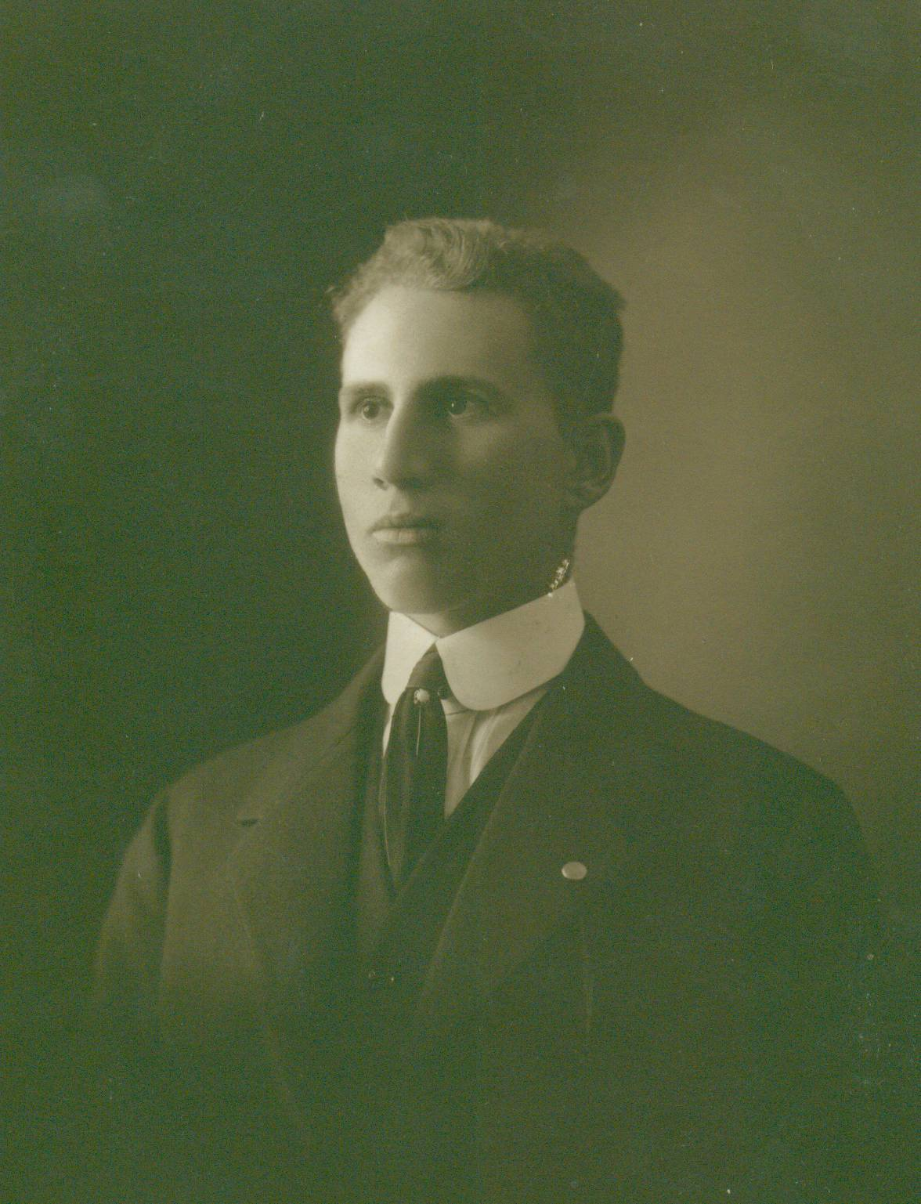

Chipman Lowe Glendenning
1897 - 1948

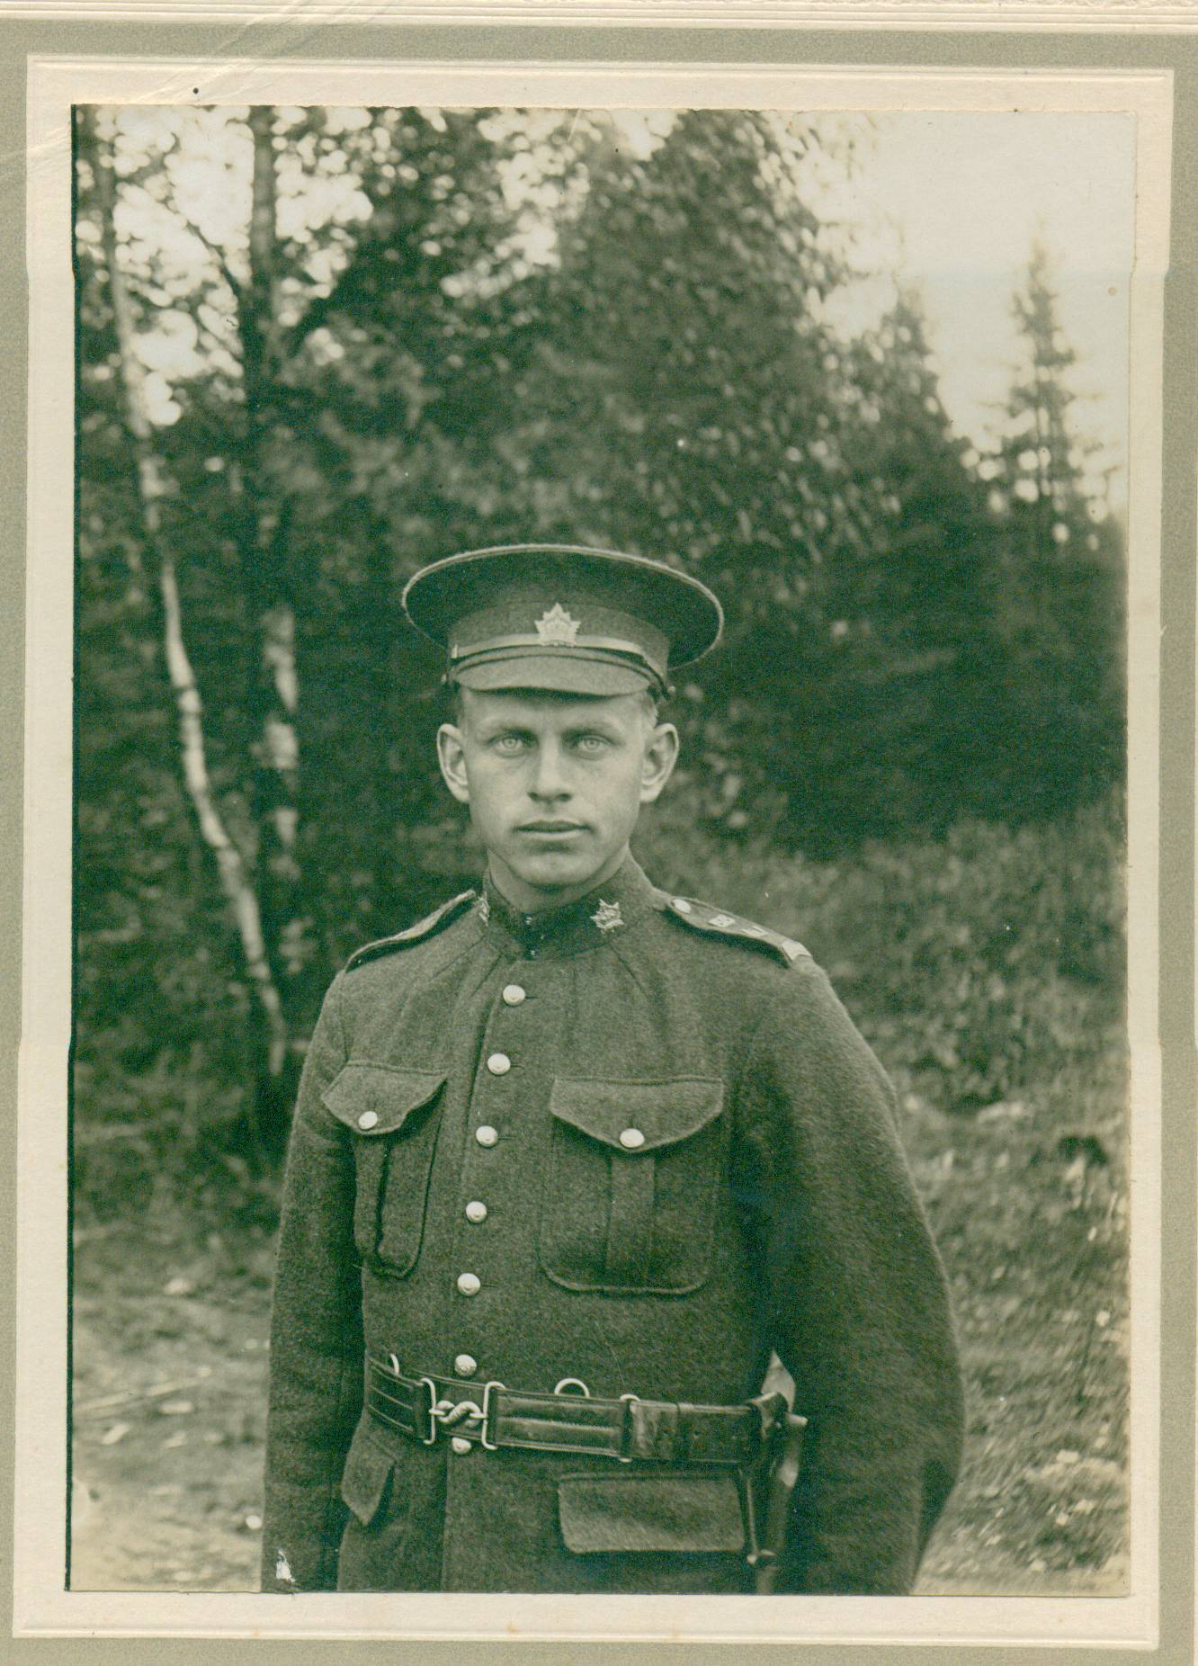
Guy Wellington Glendenning
1889-1967

Photo not available

Lillian Christina Glendenning
1891-1894

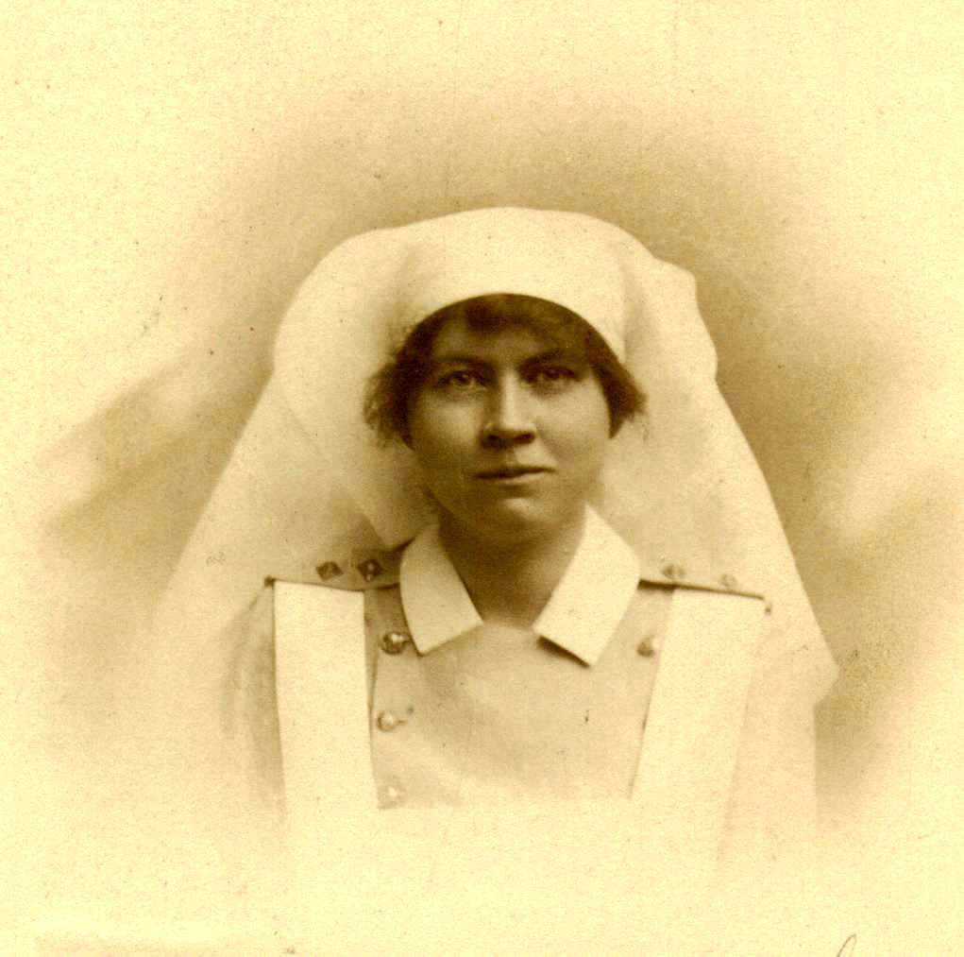

Margaret Violet Glendenning
1893-1956

Photo not available

Rufus Henry Comeau Glendenning
1896-1898

