

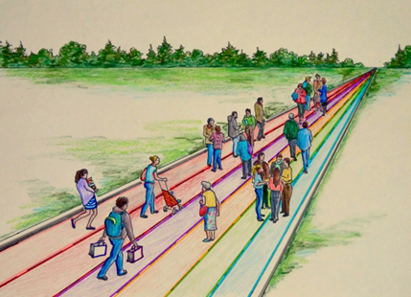
Islanders on the road of life

EDUCATION
AND
THE ROAD OF LIFE

Education 20/20 Inc.
101 Kent St.,
PO Box 624/rue Kent, BP 624
Charlottetown, PEI C1A 1M0 Canada
Tel: 902-892-2060

