Education 20/20 Inc. is an independent, broad based, national, not-for-profit education organization, located in Charlottetown, PEI and is governed by a volunteer Board of Directors.
Vision: A quality education for every Canadian.
Mission: To support and strengthen a culture of learning for all Canadians.
Mandate: To contribute to the education of our citizens by providing information, encouragement and support for a quality education for all citizens.
Activities:
- Education Award,
- Monthly electronic newsletter, website and occasional papers.
- Research, consultation and workshops

OUR THANKS TO:
- Our faithful donors
- Louise Carota, PEI artist
- ? for layout and editing
- ? Sponsors
- Islanders generally who support the cause of education

Bro/Learn/1-1


Learner on the Road of Life by Louise Carota

LEARNERS
AND
LEARNING

Education 20/20 Inc.
101 Kent St., PO Box 624/rue Kent, BP 624
Charlottetown, PEI C1A 1M0 Canada
www.education2020.ca – pei@education2020.ca

THIS BOOKLET

PEI has about 150,000 residents; all are potential learners, many are actual learners. Their future and our future depend to a large degree on the nature and quality of their current education and the education available to them in the years ahead. It is to their benefit and ours to make that education a quality one.

Organizing and delivering education services is a complex matter given all the variables - geography, culture, individual differences, ages, prior learning and personal interests. To this we must add the changing world of education from that of providing an academic education to that of preparing people to deal with, if not solve our community’s and the world’s ills.

This booklet is intended to help Islanders understand their education system, provide a framework for decision-making, provoke debate and encourage action.

DONATE NOW
Readers wishing to contribute to the improvement of education are invited to:
- Mail a contribution to the address shown on back page, or
- Use Canada Helps on our website, or
- Make a contribution in our name to the Community Foundation of Prince Edward Island

ROAD OF LIFE

We are all on the road of life. The road of life is a metaphor for the experiences we encounter between birth and death. While on the road, each person fills a number of roles, that of an
• individual,
• family member,
• citizen,
• student
• producer and
• consumer

Hurdles
The road of life, like any road, presents its share of hills, hollows twists and rough spots including:
• Need for formal qualifications
• Limits to our own learning
• Culture we carry with us and the culture we acquire
• Personal commitments and responsibilities

Essential skills
Some skills are considered essential for everyday living; while readers could make their own list, most lists would likely include the following:
• Communications
• Numeracy
• Community awareness
• Self-management
• Interpersonal relationships
• Information technology

LEARNING

Learners: Citizens in the process of changing
the way they think, feel or act

A learner is a person who, for whatever reason, is trying to bring about change in his/her life - trying to change an attitude, gain new knowledge or add to their skills. But learners are neither empty jars nor blank slates; each learner carries three pieces of luggage to every new learning situation:
• Physical, mental and emotional conditions with which the learner was born.
• Prior learning
• Imagined futures

LEARNING
A process of engaging in experiences
that have a formative effect on the way we think, feel or act

Our futures may benefit from or even require a different mix of attitudes, skills and knowledge than the ones we now have; the process of developing the new mix is called learning, the discernable change that occurs in us as a result of learning is called education

LEARNING PATH
A person’s learning path is not a straight line. The learning path below was developed in consultation with a panel of postsecondary students who told us about their learning experiences. While school oriented, it presents the typical complexities of the flow of learning experiences.
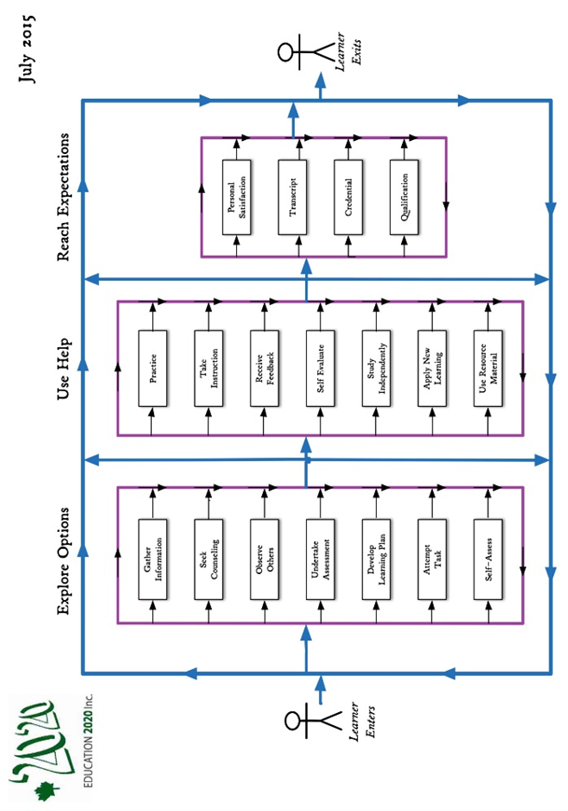

LEARNER SUPPORT SYSTEM

OBJECTIVE – to increase the level of education of Islanders

TYPICAL SUPPORT SERVICES
- Governance
- Funding
- Instruction
- Human Resources
- Learning products and technology
- Quality assurance
- Information and counselling

REASON FOR GOVERNMENT SUPPORT
Governments support education in order to 1) help citizens develop strong personal skillsets and (2) to ensure that our community has the skills needed to maintain itself as a place we want to live.

MISSING COMPONENT
Although students have guidance counsellors and classroom teachers, the system lacks personal professional advisors available to students and their parents during public school years.

ABOUT EDUCATION

- Education: Any experience that has a formative effect
on the way a person thinks, feels or acts

- Educate – to broaden the range and increase the level of performance in a person’s skillset

- Education, purpose – to develop one’s capacities as participating member of a community or society

- Education system - services put in place by a community to encourage and support the education of its citizens

- Outcome - That which is produced or occurs as a result of an event or process

- Standard” a readily distinguishable level of performance, demonstrated though the making of a product or provision of a service which is deemed worthy of recognition

- School – an institution designed for students (or pupils) to learn under the direction of teachers

- Student – someone who attends an educational institution

- School system – institutions, programs and services provided and encouraged by or with the approval of a community through its government for the purpose of providing formal education for its residents

