Memory Trees

Memory trees are planted to remember a person, place or event. But they are more than just a tribute, memory trees enhance and beautify our environment, provide shelter for our wildlife, reduce erosion and improve the quality of the air we breathe. As part of our public spaces, memory trees bring comfort, hope and peace to visitors and ensure that generations to come will know the beauty of a green plant.

Memory trees are a component of a Living Memorial Trust at the Community Foundation of Prince Island. They may be planted in any public green space including the Confederation Trail, school grounds, parks and hospital grounds. Arrangements may be made with the Foundation for named trees at selected sites of the donors choice.

Initial funding for The Living Memorial Trust at the Community Foundation of Prince Edward Island was provided by the family of Dr. Charles Keuper, a retired physician with a deep love for the natural beauty of his adopted home. Dr. Keuper was an avid and tireless worker in the establishment of Trails PEI and a person who savoured outdoor life to the full.

Community Foundation of Prince Edward Island
Queen’s Square Place, Suite 105
Charlottetown, PEI C1A 4B3
Tel: 002-892-3440

Design: Valerie Ford

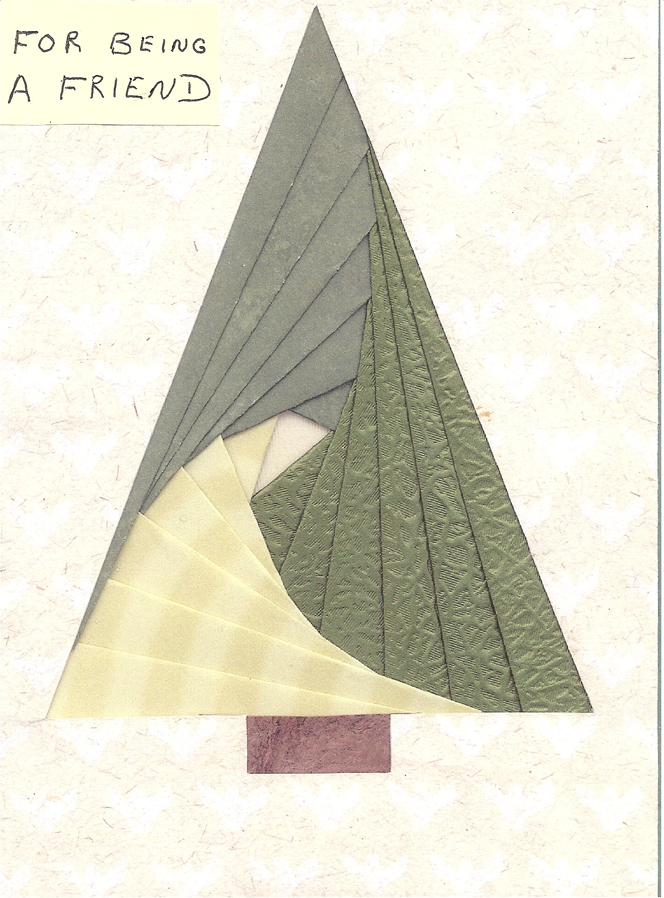

A

Memory Tree

Has Been Purchased In Your Name

By

________________________________

And will be planted in Prince Edward Island

