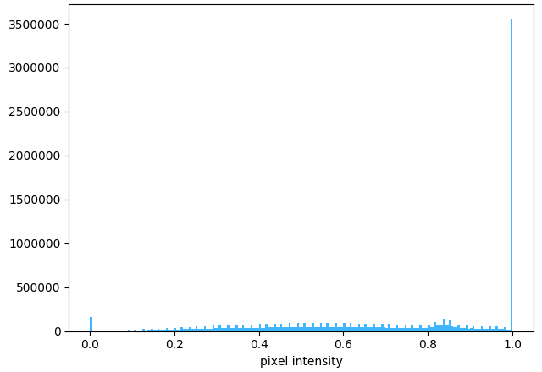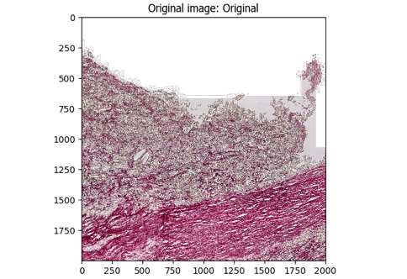**A.**

**The SR CellProfiler pipeline workflow.**

***[A].*** The original image (left) is masked using PathProfiler Tissue Segmentation Unet and used as input by CellProfiler 4.2.6; the graph (right) shows the tonal distribution in the digital whole-slide image on a RGB scale.

***[B].*** The input image is converted to a gray scaled image (left); the graph (right) shows the tonal distribution in the gray scaled image.

***{C].*** The gray scaled image is inverted, *i.e.* non-tissue will become black (left); the graph (right) shows the tonal distribution after inverting.

***[D].*** The tissue area is identified, as demarcated by the green line in the left image; the total tissue area size is calculated in pixels (right image) and tabulated (table).

***[E].*** The colors, *i.e.* stains, are unmixed using the original image (left): Other (middle), and SR (right). The graph (right) shows the tonal distribution of the SR image.

***[F].*** The SR-positive objects, *i.e.* collagen, are identified, white areas in the left image; the SR-positive objects are demarcated by a green line in the middle image, areas that are excluded due to size (minimal size 15 pixels) are demarcated in magenta; the right image shows all the identified SR-positive objects in random colors; the total number of identified objects is calculated and tabulated (table).

***[G].*** Finally, the data for each tile are saved in a comma-separated table, including meta-data such as tile positions, image location, object counts (there could be multiple patches of stained areas or tissue). The original image (top-left) is used to overlay the SR-positive objects (using random colors, top-right). The tissue area (red), and SR-positive objects (green) are all demarcated in the bottom-left image. The table (bottom-right) shows the areas occupied by each object class.

Sample used: AE11.T02-7271.SR.2017-12-23_00.46.16.ndpi

[Tile= X2000, Y12000]

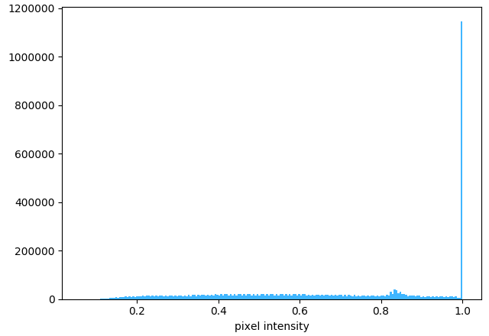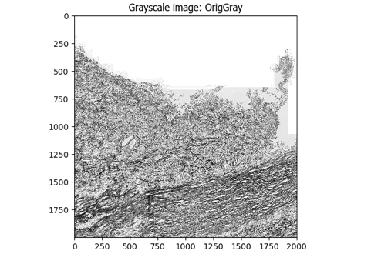**B.**

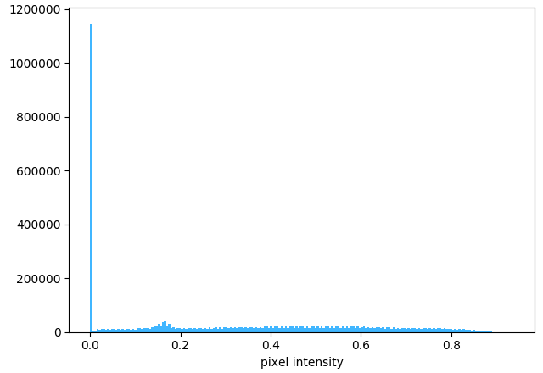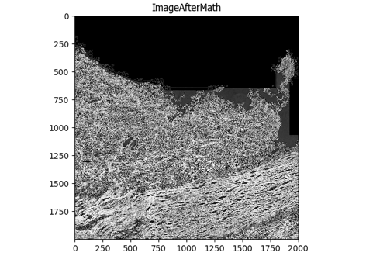**C.**

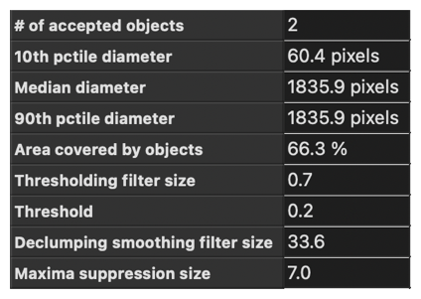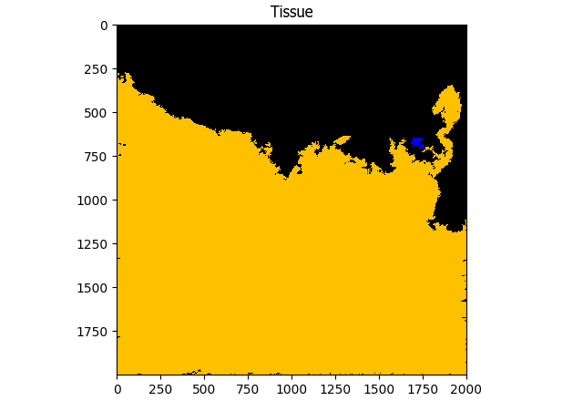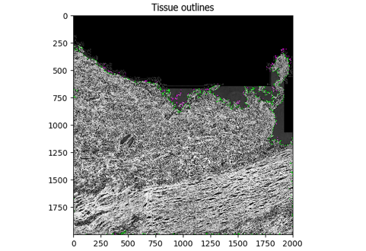**D.**

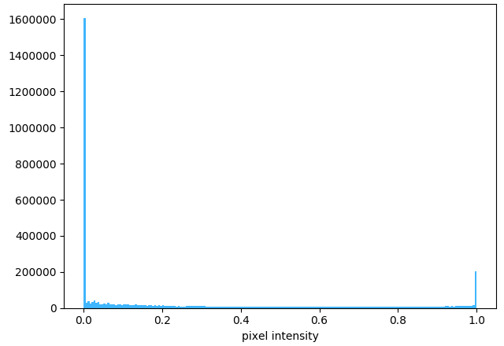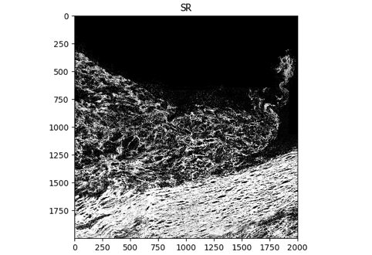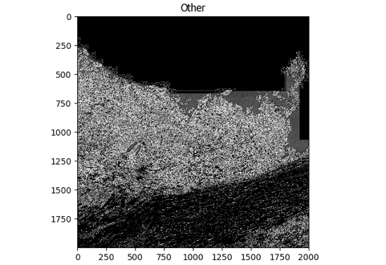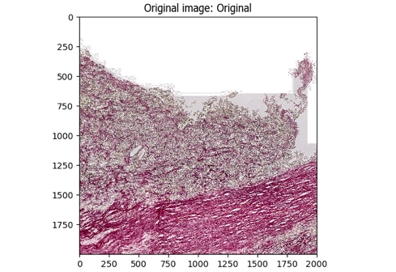**E.**

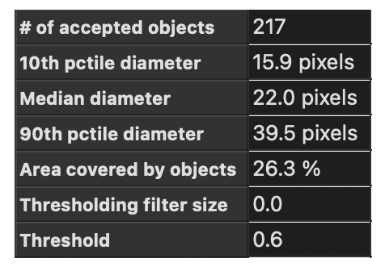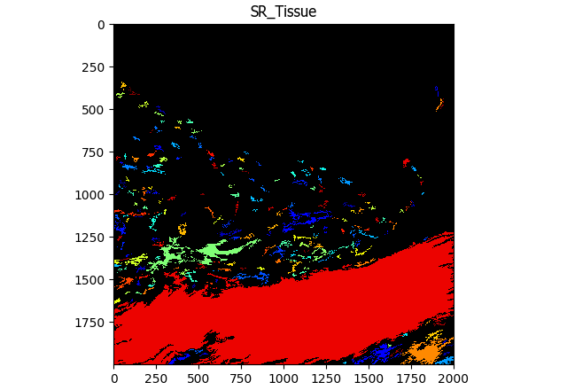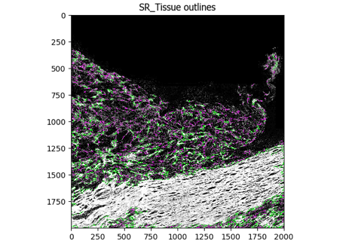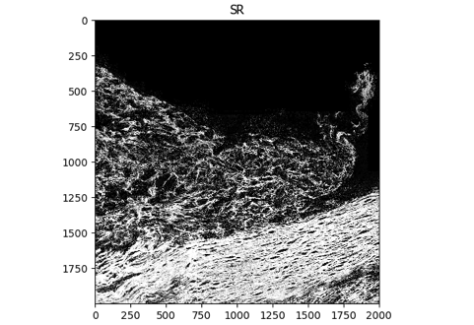**F.**

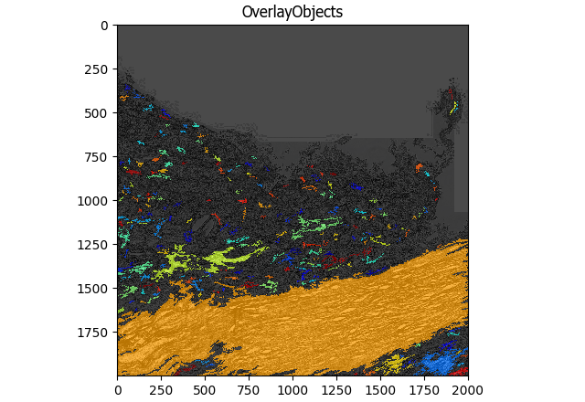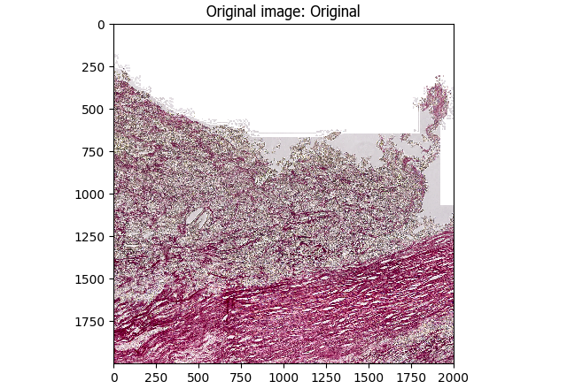

**G.**

