PLATFORM ENGINEERING
WEBCON BPS
Enterprise Installation &
Load Balancing Guide
Complete Setup from Scratch | 10,000 Users | All-Windows | Internal Network
Document Details  Category: Platform Engineering  Product: WEBCON BPS 2025  Version: 1.0  Status: PRODUCTION READY | Deployment Specs  Capacity: 10,000 Concurrent Users  Stack: All-Windows — No Linux  Proxy: IIS ARR 3.0 (Microsoft Free)  Database: SQL Server 2022

This document provides step-by-step installation and configuration instructions for deploying WEBCON BPS in a load-balanced, high-availability environment supporting 10,000 concurrent users on an all-Windows infrastructure. PowerShell automation scripts are included at the end of each phase to install all dependencies automatically from the internet.

1. Introduction & Architecture
This guide walks a Windows Server Administrator — even with no prior WEBCON BPS experience — through building a production-grade, load-balanced installation from scratch. Every step is illustrated with a reference screenshot and each phase ends with a single PowerShell script that automates all prerequisite software downloads and installations.

1.1 Architecture Overview
Study this diagram carefully before starting. It shows all four servers and how traffic flows between them.
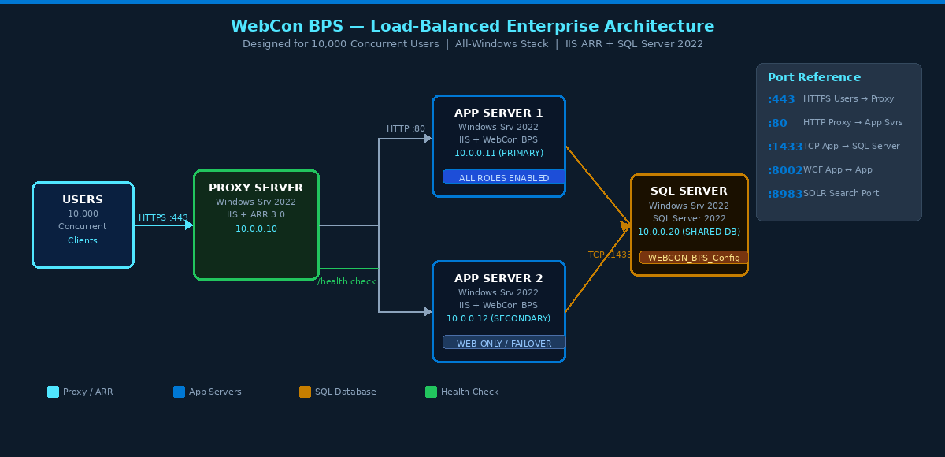
Figure 1.1 — Complete load-balanced topology: IIS ARR Proxy distributes HTTPS traffic across two App Servers sharing one SQL Server database

1.2 Traffic Flow (Step by Step)
- User opens browser and navigates to http://PROXY-SERVER01
- DNS resolves PROXY-SERVER01 to IP 10.0.0.10 (or users type the hostname directly on the internal network)
- Proxy Server (IIS ARR) receives the HTTPS request and terminates SSL
- ARR reads the ARRAffinity sticky-session cookie. New users are load-balanced; returning users go to their affinity server
- ARR forwards the request over HTTP port 80 to the selected App Server
- App Server processes the request, reads/writes to SQL Server, returns response to ARR
- ARR returns the response to the user over HTTPS

SSL Offloading
The SSL certificate lives only on the Proxy Server. Traffic inside the network uses plain HTTP port 80. This is standard practice — you manage one certificate instead of one per app server.

1.3 Server IP Reference
Server Role | Hostname | IP Address | Function
Proxy Server | PROXY-SERVER01 | 10.0.0.10 | IIS ARR load balancer + SSL termination
App Server 1 (Primary) | APP-SERVER01 | 10.0.0.11 | IIS + WEBCON BPS — all service roles
App Server 2 (Secondary) | APP-SERVER02 | 10.0.0.12 | IIS + WEBCON BPS — web traffic + failover
SQL Server | SQL-SERVER01 | 10.0.0.20 | SQL Server 2022 — shared WEBCON databases
Internal Proxy Hostname | PROXY-SERVER01 | DNS → 10.0.0.10 | The URL users type in their browser (internal network)

2. Hardware & Software Requirements
Provision all four servers before starting. Specifications below are sized for 10,000 concurrent users. Do not use lower-spec hardware — it will cause slow response times under load.
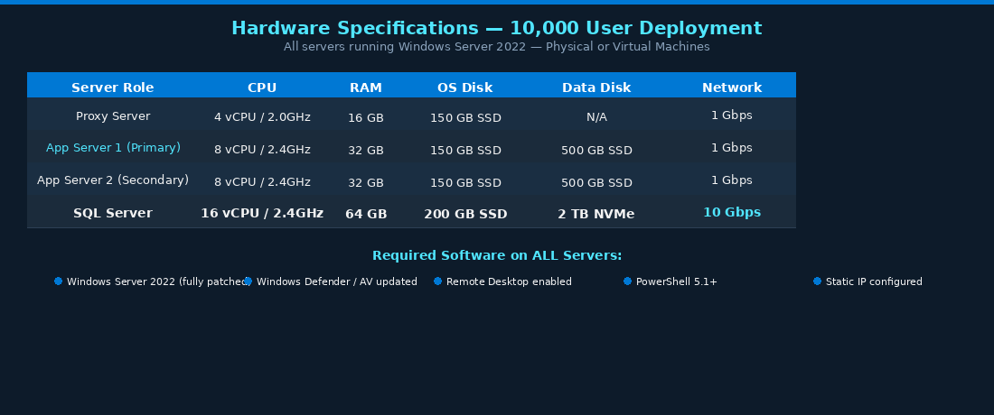
Figure 2.1 — Minimum recommended hardware per server for 10,000 concurrent users

2.1 Software Prerequisites — All Servers
Software | Required On | Notes
Windows Server 2022 (fully patched) | All 4 servers | Standard or Datacenter edition
PowerShell 5.1+ | All 4 servers | Pre-installed on Server 2022
.NET Framework 4.8 | All 4 servers | Pre-installed on Server 2022
Static IP address assigned | All 4 servers | As per IP table in section 1.3
IIS (Web Server role) | Proxy + App Servers | Installed by automation scripts
.NET 8 Hosting Bundle | App Servers only | Installed by automation script
Java 11 (OpenJDK Temurin) | App Servers only | Required for WEBCON SOLR Search
SQL Server 2022 | SQL Server only | Developer (free), Standard, or Enterprise
SQL Server Management Studio | SQL Server only | Free download from https://aka.ms/ssms
URL Rewrite 2.1 + ARR 3.0 | Proxy Server only | Installed by automation script

PHASE 1 SQL Server Configuration
Set up the shared database — complete ALL steps here before touching any App Server

3. Phase 1 — SQL Server Setup
The SQL Server is the foundation. Both App Servers share the same database. Complete every step in this phase first.
Step 3.1 Install SQL Server 2022 [SQL-SERVER01 — 10.0.0.20]
- Download SQL Server 2022 from https://www.microsoft.com/sql-server (Developer edition is free for non-production)
- Run the installer as Administrator. Select: New SQL Server standalone installation
- Feature Selection: check Database Engine Services and Full-Text and Semantic Extractions for Search
- Instance Configuration: choose Default Instance (MSSQLSERVER)
- Server Configuration > Service Accounts: set SQL Server Agent startup to Automatic
- Complete the installation. Then download and install SSMS from https://aka.ms/ssms
Step 3.2 Enable TCP/IP Protocol [SQL-SERVER01 — SQL Server Configuration Manager]
By default SQL Server only accepts local connections. Enable TCP/IP so App Servers can connect over the network.
- Press Windows key, search for SQL Server Configuration Manager, open it as Administrator
- In the left tree, expand SQL Server Network Configuration
- Click Protocols for MSSQLSERVER
- In the right pane, right-click TCP/IP and select Enable. Click OK on the confirmation.
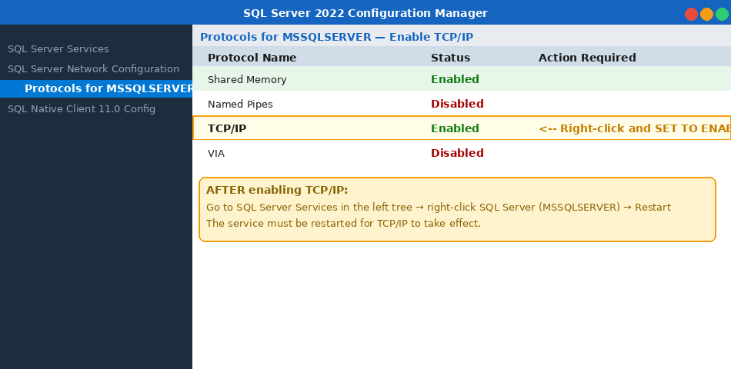
Figure 3.1 — Enable TCP/IP in SQL Server Configuration Manager. Right-click TCP/IP and select Enable.
- Navigate to SQL Server Services in the left tree
- Right-click SQL Server (MSSQLSERVER) and select Restart — TCP/IP won't activate until service restarts
Step 3.3 Create the WEBCON Service Account in Active Directory [Domain Controller]
WEBCON BPS needs a Windows domain account used by both App Servers. This shared account is how they share the same database without permission conflicts.
- On your Domain Controller, open Active Directory Users and Computers from Administrative Tools
- Create or navigate to a Service Accounts OU. Right-click it and select New > User
- Fill in the fields as shown in the screenshot below
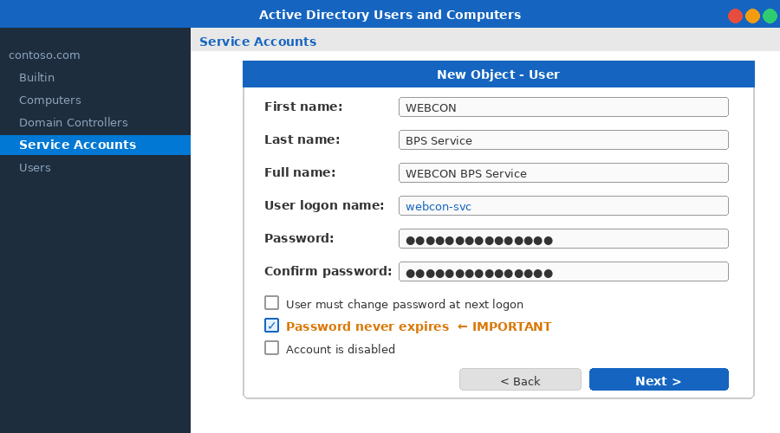
Figure 3.2 — Active Directory New User wizard. Set Password never expires and do NOT require change at next logon.
- Set a strong password — e.g. Wbc0n@Svc#2025! — and write it down. You will need it multiple times.
- Uncheck 'User must change password at next logon'. Check 'Password never expires'. Click Finish.

CRITICAL
Username format: CONTOSO\webcon-svc (replace CONTOSO with your AD domain name)
This EXACT same account must be used on both App Server 1 and App Server 2.
If different accounts are used the servers will not form a valid farm.
Step 3.4 Grant SQL Server Access to the Service Account [SQL-SERVER01 — SSMS]
The service account needs sysadmin rights on SQL Server so WEBCON BPS can create and manage databases during installation.
- Open SSMS on the SQL Server. Connect with Windows Authentication as Administrator
- Click New Query. Paste the script below and press F5 (or click Execute)
-- Run in SSMS on SQL-SERVER01 as Administrator
-- Replace CONTOSO with your actual Active Directory domain name

-- Step 1: Create a Windows Authentication login
CREATE LOGIN [CONTOSO\webcon-svc] FROM WINDOWS;
GO

-- Step 2: Grant sysadmin server role (required for installation phase)
ALTER SERVER ROLE sysadmin ADD MEMBER [CONTOSO\webcon-svc];
GO

-- Step 3: Verify (should return one row with is_disabled = 0)
SELECT name, type_desc, is_disabled
FROM sys.server_principals
WHERE name = N'CONTOSO\webcon-svc';
GO

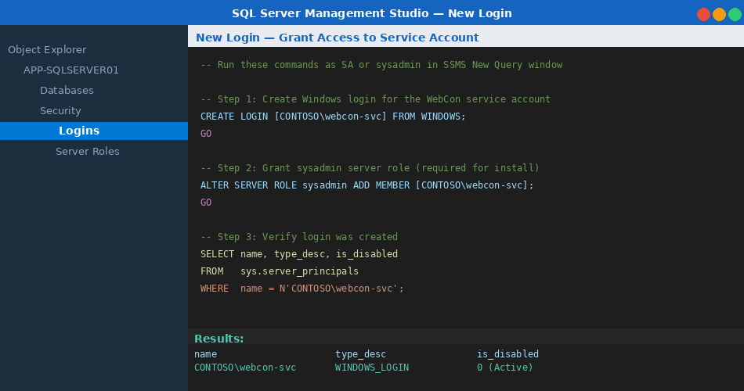
Figure 3.3 — SSMS query window showing the commands to create the service account login and grant sysadmin rights
- Verify the result set shows one row with is_disabled = 0
Step 3.5 Open Windows Firewall — Port 1433 [SQL-SERVER01]
Run this in PowerShell as Administrator on the SQL Server. Only the two App Servers are allowed through — all other hosts remain blocked.
# Run in PowerShell as Administrator on SQL-SERVER01

New-NetFirewallRule `
-DisplayName 'WEBCON BPS - SQL Server Port 1433' `
-Direction Inbound `
-Protocol TCP `
-LocalPort 1433 `
-Action Allow `
-RemoteAddress '10.0.0.11','10.0.0.12'

Write-Host 'Firewall rule created.' -ForegroundColor Green

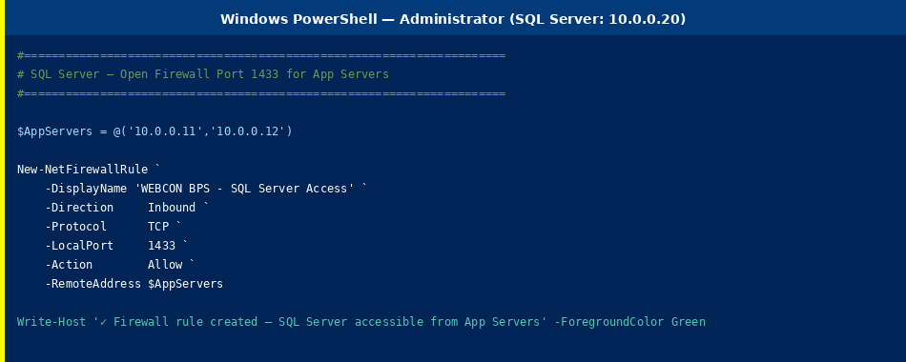
Figure 3.4 — PowerShell command to open SQL Server port 1433, restricted to App Server IPs only

3.6 Phase 1 Automation Script — SQL Server
The script below automates Steps 3.2 through 3.5. Run it as Administrator on SQL-SERVER01 after SQL Server 2022 is installed. It enables TCP/IP, restarts the SQL service, opens the firewall, and creates the SQL login.
#Requires -RunAsAdministrator
<#
.SYNOPSIS WebCon BPS — SQL Server Preparation Script
.NOTES Run on SQL-SERVER01 (10.0.0.20) as Administrator.
SQL Server 2022 must already be installed.
Estimated runtime: 2-3 minutes.
#>
param(
[string]$DomainUser = 'CONTOSO\webcon-svc',
[string]$AppSrv1IP = '10.0.0.11',
[string]$AppSrv2IP = '10.0.0.12'
)
Set-StrictMode -Version Latest; $ErrorActionPreference = 'Stop'
Write-Host '===================================================' -ForegroundColor Cyan
Write-Host ' WebCon BPS - SQL Server Setup Script ' -ForegroundColor Cyan
Write-Host '===================================================' -ForegroundColor Cyan

# ── Step 1: Enable TCP/IP via SMO ─────────────────────────────
Write-Host '[1/4] Enabling SQL Server TCP/IP protocol...' -ForegroundColor Yellow
[reflection.assembly]::LoadWithPartialName('Microsoft.SqlServer.SqlWmiManagement') | Out-Null
$wmi = New-Object Microsoft.SqlServer.Management.Smo.Wmi.ManagedComputer
$tcp = $wmi.ServerInstances['MSSQLSERVER'].ServerProtocols['Tcp']
$tcp.IsEnabled = $true
$tcp.Alter()
Write-Host ' TCP/IP enabled.' -ForegroundColor Green

# ── Step 2: Restart SQL Server service ────────────────────────
Write-Host '[2/4] Restarting SQL Server (MSSQLSERVER)...' -ForegroundColor Yellow
Restart-Service -Name 'MSSQLSERVER' -Force
Start-Sleep -Seconds 10
Write-Host ' SQL Server restarted.' -ForegroundColor Green

# ── Step 3: Open Windows Firewall port 1433 ───────────────────
Write-Host '[3/4] Adding firewall rule: TCP 1433 for App Servers...' -ForegroundColor Yellow
New-NetFirewallRule ``
-DisplayName 'WEBCON BPS - SQL Server 1433' ``
-Direction Inbound ``
-Protocol TCP ``
-LocalPort 1433 ``
-Action Allow ``
-RemoteAddress $AppSrv1IP, $AppSrv2IP ``
-ErrorAction SilentlyContinue | Out-Null
Write-Host ' Firewall rule created.' -ForegroundColor Green

# ── Step 4: Create SQL login via sqlcmd ───────────────────────
Write-Host '[4/4] Creating SQL login for service account...' -ForegroundColor Yellow
$sql = "CREATE LOGIN [$DomainUser] FROM WINDOWS;"
$sql += " ALTER SERVER ROLE sysadmin ADD MEMBER [$DomainUser];"
$sql | sqlcmd -S localhost -E
Write-Host ' SQL login created and sysadmin granted.' -ForegroundColor Green

Write-Host '---------------------------------------------------' -ForegroundColor Cyan
Write-Host ' SQL Server setup COMPLETE.' -ForegroundColor Green
Write-Host ' Next: run 02_AppServer_Setup.ps1 on App Servers.' -ForegroundColor White

Phase 1 Complete
SQL Server is prepared. Both App Servers can now connect on port 1433. Proceed to Phase 2.

PHASE 2 App Server 1 — Primary Installation
Install all prerequisites then run the WEBCON BPS installer as a new installation

4. Phase 2 — App Server 1 (Primary)
App Server 1 is the primary node. It runs all WEBCON BPS service roles: workflow engine, license service, SOLR search indexer, email sender, and scheduled action runner. App Server 2 will join as a secondary that handles only web requests.
Step 4.1 Install IIS with Required Windows Features [APP-SERVER01 — 10.0.0.11]
Open PowerShell as Administrator on App Server 1 and run the following command. It installs IIS with every feature WEBCON BPS requires.
# Run in PowerShell as Administrator on APP-SERVER01

Install-WindowsFeature -Name Web-Server, Web-Windows-Auth, Web-Asp-Net45,
Web-Net-Ext45, Web-ISAPI-Ext, Web-ISAPI-Filter,
Web-Mgmt-Console, Web-Scripting-Tools, Web-Stat-Compression
-IncludeManagementTools

Write-Host 'IIS installation complete.' -ForegroundColor Green

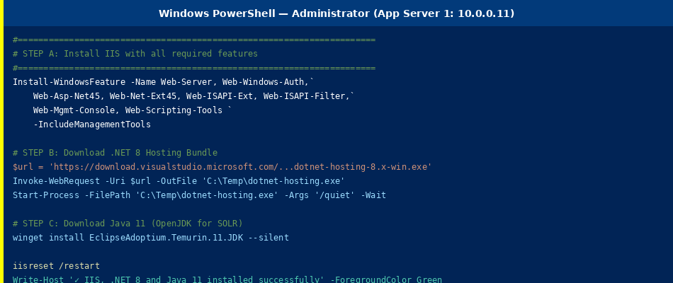
Figure 4.1 — PowerShell command to install IIS with all required features. Run as Administrator.
Step 4.2 Install .NET 8 Hosting Bundle [APP-SERVER01]
- Open a browser on App Server 1 and go to: https://dotnet.microsoft.com/download/dotnet/8.0
- Under .NET 8.0, click the Hosting Bundle download link
- Run the downloaded installer as Administrator (accept all defaults)
- Open PowerShell and run: iisreset /restart
Why the Hosting Bundle?
The Hosting Bundle installs both the .NET 8 runtime AND the ASP.NET Core module for IIS. Without it, IIS cannot host the WEBCON BPS Portal application.
Step 4.3 Install Java 11 for SOLR Search [APP-SERVER01]
WEBCON BPS Search Server (SOLR) requires Java 11 or higher. Use Windows Package Manager:
# Run in PowerShell as Administrator on APP-SERVER01
winget install EclipseAdoptium.Temurin.11.JDK `
--silent --accept-package-agreements --accept-source-agreements

# Verify Java is installed and in PATH
java -version
# Expected output: openjdk version "11.x.x" ...

winget not available?
Download OpenJDK 11 (Temurin) manually from https://adoptium.net — choose the .msi installer for Windows x64. After installing, add the Java bin folder to the System PATH environment variable.
Step 4.4 Run the WEBCON BPS Installer — New Installation [APP-SERVER01]
Obtain the WEBCON BPS 2025 installer from https://community.webcon.com. Copy it to App Server 1 and run it as Administrator.
- Double-click the WEBCON BPS installer .exe and click Yes on the UAC prompt
- Accept the End User License Agreement and click Next
- On the Mode Selection screen, select New WEBCON BPS Installation as shown below
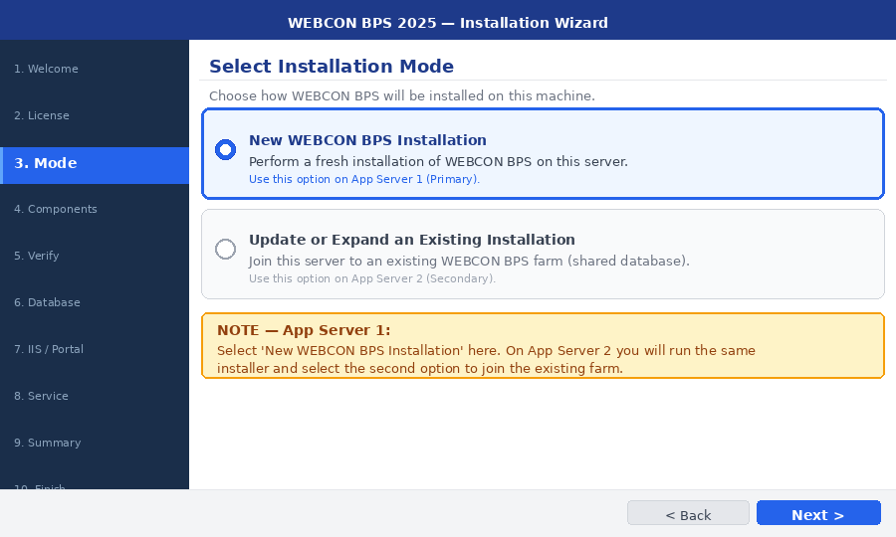
Figure 4.2 — Installer Mode Selection. Choose 'New WEBCON BPS Installation' on App Server 1.
- Select Standalone (non-SharePoint) on the next screen and click Next
- The System Verification screen checks prerequisites. All items must show a green checkmark. Resolve any red X before continuing.
- On Component Selection: ensure BPS Portal, BPS Service, and BPS Search Server are all checked
Step 4.5 Configure Database Connection [APP-SERVER01 — Installer]
On the Database Configuration screen, enter the SQL Server connection details:
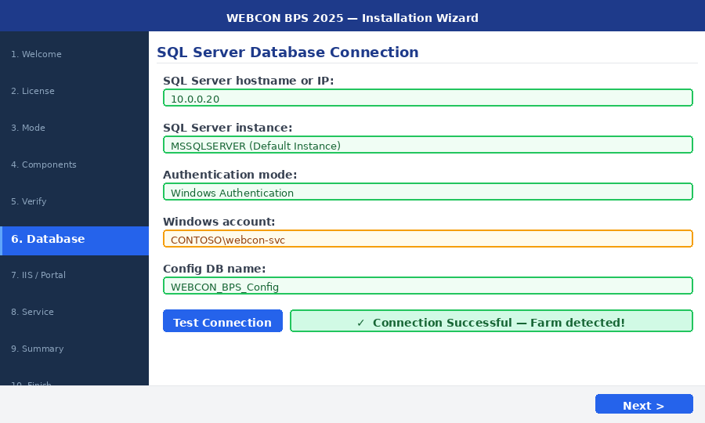
Figure 4.3 — Database Connection. Enter SQL Server IP (10.0.0.20), Windows Authentication with the service account, and click Test Connection.
- SQL Server: 10.0.0.20 (or your SQL Server hostname)
- Authentication: Windows Authentication
- Windows account: CONTOSO\webcon-svc (the service account from Step 3.3)
- Config Database Name: WEBCON_BPS_Config (leave as default)
- Click Test Connection — you must see a green success message before proceeding

Connection Fails?
Check: (1) TCP/IP is enabled on SQL Server and service was restarted, (2) Firewall rule allows port 1433 from this server's IP, (3) Service account has sysadmin rights in SQL. Run the Phase 1 automation script to fix all three.
Step 4.6 Configure the Portal URL — MOST CRITICAL STEP [APP-SERVER01 — Installer]
This is the single most important configuration value in the entire installation. The wrong URL causes authentication failures, broken email links, and ADFS/OAuth redirect errors.
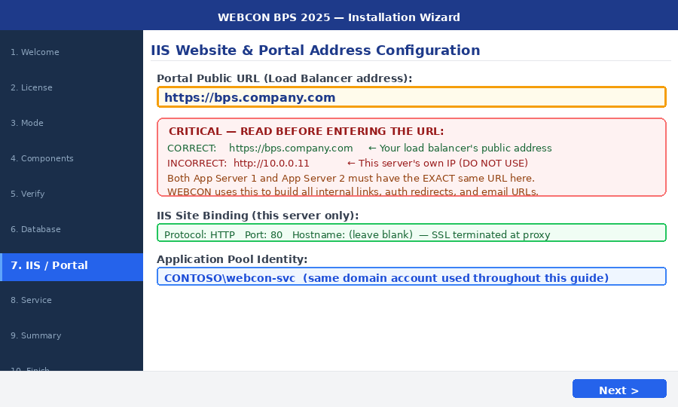
Figure 4.4 — Portal Address configuration. ALWAYS enter the Load Balancer's proxy server hostname, never this server's own IP.

CRITICAL
CORRECT: http://PROXY-SERVER01 <- Your proxy server hostname
INCORRECT: http://10.0.0.11 <- This server's own IP (DO NOT enter this)
WEBCON uses this URL to generate all internal links and email notification URLs.
If you set it to an App Server IP, links will break when users are on the other server.
App Server 1 and App Server 2 MUST have the EXACT same value here.
Use http:// not https:// since there is no SSL certificate for now.

For the IIS Binding on this server, set Protocol to HTTP and Port to 80. SSL is handled at the Proxy — not at App Servers.
Step 4.7 Configure the BPS Service Account [APP-SERVER01 — Installer]
When the installer asks for BPS Service credentials, enter the service account created in Step 3.3:
- Username: CONTOSO\webcon-svc
- Password: the password set in Step 3.3
- This account will run the WEBCON BPS Workflow Service (Windows service) on this server
Step 4.8 Configure Service Roles — Enable ALL on Primary [APP-SERVER01 — Installer]
On the Service Configuration screen, keep ALL roles checked. This is the primary server — all background processing runs here.
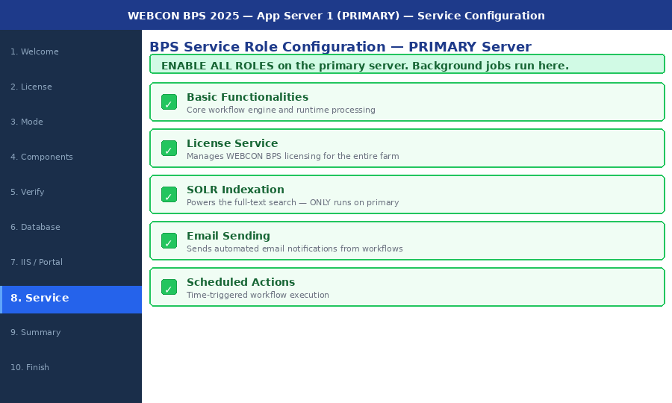
Figure 4.5 — Service Roles on App Server 1. Keep ALL roles checked. Background jobs run on this primary server.

Role | Purpose | Primary?
Basic Functionalities | Core workflow engine — processes all workflow steps | YES — keep checked
License Service | Manages WEBCON BPS licensing for the entire farm | YES — keep checked
SOLR Indexation | Full-text search across all workflows (runs only here) | YES — keep checked
Email Sending | Sends automated email notifications from workflows | YES — keep checked
Scheduled Actions | Runs time-triggered workflow actions | YES — keep checked

- Click Next to proceed to the installation summary
- Review the summary and click Install. The installer creates SQL databases and configures IIS. Takes 5-15 minutes.
- When complete, click Finish
- Test: open a browser on the server and navigate to http://localhost — the WEBCON BPS login page should appear
Step 4.9 Set IIS App Pool Idle Timeout to 0 [APP-SERVER01 — IIS Manager]
IIS shuts down an idle app pool after 20 minutes by default, causing very slow first requests after idle periods. Change this to 0 (disabled) on both App Servers.
- Open IIS Manager: press Windows key, type inetmgr, run as Administrator
- In the left tree, click Application Pools
- Right-click WEBCONBPS and select Advanced Settings
- Under Process Model, find Idle Time-out (minutes) and change 20 to 0
- Click OK to save
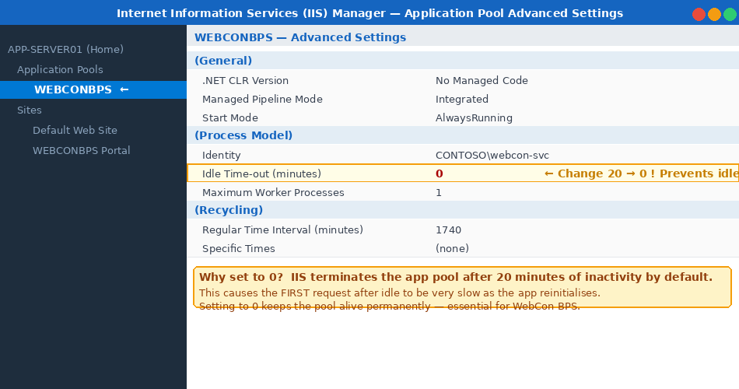
Figure 4.6 — IIS Advanced Settings. Change Idle Time-out from 20 to 0 to prevent IIS from shutting down WEBCON BPS after inactivity.

4.10 Phase 2 Automation Script — App Server Dependencies
Run this PowerShell script as Administrator on App Server 1 (and later App Server 2). It automatically installs IIS, .NET 8 Hosting Bundle, Java 11, and configures the Windows Firewall — all from the internet with no manual downloads needed.
#Requires -RunAsAdministrator
<#
.SYNOPSIS WebCon BPS — App Server Dependency Installer
.NOTES Run on BOTH App Server 1 (10.0.0.11) and App Server 2 (10.0.0.12).
Installs: IIS with required features, .NET 8 Hosting Bundle,
Java 11 (OpenJDK Temurin via winget), Windows Firewall rules.
Estimated runtime: 10-15 minutes (depends on internet speed).
#>
param(
[string]$ProxyIP = '10.0.0.10',
[string]$AppSrv1IP = '10.0.0.11',
[string]$AppSrv2IP = '10.0.0.12'
)
Set-StrictMode -Version Latest
$Tmp = 'C:\Temp\WebConBPSSetup'
New-Item -ItemType Directory -Force -Path $Tmp | Out-Null

Write-Host '===================================================' -ForegroundColor Cyan
Write-Host ' WebCon BPS - App Server Dependency Installer ' -ForegroundColor Cyan
Write-Host '===================================================' -ForegroundColor Cyan

# ── Step 1: IIS with all required features ────────────────────
Write-Host '[1/5] Installing IIS features...' -ForegroundColor Yellow
$iisFeatures = @(
'Web-Server','Web-Windows-Auth','Web-Asp-Net45','Web-Net-Ext45',
'Web-ISAPI-Ext','Web-ISAPI-Filter','Web-Mgmt-Console',
'Web-Scripting-Tools','Web-Stat-Compression'
)
Install-WindowsFeature -Name $iisFeatures -IncludeManagementTools | Out-Null
Write-Host ' IIS installed with all WEBCON BPS required features.' -ForegroundColor Green

# ── Step 2: .NET 8 Hosting Bundle ─────────────────────────────
Write-Host '[2/5] Downloading .NET 8 Hosting Bundle...' -ForegroundColor Yellow
# If URL changes, find latest at: https://dotnet.microsoft.com/download/dotnet/8.0
$dotnetUrl = 'https://download.visualstudio.microsoft.com/download/pr/' +
'dotnet-hosting-8.0-win.exe'
$dotnetExe = Join-Path $Tmp 'dotnet-hosting-8.exe'
try {
[Net.ServicePointManager]::SecurityProtocol = [Net.SecurityProtocolType]::Tls12
Invoke-WebRequest -Uri $dotnetUrl -OutFile $dotnetExe -UseBasicParsing
Write-Host ' Downloading complete. Installing silently...' -ForegroundColor Yellow
Start-Process -FilePath $dotnetExe -ArgumentList '/quiet /norestart OPT_NO_X86=1' -Wait
Write-Host ' .NET 8 Hosting Bundle installed.' -ForegroundColor Green
} catch {
Write-Warning 'Download failed. Manually download Hosting Bundle from https://dotnet.microsoft.com/download/dotnet/8.0'
}

# ── Step 3: Java 11 (required for WEBCON SOLR Search) ─────────
Write-Host '[3/5] Installing Java 11 (OpenJDK Temurin via winget)...' -ForegroundColor Yellow
try {
winget install EclipseAdoptium.Temurin.11.JDK ``
--silent --accept-package-agreements --accept-source-agreements
# Refresh PATH in current session
$env:Path = [System.Environment]::GetEnvironmentVariable('Path','Machine') + ';' +
[System.Environment]::GetEnvironmentVariable('Path','User')
Write-Host ' Java 11 installed.' -ForegroundColor Green
} catch {
Write-Warning 'winget failed. Manually install OpenJDK 11 from https://adoptium.net'
}

# ── Step 4: Firewall rules ────────────────────────────────────
Write-Host '[4/5] Configuring Windows Firewall rules...' -ForegroundColor Yellow

# HTTP port 80 - from Proxy Server only
New-NetFirewallRule -DisplayName 'WEBCON - HTTP from Proxy :80' ``
-Direction Inbound -Protocol TCP -LocalPort 80 ``
-Action Allow -RemoteAddress $ProxyIP -ErrorAction SilentlyContinue | Out-Null

# WCF port 8002 - inter-server farm communication
New-NetFirewallRule -DisplayName 'WEBCON - WCF Farm :8002' ``
-Direction Inbound -Protocol TCP -LocalPort 8002 ``
-Action Allow -RemoteAddress $AppSrv1IP,$AppSrv2IP ``
-ErrorAction SilentlyContinue | Out-Null

# SOLR port 8983 - search queries
New-NetFirewallRule -DisplayName 'WEBCON - SOLR Search :8983' ``
-Direction Inbound -Protocol TCP -LocalPort 8983 ``
-Action Allow -RemoteAddress $AppSrv1IP,$AppSrv2IP ``
-ErrorAction SilentlyContinue | Out-Null

Write-Host ' Firewall rules created.' -ForegroundColor Green

# ── Step 5: Restart IIS and verify ───────────────────────────
Write-Host '[5/5] Restarting IIS and verifying installation...' -ForegroundColor Yellow
iisreset /restart | Out-Null
$iis = Get-Service W3SVC
if ($iis.Status -eq 'Running') { Write-Host ' IIS: Running' -ForegroundColor Green }
else { Write-Warning 'IIS is not running. Check Event Viewer.' }
try { $jv = java -version 2>&1; Write-Host (' Java: ' + $jv[0]) -ForegroundColor Green }
catch { Write-Warning 'Java not found in PATH. Restart session and retry.' }
try { $dv = dotnet --version; Write-Host (' .NET SDK: ' + $dv) -ForegroundColor Green }
catch { Write-Warning '.NET not found. Reboot and verify.' }

Write-Host '---------------------------------------------------' -ForegroundColor Cyan
Write-Host ' App Server setup COMPLETE.' -ForegroundColor Green
Write-Host ' NEXT: Run the WEBCON BPS installer on this server.' -ForegroundColor White
Write-Host ' Download from: https://community.webcon.com' -ForegroundColor White

Phase 2 Complete
App Server 1 is running WEBCON BPS. Verify at http://localhost on that server. Proceed to Phase 3.

PHASE 3 App Server 2 — Secondary Node
Join the existing farm as a load-balanced secondary and failover node

5. Phase 3 — App Server 2 (Secondary)
App Server 2 joins the existing WEBCON BPS farm. It connects to the same SQL Server. The critical difference: App Server 2 has ALL service roles disabled — it serves only web requests. Background processing stays on App Server 1.

Version Match Required
Copy the EXACT same WEBCON BPS installer .exe from App Server 1 to App Server 2. Even a minor version mismatch (e.g. 2025.1.1.87 vs 2025.1.1.94) will cause farm registration errors.
Step 5.1 Install Prerequisites on App Server 2 [APP-SERVER02 — 10.0.0.12]
Run the same automation script from Section 4.10 on App Server 2. It is identical — IIS, .NET 8, Java 11, firewall.
# Run the SAME script from Section 4.10 on APP-SERVER02
# After it completes, verify:

Get-WindowsFeature Web-Server | Select-Object Name, Installed
java -version
dotnet --version

Step 5.2 Run the WEBCON BPS Installer — Expand Existing [APP-SERVER02]
Run the same installer file on App Server 2 as Administrator. This time select the second option.
- Launch the WEBCON BPS installer as Administrator on App Server 2
- On the Mode Selection screen, select: Update or expand an existing WEBCON BPS installation

Figure 5.1 — On App Server 2 select 'Update or expand an existing WEBCON BPS installation' to join the existing farm
- Enter the same SQL Server connection details as App Server 1. Click Test Connection.

Figure 5.2 — Connect to the SAME SQL Server and SAME WEBCON_BPS_Config database as App Server 1
- The installer detects the existing farm. Click Continue.
Step 5.3 Enter the Same Portal URL [APP-SERVER02 — Installer]
Enter exactly the same load balancer URL as App Server 1. Copy-paste to avoid typos.
http://PROXY-SERVER01

# This is the proxy server hostname — users type this in their browser.
# No public DNS or SSL certificate required for internal network access.


Figure 5.3 — Identical load balancer URL on App Server 2. Both servers must have this exact same value.
Step 5.4 Enter the Same Service Account [APP-SERVER02 — Installer]
- Username: CONTOSO\webcon-svc (identical to App Server 1)
- Password: same password
- The IIS Application Pool identity must also be set to this same account
Step 5.5 Configure Service Roles — Disable ALL [APP-SERVER02 — Installer]
On the Service Configuration screen, UNCHECK every single role. This is the most important difference between App Server 1 and App Server 2.
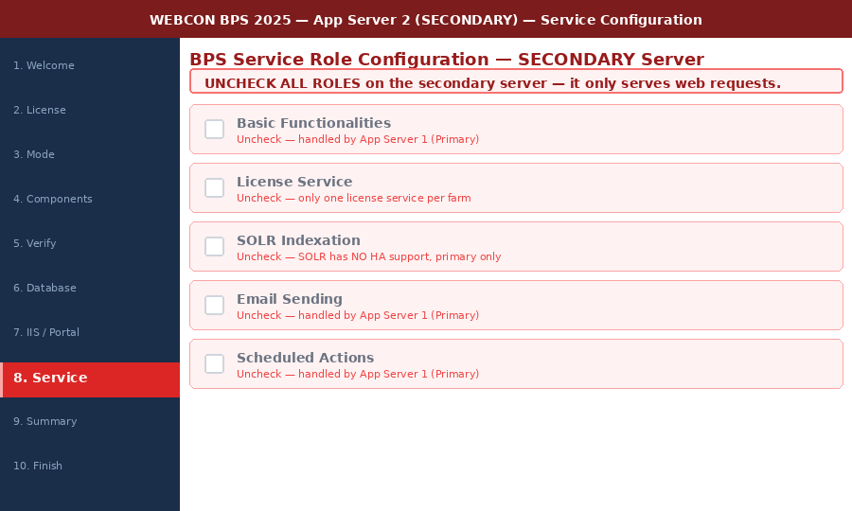
Figure 5.4 — On App Server 2, UNCHECK ALL service roles. It serves only HTTP web requests.

CRITICAL
ALL service roles must be UNCHECKED on App Server 2.
Running SOLR Indexation on both servers corrupts the search index.
Running License Service on both servers causes licence enforcement errors.
App Server 2 is a web-tier node only — background tasks stay on App Server 1.

- Uncheck: Basic Functionalities, License Service, SOLR Indexation, Email Sending, Scheduled Actions
- Click Next and complete the installation (5-10 minutes)
- Test: browse to http://localhost on App Server 2 — WEBCON BPS login page should appear
- Set the IIS App Pool Idle Timeout to 0 on App Server 2, exactly as done in Step 4.9

Figure 5.5 — Set Idle Time-out to 0 on App Server 2's IIS App Pool as well
Step 5.6 Open Inter-Server Communication Ports [Both App Servers]
Run on BOTH App Servers to allow farm coordination and SOLR queries between them:
# Run on BOTH APP-SERVER01 and APP-SERVER02

# WCF Service — farm coordination between app servers
New-NetFirewallRule -DisplayName 'WEBCON WCF Port 8002' `
-Direction Inbound -Protocol TCP -LocalPort 8002 `
-Action Allow -RemoteAddress '10.0.0.11','10.0.0.12'

# SOLR search — secondary queries primary's SOLR index
New-NetFirewallRule -DisplayName 'WEBCON SOLR Port 8983' `
-Direction Inbound -Protocol TCP -LocalPort 8983 `
-Action Allow -RemoteAddress '10.0.0.11','10.0.0.12'

Step 5.7 Configure Failover in WEBCON Designer Studio [APP-SERVER01 — Designer Studio]
After both servers are installed, open WEBCON BPS Designer Studio on App Server 1 to configure the failover relationship:
- Open WEBCON BPS Designer Studio from the Start menu on App Server 1
- Navigate to: System Configuration > Service Configuration > Services
- You should see two entries — APP-SERVER01 and APP-SERVER02
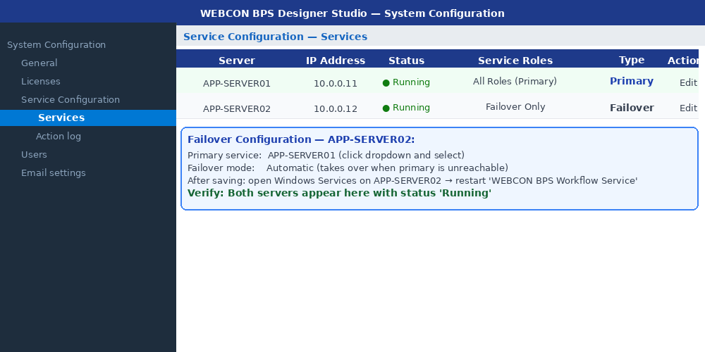
Figure 5.6 — Designer Studio Service Configuration showing both servers. Set APP-SERVER02 as failover for APP-SERVER01.
- Click on APP-SERVER02's entry. In Failover settings, set Primary Service to APP-SERVER01
- Click Save
- On APP-SERVER02, open Windows Services, find WEBCON BPS Workflow Service and click Restart

Phase 3 Complete
Both App Servers are in the farm and sharing the SQL database. Proceed to Phase 4 to configure the Proxy Server.

PHASE 4 Proxy Server — IIS ARR Load Balancer
Install Microsoft Application Request Routing and configure load balancing

6. Phase 4 — Proxy Server (IIS ARR)
The Proxy Server uses Microsoft's free IIS Application Request Routing (ARR) to load balance HTTPS traffic across the two App Servers. It handles SSL termination, sticky sessions, and health monitoring — all managed through standard IIS Manager.
ARR is free
Application Request Routing is a free Microsoft download for IIS. No licence purchase required. It is production-ready and supported by Microsoft for enterprise Windows deployments.
Step 6.1 Install IIS on the Proxy Server [PROXY-SERVER01 — 10.0.0.10]
# Run in PowerShell as Administrator on PROXY-SERVER01
Install-WindowsFeature -Name Web-Server -IncludeManagementTools

# Verify IIS is running
Get-Service W3SVC | Select-Object Status, Name

Step 6.2 Install URL Rewrite 2.1 — FIRST [PROXY-SERVER01]
URL Rewrite MUST be installed before ARR. ARR depends on it. Do not reverse this order.
- On the Proxy Server, open a browser and go to: https://www.iis.net/downloads/microsoft/url-rewrite
- Click Download and run the .msi installer as Administrator
- Accept all defaults and complete the installation
Step 6.3 Install ARR 3.0 — SECOND [PROXY-SERVER01]
- Go to: https://www.iis.net/downloads/microsoft/application-request-routing
- Click Download and run the .msi installer as Administrator
- Open PowerShell and run: iisreset /restart
- Open IIS Manager — you should now see a Server Farms node in the left tree. If not visible, reinstall ARR.
Step 6.4 Enable the ARR Proxy [PROXY-SERVER01 — IIS Manager]
Before ARR can forward any traffic, the proxy function must be explicitly activated.
- Open IIS Manager (run inetmgr from Start menu)
- Click the server name at the top of the left tree (PROXY-SERVER01)
- In the main panel, double-click Application Request Routing Cache
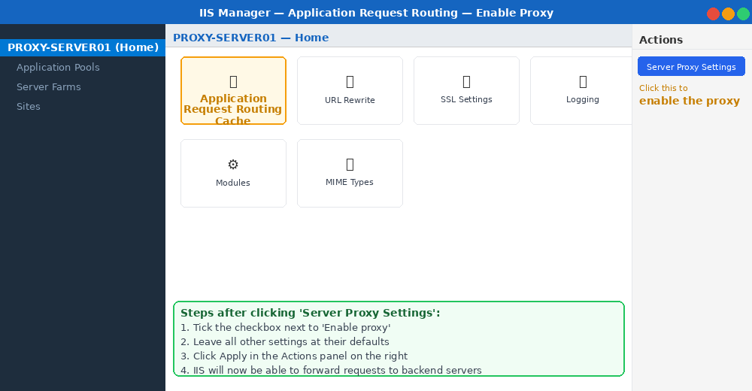
Figure 6.1 — Double-click 'Application Request Routing Cache' then click 'Server Proxy Settings' in the Actions panel.
- In the Actions panel on the right, click Server Proxy Settings
- Check the checkbox next to Enable proxy
- Click Apply in the Actions panel
Step 6.5 Create the Server Farm [PROXY-SERVER01 — IIS Manager]
The Server Farm defines which backend servers receive traffic.
- In IIS Manager, right-click Server Farms in the left tree and select Create Server Farm
- Enter farm name: WebConBPS_Farm and click Next
- In the Server address field, type 10.0.0.11 and click Add
- Type 10.0.0.12 and click Add again
- Click Finish
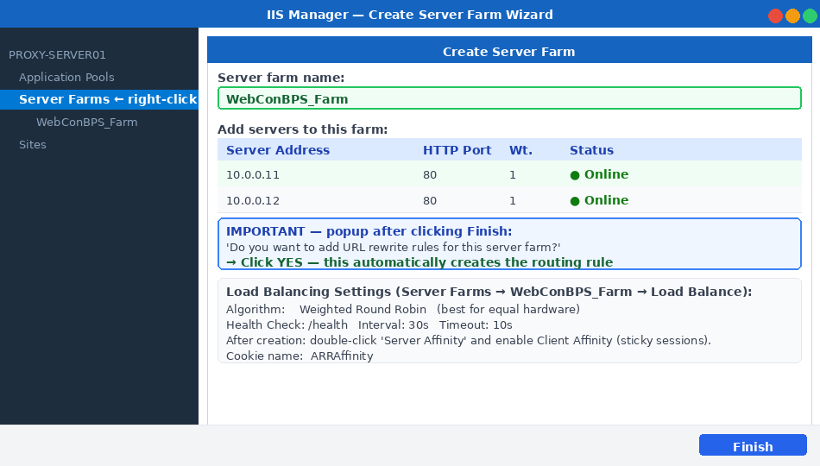
Figure 6.2 — ARR Create Server Farm wizard. Add both App Servers. Click Finish then click YES when asked about URL rewrite rules.
- When the popup appears — 'Do you want to add URL rewrite rules?' — click YES. This auto-creates the routing rule.
Step 6.6 Enable Sticky Sessions — Client Affinity [PROXY-SERVER01 — IIS Manager]
Sticky sessions are mandatory for WEBCON BPS. Without them, users lose their session when consecutive requests hit different servers.
- In IIS Manager, expand Server Farms and click WebConBPS_Farm
- Double-click Server Affinity
- Check the checkbox next to Client affinity
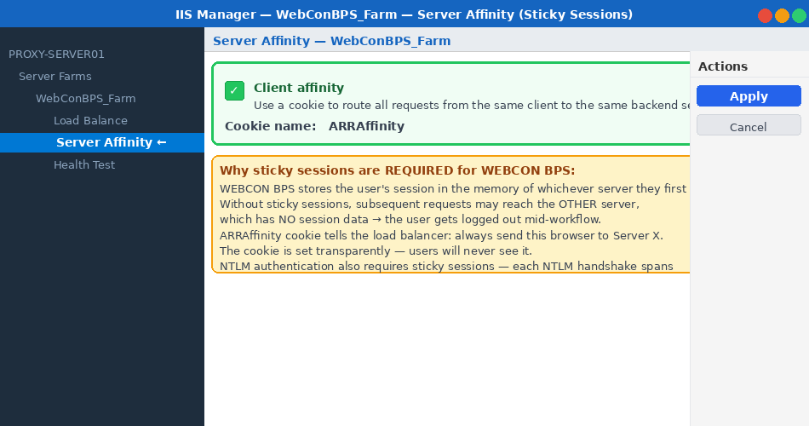
Figure 6.3 — Enable Client Affinity (sticky sessions). The ARRAffinity cookie routes each browser's requests to the same App Server.
- Leave the Cookie name as ARRAffinity
- Click Apply
Step 6.7 Configure Health Monitoring [PROXY-SERVER01 — IIS Manager]
WEBCON BPS exposes a /health endpoint that returns HTTP 200 when healthy. ARR polls it every 30 seconds and auto-removes failed servers.
- In IIS Manager, click WebConBPS_Farm
- Double-click Health Test
- In the URL field enter: /health
- Set Interval (seconds) to 30 and Time-out (seconds) to 10
- Click Apply
Health check behaviour
If a server fails to respond within 10 seconds for three consecutive polls, ARR stops routing to it. When it recovers, it is automatically added back. No manual intervention is needed.
Step 6.8 SSL Certificate — Optional for Internal Deployment [PROXY-SERVER01 — IIS Manager]
Since this is an internal network deployment, SSL is optional. Users access WEBCON BPS via http://PROXY-SERVER01 (plain HTTP, port 80) — no certificate is required to get started. You can skip this entire step for now.
Adding SSL later (when required)
When your organisation is ready for HTTPS on internal apps: obtain a certificate from your internal CA (or create a self-signed cert), import it via IIS Manager > Server Certificates > Import, then add an HTTPS binding on port 443 to the Default Web Site. Update the Portal URL in appsettings.json to https://PROXY-SERVER01 if you switch.
- In IIS Manager, click PROXY-SERVER01 in the left tree
- Double-click Server Certificates in the main panel
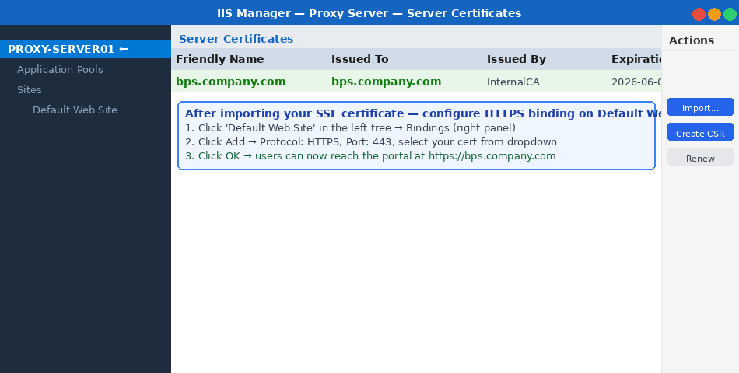
Figure 6.4 — IIS Server Certificates panel. Click Import to import a certificate from your CA. For testing only: Create Self-Signed Certificate.
- For internal-only deployment: SSL is optional. If required later, use an internal CA certificate and import via IIS Manager > Server Certificates > Import.
- For internal HTTP (no SSL): no HTTPS binding is needed. Users access via http://PROXY-SERVER01 on port 80 directly.
Internal Network — No SSL Required
Since WEBCON BPS is deployed on an internal network, HTTPS is optional. The default HTTP binding on port 80 created by the installer is sufficient. Users access the system via http://PROXY-SERVER01. If you add SSL later (recommended), import an internal CA certificate and add an HTTPS :443 binding on Default Web Site.
Step 6.9 Open Firewall on the Proxy Server [PROXY-SERVER01]
# Run in PowerShell as Administrator on PROXY-SERVER01

# HTTPS - inbound from users on the internet
New-NetFirewallRule -DisplayNam'WEBCON HTTP Inbound :80' `
-Direction Inbound -Protocol TCP -LocalPort 80 -Action Allow

6.10 Phase 4 Automation Script — Proxy Server
The script below automates the entire Proxy Server setup: installs IIS, downloads URL Rewrite and ARR from Microsoft, enables the proxy, creates the server farm with sticky sessions, configures health monitoring, and sets up firewall rules. Two manual steps remain after: importing the SSL certificate and adding the HTTPS binding.
#Requires -RunAsAdministrator
<#
.SYNOPSIS WebCon BPS — Proxy Server (IIS ARR) Full Setup
.NOTES Run on PROXY-SERVER01 (10.0.0.10) as Administrator.
Installs IIS, URL Rewrite 2.1, ARR 3.0.
Creates server farm, enables sticky sessions, configures
health monitoring and firewall rules.
Estimated runtime: 5-8 minutes.
#>
param(
[string]$AppSrv1 = '10.0.0.11',
[string]$AppSrv2 = '10.0.0.12',
[string]$FarmName = 'WebConBPS_Farm'
)
Set-StrictMode -Version Latest
$Tmp = 'C:\Temp\WebConBPSSetup'
New-Item -ItemType Directory -Force -Path $Tmp | Out-Null

Write-Host '===================================================' -ForegroundColor Cyan
Write-Host ' WebCon BPS - Proxy Server (IIS ARR) Setup ' -ForegroundColor Cyan
Write-Host '===================================================' -ForegroundColor Cyan

# ── Step 1: Install IIS ───────────────────────────────────────
Write-Host '[1/6] Installing IIS...' -ForegroundColor Yellow
Install-WindowsFeature -Name Web-Server -IncludeManagementTools | Out-Null
Write-Host ' IIS installed.' -ForegroundColor Green

# ── Step 2: URL Rewrite 2.1 (MUST be installed before ARR) ───
Write-Host '[2/6] Downloading and installing URL Rewrite 2.1...' -ForegroundColor Yellow
$urUrl = 'https://download.microsoft.com/download/1/2/8/' +
'128E2E22-C1B9-44A4-BE2A-5859ED1D4592/rewrite_amd64_en-US.msi'
$urMsi = Join-Path $Tmp 'urlrewrite.msi'
Invoke-WebRequest -Uri $urUrl -OutFile $urMsi -UseBasicParsing
Start-Process msiexec.exe -ArgumentList "/i `"$urMsi`" /quiet /norestart" -Wait
Write-Host ' URL Rewrite 2.1 installed.' -ForegroundColor Green

# ── Step 3: ARR 3.0 ──────────────────────────────────────────
Write-Host '[3/6] Downloading and installing ARR 3.0...' -ForegroundColor Yellow
$arrUrl = 'https://download.microsoft.com/download/E/9/8/' +
'E9849D6A-020E-47E4-9FD0-A023E99B54EB/requestRouter_amd64.msi'
$arrMsi = Join-Path $Tmp 'arr.msi'
Invoke-WebRequest -Uri $arrUrl -OutFile $arrMsi -UseBasicParsing
Start-Process msiexec.exe -ArgumentList "/i `"$arrMsi`" /quiet /norestart" -Wait
iisreset /restart | Out-Null
Start-Sleep -Seconds 5
Write-Host ' ARR 3.0 installed and IIS restarted.' -ForegroundColor Green

# ── Step 4: Enable ARR proxy ─────────────────────────────────
Write-Host '[4/6] Enabling ARR proxy mode...' -ForegroundColor Yellow
Import-Module WebAdministration
Set-WebConfigurationProperty ``
-Filter 'system.webServer/proxy' -Name 'enabled' -Value $true -PSPath 'IIS:\'
Write-Host ' ARR proxy enabled.' -ForegroundColor Green

# ── Step 5: Create server farm + sticky sessions ──────────────
Write-Host '[5/6] Creating server farm with sticky sessions...' -ForegroundColor Yellow

Add-WebConfigurationProperty ``
-Filter 'webFarms' -Name '.' -Value @{name=$FarmName} -PSPath 'IIS:\'
Add-WebConfigurationProperty ``
-Filter "webFarms/webFarm[@name='$FarmName']" ``
-Name '.' -Value @{address=$AppSrv1} -PSPath 'IIS:\'
Add-WebConfigurationProperty ``
-Filter "webFarms/webFarm[@name='$FarmName']" ``
-Name '.' -Value @{address=$AppSrv2} -PSPath 'IIS:\'

# Enable Client Affinity (sticky sessions) — required for WebCon BPS
$affinityFilter = "webFarms/webFarm[@name='$FarmName']/applicationRequestRouting/affinity"
Set-WebConfigurationProperty -Filter $affinityFilter -Name 'useCookie' -Value $true -PSPath 'IIS:\'
Set-WebConfigurationProperty -Filter $affinityFilter -Name 'cookieName' -Value 'ARRAffinity' -PSPath 'IIS:\'
Write-Host ' Server farm created. Sticky sessions enabled (cookie: ARRAffinity).' -ForegroundColor Green

# ── Step 6: Health monitoring on /health endpoint ─────────────
Write-Host '[6/6] Configuring health monitoring (/health, 30s interval)...' -ForegroundColor Yellow
$hcFilter = "webFarms/webFarm[@name='$FarmName']/applicationRequestRouting/healthCheck"
Set-WebConfigurationProperty -Filter $hcFilter -Name 'url' -Value "http://$AppSrv1/health" -PSPath 'IIS:\'
Set-WebConfigurationProperty -Filter $hcFilter -Name 'interval' -Value '00:00:30' -PSPath 'IIS:\'
Write-Host ' Health monitoring configured.' -ForegroundColor Green

# Firewall rules
New-NetFirewallRule -DisplayName 'WEBCON - HTTPS Inbound 443' ``
-Direction Inbound -Protocol TCP -LocalPort 443 -Action Allow ``
-ErrorAction SilentlyContinue | Out-Null
New-NetFirewallRule -DisplayName 'WEBCON - HTTP Inbound 80' ``
-Direction Inbound -Protocol TCP -LocalPort 80 -Action Allow ``
-ErrorAction SilentlyContinue | Out-Null

Write-Host '---------------------------------------------------' -ForegroundColor Cyan
Write-Host ' Proxy Server setup COMPLETE.' -ForegroundColor Green
Write-Host ' MANUAL STEPS REMAINING (cannot be automated):' -ForegroundColor Yellow
Write-Host ' 1. Import SSL certificate via IIS Manager > Server Certificates > Import' -ForegroundColor White
Write-Host ' 2. Add HTTPS binding on Default Web Site (port 443, select cert)' -ForegroundColor White
Write-Host ' 3. Open IIS Mgr > Server Farms > WebConBPS_Farm and verify both servers online' -ForegroundColor White

Phase 4 Complete
The Proxy Server is load-balancing traffic. Proceed to Phase 5 to configure WEBCON BPS to trust the proxy.

PHASE 5 WEBCON BPS — Trust the Proxy
Configure forwarded headers so WEBCON generates correct HTTPS links

7. Phase 5 — Configure WEBCON BPS to Trust the Proxy
When requests arrive at an App Server, they come from the Proxy Server IP (10.0.0.10), not the user's real IP. Without this configuration, WEBCON BPS generates http:// links instead of https://, and external authentication providers (ADFS, Microsoft Entra ID) reject login because the redirect URI doesn't match.
Do this on BOTH App Servers.
Step 7.1 Edit appsettings.json on Both App Servers [APP-SERVER01 and APP-SERVER02]
Find the WEBCON BPS Portal folder. In IIS Manager, click the WEBCONBPS site and check Physical Path in the Actions panel. The config file is inside that folder.
- Navigate to the WEBCON BPS Portal folder — typically C:\inetpub\wwwroot\WEBCONBPS\
- Open appsettings.json in Notepad (right-click > Open with > Notepad)
- Add the Security block shown below. Do NOT delete existing JSON — merge it in carefully.
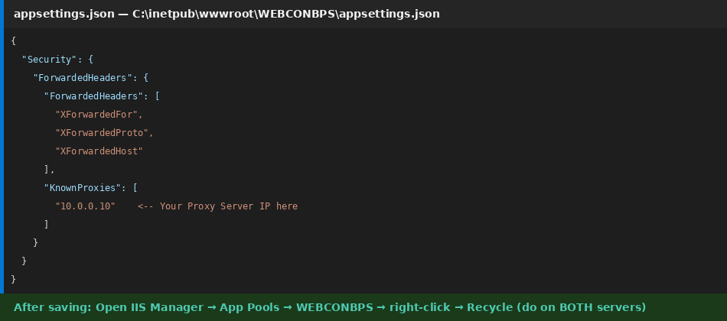
Figure 7.1 — appsettings.json with the Security section added. Replace 10.0.0.10 with your actual Proxy Server IP. Edit on BOTH App Servers.
// Add this Security block inside appsettings.json on BOTH App Servers.
// Replace 10.0.0.10 with your actual Proxy Server IP address.
{
"Security": {
"ForwardedHeaders": {
"ForwardedHeaders": [
"XForwardedFor",
"XForwardedProto",
"XForwardedHost"
],
"KnownProxies": [
"10.0.0.10"
]
}
}
}

- Save the file
- Open IIS Manager > Application Pools > right-click WEBCONBPS > Recycle — do this on BOTH App Servers
After editing appsettings.json
You must recycle the IIS App Pool on both servers for the changes to take effect. Without this, WEBCON will continue generating http:// links even after editing the file.
Step 7.2 Configure DNS [Internal DNS Server]
Since this is an internal-only deployment, users access WEBCON BPS by typing the Proxy Server hostname directly into their browser: http://PROXY-SERVER01. No public DNS or SSL certificate is needed. You just need the hostname to resolve inside your network.
Scenario | What To Do | Result
Domain-joined network (recommended) | Add an A record in your internal Windows DNS: PROXY-SERVER01 -> 10.0.0.10 | All domain machines resolve the name automatically
Workgroup / no internal DNS | Add to hosts file on each client: 10.0.0.10 PROXY-SERVER01 | Quick workaround — not scalable beyond a few machines
Hostname already resolvable | Nothing needed — server hostname already resolves on the network | Users type http://PROXY-SERVER01 and it works immediately

Verify the hostname resolves and the portal is reachable from a client machine:
# Test 1: hostname resolves
ping PROXY-SERVER01
# Expected: Pinging PROXY-SERVER01 [10.0.0.10] ...

# Test 2: portal is reachable
Invoke-WebRequest -Uri 'http://PROXY-SERVER01' -UseBasicParsing
# Expected: StatusCode : 200

PHASE 6 Verification & Testing
Run all checks before declaring the environment production-ready

8. Phase 6 — Testing & Verification
Do not skip this section. Every test below must pass before the environment is opened to end users. Document results for your change record.
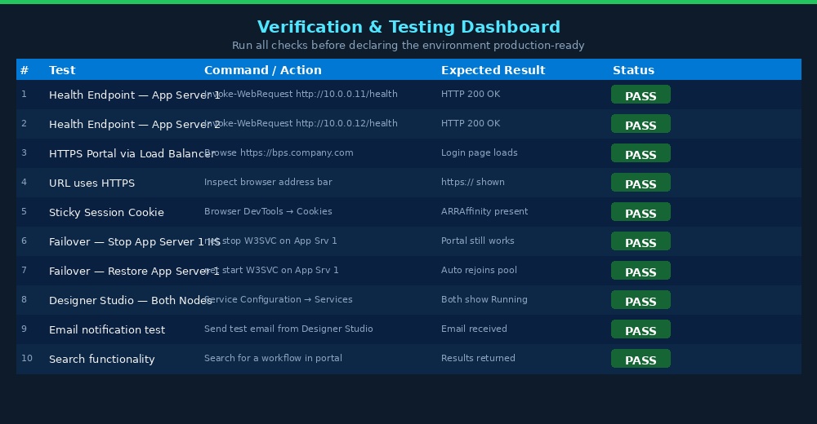
Figure 8.1 — Verification checklist. All 10 tests must pass before go-live.
Step 8.1 Test Health Endpoints from Proxy Server [PROXY-SERVER01]
# Run in PowerShell on PROXY-SERVER01
$servers = @('http://10.0.0.11/health', 'http://10.0.0.12/health')
foreach ($url in $servers) {
try {
$r = Invoke-WebRequest -Uri $url -UseBasicParsing -TimeoutSec 10
Write-Host "$url -> HTTP $($r.StatusCode)" -ForegroundColor Green
} catch {
Write-Host "$url -> FAILED: $_" -ForegroundColor Red
}
}
# Both must return HTTP 200. If not, check IIS and WEBCON on that server.

Step 8.2 Test Portal via Load Balancer [Client Machine — NOT a server]
- Open a browser on a client machine (not one of the four servers)
- Navigate to http://PROXY-SERVER01
- WEBCON BPS login page should appear
- Log in with WEBCON administrator credentials
- Browser address bar shows http://PROXY-SERVER01 — the internal proxy hostname
- Open DevTools (F12) > Application > Cookies > PROXY-SERVER01 — verify ARRAffinity cookie is present
Step 8.3 Test Failover [Both App Servers]
- Stay logged in to WEBCON BPS via the load balancer URL in your browser
- On APP-SERVER01, run: net stop W3SVC (stops IIS on that server)
- Immediately refresh your browser — the portal should STILL work, now served by APP-SERVER02
- On PROXY-SERVER01, run: Invoke-WebRequest http://10.0.0.11/health — should now fail (expected)
- Run: net start W3SVC on APP-SERVER01. Within 30 seconds ARR detects recovery and resumes routing to it.
- Repeat the test stopping APP-SERVER02 to verify APP-SERVER01 serves alone successfully
Step 8.4 Verify Both Nodes in Designer Studio [APP-SERVER01]
- Open WEBCON BPS Designer Studio > System Configuration > Service Configuration > Services
- Both APP-SERVER01 and APP-SERVER02 must show Status: Running
- APP-SERVER01 shows type Primary with all roles. APP-SERVER02 shows type Failover.

Figure 8.2 — Designer Studio with both servers showing Running status. This confirms the farm is healthy.

9. Troubleshooting Reference
Symptom | Root Cause | Resolution
Portal generates wrong server IP in links | appsettings.json KnownProxies not set or app pool not recycled | Add KnownProxies entry (Section 7.1). Recycle WEBCONBPS app pool on both app servers.
Users randomly logged out mid-session | Sticky sessions not enabled on ARR | IIS Manager > Server Farms > WebConBPS_Farm > Server Affinity > enable Client affinity
App Server 2 shows duplicate job errors | Service roles still enabled on App Server 2 | Re-run WEBCON installer on App Server 2 and uncheck ALL service roles
Cannot connect to SQL Server (connection refused) | TCP/IP disabled or firewall blocking port 1433 | Enable TCP/IP in SQL Config Manager, restart SQL service, verify firewall rule for port 1433
/health returns 404 or connection refused | WEBCON Portal stopped or App Pool stopped | In IIS Manager: start the site and recycle the WEBCONBPS app pool
ADFS / Entra ID authentication redirect fails | Portal URL set to server IP instead of LB URL | Re-run installer on both servers and enter http://PROXY-SERVER01 as the Portal URL
SOLR search returns no results | Java not installed or SOLR service not running | Verify Java 11 in PATH. Check WEBCON BPS Workflow Service is Running on App Server 1
ARR shows one server unavailable (red in farm) | Health check failing — /health not responding | Check /health manually. Ensure port 80 is open from proxy to app server.
Installer fails at database step | Service account missing SQL rights or wrong credentials | Verify login exists in SSMS. Run the SQL setup script from Section 3.6 to recreate.
Server Farm not visible in IIS Manager | ARR installed before URL Rewrite | Uninstall ARR, install URL Rewrite, then reinstall ARR. Restart IIS.

10. Port Reference
Port | Protocol | Direction | Purpose
443 | TCP | Internet -> Proxy Server | HTTPS user access — SSL terminated at proxy
80 | TCP | Proxy Server -> App Servers | HTTP load-balanced traffic (internal only)
1433 | TCP | App Servers -> SQL Server | SQL Server database connections
8002 | TCP | App Servers <-> App Servers | WEBCON BPS WCF farm coordination
8983 | TCP | App Servers -> App Server 1 | WEBCON BPS SOLR search queries
3389 | TCP | Admin workstations -> All | Remote Desktop — administrative access only

Environment Deployment Complete
Your WEBCON BPS platform is load-balanced, SSL-terminated, health-monitored, and ready for 10,000 users.
For ongoing management use WEBCON BPS Designer Studio to configure workflows, users, and system settings.

