Website Proposal for  
American Motorcycle Historical Society

Honoring the Heritage of American Motorcycles

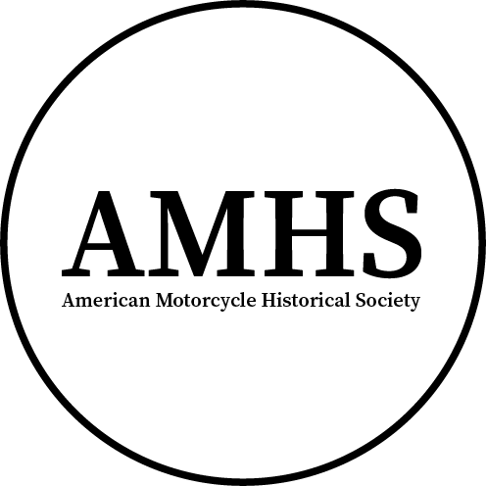

Created by:

Brennan P. Goewert  
[https://bgoewert.com](https://bgoewert.com/)Spring 2024

Note: This is an educational project for St. Louis Community College

Table of Contents

Basic Information and User Analysis 1

Design and Development 2

Week 3 Updates 4

# Basic Information and User Analysis

## Name of Organization

American Motorcycle Historical Society

## Type of Organization

Non-Profit

## Purpose of Organization

Preserve the history of American motorcycles by sharing information, organizing relevant events, and providing services and support for enthusiasts and historians.

## Tagline

Honoring the Heritage of American Motorcycles

## Target Audience

Motorcycle enthusiasts and historians.

## Three Things to Convey to Users

* Where to get information about motorcycles.
* Where to find nearby events.
* How to get support to find information, services, parts, or motorcycles for sale.

## Three Things That Users Want

* Information on certain motorcycle models or manufacturers.
* Where to find nearby events.
* Where to find parts or old motorcycles to purchase.

## Three Similar/Competitor Websites

* [Italian Moto History (bgoewert.com)](https://italian-moto-history.bgoewert.com/)
* [The History of American Motorcycles (Chopper Exchange Blog)](https://blog.chopperexchange.com/motorcycle-life/motorcycles-for-sale/the-history-of-american-motorcycles/)
* [An A-to-Z Guide to American Motorcycles (RideApart)](https://www.rideapart.com/features/253938/an-a-to-z-guide-to-american-motorcycles/)
* [New-York Historical Society](https://www.nyhistory.org/)

# Design and Development

## Visual Representation of The Business

The primary logo consists of an all-black, centered, encircled, large, initialized version of the name (AMHS) and smaller full name below it. The alternate logo excludes the full name.

## Preferred Font Types

Open-source fonts that have less licensing restrictions and more availability. Serif font for logo and headings, possibly bold or semi-bold. Sans serif for body copy.

* Source Serif 4
* Source Sans 3

## Preferred Colors

In addition to black and white, the following colors may be used:

* #2E3F5C - dark blue
* #27529C - blue
* #0050DB - bright blue
* #86692D - gold
* #DB9500 - yellow-gold?

## Photos that could represent the Organization

* [Cecial Brown, American speedway ace, on his Indian motorcycle](https://openverse.org/image/186bd4d8-193d-4c31-b68d-cf1a4a71613d?q=American Motorcycle)
* [Vacationers on Motorcycles in South Park, Colorado](https://commons.wikimedia.org/wiki/File:VACATIONERS_ON_MOTORCYCLES_-_NARA_-_544844.jpg)
* [1917-18 Harley Davidson motorcycles for the war department](https://commons.wikimedia.org/wiki/File:Motor_Vehicles_-_In_Use_-_Harley_Davidson_motorcycles,_some_with_side_cars_on_the_road_manufactured_by_the_Harley_Davidson_Co.,_Milwaukee,_Wis._For_the_War_Department_-_NARA_-_45504463.jpg)
* [Seattle motorcycle club, ca. 1910](https://commons.wikimedia.org/wiki/File:Seattle_motorcycle_club,_ca_1910_(MOHAI_7177).jpg)

## Possible Web Page Titles

* Motorcycles
  + Manufacturers
  + Racing
* Events
* Museums
* About
* Contact

## Required Features

* Calendar/list of events
* Site search
* Contact form with type of inquiry
  + Added a museum/event
  + Request information on given model
  + Reporting or requesting update to historical information
  + Etc.

## Optional Features

* Integration with event hosting platforms (e.g., Eventbrite) so there is no need to curate events.
* Separate form for approval process to add events/museums or report/request update to historical information.
  + This can probably be done with WordPress
* Newsletter to notify people of upcoming events

# Week 3 Updates

## Research and Needs

While looking into how an organization like this might display their content, additional websites were found that may be used for reference.

* [New York Historical Society](https://www.nyhistory.org/)
* [Indiana Historical Society](https://indianahistory.org/)

## Wireframe

An initial wireframe has been created showing the proposed layout of content for desktop, tablet, and mobile devices.

View the [Wireframe v1](https://mystlcc-my.sharepoint.com/:b:/g/personal/bgoewert2_my_stlcc_edu/EWBP9jpXPNtHsv069bJb8ZEBrHI4aR6_-DB9ZjssXh_Ogg?e=2UAec2)

Note: The layout is subject to change based on any newly discovered research or needs and the position of content may look different from the end product.

## Artwork

### Logo

An alternate logo has been created without the subheading of the full organization name. This logo is to be used in instances where the subheading can not be easily read. In addition, the outlining circle stroke has been increased for smaller sizes.

* [Primary Logo](https://mystlcc-my.sharepoint.com/:i:/g/personal/bgoewert2_my_stlcc_edu/EZ6xA94xn81GrjjM5MELpBMBp8VJrTYTT1MakCpUubar7g?e=WOs4l6)
* [Alternate Logo](https://mystlcc-my.sharepoint.com/:i:/g/personal/bgoewert2_my_stlcc_edu/EQwrV5w5bqVNjMIUiPHozegBiVCJdaEdPAuJ2KP6cXeKDg?e=htD84r)

### Brand Guidelines

In order to provide a central document that is easy to reference, a brand guideline was created. This first version only contains a color palette.

View the [Brand Guidelines v0.1](https://mystlcc-my.sharepoint.com/:b:/g/personal/bgoewert2_my_stlcc_edu/ERyAKt76pRdClBuYkdAHIb0BVXNcah9y-6-84TJwx68YfA)