Website Proposal

American Motorcycle
Historical Society

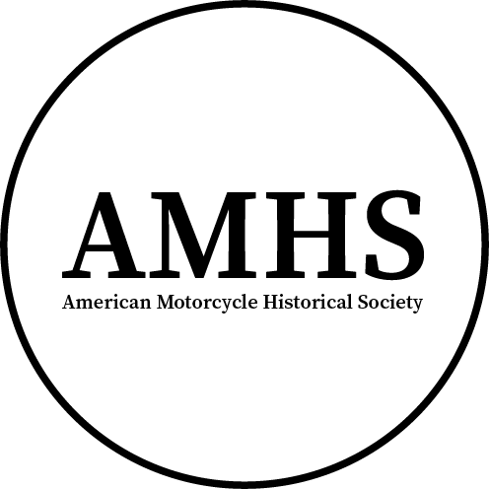

Created By:
Brennan P. Goewert
https://bgoewert.com
Spring 2024
Note: This is an educational project for St. Louis Community College
Table of Contents
Basic Information and User Analysis 1
Design and Development 3
Week 3 Updates 5
Week 4 Updates 6

Basic Information and User Analysis

Name of Organization
American Motorcycle Historical Society

Type of Organization
Non-Profit

Purpose of Organization
Preserve the history of American motorcycles by sharing information, organizing relevant events, and providing services and support for enthusiasts and historians.

Tagline
Honoring the Heritage of American Motorcycles

Target Audience
Motorcycle enthusiasts and historians.

Three Things to Convey to Users
- Where to get information about motorcycles.
- Where to find nearby events.
- How to get support to find information, services, parts, or motorcycles for sale.

Three Things That Users Want
- Information on certain motorcycle models or manufacturers.
- Where to find nearby events.
- Where to find parts or old motorcycles to purchase.

Three Similar/Competitor Websites
- Italian Moto History (bgoewert.com)
- The History of American Motorcycles (Chopper Exchange Blog)
- An A-to-Z Guide to American Motorcycles (RideApart)

Design and Development

Visual Representation of The Business
The primary logo consists of an all-black, centered, encircled, large, initialized version of the name (AMHS) and smaller full name below it. The alternate logo excludes the full name.

Preferred Font Types
Open-source fonts that have less licensing restrictions and more availability. Serif font for logo and headings, possibly bold or semi-bold. Sans serif for body copy.
- Source Serif 4
- Source Sans 3

Preferred Colors
In addition to black and white, the following colors may be used:
- #2E3F5C - dark blue
- #27529C - blue
- #0050DB - bright blue
- #86692D - gold
- #DB9500 - yellow-gold?

Photos that could represent the Organization
- Cecil Brown, American speedway ace, on his Indian motorcycle (openverse.org)
- Vacationers on Motorcycles in South Park, Colorado (commons.wikimedia.org)
- 1917-18 Harley Davidson motorcycles for the war department (commons.wikimedia.org)
- Seattle motorcycle club, ca. 1910 (commons.wikimedia.org)

Possible Web Page Titles
- Motorcycles
  - Manufacturers
  - Racing
- Events
- Museums
- About
- Contact

Required Features
- Calendar/list of events
- Site search
- Contact form with type of inquiry
  - Added a museum/event
  - Request information on given model
  - Reporting or requesting update to historical information
  - Etc.

Optional Features
- Integration with event hosting platforms (e.g., Eventbrite) so there is no need to curate events.
- Separate form for approval process to add events/museums or report/request update to historical information.
- This can probably be done with WordPress
- Newsletter to notify people of upcoming events

Week 3 Updates

Research and Needs
While looking into how an organization like this might display their content, additional websites were found that may be used for reference.
- New York Historical Society (nyhistory.org)
- Indiana Historical Society (indianahistory.org)

Wireframe
An initial wireframe has been created showing the proposed layout of content for desktop, tablet, and mobile devices.
AMHS Wireframe v1.pdf
Note: The layout is subject to change based on any newly discovered research or needs and the position of content may look different from the end product.

Artwork

Logo
An alternate logo has been created without the subheading of the full organization name. This logo is to be used in instances where the subheading can not be easily read. In addition, the outlining circle stroke has been increased for smaller sizes.
- Primary Logo.png
- Alternate Logo.png

Brand Guidelines
In order to provide a central document that is easy to reference, a brand guideline was created. This first version only contains a color palette.
AMHS Brand Guidelines v0.1.pdf

Week 4 Updates

Research and Needs

Similar/Competitor Sites
These are some additional sites I’ve found that are either direct competition or serve a similar purpose. They also may contain information useful to creating content for the site.
- https://archivemoto.com/
- https://nationalmcmuseum.org/

Content Ideas
Instead of polluting this document with content, I’ve created another in order to store ideas for content including historical figures, stories, and other worthwhile content. Currently, it only contains names of characters I’ve come across during my search to find pre-war images.
AMHS Website Content Ideas.odt

Sitemap
A sitemap was created last week, but it was in an unfinished state. Following further research into other historical societies’ websites, I’ve updated the sitemap to a more finalized version.
AMHS Sitemap v3.pdf

Wireframe
Following the update to the sitemap, a new wireframe was created for a majority of the pages. This new wireframe will be the final version. Responsive versions will simply be created along with the mock-ups.
AMHS Wireframe v3.pdf

Brand Guidelines
A basic brand guide has been created to document the logo, typography, and color usage for the entire organization. This document is still a work-in-progress and is missing pages for the wordmark and combination logo variations as well as instructions for color usage.
AMHS Brand Guidelines v0.4.pdf

Mock-ups
In order to efficiently create an effective creative style for the website, mock-ups were created of various pages. This includes the use of color, content, and media to display what some of the pages might look like. Iterating design choices with a mock-up is more effective than making these decisions during development.
AMHS Mockups v1.pdf

Week 5 Updates

Research
In order to mock-up the website’s different pages, I’ve found some additional content and information that can be used. A single upcoming event, a couple of nationally recognized museums, and information related to memberships, has been compiled to be re-used.

Mock-ups
The remaining main pages have been created for the desktop version, minus a couple of features such as the image collage with links to articles. Additional time was taken in order to choose the layout and design which took away work hours from other areas.
AMHS Mockups Desktop v2.pdf

Coding
Work has started on coding the basic layout and styles. However, it is very early days was briefly paused to work on mock-ups and a prototype/storyboard.
The code repository and development site can be viewed on GitHub.

Prototyping
This is the general storyboard for the website. It shows a mockup and user flow of the site to help to develop something that looks good and is usable.
Penpot Interactive Prototype

