Website Content Ideas

American Motorcycle
Historical Society

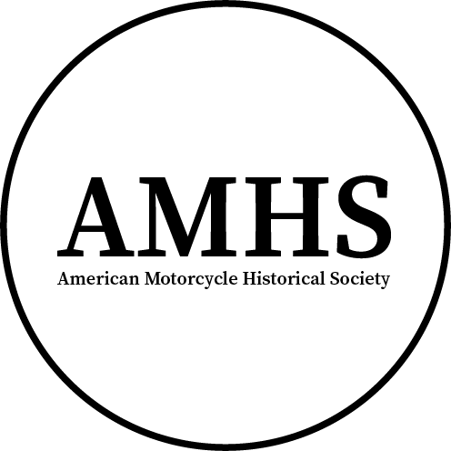

Created By:
Brennan P. Goewert
https://bgoewert.com
Spring 2024
Note: This is an educational project for St. Louis Community College
Table of Contents
Historical Figures 1

Historical Figures

Cecil Brown
After looking for an image for the hero section, I’ve found that the proposed image of Cecil Brown was taken in Australia. I’ve yet to find any information on him. Because of this, he will not be included in the initial publications.

Ashley Franklin Van Order
Found a Smithsonian Magazine article on board-track racing that named A.F. Van Order and his collection of photographs “the most complete and compelling visual record of early motorcycle racing” (Schonauer, 2011). Other than this article and ArchiveMoto.com, I have yet to find a collection of his photos.

Eddie Hasha
Another famous board track racer, who's death contributed to the demise of board tracks.
https://en.wikipedia.org/wiki/Eddie_Hasha

Edward “Teddy” Carroll
One of the first factory riders for Indian.
https://en.wikipedia.org/wiki/Teddy_Carroll

