#nB51 manual
(very draft version)
The project repository (i.e. binaries, manual, and examples) are available at: https://github.com/bgolab/nB51/tree/main

Wiring
Original breadboard wiring: STC8G1K08A
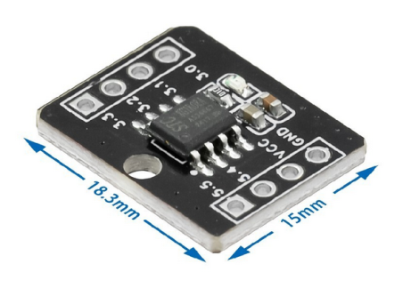

Getting started
Flash the latest BASIC hex file (e.g. nB51.hex). Start a terminal emulator e.g. TeraTerm (9600,8,N,1). The 8051 will boot.
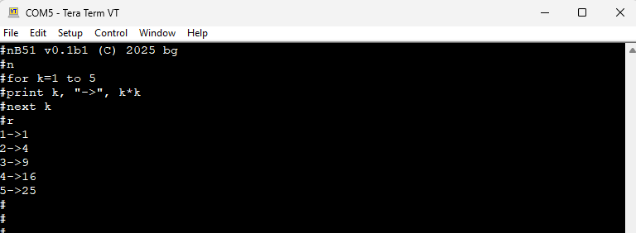
Enter an example BASIC program (you can use Copy & Paste)
for k=1 to 5
print k, “,”, k*k
next k
end
Use ‘c’ to see the code, ‘r’ to run the code. The ‘n’ clears the program memory.
You can use @N (e.g. @0) to delete Nth line or @N <code> (@0 print 1) to insert the line of code.
Capital and small letters accepted for keywords (i.e. ‘CLS’ equals ‘cls’). For the names small and capital letters are NOT recognized (i.e. ‘as’ is the same name as ‘AS’)

NOTE: If you use TeraTerm and some characters are lost during Copy & Paste operation consider increasing the ‘Paste delay per line’ in Setup->Additional Settings->Copy and Paste

Limits
-VAR / LABEL NAME: 4 chars
-program size: 1024 chars (shared memory with tokens and name!)

MEMORY MAP
[SOURCE_CODE][OS CMD BUFFER][TOKENS][HEAP]……[NAMES]

Program structure
Program Structure | Description/Comments | Example
gosub sub1  end  subr: [sub1 <code> return | Command ‘end’ has to be the last line of the main code.  Subroutines have to follow the ‘end’. | gosub callme  end  callme: print “Hi!” return

System commands
Command | Description/Comments | Example
ESC | Stop the running program or skip loading auto.bas when booting
c | Show code
r | run code
n | New – clear VM memory and code
t | Show Tech Info (tokens, names, mem info)
g | Compile to tokens (might be disabled to save memory)
u | Upload tokens from UART  The protocol (T sets token, A sets address, R runs:  w/o addr set(print 7): 140T 130T 7T R;  w/ addr set to 0(print -7): '0A 140T 181T 130T 7T R'
l | List tests
0-… | Load N-th tests
l, s | Load/Save program from/to EEPROM (auto.bas)
ee, ed | EEPROM erase/dump
@N, @N <code> | @N - delete N-th line; @N <code> - insert <code> before N-th line | @3 – removes 3rd line  @4 cls – insert ‘cls’ before line 4

The BASIC language
VARIABLES & EXPRESSIONS
-variable name: letter&digits starting w/ a letter
-expr(arithmetic expression): combination of INT, ops/brackets( +, -, *, /, %,(, )) and INT vars;
-hex integer format supported, e.g. 0xAA
Command | Description/Comments | Example
var=expr | INT var, name=expr, 1st-reference creates var(value=0); | sy=2 + a*20

PROGRAM FLOW CONTROL
NOTE: The FOR-loop STEP/TO values are evaluated only once, before entering the FOR-loop.
Command | Description/Comments | Example
FOR v=expr TO expr [STEP expr] [code] NEXT var | If STEP[default=1]; INT supported; loop nesting supported | FOR k = 5 TO 1 STEP -1 NEXT k END
IF expr relop expr THEN [code] [ELSE] [code] ENDIF | INT supported; nesting supported; | if a>1 then print “ok” else print “bad” endif
label:  GOTO label/var | Label starts with a letter, terminated by colon; up to 8 letter & digits( plus ‘_’); | k=1 again: print k k=k+1  if k<5 then goto again: endif
GOSUB label/var | NOTE :Label must be located after END | gosub task0 end
label: RETURN | label: [code] RETURN | task0: print “done” return
END | Last command. GOSUB labels follows END  NOTE: END is obligatory if you use GOSUB | End

INPUT, OUTPUT, DATA, MEMORY
Command | Description/Comments | Example
PRINT expr[, “txt”], [;]? | Prints expr, sexpr separated by ‘,’; ‘;’ - skips NEW LINE? | PRINT "6/3=", 6/3 (with NEW LINE)  PRINT 1; (w/o NEW LINE because of ‘;’)
INPUT var,… | Assign int values to (array) var | INPUT “num?“, name
DATA const, const  READ var, var  RESTORE | DATA - INT constants supported  READ - assign DATA specified input to vars  RESTORE - Reset data pointer | DATA 1, 2  READ v, y
POKE addr,value  PEEK(addr) | Memory write/read; hex supported;  mem-map(incl. fantom addresses):  xdata: real addr,  sfr: 0xC00+addr;  magic: 0xF00+addr | Magix: 0xF00 – contains the memory address of the HEAP

TIME (two independent timers: for PAUSE and for GETTICK() settable byGETTICK(N))
Command | Description/Comments | Example
GETTICK(msec) | Sets msec for the GETTICK timer | Gettick(0) 0 (resets the timer for gettick())
GETTICK() | Ticks; MAX 32767 msec | a=gettick()
PAUSE msec | Delay (blocking) in msec | PAUSE 2*500

LOGICAL
Command | Description/Comments | Example
AND(expr,expr) |  | PRINT AND(0x3,0xF)
OR(expr,expr) |  | PRINT OR(0x3,0xF)
NOT(expr) |  | PRINT HEX$(NOT(0x0F))

GPIO
Command | Description/Comments | Example
PMODE pin,mode | const: IN,OUT,PUP,PDOWN, ADC, PWM | pmode 100, tsensor temp= aread(100)
AREAD(pin) | Read analog pin; pins=?; | pmode 26, adc voltage=aread(26)
AWRITE pin,cycle | PWM duty=cycle/65535,cycle<65535 | pmode 22, pwm awrite 22, 16000
DREAD(pin) | Read digital pin | y=15 pmode y,in pmode y,pullup  for k=1 to 2 step 0 pause 50 print dread(y) next k
DWRITE pin,value | Write digital pin | pmode 25,out dwrite 25,high pause 3000 dwrite 25,low

OLED (OLED 0.91” supported)
NOTE: use ‘lref’ to refresh the screen as ALL the lxxx command update only the memory buffer
Command | Description/Comments | Example
LPLOT X, Y | Draw point at X, Y | for x=0 to 127 lplot x,fix(15+15*sin(6.28*x/128)) next x lref
LDRAW X0, Y0, X1, Y1 | Draw line from X0, Y0 to X1, Y1 | ldraw 10, 10, 20,20 lref
LCIRCLE x, y, r | Draw circle at x, y, r | lcircle 15, 15, 10
LPRINT expr, sexpr [AT x,y] | Print expr, sexpr separated by ‘,’  [AT x, y] (default 0,0) | lprint “2+2=”, 2+2 AT 10,10 lref
LCLS | Clear Screen | lcls lref
LREF | Refresh LCD (copy mem to LCD) | lref

TONE SUPPORT (tested on piezo)
Command | Description/Comments | Example
TONE pin, freq | Start PWM square signal at freq, duty 50% on a pin; freq>10Hz; non-blocking; | TONE 18, 440
NOTONE pin | Stop generating the signal on a pin | NOTONE 18

SERVO SUPPORT (tested on Tower Pro Sg90 where the pulse is between 500-2400 usec) - EXPERIMENTAL
Command | Description/Comments | Example
SERVO pin, angle [pulsemin, pulsemax] | Enable servo on a pin, set the angle (0…180 deg); optional: min/max pulse in usec(default: 500/2000usec, allowed min/max values: 500-2400usec) | SERVO 19, 90  SERVO 19, 9, 500, 2400
NOSERVO pin | Disable servo on a pin | NOSERVO 19

I2C/UART SUPPORT
-xREAD/xWRITE are blocking (waits for the data forever); non-blocking by checking if the fifo(xREADABLE/xWRITEABLE)

