**Steps to change web part default icon**

In this exercise we will see how to change the default icon of web part when adding web part to a page. By default it shows a page icon with web part name when adding a new web part to page.

**Step 1:**Edit **WebPartPropertiesWebPart.manifest.json** webpart **manifest.json** file. Change **officeFabricIconFontName** property inside array **preconfiguredEntries**. Defualt value is “**Page**”

"preconfiguredEntries": [{

    "groupId": "5c03119e-3074-46fd-976b-c60198311f70", // Other

    "group": { "default": "Other" },

    "title": { "default": "WebPartProperties" },

    "description": { "default": "WebPartProperties description" },

    "officeFabricIconFontName": "Page",

    "properties": {

**Step 2:** Gulp serve the web part to see current default icon.

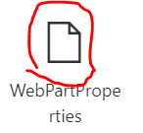

**Step 3:** Go to following link for office fabric icons:

<https://developer.microsoft.com/en-us/fluentui#/styles/web/icons>

**Step 4**: Remember the name of any icon which you want to use as your default icon for webpart and update that name in webpart **manifest.json** file. For example here we want to use **PageHeaderEdit** icon.

 "officeFabricIconFontName": "PageHeaderEdit",

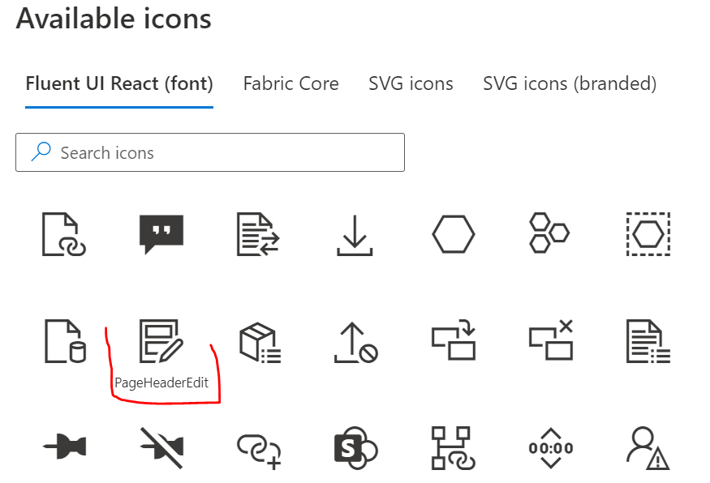

**Step 5:** After changes, **gulp serve** web part again to test the changes. Now you can see the new icon of the web part when trying to add web part to your page.

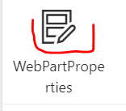

**Step 6:** If you want to use any external image as icon then you have change property from **officeFabricIconFontName** to **iconImageUrl** and give either the link of the image location or convert image to base 64 and specify the base 64 string in **manifest.json** file.

For example, we want to show black balloon icon image at link: <https://camo.githubusercontent.com/cb325fe4e2c82cf6d01de92e7e1942fcd6474911f17862c71fd3be6f4925e2d5/68747470733a2f2f692e696d6775722e636f6d2f4a4f6a626a696b2e706e67>

 "iconImageUrl": "https://camo.githubusercontent.com/cb325fe4e2c82cf6d01de92e7e1942fcd6474911f17862c71fd3be6f4925e2d5/68747470733a2f2f692e696d6775722e636f6d2f4a4f6a626a696b2e706e67",

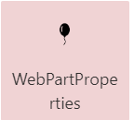

**Step 7:** To use **base64** encoded image, you can use the base64 string instead of an absolute URL to the image. We can use any of the online services to **base64 encode** our image. Here is an example of such **encoding** service [**https://www.base64-image.de/**](https://www.base64-image.de/)

In the browser, open <https://www.base64-image.de/>. And upload the image. Click “show code” to get the base64 encoded string.

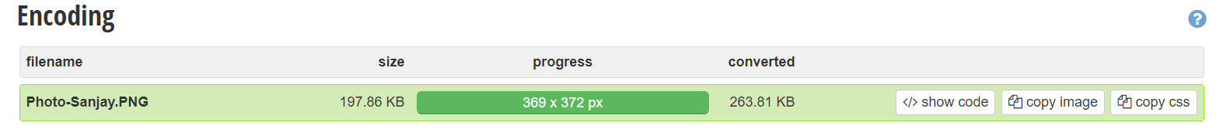

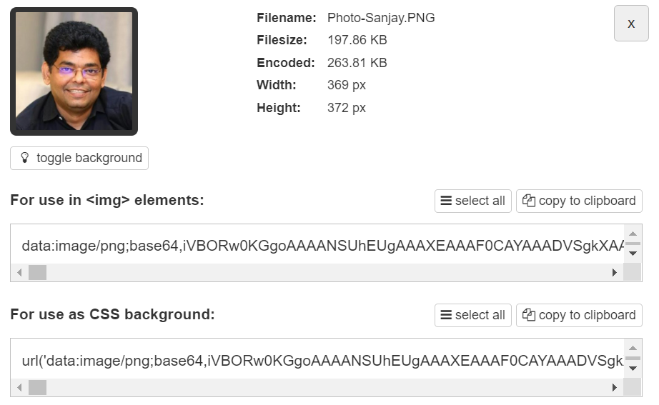

**Step 8:** Click “**copy to clipboard**” to get the base64 encoded string and set it to **iconImageUrl** property in the web part manifest.

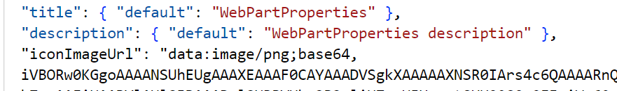

**Step 9:** Run **gulp serve** to see the new encoded icon for web part



**Advantages of using base64 encoded image**

* Base 64 encoding works on almost all formats (e.g. bitmap, jpg, png, etc.).
* The image need not be deployed along with web part assets.

**General Observation**

If you specify both the **officeFabricIconFontName** and the **iconImageUrl** properties in web part manifest, the icon specified in **officeFabricIconFontName** will be used.