In this article, we will see how to create a web part using SharePoint Framework.

Open PowerShell command window and create a new project directory in your favourite location.

Use command: md ‘directory-name’. Here our directory name is helloworld-webpart.

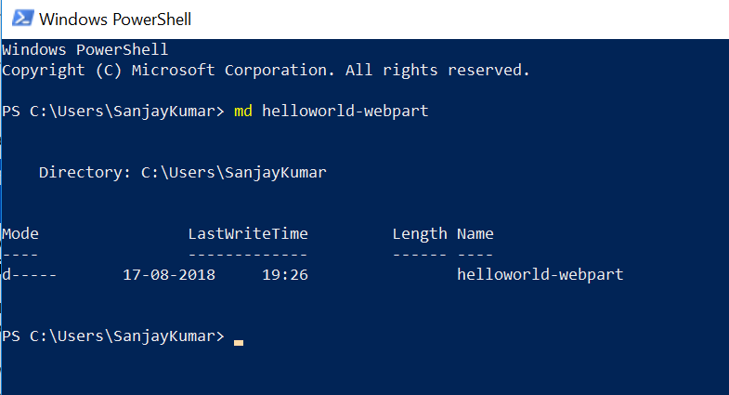

Go to the project directory helloworld-webpart using cd command.

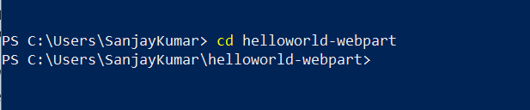

Create a new HelloWorld web part by running the Yeoman SharePoint Generator. Type the command as shown in below image.

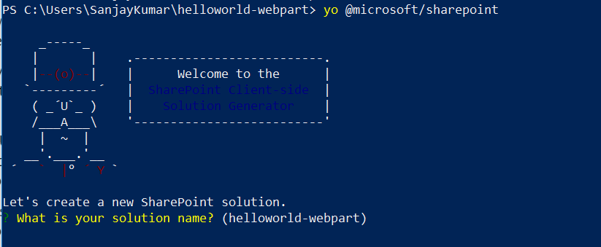

Accept the default ‘helloworld-webpart’ as your solution name, and then select Enter.

Select ‘SharePoint Online only (latest)’ and press Enter key.

Select ‘Use the current folder’ for where to place the files.

Select ‘N’ to require the extension to be installed on each site explicitly when it's being used.

Select ‘WebPart’ as the client-side component type to be created.

Accept the default HelloWorld as your web part name, and then select Enter.

Accept the default HelloWorld description as your web part description, and then select Enter.

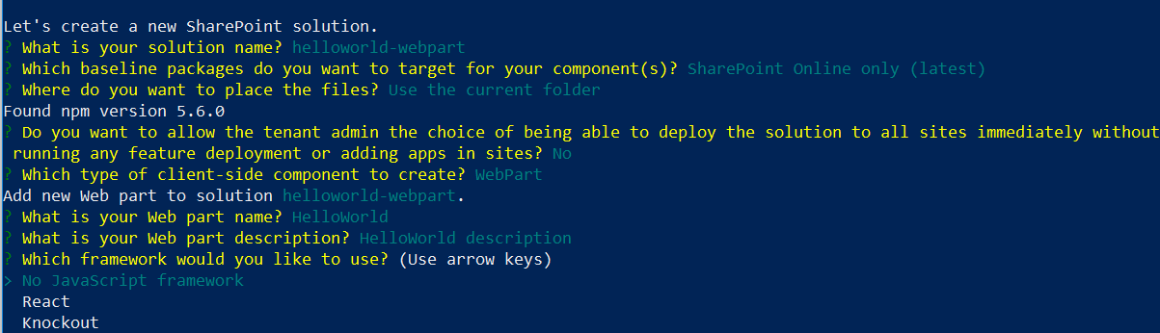

Accept the default ‘No javascript web framework’ as the framework you would like to use, and then press Enter key.

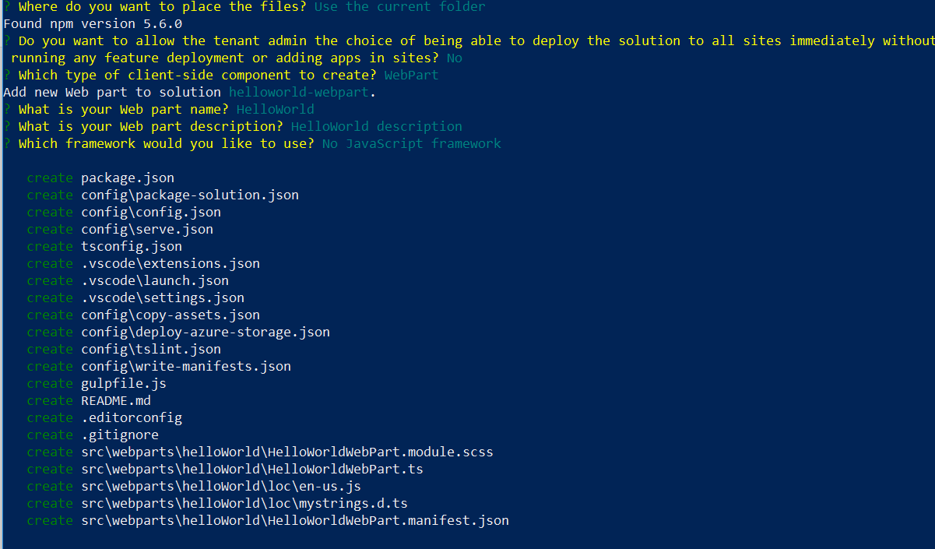

At this point, Yeoman installs the required dependencies and scaffolds the solution files along with the **HelloWorld** web part. This might take a few minutes.

When the scaffold is complete, you should see the following message indicating a successful scaffold.

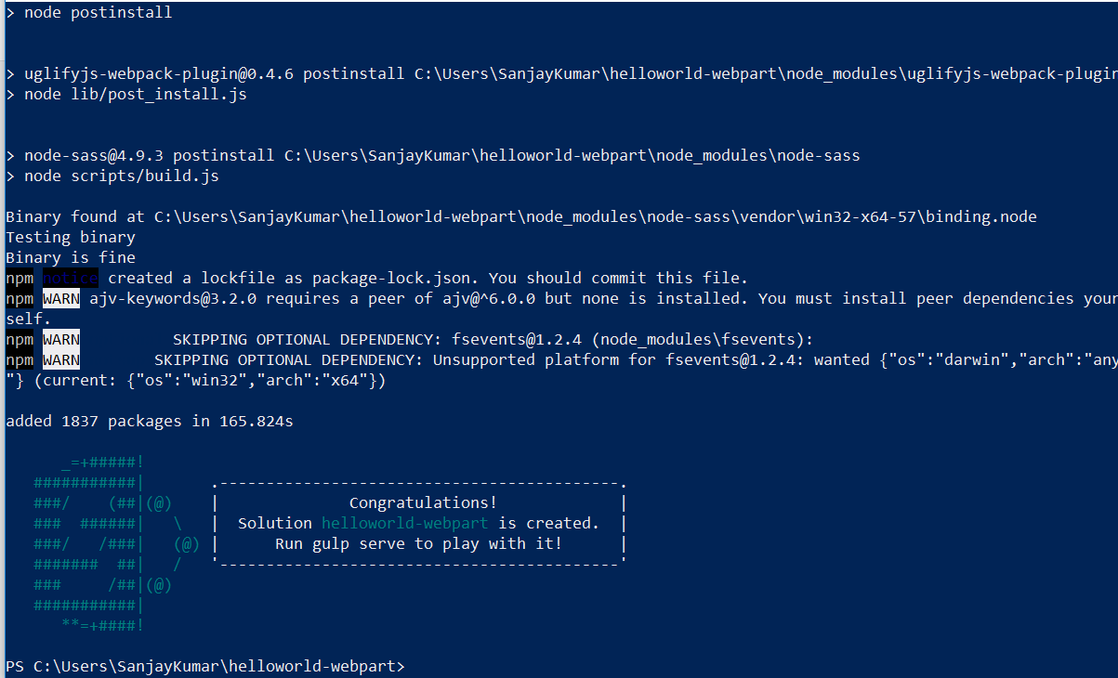

**Preview the web part**

To preview your web part, build and run it on a local web server. The client-side toolchain uses HTTPS endpoint by default. However, because a default certificate is not configured for the local dev environment, your browser reports a certificate error. The SPFx toolchain comes with a developer certificate that you can install for building web parts.

To install the developer certificate and preview your web part

Switch to your console, ensure that you are still in the **helloworld-webpart** directory, and then enter the following command:

gulp trust-dev-cert

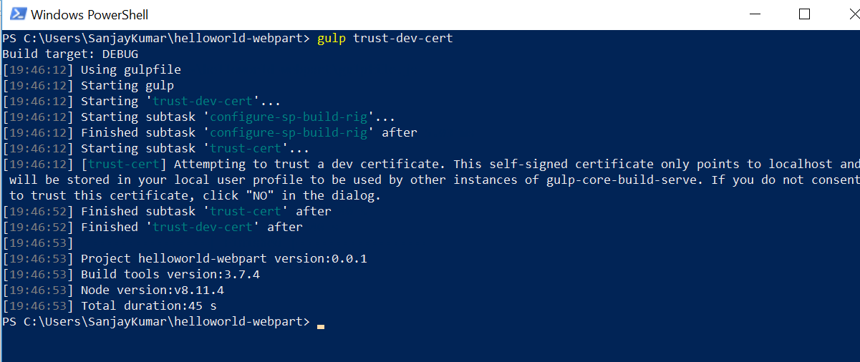

Now that we have installed the developer certificate, enter the following command in the console to build and preview your web part:

gulp serve

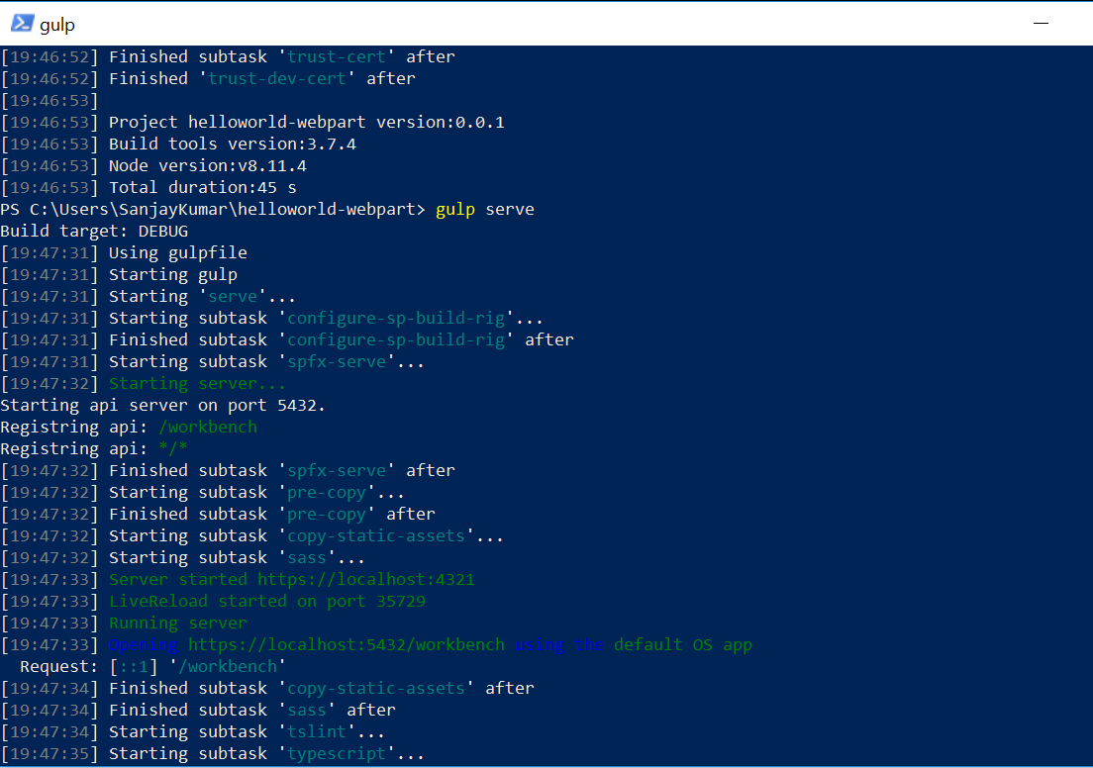

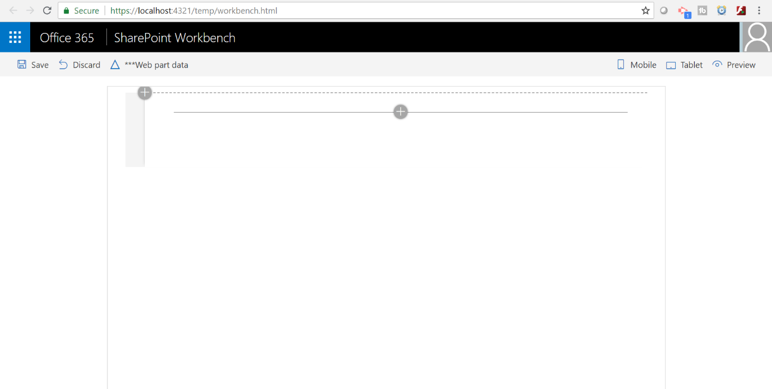

SharePoint client-side development tools use [gulp](http://gulpjs.com/) as the task runner to handle build process tasks such as:

Bundling and minifying JavaScript and CSS files.

Running tools to call the bundling and minification tasks before each build.

Compiling SASS files to CSS.

Compiling TypeScript files to JavaScript.

Visual Studio Code provides built-in support for gulp and other task runners. Select Ctrl+Shift+B on Windows or Cmd+Shift+B on Mac to debug and preview your web part.

SharePoint Workbench is a developer design surface that enables you to quickly preview and test web parts without deploying them in SharePoint. SharePoint Workbench includes the client-side page and the client-side canvas in which you can add, delete, and test your web parts in development.

To add the HelloWorld web part, select the **add** icon (*this icon appears when you mouse hovers over a section as shown in the previous image*). This opens the toolbox where you can see a list of web parts available for you to add. The list includes the **HelloWorld** web part as well other web parts available locally in your development environment.

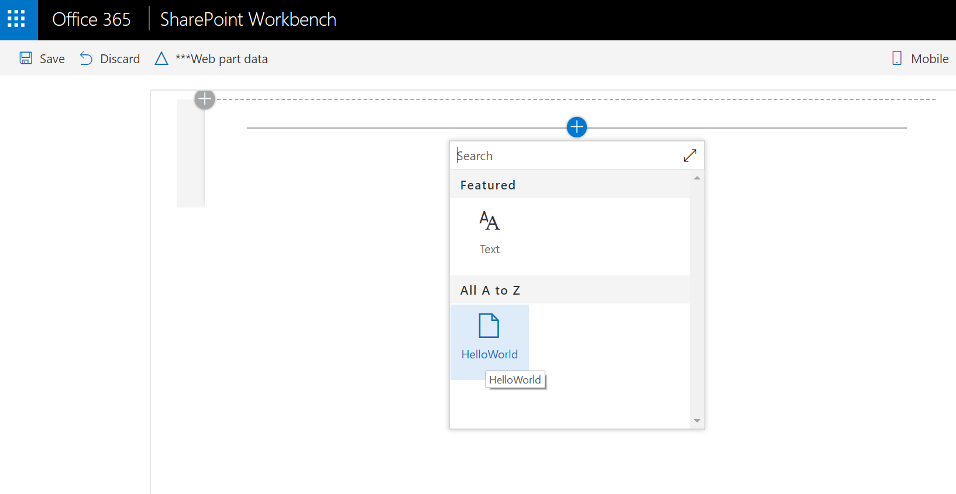

Select **HelloWorld** to add the web part to the page.

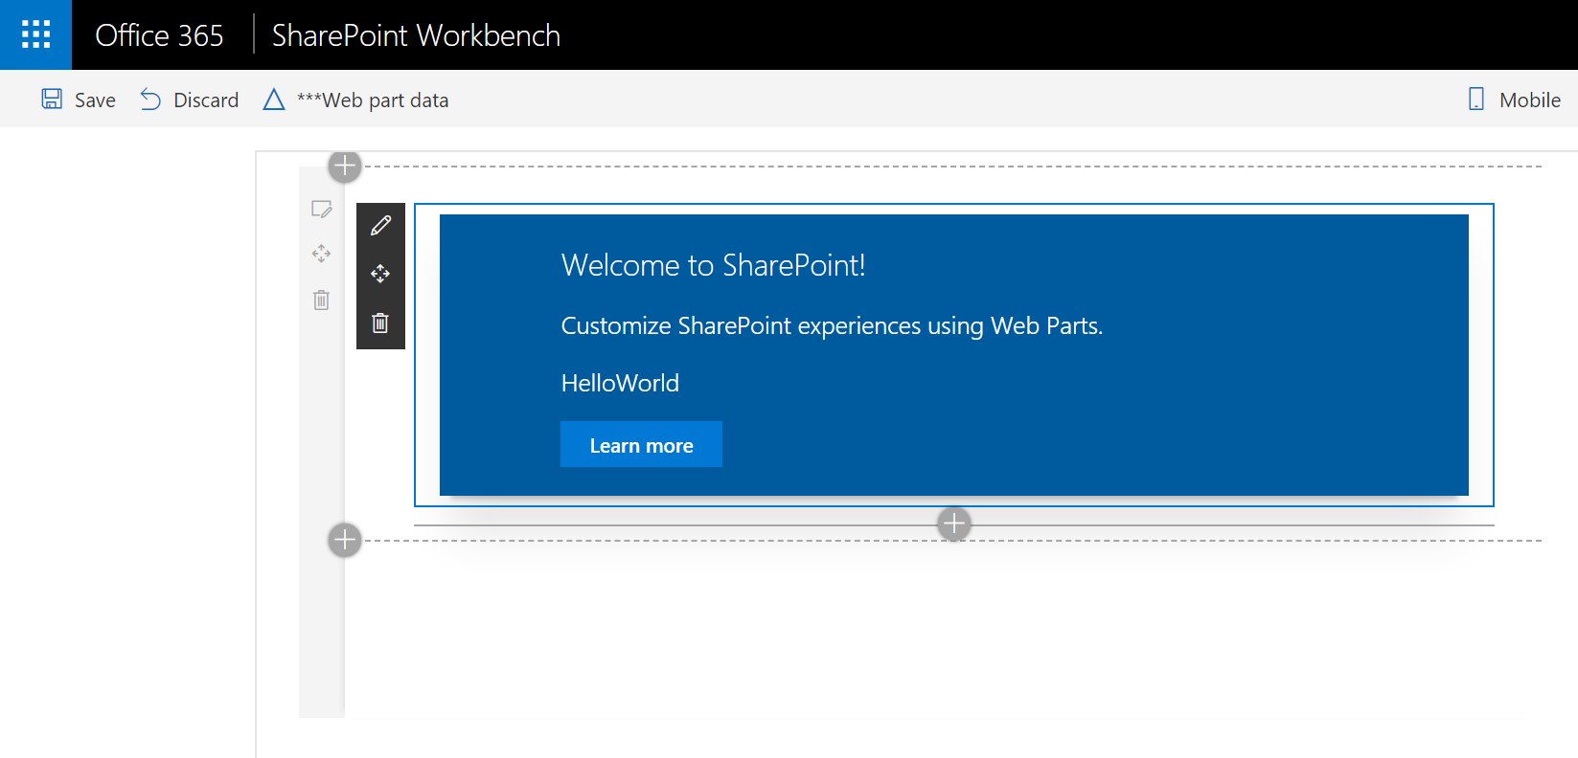

Congratulations! You have just added your first client-side web part to a client-side page.

Select the pencil icon on the far left of the web part to reveal the web part property pane.

The property pane is where you can define properties to customize your web part. The property pane is client-side driven and provides a consistent design across SharePoint.

