**Third party anonymous REST API Call from SPFx WebPart**

In this article we will see how to call a third party **anonymous REST API** form SPFx web part.

**Step 1-** Open **Node.js** command prompt. Create a directory using **md** command. Go to newly created directory/ folder using **cd** command and run **yeoman generator** command to create new SPFx project.

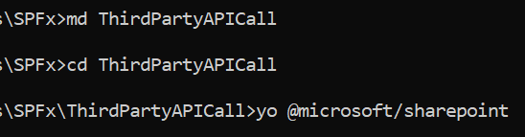

**Step 2**- Give all the details for creating new project like **solution name, component type (webpart**), **webpart name** and **template** (JS Framework)

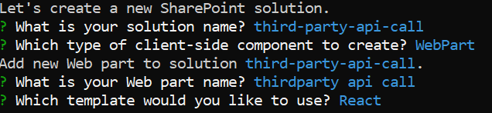

**Step 3-** Open project in VS Code by using **code .** command



**Step 4-** Go to interface **IThirdpartyApiCallProps.ts** inside **components** folder ‘**src\webparts\thirdpartyApiCall\components’** and add a new property of type **any**. We are using **type** **any** in place of string or number etc. So that we can accept **any type** of **response** from the **Rest API.**

JokeText:any;

**Step 5-** Now open React component file **ThirdpartyApiCall.tsx** and update **render()** method to display the text you get from Rest API call.

<div>Joke from Rest API: <strong>{this.props.JokeText}</strong></div>

**Step 6:** Go to web part .ts file **ThirdpartyApiCallWebPart.ts**.

1. Import **HttpClient**

import{HttpClient,HttpClientResponse} from '@microsoft/sp-http';

2. Create a new private **function _getJoke()** to call **Rest** API. From this **API** we are getting **Response** as **text** but we can have **APIs** returning response as **JSON** objects.

 private _getJoke(): Promise<any> {

    return this.context.httpClient.get(

      `https://geek-jokes.sameerkumar.website/api`,

      HttpClient.configurations.v1

    )

    .then((response: HttpClientResponse) => {

      return response.text();

    })

    .then(textResponse => {

      return textResponse;

    }) as Promise<any>;

  }

3. Update the **render()** method and call the private method created for Rest API call.

  public render(): void {

    if (!this.renderedOnce) {

      this._getJoke().then(response =>{

    const element: React.ReactElement<IThirdpartyApiCallProps> = React.createElement(

      ThirdpartyApiCall,

      {

        JokeText : response

      }

    );

    ReactDom.render(element, this.domElement);});

    }

  }

