**SharePoint Framework (SPFx) - Graph API - Get User Profile from Office 365.**

**Step 1:**Create a folder with the name GraphAPI-1 on your local drive.

C:\Users\ABC\Documents\SPFx\**GraphAPI-1**

**Step 2:**Open the location in the command prompt using cd command. Scaffold the SPFx solution using Yeoman Generator

*yo @microsoft/sharepoint*

**Step 3:**Give the webpart name and other details as shown below

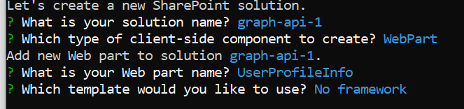

**Step 4:**Install MS Graph types node package by using command:

*npm install @microsoft/microsoft-graph-types --save-dev*

**Step 5:** Open the solution in VS Code. You can use the "Code ." command in the command prompt directly to open the solution in VS Code. Go to web part type script file **UserProfileInfoWebPart.ts** and import **MSGraphClient** and **MicrosoftGraph** as below:

import { MSGraphClient } from '@microsoft/sp-http';

import * as MicrosoftGraph from '@microsoft/microsoft-graph-types';

**Step 6:** Update **render()** method.

 this.context.msGraphClientFactory

      .getClient()

      .then((graphclient: MSGraphClient): void => {

        graphclient

          .api('/me')

          .get((error, user: MicrosoftGraph.User, rawResponse?: any) => {

            this.domElement.innerHTML = `

    <section class="${styles.userProfileInfo} ${!!this.context.sdks.microsoftTeams ? styles.teams : ''}">

      <div class="${styles.welcome}">

      <p class="${styles.description}">Display Name: ${user.displayName}</p>

      <p class="${styles.description}">Given Name: ${user.givenName}</p>

      <p class="${styles.description}">Surname: ${user.surname}</p>

      <p class="${styles.description}">Email ID: ${user.mail}</p>

      <p class="${styles.description}">Mobile Phone: ${user.mobilePhone}</p>       </div>

    </section>`;

          });

      });

**Step 7:** Run gulp serve and check your web part in workbench. This is getting your user profile details from M 365 using Graph API.

