# Setup development environment for SharePoint Framework (SPFx) development

Before you start custom development for SharePoint Framework solutions, you need to configure your development box. For this you need to install some of the developer tools which we will cover in this article.

1. Install Node.js from below link:

<https://nodejs.org/en/>

Select the stable version recommended for most of the users. Here it is 8.11.4 LTS. This version could be different. Please check the latest version of Node.js supported by SharePoint Framework (SPFx) during the time of installation and install that version.

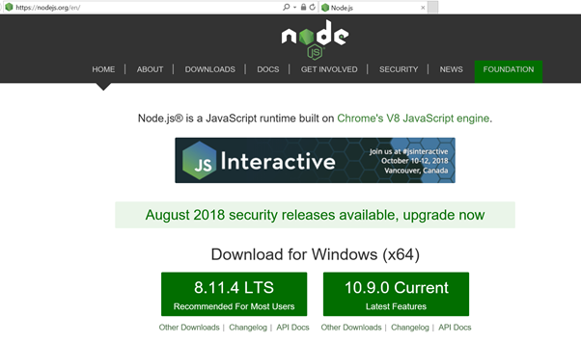

Run msi installer ‘node-v8.11.4-x64.msi’ and click next button with default options

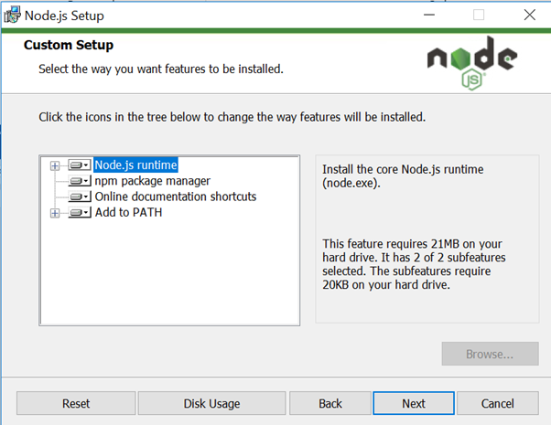

After successful installation you will get message ‘Node.js has been successfully installed’ as shown in below image.

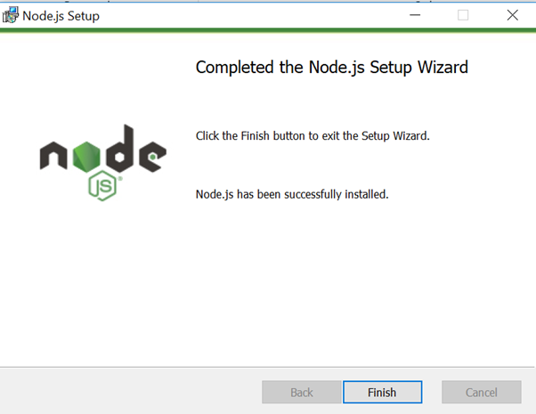

To test installation of node.js, open PowerShell and type node -v to check node.js version and npm – v to check npm version. If everything is OK then you will get version numbers as shown in below image.

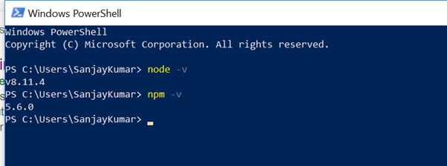

2. Install Visual studio code. Download code editor Visual studio code from below link:

<https://code.visualstudio.com/>

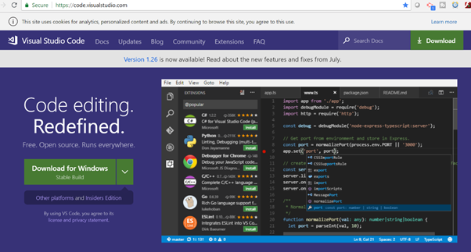

Run installer ‘VSCodeUserSetup-x64-1.26.0.exe’ and click next buttons with default options selected.

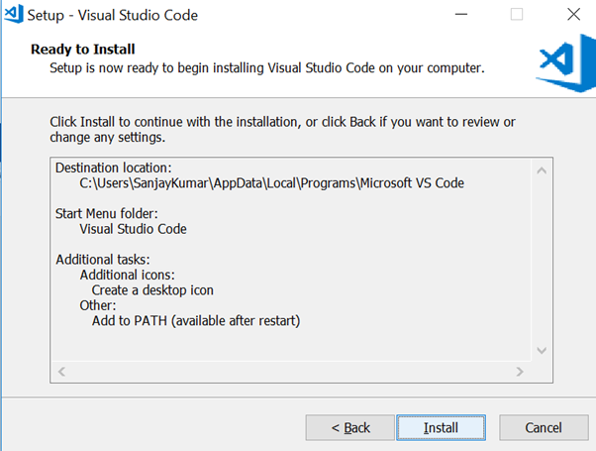

After installation you can launch Visual Studio Code to verify installation.

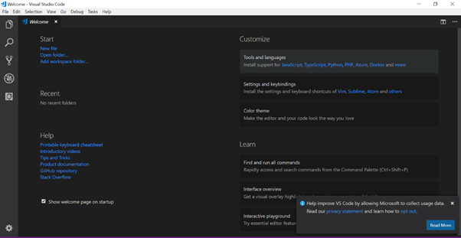

3. Install Yeoman and gulp

The Yeoman SharePoint web part generator helps you quickly create a SharePoint client-side solution project with the right toolchain and project structure.

First check npm packages installed in your machine:

***npm list -g –depth=0***

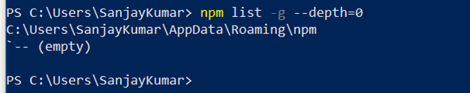

Enter the following command to install Yeoman and gulp:

***npm install -g yo gulp***

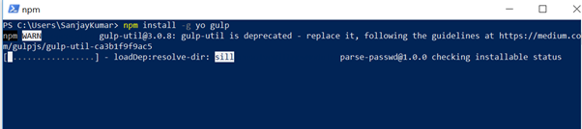

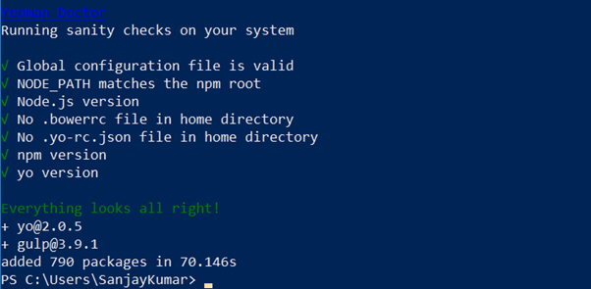

To install the SharePoint Framework Yeoman generator globally, enter the following command

***npm install -g @microsoft/generator-sharepoint***

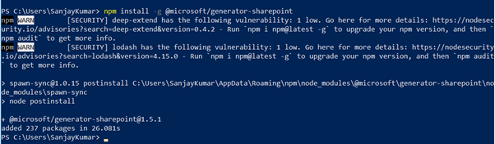

To start yoman template for SharePoint SPFx webpart type below command in PowerShell:

***yo @microsoft/sharepoint***

