**Custom web part property**

**Define property default value in onInit() function**

We have seen that we can define default values of properties in manifest.json file **WebPartPropertiesWebPart.manifest.json** inside **preconfiguredEntries** like:

"preconfiguredEntries": [{

    "groupId": "5c03119e-3074-46fd-976b-c60198311f70", // Other

    "group": { "default": "Other" },

    "title": { "default": "WebPartProperties" },

    "description": { "default": "WebPartProperties description" },

    "officeFabricIconFontName": "Page",

    "properties": {

      "description": "WebPartProperties",

      "myDropdown": "Red",

      "myMultiline":"My sample text",

      "myCheckbox": true,

      "myToggle":true

    }

  }]

There could be a scenario where you want to set default property value dynamically based on some condition inside the code. In this case we will use **onInit()** method of web part **WebPartPropertiesWebPart.ts**.

 protected onInit(): Promise<void> {

    this._environmentMessage = this._getEnvironmentMessage();

    this.properties.myMultiline = "My sample text from onInit";

    return super.onInit();

  }

This will override the default value mentioned in **manifest.json** file.

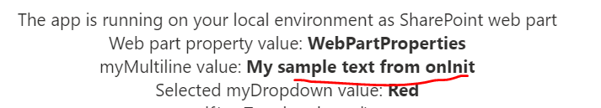

**Disable Reactive Changes**

If want to show **‘Apply’** button in property pane, so that property changes are applied only on the click of **‘Apply’** button then you can disable the reactive changes. To do this you have to define a reserved function just after the onInit() function inside the web part file **WebPartPropertiesWebPart.ts**

protected get disableReactivePropertyChanges(): boolean {

    return  true;

  }

Just return true to disable reactive property changes.

Now you can see the Apply button in property pane.

