# React component life cycle

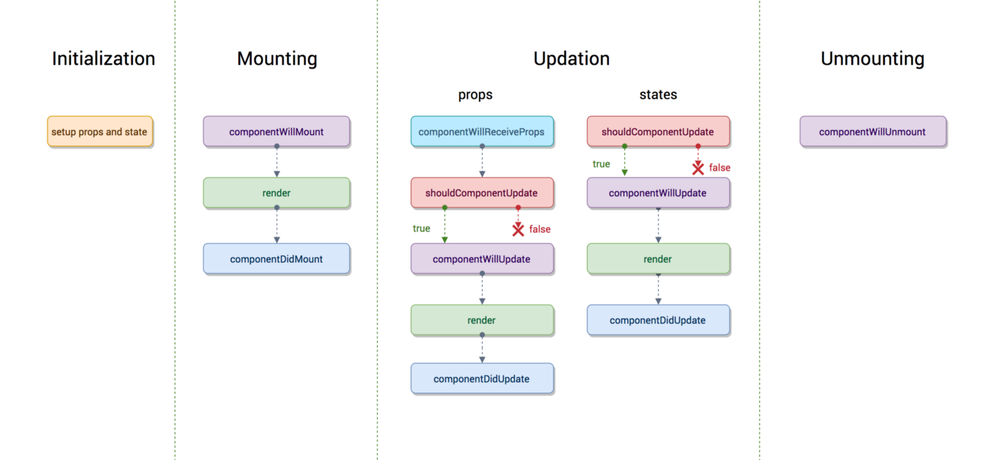

**constructor()**

This lifecycle method is the first one that is called and is usually where you will **set the state** of your component.

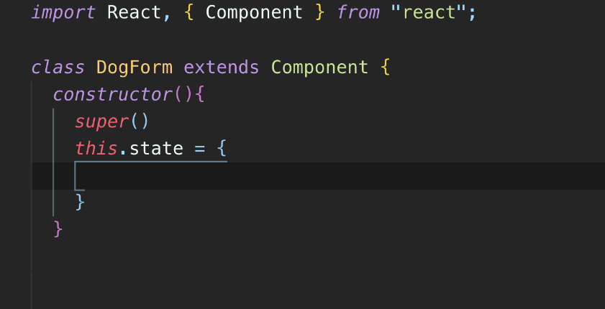

**render()**

This method is called after the constructor method has finished. It is the only lifecycle method required by React. This method is in charge of displaying HTML markup to the user. At this point in the component’s lifecycle, the component is mounted in the DOM.

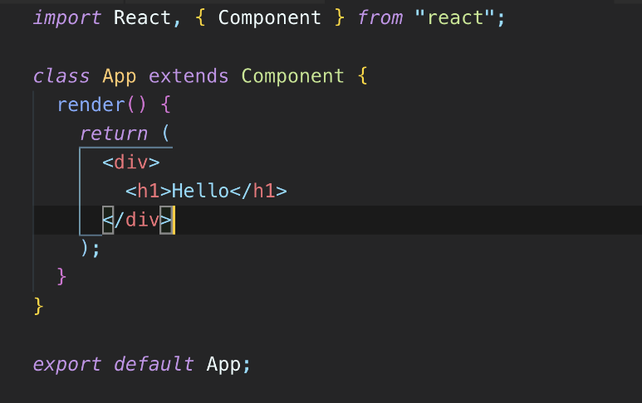

**ComponentDidMount()**

This method is available after the component has mounted. That is after the HTML from the render() has finished loading. It is called once in the component’s lifecycle and it signals that the component and all of its sub-component have rendered properly. One of the most common uses for this lifecycle method is to make API calls, because at this point the component has already mounted and is available to the DOM.

