Ben Goodwin

DS6371 HW 10

Question 1:

A)

R input:

#Question 1

#libraries

library(ggplot2)

#read data

birdDat <- read.csv("birdDat.csv")

head(birdDat)

#EDA the data

plot(birdDat$Mass,birdDat$Tcell)

#make da regression model

birdLm <- lm(Tcell~Mass,data = birdDat)

summary(birdLm)

plot(birdDat$Mass,birdDat$Tcell , ylim=c(0, 0.7), xlab="Mass", ylab="Tcell", main="Regression, CI, PI")

abline(birdLm, col="lightblue")

newx <- seq(3, 10, by=0.05)

conf_interval <- predict(birdLm, newdata=data.frame(Mass=newx), interval="confidence",

level = 0.99)

lines(newx, conf_interval[,2], col="blue", lty=2)

lines(newx, conf_interval[,3], col="blue", lty=2)

pred_interval <- predict(birdLm, newdata=data.frame(Mass=newx), interval="prediction",

level = 0.99)

lines(newx, pred_interval[,2], col="orange", lty=2)

lines(newx, pred_interval[,3], col="orange", lty=2)

R output:

99% CI plot:

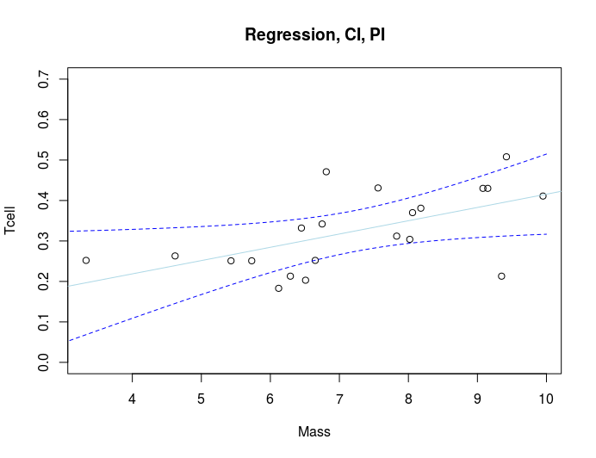

99% PI plot:

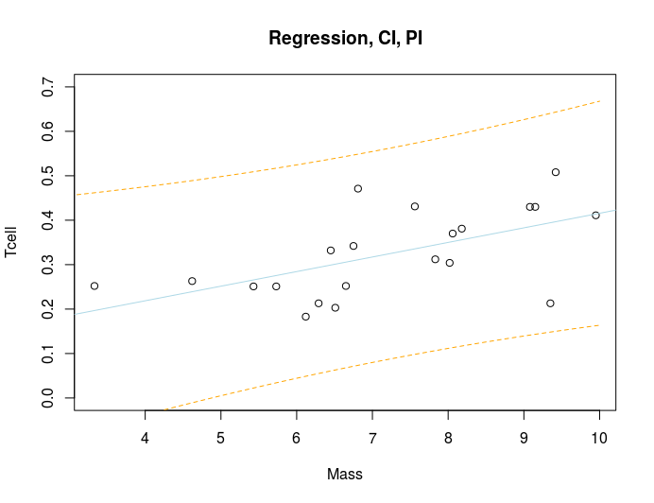

Combined Plot

B)

R input:

R output:

C)

|  |  |
| --- | --- |
| **Critical Values: = 2.539**  **Test Statistic: 1.112**  **Pvalue: 0.27996**  **Decision:** Fail to reject | **Conclusion:**  **There is insufficient evidence at the .01 significance level that the linear correlation coefficient/slope is different than 0 (p-value = 0.27996)** |

|  |  |
| --- | --- |
| **Critical Values: = 2.539**  **Test Statistic: 3.084**  **Pvalue: 0.00611**  **Decision:** Reject | **Conclusion:**  **There is sufficient evidence at the .01 significance level that the linear correlation coefficient/slope is different than 0 (p-value = 0.00611)** |

99% Confidence Interval:

Intercept: (-0.137591407,0.31258537)

Mass: (0.002376893,0.06326609)

R input:

R output:

R input:

R output:

D) State the regression equation:

E) Slope Interpretation:

Each one unit increase in mass results in a 0.03282 increase in the expected Tcell count.

F) Y-Intercept Interpretation:

The predicted Tcell count for a bird with 0 mass is 0.08750

G)

R input:

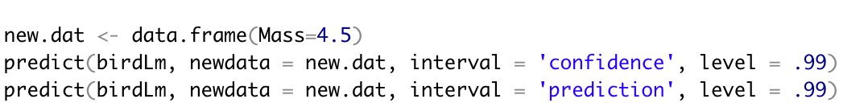

R output:



Interpretation:

Under repeated sampling, then about 99% of the intervals produce will capture the true mean Tcell count for a bird with 4.5kg of stones carried.

H) Prediction Interval

R input:



R output:



Interpretation:

Given the observed weights carried by birds, the Tcell count for a bird that carried 4.5kg will be between -0.01593192 and 0.4863193. In general, if we would repeat our sampling process infinitely, 99% of the such constructed prediction intervals would contain the new Tcell measurement.

I)

A



B



Part II

A

R Input



R output:



B

R Input



R Output



Part III

1. Interpret:

We are 99% confident that the estimated mass needed to obtain a mean Tcell count of 0.3 is between -4.389857 and 8.342649

1. Interpret”

We are 99% confident that the mass required for a Tcell count of 0.3 is between -17.968869 and 21.921661

J

R Input:

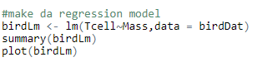

R output:

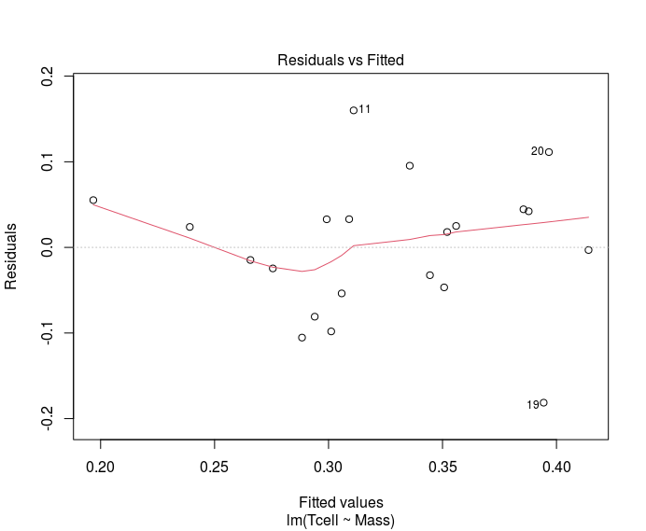

K

R input:

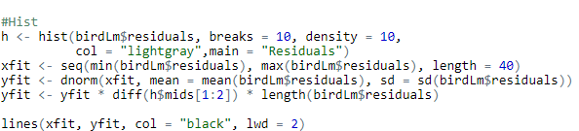

R output:

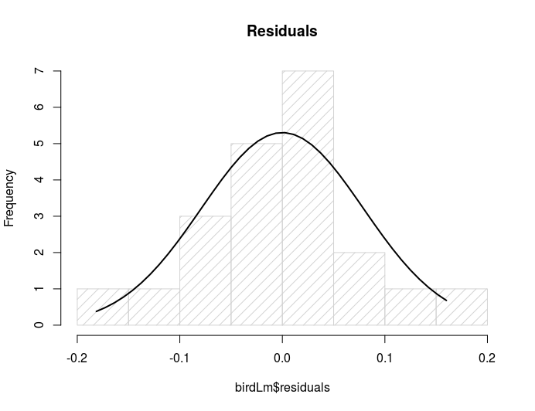

L

R input:

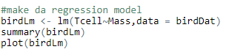

R output:

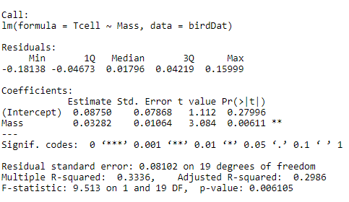

The regression model accounts for 33.36% of the variance.

Question 2

1. B_0:0.08750

B_1:0.03282

B)

|  |  |
| --- | --- |
| **Critical Values: = 2.539**  **Test Statistic: 1.163197**  **Pvalue: 0.259151**  **Decision:** Fail to reject | **Conclusion:**  **There is insufficient evidence at the .01 significance level that the linear correlation coefficient/slope is different than 0 (p-value = 0.259151)** |

|  |  |
| --- | --- |
| **Critical Values: = 2.539**  **Test Statistic: 3.177562**  **Pvalue: 0.004957**  **Decision:** Reject | **Conclusion:**  **There is sufficient evidence at the .01 significance level that the linear correlation coefficient/slope is different than 0 (p-value = 0.004957)** |