Ben Goodwin

MSDS6371-HW 2

Question 1

A)

B) 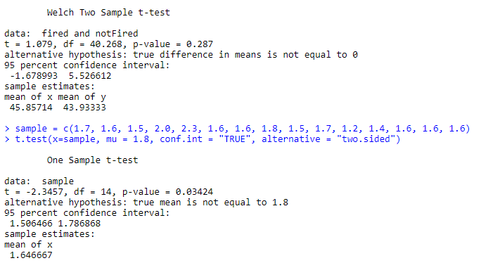

Question 2

1. Null hypothesis: H_0: Mu_fired = Mu_not_fired

Alternative hypothesis: H_A: Mu_fired =! Mu_not_fired

P-value: Very Very small (2.735e^(-08))

Statistical conclusion: Reject H_0 and conclude there is enough evidence to warrant further investigation into the suggestions that there is discrimination based on age. Since the subjects in this sample came from a random sample, we can draw inference on the population.

1. Step 1: H_0: Mu_fired = Mu_not_fired

Step 1: H_A: Mu_fired != Mu_not_fired

Step 2: TCV: +/- 2.01

Step 3: Test Statistic = 1.10

Step 4: P-value =0.28

Step 5: FTR H_0!

Step 6: Since we failed to reject the null hypothesis, there is not enough evidence to suggest that people who are fired and not fired are different based on age. Since the subjects in this sample came from a random sample, we can draw inference on the population.

1. The p-value from step B at alpha=0.05 is not considered significant, and the p-value from part A at alpha =0.05 is considered significant. I find this conclusion interesting and warrants further investigation.
2. A 95% CI for a difference in means: (-1.6,5.52). If we repeatedly sampled and computed confidence intervals, 95% of the intervals would contain the true population mean.
3. Pooled Standard deviation

The standard error of (x_bar_fired-x_bar_not_fired)

1. 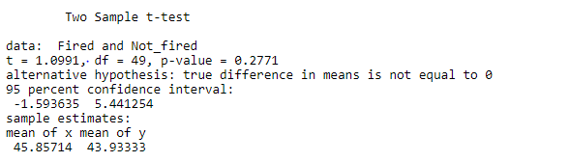

Question 3

* A) 1. H0: The mean amount of cash is the same between schools
* HA: The mean amount of cash differs between schools
* 2. n1=16,n2=14, sd1=304.2678,sd2=36.71931
* 3. Test statistic: 1.4945
* 4. P-value: 0.1551
* 5. Fail to reject the null
* 6. We don’t have enough evidence to say that the students carry different amounts of cash.
* Since random sampling was not employed, as students from business classes were sampled and cannot be generalized to entire populations, so a narrow scope. A 95% confidence interval: (-48.39481,277.644)

B) The p-values are roughly equal 0.1732 and 0.1551, and we can draw the same conclusion. This could have to do with the samples not being random and using different tests to reach the same conclusion.