Ben Goodwin

DS6371 HW 8

Question 1)

R output of Payroll and Wins

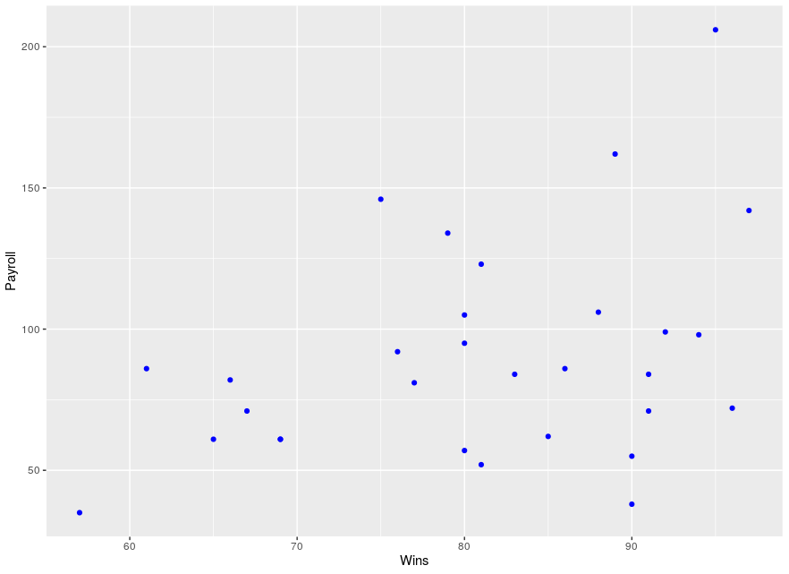

R input:

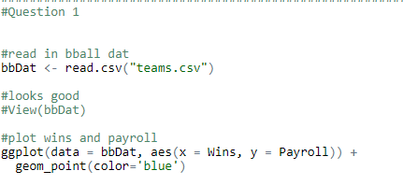

SAS input:

SAS output of Payroll and Wins

Interpretation: Based on the above plots visualizing the relationship between Wins and payroll, I expect to see positive correlation, although it is very weak, certainly less than 0.5. Why? There is visual evidence of positive correlation, as the data certainly has an observable trend to it. We can see that there appears to be a evidence of a weak linear relationship. I would imagine the correlation coefficient is around 0.2.

Question 2)

R input:

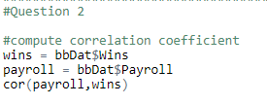

R output:



SAS input:

SAS output:

Based on the teams data the correlation coefficient as I calculated is 0.366. This shows that there is positive correlation and that there is evidence of a weak linear relationship.

Question 3)

R input:

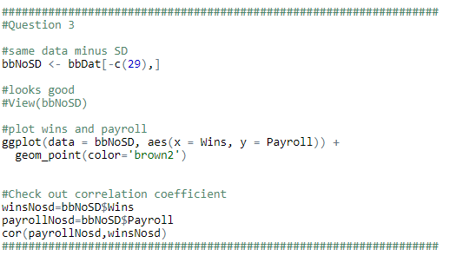

R output:

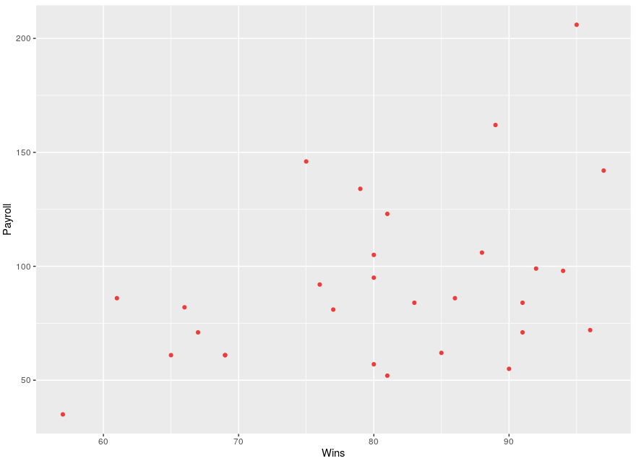



Interpretation: Since we removed one point, the plot did not change significantly. However, removing San Diego from the data changes the correlation coefficient by 0.06. This difference strengthens the correlation in the positive direction.

Question 4)

I think that the league commissioner is taking a single example and trying to generalize it to the broader population of NBA teams. There is also the argument of NYY who had the highest payroll and also the highest number of wins. Aside from Chicago most higher paying teams have more wins. I think more long term sampling is required to determine if this is statement can be backed by fact.

Question 5)

The population for this data are MLB teams. Interestingly there are 30 MLB teams, and the sample here includes all 30 teams. Here we have a rare opportunity where our population is the same as our sample. The population here are MLB teams, along with their wins, and payrolls. These data cannot be considered a random sample since it is the entire population, however, you could use a mechanism to randomly sample this population and draw inference on some other question of interest.