CS 7337 – Natural Language Processing

Final Exam

Ben Goodwin

April, 2022

Instructions: Clarity of answers is more important than length of answers. Although not required (unless indicated otherwise), feel free to use graphs, charts, visuals, et al in your answers if you feel these artifacts can help support your answers. There are no bonus points for using these artifacts. Submit your answers in PDF or Word document format.

Due date: See course wall announcement.

Q1.

1. [5 pts] What is Distributional Hypothesis in the context of distributional semantics? Give a short explanation with some examples.

The main point of this hypothesis states that there is a correlation between distributional similarity and meaning similarity, which allows utilizing the former to estimate the latter. Furthermore, distributional approaches to meaning acquisition utilize distributional properties of linguistic entities as the building blocks of semantics. A simpler definition of the distributional hypothesis states, “words which are similar in meaning occur in similar contexts.” The general idea behind this hypothesis states that there is a correlation between distributional similarity and meaning similarity.

*“a word is characterized by the company it keeps”* – John Rupert Firth

NLP use cases: Semantic similarity, word clustering, sentiment analysis, document clustering

Examples:

If we want to find a word like *magazine,* we can look for words that occur in similar contexts, such as *newspaper*.

“I was reading a *magazine today”* and “I was reading a *newspaper* today”

“The *magazine* published an article” and “The *newspaper* published an article”

“He buys the *magazine* every day” and “He buys the *newspaper* every day”

If we want to find a word like *duty*, we can look for words that occur in similar contexts, such as *responsibility*.

“His *duty* is to serve the nation” and “His responsibility is to serve the nation”

“I have a *duty* to stop the criminal” and “I have a *responsibility* to stop the criminal”

1. [5 pts] Latent Semantic Analysis (LSA) and Latent Dirichlet Allocation (LDA) are two widely used techniques for topic modeling. Give a short overview of the two approaches and any similarities/differences between them.

Latent Semantic Analysis (LSA):

Supports organic topic modeling.

LSA-based topic modeling tries to find groups of words associated with the largest variances between documents in the corpus.

It answers the question, “What small groups of words, when found in documents, predict those documents from being very different overall from the rest of the corpus”?

Dimensionality reduction will get us from a board vocabulary into a smaller number of groups with a smaller number of words in each group that do the best job of differentiating some of the documents in the corpus to other documents in the corpus.

Tries to separate the corpus by means of topic words.

LSA starts with a large term document matrix, but then it creates a topic-to-topic matrix. Leaves most words behind, reduces the words in the vocabulary and chooses ones that to a good job separating documents.

Latent Dirichlet Allocation (LDA):

Intuitively, LDA construes topics as groups of words that have high co-occurrences among different documents in the corpus.

Different topics can share keywords when those keywords co-occur frequently enough across the different topics.

LDA uses a probability distribution of how likely it is that a word is in a topic and that a topic is assigned to a document.

LDA keeps on moving words into different topics, and reassigning topics to documents in a different way until its maximized the values.

LDA Process:

1. For every word *k* in every document *d*, compute:

P(z|d) = proportion of words in document *d*, assigned topic *z*

P(k|z) = proportion of assignments to topic *z* among all docs having word *k*

2. Now reassign word *k* in document *d* to whatever topic the highest *P*(*z*|*d*) x *P*(*k*|*z*) from all topics that you can substitute for *k*.

Now repeat these steps over and over.

Similarities/Differences:

In LSA the question of “what small groups of words when found in documents, predict those documents being very different overall from the rest of the corpus” becomes unlikely that any of the topics will share keywords, compared to what LDA would produce, LDA can overlap, LSA is wired to find these separations. (If keywords occur across multiple topics)

LDA like LSA it sort of discovers what the topics are that are latent.

Primary difference between LSA and LDA is that LSA uses a topic-by-topic matrix, which looks at how often a topic occurs on the same document as another topic, LSA tries to avoid sharing of document topics. LDA instead looks at probability distributions, and asks, what is the probability of a word being assigned to a certain topic, and the then document distribution over the topic. Probability of a topic being assigned to a particular document.

Q2.

* 1. [5 pts] You are a Data Scientist for an e-commerce site for electronics which also supports 3rd party sellers. You would like to build a system to find and match the same products that sellers on your website sell so that you can present them in a single product page. You decide to use product titles to compute product similarity. Which similarity metric, Jaccard or Cosine, would you use and why?

Jaccard similarity is good for cases where duplication does not matter, and cosine similarity is good for cases where duplication matters while analyzing text similarity.

I would use Jaccard similarity for the reasons above, furthermore as an example:

“LED TV HD TV blu-ray TV” will have the exact same Jaccard similarity as “LED TV HD blu-ray” which would not be the case for cosine similarity.

In the context of this problem a more desirable result for presenting results on a single product page is via Jaccard.

* 1. Consider the following table which lists electronic items for sale on two ecommerce shopping websites. Products in row -1 are the same product, row-2 are different TV models of the same brand and row-3 are different products.

|  |  |
| --- | --- |
| Product Title 1 (Site 1) | Product Title 2 (Site 2) |
| 50 Inch Class H6570G 4K Ultra HD  Android Smart TV with Alexa  Compatibility 2.5” 2020 Model Black  Silver White HDR LED | Hisense H6570G |
| QN75Q90TAFXZA crystal 2.5” Quantum  LCD | Samsung crystal UN55TU8000FXZA QLED |
| EGLF2 50 Ultra Full Motion Articulating  TV Wall Mount Bracket swivel full | VIZIO EGLF2 |

[10 pts] Considering your answer to 2a) will your similarity calculation approach work on this dataset? Explain with examples.

The approach I took was to use the Jaccard similarity because in the context of the written problem, we needed to have multiple potentially duplicate products return after running a search query, and in this case the solution seemed to be Jaccard similarity.

My thoughts were that the Jaccard similarity would perform well on the first and third row, and not as well on the second.

Row 1: Where we have the same product, because Jaccard can handle the case where we have duplication. In this row we have “H6570G” appearing in both cells, so Jaccard will work here.

Row 2: Different TV models of the same brand, between the two cells, we have a single intersecting word, “crystal” and other than that the cells are completely different. Jaccard will have trouble here.

Row 3: Different products all together. There is only one intersecting word here, “EGLF2” and this concerns a completely different product than the one referenced, one is a clearly defined TV mount whereas the other cell seems to refer to something completely different or similar, we aren’t sure due to the lack of information. Again, Jaccard falters here.

To support my reasoning and answers I inputted each of the product descriptions into a Jupyter notebook and computed both the Jaccard distance and the Jaccard similarity.

In the code block below, I computed the Jaccard Similarity

[10 pts] Suppose that you are given IDF scores for all tokens (see Table below). Can this help you come up with a better approach for computing title similarity? Explain with examples.

|  |  |
| --- | --- |
| Product Title 1 (Site 1) | Product Title 2 (Site 2) |
| 50(6.3) Inch(8) Class(8.5) H6570G(10.2)  4K(9.4) Ultra(6.6) HD(5.7) Android(2.6)  Smart(6.1) TV(3.9) with(4) Alexa(6.9)  Compatibility(15.6) 2.5”(5.7) 2020(6.8)  Model(12.6) Black(6.8) Silver(7.8)  White(12.6) HDR(12.2) LED (6.9) | Hisense(9.5) H6570G(10.2) |
| QN75Q90TAFXZA(13.7) crystal(11.3)  2.5”(5.7) Quantum(7.8) LCD(6.8) | Samsung(8) crystal(11.3)  UN55TU8000FXZA(16.5)  QLED(4) |
| EGLF2(15.6) 50(6.3) Ultra(6.6) Full(5.6)  Motion(6.7) Articulating(2.6) TV(3.7) Wall(8.5) Mount(9.5) Bracket(11)  swivel (8.5) full (5.6) | VIZIO(10) EGLF2(15.6) |

Inverse document frequency looks at how common (or uncommon) a word is amongst the corpus. IDF is calculated as follows where *t* is the term (word) we are looking to measure the commonness of and *N* is the number of documents (d) in the corpus (D). The denominator is simply the number of documents in which the term, *t*, appears in:



There are a few approaches here for computing title similarity bow that we have IDF scores for all the tokens:

We can compute the cosine similarity matrix which contains the pairwise cosine similarity score for every pair of sentences (vectorized using tf-idf)

Since this is a task somewhat akin to a search engine task, we could use these idf scores to rank these results based on relevance, with results which are more relevant to the user having higher idf scores.

Idf will also help with distinguishing relevant and non-relevant terms, hence the *inverse document frequency* incorporates the weight of terms that occur very frequently in the document set.

Q3.

1. [10 pts] Recommender systems are a subtype of information filtering systems that help users discover new and relevant items by presenting items similar to their previous interactions or preferences. Some famous examples of recommender systems are Amazon’s “Books you may like” and Netflix’s “Because you watched” carousels.

You are building a recommender system for your food delivery service startup and have data on co-purchases for food items f1, f2, . . ., fn (for example, food item f1 is commonly bought together with food item f4). How can you use techniques such as Word2Vec to recommend similar items to users who may have bought or show interest in any one of the items?

1. [10 pts] Word2Vec implements two different neural models: skip-gram and continuous bag of words (CBOW). Briefly explain the differences between the two models. Under which circumstances would you prefer the skip-gram model over CBOW?

Q4.

You are building a product classification system for an online electronics store. The system should classify an incoming stream of millions of products to one of the 3000+ leaf level product types in the taxonomy such as laptops, smart TVs, wireless headphones, car speakers, among others. The system should be very precise because it’s important to assign products to the right category to facilitate the customer shopping experience. Each instance in your dataset has product title, description and image fields. See example below:

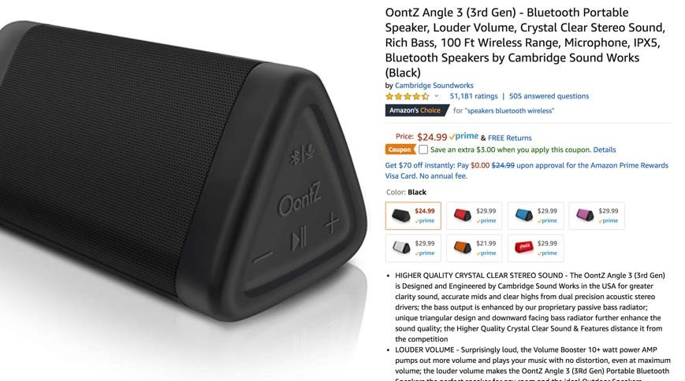

1. [5 pts] What features would you use for your machine learning-based classifier?

1. [5 pts] Assume that you only have access to product titles in your dataset (i.e., you have less data to play with) instead of product titles, description and images. How will this affect feature engineering and the NLP pipeline for your classifier?

1. [10 pts] Obtaining training data is paramount for a large-scale classification system. You have a limited budget and can’t hire an army of analysts to manually label every single instance. Discuss some strategies for obtaining training data for the classifier.

1. [5 pts] How would you handle products that are misclassified?

Q5.

1. [10 pts] Sentiment analysis: consider the following review of a restaurant:

*“I took my father out for dinner to Le Bistro on New Year’s Eve. The décor and service were fantastic. We enjoyed the food, especially their French countryside specials and their Chardonnay collections. However, my father thought the menu prices were a bit on the high side. Valet parking was also expensive. Overall, we definitely recommend Le Bistro for special occasions!”*

*Overall rating: 8 stars out of 10*

*“*

Identify the opinion object(s), feature(s), opinion(s), opinion holder(s) and opinion time in this review.

1. [10 pts] Design a sentiment analysis system for restaurant reviews (see example in 5a). Your answer should make use of the techniques discussed in class. The output of the system should assign a sentiment label of Positive or Negative to reviews.