6985 Professional Design Patterns in VB.NET
Chapter 2: Design Patterns in the Data Tier
About the NWDSA Data Access Application

Contents
First Iteration
Second Iteration
Creating the Second Iteration
Getting and Installing SQLXML 3.0
Notes on the Second Iteration

First Iteration
The first iteration of the data access layer app, NWDSA, supports access via three different data providers:

- .NET Data Provider for SQL Server (SqlClient)
- .NET Data Provider for OLE DB (OleDb)
- .NET Data Provider for ODBC (Odbc)

It also supports data output in two formats:

- DataReader
- DataSet

See the figure on page 83. To use the application, the developer can choose the data provider at design time, and the output type at runtime.

Second Iteration
The second iteration of the app is a direct extension of the first, using the same principles. It supports four data providers:

- .NET Data Provider for SQL Server (SqlClient)
- .NET Data Provider for OLE DB (OleDb)
- .NET Data Provider for ODBC (Odbc)
- SQLXML 3.0 (this is not technically a "data provider" in the same way as the others, but we can think of it as such)

And it supports output in six formats:

- DataReader
- DataSet
- XmlDocument
- XmlReader
- Scalar (Integer, String, etc)
- NonQuery (returns an integer indicating the number of affected records)

Creating the Second Iteration
In the second iteration, the existing code (from the first iteration) is unchanged; we simply:

- Add 4 new abstract output classes
- Add 1 new concrete factory
- Add extra support code required in three existing concrete factories
- Add another 18 concrete output classes to the existing 6 to make 24

In addition, the second iteration of NWDSA makes use of the managed classes provided by SQLXML 3.0 (in the Microsoft.Data.SqlXml class), the server employing the NWDSA application should have SQLXML 3.0 installed. We'll talk about that next.

Getting and Installing SQLXML 3.0
SQLXML 3.0 includes the SQLXML managed classes and other features, including updategrams, XML template queries, and SOAP support. These examples rely only on the SQLXML managed classes contained in the Microsoft.Data.SqlXml namespace.

Since NWDSA relies only on the SQLXML managed classes, installation and configuration of SQLXML 3.0 (for the purpose of NWDSA) is rather simple:

- Download the SQLXML 3.0 self-extracting executable from Microsoft's web site (at the time of writing, you can get it from http://msdn.microsoft.com/downloads/sample.asp?url=/msdn-files/027/001/824/msdncompositedoc.xml.
- Execute the downloaded file, sqlxml.exe. The Setup Wizard will start:

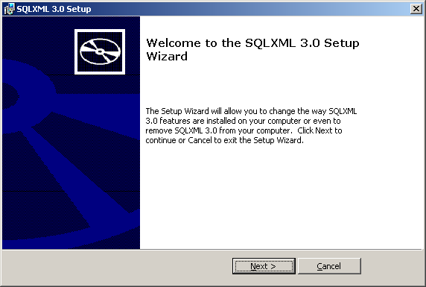

- If you select the default installation (recommended), you’ll see this Wizard page:

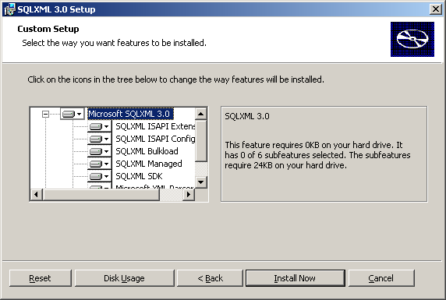

- Press the Install Now button; everything should install smoothly. If it does, you'll see the following:

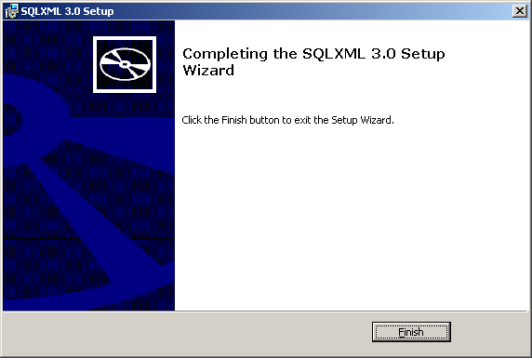

The NWDSA (second iteration) code already contains a reference to SQLXML 3.0.

A recent article on using VB.NET and SQLXML 3.0 including HTTP support for SQL 2000 queries can be found at http://msdn.microsoft.com/library/en-us/dnsql2k/html/sql_ProjandTasksSample.asp.

Notes on the Second Iteration
The version currently available (released August 19, 2002) is almost complete. It does, at least, demonstrate the point of the exercise, in that the developer chooses from one of four data providers at design time, and can then use it to generate data in any of the six output formats at runtime. Here's a screenshot of the interface that you'll see when you run the Windows test application – with one button and one output area for each output format:

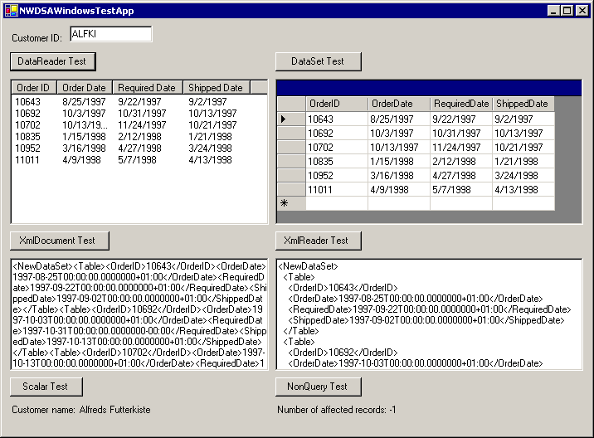

There are three outstanding issues with the second iteration of NWDSA at present:

- The SQLXML concrete factory class does not have an implementation for returning data in DataReader format. The challenge here is to populate a DataReader with XML-based results generated by the SQLXML query. As far as we know, there is no good clean method for taking XML results and using them to fill a DataReader.
If you have suggestions, please let us know – by contacting Wrox Press at feedback@wrox.com or John Slater at john_slater@intuit.com or jr_slater@hotmail com.
- The .NET concrete factories' implementations for returning an XmlReader are hampered by a problem streaming the data from a DataSet object into the XmlReader. The data will not stream cleanly; so, as a temporary workaround, it is being streamed first into an XML file, and from the file into the XmlReader. We're working on understanding the reason for this. Again, suggestions are welcome.
- Opening and closing of connections is not as clean as it might be. This is less important in the context of the example – because the main purpose of the example is to demonstrate the structure and extensibility of the Abstract Factory design pattern. However, the connection issue would (of course) need cleaning up if we were building for a production environment.

Last update: 19 August 2002

