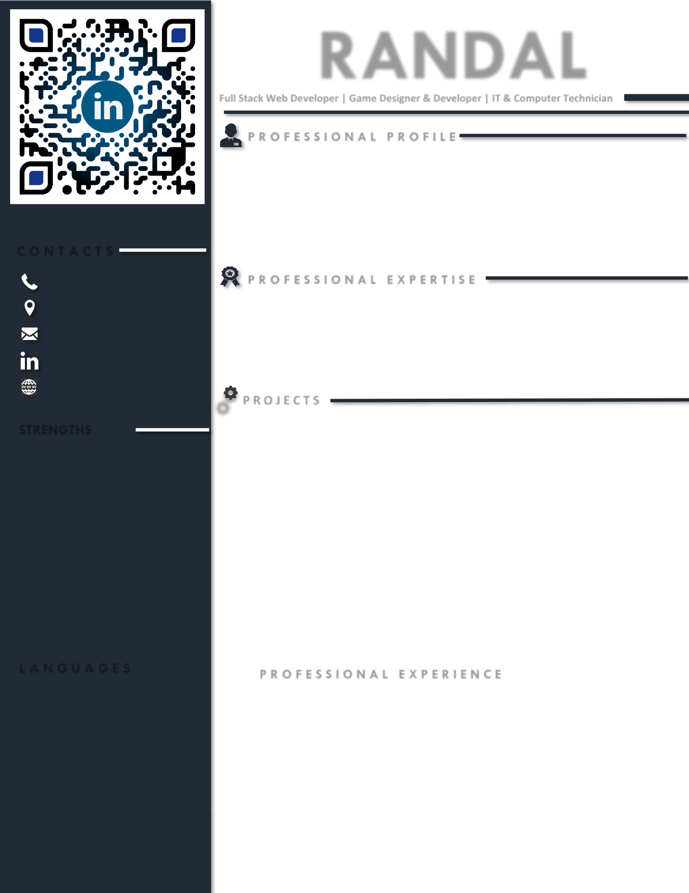**RANDAL**

**Full Stack Web Developer | Game Designer & Developer | IT & Computer Technician**

**PROFESSIONAL PROFILE**

|  |  |  |
| --- | --- | --- |
|  | A dedicated, result-oriented, & reputable **Full Stack Web Developer** and **Game Designer & Developer** with |  |
|  | extensive practical experience of **+5** years in the field of Web Development, Information technology, and |  |
|  | Sales & Retails. With strong expertise in Web Designing & Development, Logical Design, Project Management, |  |
|  | Project Deployment, Project Execution, Requirement Gathering, Internal Network Security, IDEs & Tools for |  |
|  | Developments & Designing, Sales & Retails, and Programming (C++, C#, Typescript, Java, JavaScript, & |  |
|  | Python). An impressive communicator with outstanding writing and verbal skills. Currently working as a **Field** |  |
|  | **Technician and Computer Technician** at **Swift River Environmental Services** . Having career objective to |  |
|  | be a **Full Stack Web Developer** to work in a creative & innovative environment; acquiring a challenging |  |
| **CONTACTS** | position in a reputable & growth-oriented organization that provide constant personal development. |  |
|  |  |

+1 720 331 9724

Littleton, CO 80122, United States

Egan.randal@gmail.com

in/randal-egan

Randalegan.com

**STRENGTHS**

* Adaptability
* Problem Solving
* Organizational
* Analytical Skills
* Well Communication
* Intuitive Leader
* Teamwork
* Critical Thinking
* Flexibility
* Time Management
* Hard Worker
* Management Skills
* Administration Skills

**PROFESSIONAL EXPERTISE**

|  |  |  |  |  |  |
| --- | --- | --- | --- | --- | --- |
| • | Web Designing | • | GIT/Github | • | Testing |
| • | Web Development | • React, Express, & Node | | • | Documentation |
| • | Algorithm Design | • | Redux, Context | • | CSS |
| • | Project Management | • | APIs | • | SQL |
| • | Project Deployment | • | Java Script | • | Typescript |
| • | C++ & C# | • | Java & Python | • | MySQL |

 **PROJECTS**

**EXPRESS GROOMER Full Stack Developer Responsibilities & Achievements:**

* Successfully served as **Full Stack Developer**.
* Successfully utilized the skills such as Full Stack React, JavaScript, Ant Design, Node, Express, and Postgress.
* Responsible for the architectural design, user flow, and frontend & backend development.
* Our app brings clients and groomers together in one seamless platform.

**SECRET FAMILY RECIPES Backend Developer Responsibilities & Achievements:**

* Successfully served as **Full Stack Developer** and team of 5 developed application to store food recipes.
* Utilized the skills such as Full Stack React, JavaScript, Ant Design, Node, Express, and Postgres.
* Oversaw front end development.
* Designed and implemented a RESTful backend using Express.

**LANGUAGES** 

* **ENGLISH** (Fluent)

**PROFESSIONAL EXPERIENCE** 

**FIELD TECHNICIAN & COMPUTER TECHNICIAN** **4/2018 – Present**

**Swift River Environmental Services** **Littleton, CO 80120**

**Responsibilities & Achievements:**

* Assist in gathering samples of groundwater from landfill monitoring wells.
* Assist in gathering measurements of gas levels from landfill monitoring wells.
* Responsible for ensuring samples are filled according to specifications put in place.
* Responsible for ensuring samples are delivered intact.
* Responsible for putting reports together once groundwater lab data is sent from the lab.
* Responsible for computer management, some security of the internal network and maintaining user profiles on work computers.
* Responsible for identifying & troubleshooting problems, maintaining hardware & software, resolving network, and connectivity issues.