EECE5644 Exam 3

Ben Gowaski

6/8/2019

**Question 1:**

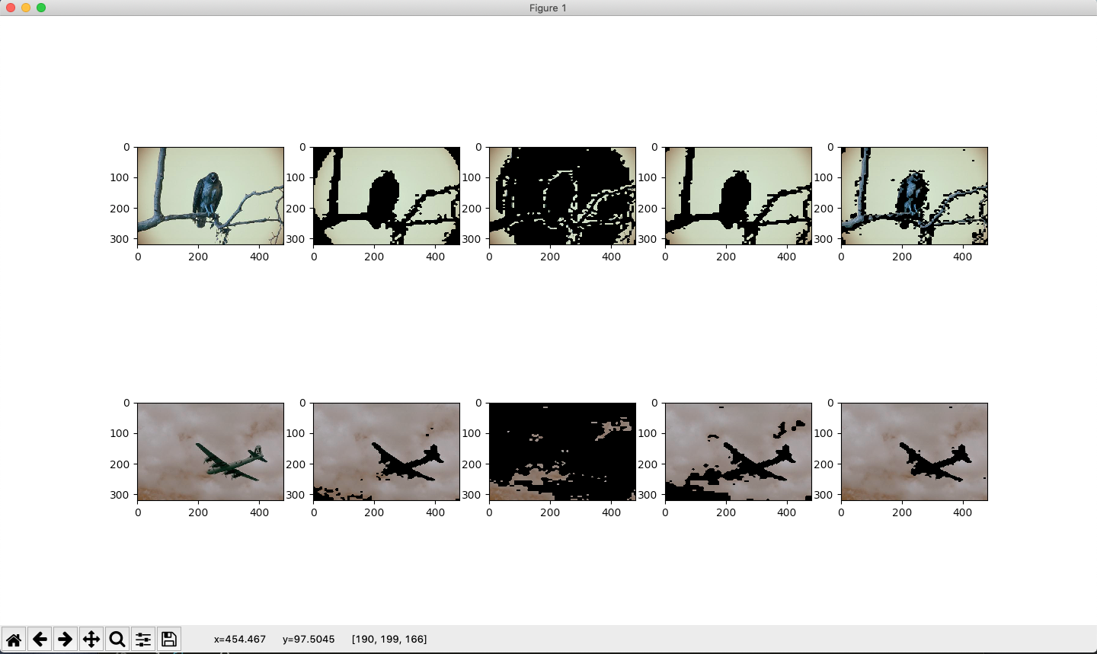

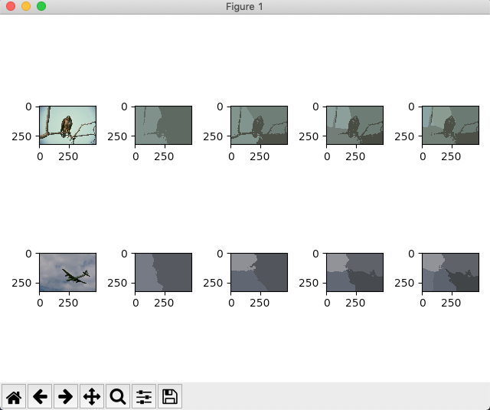**Output from Kmeans and GMM for K = 0 (none/original image),2,3,4,5, respectively:**

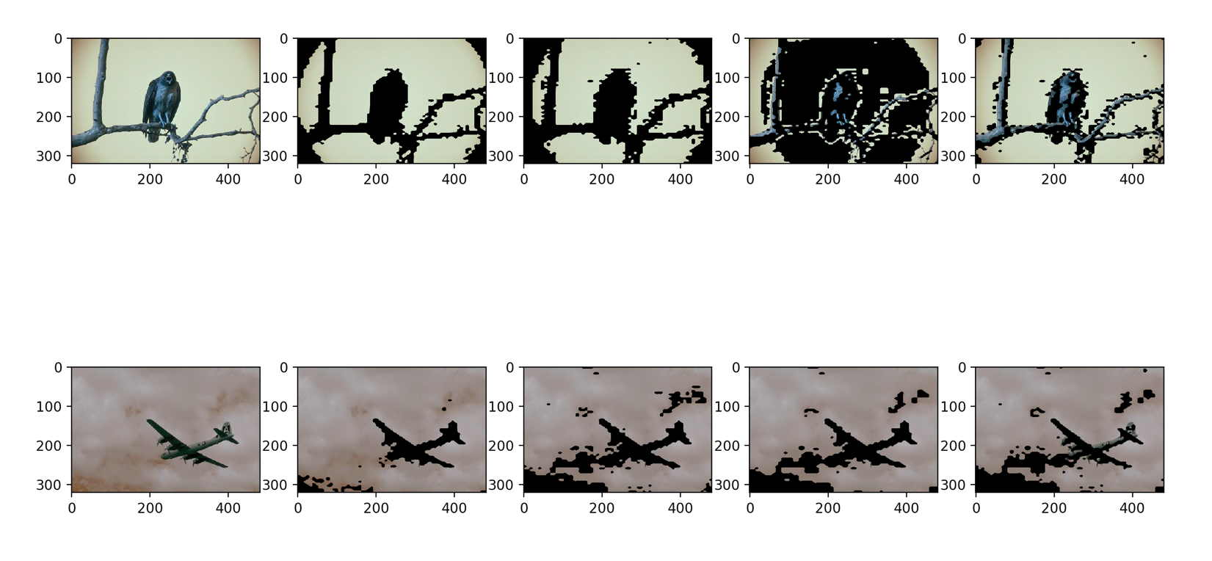

**Question 1 Continued:**

As we can see with the K-means images, as we increase iterations (from left to right) we see that the clustering adjusts, and the algorithm is revising itself. Revising the distances of points to clusters is set by a “Hard Assignment” around the centroid locations. Therefore, as more iterations happen, this optimizes the hard assignments, but can also lead to overlapping or misjudged groupings causing some difficulties with results, especially with color images opposed to grayscale (only color used in above examples).

For the GMM models we use “soft assignment” which reduces the uncertainty of the assignment if we are unsure about it. The airplane example is great for this as we can see above versus the k-means results. The EM algorithm helps us with reducing this uncertainty of where to place values.

**Question 2:**

**Resulting Plot/Chart**

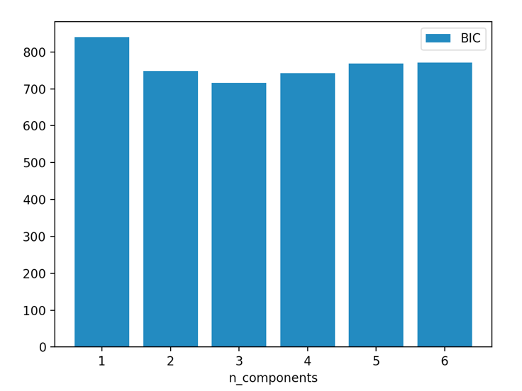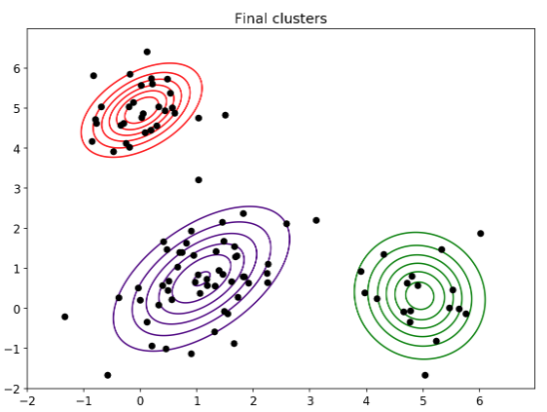

**Did BIC frequently select thecorrect number of Gaussians (which is 3 in this case)? Why did the errors in BIC model order selection happen, considering your particular GMM that generated your data samples? Could it have been the EM algorithm not finding the global maximum in some of the cases? In the cases where the BIC resulted in an incorrect model order selection, could you visually appreciate the reason for why that could have been the case (based on the data/contour plots you provide)?**

We prefer the model with the lowest BIC, thus resulting with K = 3 as displayed in the bar chart above. Errors occur in BIC because there is a stronger inherent penalty for the number of parameters introduced. Since we chose a large enough parameter set, we can see this displayed in the above. With larger samples, BIC is less likely to choose too big of a model, but it can choose too small of a model, which in this case we can point the fault at the EM algorithm for not finding the global maximum in which BIC would not be able to then find the largest model. Also, if there are too many samples, the EM, or using a different GMM covariance type, we can incorrectly group the parameters resulting in very different BIC outcomes. Based on the definition of delta BIC = BICm – BIC* we can see that the difference between K = 3 and the other models to be large and therefore confirming that K = 3 would be the right model.