EECE564 Intro to ML

Exam 4

Ben Gowaski

06/15/19

**Question 1:**

SVM Decision Boundary:

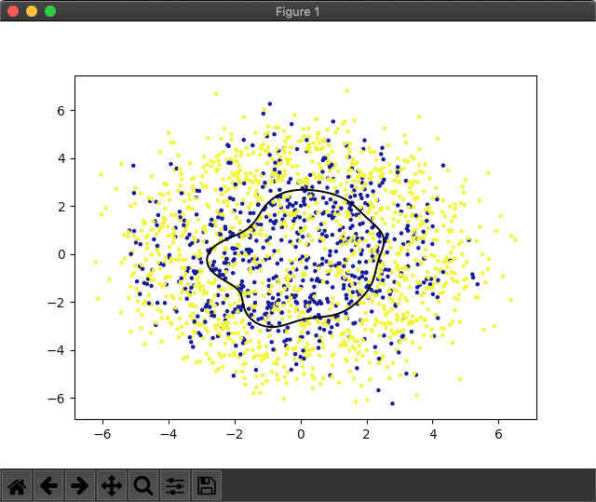

MLP Estimated Loss Plot:

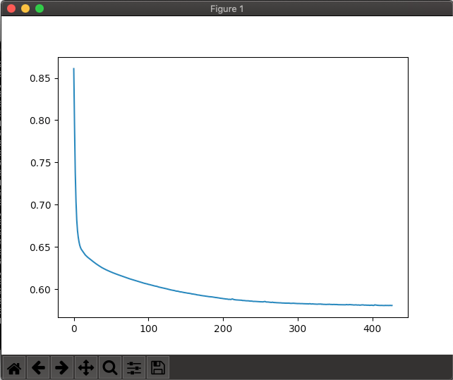

SVM SCORES for K = 1 through 10

[0.6853932584269663, 0.6834170854271356, 0.6464646464646465, 0.6808510638297872, 0.7038834951456311, 0.7351598173515982, 0.6768558951965066, 0.68, 0.6666666666666666, 0.6994535519125683]

MLP SCORES for K = 1 through 10

[0.6629213483146067, 0.7085427135678392, 0.6464646464646465, 0.6968085106382979, 0.6990291262135923, 0.7625570776255708, 0.6855895196506551, 0.66, 0.6565656565656566, 0.6939890710382514]

We can see that the scores for both are very similar. This is very convincing for the training data output used to classify the input/test data with minimum probability of classification error. If the two outputs were very different then we could not be confident in these results.

**Question 2:**

Estimated Test Performance:

Logistic Softplus

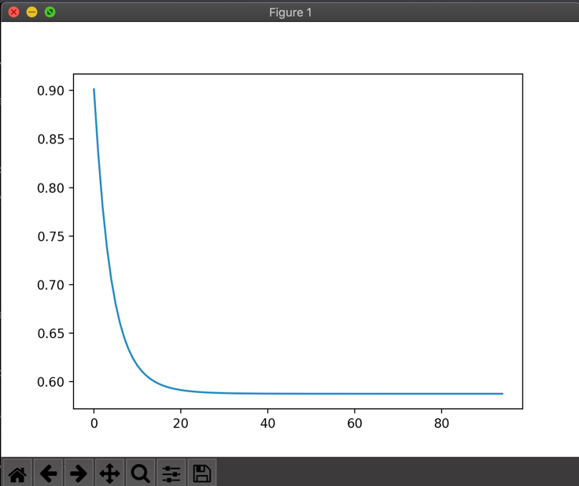

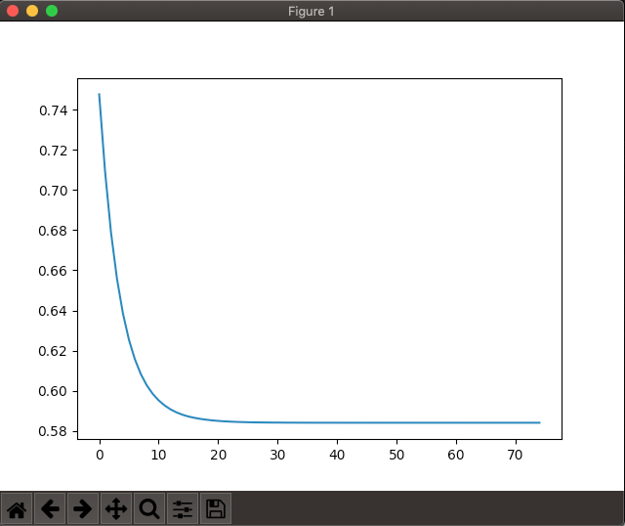

MLP SCORES

[0.7160037002775208, 0.7292817679558011, 0.7296058661778185, 0.7234814143245694, 0.7287822878228782, 0.7302867383512545, 0.731433506044905, 0.719634703196347, 0.7205479452054795, 0.7456382001836547]

MLP SOFT SCORES

[0.7160037002775208, 0.7292817679558011, 0.7296058661778185, 0.7234814143245694, 0.7287822878228782, 0.7302867383512545, 0.731433506044905, 0.719634703196347, 0.7205479452054795, 0.7456382001836547]

We can see near identical results from the logistic and softplus nonlinearities for the perceptrons using 10-fold cross-validation. We can see a steady increase in estimation from K=1 through K = 10 which is very convincing for supporting the results of the input data.