Introduction
This document records some decisions and assumptions about how our software handles rsync URIS. Specifications are given, where appropriate.

The software diagram is from Andrew Chi’s “Resource Public Key Infrastructure Denial of Service Assessment”.

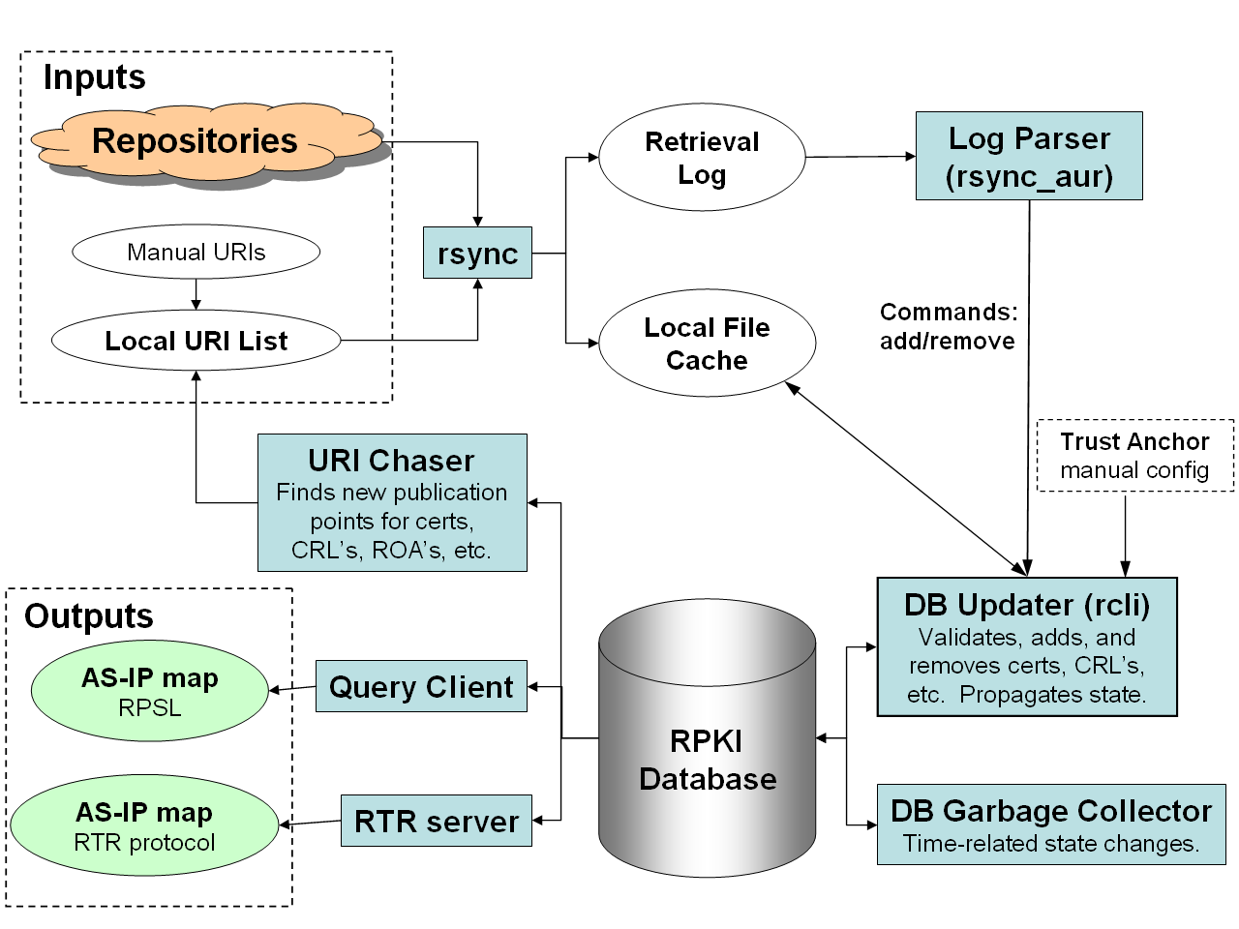

Potential URI issues
This section list things we may want to handle specially, along with how to handle them, and why.

Later sections show where in the code we handle the issue. These sections correspond to the software diagram, above. In some cases, the same issue may be handled in multiple locations. This is partly because we receive URIs from multiple sources and may intake them at different points in the software.

URI path contains “/..” segment.
This is allowed, but discouraged by RFC 3986, section 5.

RFC 3986, section 5.2.4 contains pseudocode to normalize the URI. However, it does not handle the case for which there are enough “/..” segments to walk out of the path entirely. (An alternate understanding is that it allows this). In this case, we drop the URI. In other cases, we follow the pseudocode to normalize the path, which allows us to more completely determine which URIs subsume others. Either way, we warn the user that a change has been made.

URI path contains “/.” segment.
This is allowed, but discouraged by RFC 3986, section 5.

We follow the pseudocode in RFC 3986 section 5.2.4 to normalize the path, which allows us to more completely determine which URIs subsume others. We warn the user that a change has been made.

URI contains “//” in the path.
This appears to be implicitly allowed by RFC 3986, in general. I did not see it explicitly mentioned, but I think it is treated as an empty path segment.

We collapse “//” to “/” in the path and warn that a change has been made.

URI (ends | does not end) with ‘/’
We disregard any trailing slash when we check whether one URI subsumes another.

Consider this URI:
rsync://www.example.com/path1/path2/filename.ext
We consider ‘path1’ to be the module name. If that is the last portion of the URI, then we include the trailing slash in the SRC argument to rsync. Otherwise, we do not include the trailing slash.

Related:
rsync://www.example.com/
without any path segment, and with or without a trailing slash, appears to be allowed by specifications, but does not work with rsync. So, we reject these.

URI contains ‘?’ or ‘#’
This is disallowed by the combination of RFC 5781 and RFC 3986. Drop the URI and warn the user.

From RFC 5781 section 2:
The rsync URI follows the general syntax from RFC 3986 and is defined
by the following ABNF [RFC5234]:

rsyncuri = "rsync:" hier-part
; See RFC 3986 for the definition
; of hier-part
From RFC 3986 section 3:
The generic URI syntax consists of a hierarchical sequence of
components referred to as the scheme, authority, path, query, and
fragment.

URI = scheme ":" hier-part [ "?" query ] [ "#" fragment ]

URI contains non-URI character
Allowable characters are defined by RFC 3986. We drop the URI and warn the user.

The characters that are allowed in a URI can be deduced from these three references, as follows:
From RFC 3986 section 2
A URI is composed from a limited set of characters consisting of
digits, letters, and a few graphic symbols. A reserved subset of
those characters may be used to delimit syntax components within a
URI while the remaining characters, including both the unreserved set
and those reserved characters not acting as delimiters, define each
component's identifying data.

From RFC 3986 section 2.2:
reserved = gen-delims / sub-delims

gen-delims = ":" / "/" / "?" / "#" / "[" / "]" / "@"

sub-delims = "!" / "$" / "&" / "'" / "(" / ")"
/ "*" / "+" / "," / ";" / "="

From RFC 3986 section 2.3:
unreserved = ALPHA / DIGIT / "-" / "." / "_" / "~"

Summarizing this and the previous section, valid characters in a URI are ascii hex values [20-7e] set-minus:
space “ # $ % < > ? \ ^ ` { | }

Note that “%” may only appear in a URI introducing a percent encoding sequence. From RFC 3986 section 2.1:
pct-encoded = "%" HEXDIG HEXDIG
Further note that rsync, not following this standard, accepts “%” chars. So, we will pass them thru, regardless of whether it is followed by 2 hex-digits.

URI exceeds 1023 characters
This is our arbitrary limit. URIs longer than this are dropped with a warning.

File type does not match filename extension
This is handled in two ways.

(1) When rcli receives a file to check and possibly insert into the db, it generally does not know for sure what the file type should be. It infers the file type from the filename extension. If the file does not pass the checks for that file type, it is dropped.

(2) In some cases, we know what the file type, and corresponding filename extension, must be. Eg reading a filename from a certificate field with a particular OID, or reading/writing filenames to some database fields. In these cases, we check these filename extensions from draft-ietf-sidr-repos-struct-09 section 2.2:
CRL: .crl
Manifest: .mft
Certificate: .cer
ROA: .roa

In general rcli should warn if these do not match.

It is anticipated that other types of signed object, and their filename extensions, may be added in the future.

We also support some legacy extensions, including: man, mnf, ... . Option to warn? Until a certain date?

URI does not start with “rsync://”
RFC 5871 requires “rsync:”. For remotes sources, we will always require “//” plus an authority section. However the authority section is fairly arbitrary, so we just check for “rsync://”. If it’s not there, reject the URI and warn.

URI contains shell meta-characters
Within the scope of valid URI characters, this is allowed, but may cause problems. Any program using the URI on a shell command line will need to do the proper quoting / escaping.

URI contains characters that confuse rsync.log format
This is solved by restricting to characters allowed in a URI to those given in section 2.6 of this document.

URI contains filesystem special characters
Because we run on POSIX and restrict URI characters based on section 2.6, there is nothing else we need to do.

URI contains authority-userinfo
This is allowed. Any program that calls rsync should make sure it does not hang (eg waiting for a password).

URI contains authority-port
It is allowed to specify a port, no port, or an empty port. Since the default port for rsync is 873, we could collapse “:” or “:873” into “”. Currently, we are not doing this. (Not yet implemented.)

Here is a list of ports that might deserve restricting.
0 Reserved (software could be weird about this)
7 Echo (protocol weirdness)
9 Discard (send timeouts)
19 Character Generator Protocol (protocol weirdness)
22 Secure Shell (people getting mad at us)
25 Simple Mail Transfer Protocol (people getting mad at us)
35 "Any private printer server protocol" (printer*)
170 Print-srv (printer*)
515 Line Printer Daemon (printer*)
631 CUPS or IPP (printer*)
1194 OpenVPN (people getting mad at us, maybe)
6566 SANE (printer*)
9100 PDL Data Stream (printer*)

Andrew: We should not restrict incorrect, well-known ports because repository managers frequently use port 80 or other well-knowns.
We warn on these ports, but do not restrict. (Not yet implemented.)

URI path or segment exceeds filesystem max length
This failure cannot be predicted, in the general case. Any program that calls rsync will need to check for this failure and handle it.

URI points to local, or non-routeable resource
These are not valid rsync URIs in the RPKI. This may be an attack vector, but we also need to support someone using using local pointers (eg for end-to-end testing on one’s own box). As of now, we are not addressing this. Maybe not worth the programmer cycles or the CPU cycles?

Resources we might consider restricting:
RFC 3330 Special-Use IPv4 Addresses:
0.0.0.0/8
10.0.0.0/8
127.0.0.0/8
169.16.0.0/16
172.16.0.0/12
192.0.2.0/24
192.168.0.0/16
255.255.255.255
RFC 5156 Special-Use IPv6 Addresses:
::1/128 loopback address
::/128 unspecified address
::FFFF:0:0/96 IPv4-Mapped Addresses
::<ipv4-address>/96 IPv4-Compatible Addresses (deprecated)
fe80::/10 Link-Scoped Unicast
fc00::/7 Unique-Local
2001:db8::/32 Documentation Prefix
2001:10::/28 ORCHID
::/0 default unicast
RFC 2606 Reserved Top Level DNS Names
.test
.example
.invalid
.localhost
Other
localhost
*.localdomain
*.local

DB Updater (rcli)
Handles these cases:
- URI path contains “/..” segment.
- URI path contains “/.” segment.
- URI contains “//” in the path.
- URI (ends | does not end) with ‘/’
- URI contains ‘?’ or ‘#’
- URI contains non-URI character
- URI exceeds 1024 characters
- File type does not match filename extension
- URI does not start with “rsync://”

The database schema should hold the original URI for diagnostics. It should also have a separate field to hold the normalized URI.

When rcli receives a file to input, it infers the filetype based on the filename extension. If the file does not pass the tests for the inferred file type, it is rejected. It is different when rcli reads a URI from a field in a Certificate. In this case, it knows what file type must be in the field, so it can check the file extension.

RPKI Database
Handles these cases:
- URI exceeds 1023 characters

URI Chaser
Handles these cases:
- URI path contains “/..” segment.
- URI path contains “/.” segment.
- URI contains “//” in the path.
- URI (ends | does not end) with ‘/’
- URI contains ‘?’ or ‘#’
- URI contains non-URI character
- URI exceeds 1023 characters
- URI does not start with “rsync://”

URI Chaser also sorts URIs and removes subsumed ones before sending the list to the rsync wrapper.

rsync wrapper
Handles these cases:
- URI contains shell meta-characters
- URI contains characters that confuse rsync.log format
- URI contains filesystem special characters
- URI contains authority-userinfo
- URI path or segment exceeds filesystem max length

The rsync wrapper relates to the retrieval log and the local file cache.

Log Parser (rsync_aur)
Handles these cases:
- URI contains characters that confuse rsync.log format
- URI contains filesystem special characters

The log parser relates to the retrieval log and the local file cache.

