**How To Run The Experiment**

1. Clone the github repository, making sure to pull the latest code so it is up to date.
2. Navigate to <https://labjs.felixhenninger.com/>
3. On the side bar, click on the drop down menu near the play button.

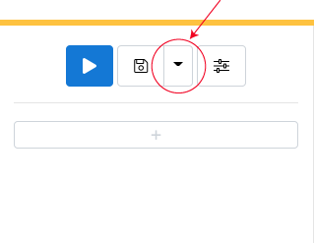

1. In that drop down menu, click *Open* to open the mousetracking.study.json file from the repository. The path to the file should be:

[EyegazeTrackerPINEntry](https://github.com/bgradel/EyegazeTrackerPINEntry)/[code](https://github.com/bgradel/EyegazeTrackerPINEntry/tree/master/code)/[mousetracking_experiment](https://github.com/bgradel/EyegazeTrackerPINEntry/tree/master/code/mousetracking_experiment)/mousetracking.study.json

1. Once the file is uploaded, run the experiment by clicking the blue play button on the side bar.