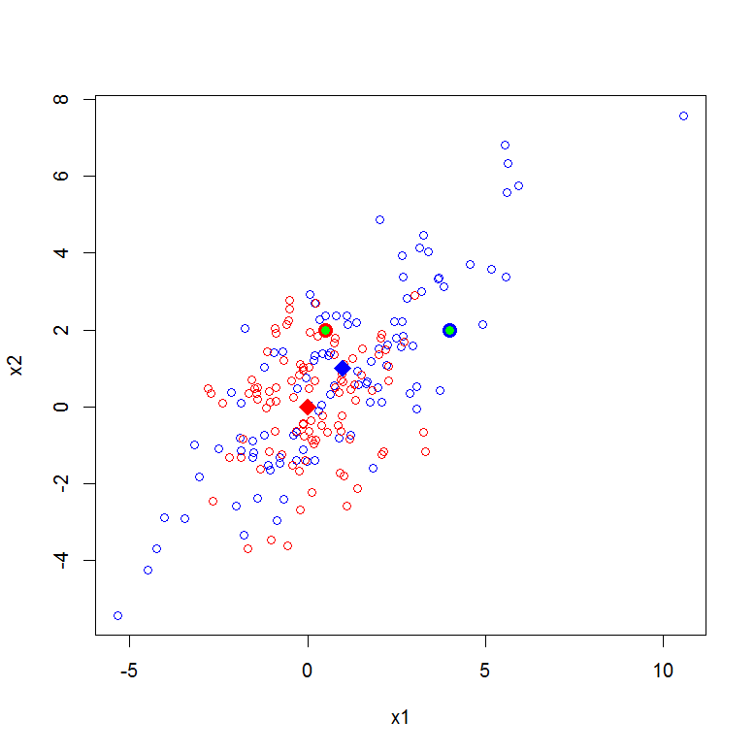

Random sample from the two multivariate distributions are plotted. Red points are from class 1; blue points are from class 2, means are plotted as diamonds. New points are plotted in green, with Bayes classifier circle around (i.e. red circle indicates a point classified as class 1; blue circle as class 2)