1. Hook-billed kite
   1. Plots
      1. Scatter plots
      2. PCA scatter plots
      3. QQ plots

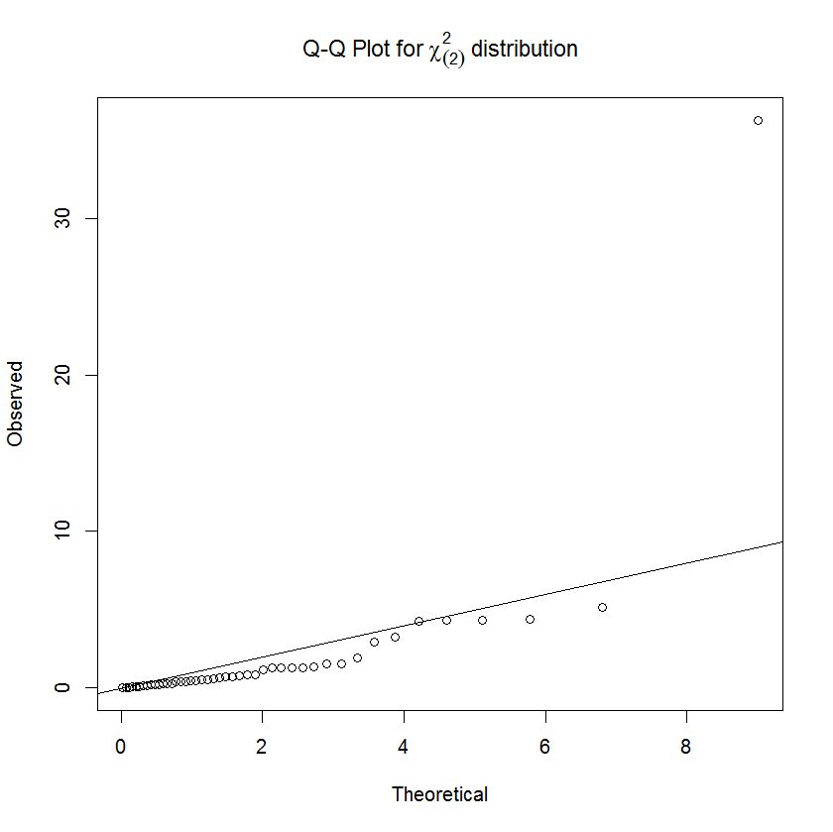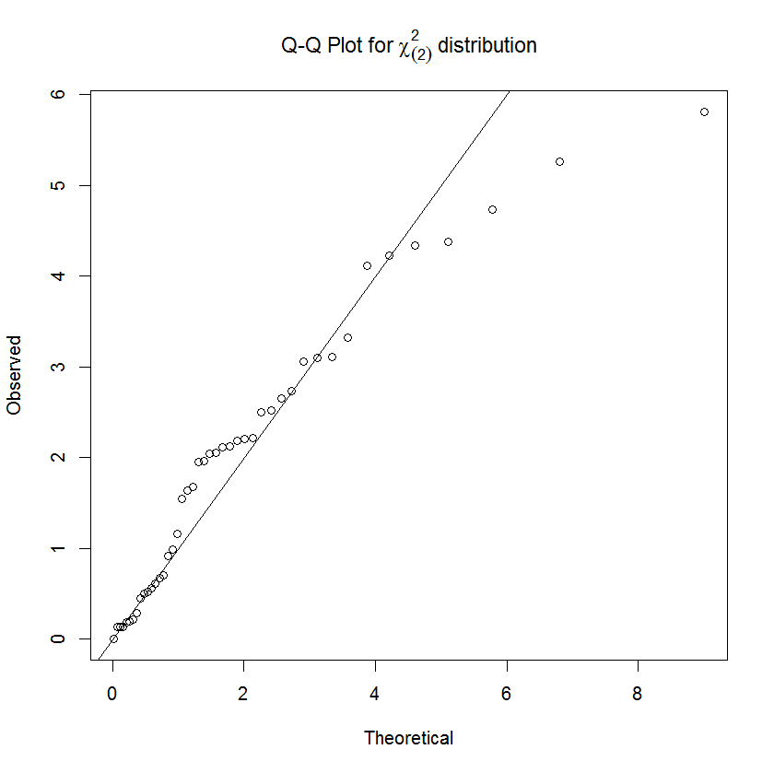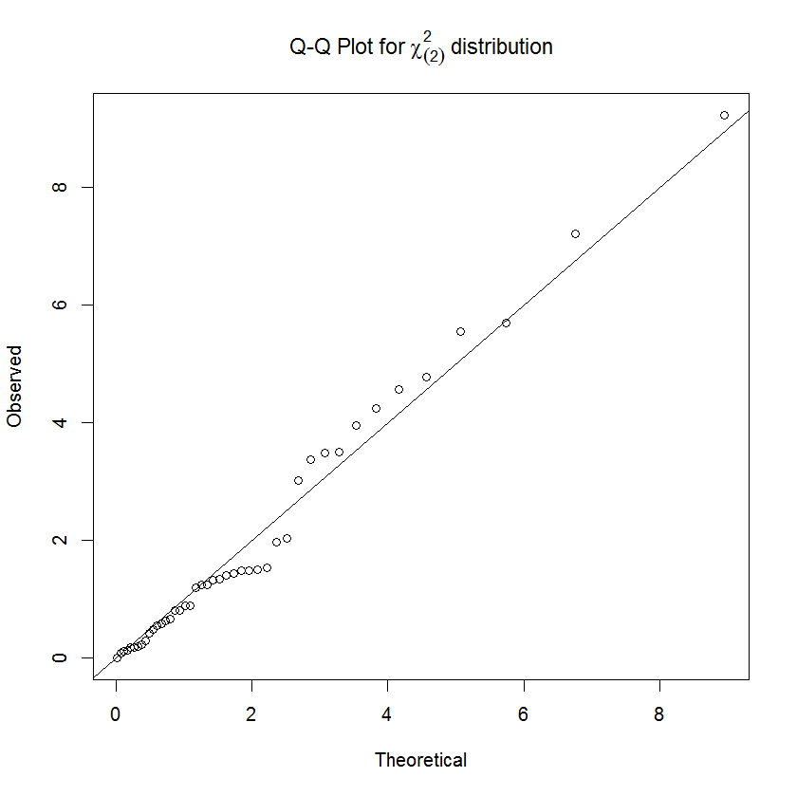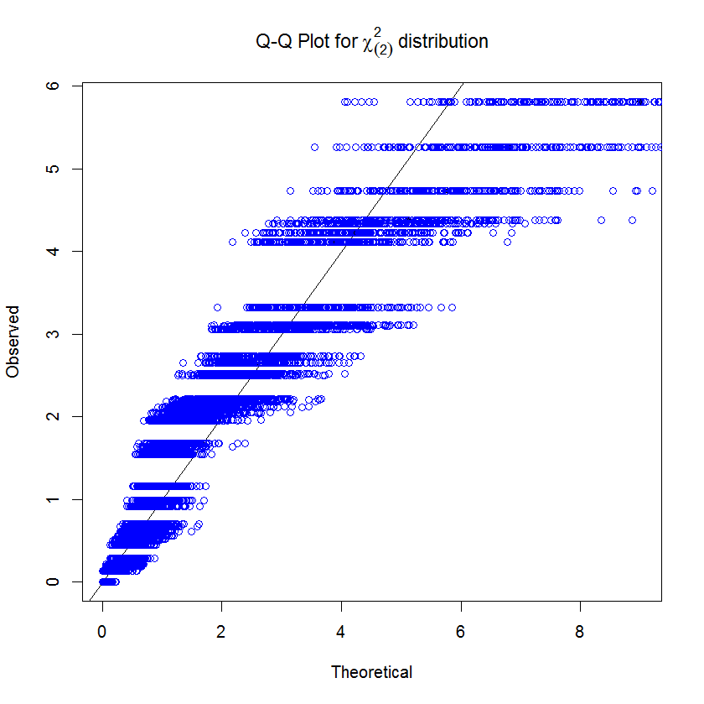

For the male population, removal of an outlier for individual 31 results in a QQ plot that does not show any deviation from the chi-square assumption. The female population does not fit the like as nicely in one try, but a QQ envelope shows that the higher ranked observations are not out of the norm for a χ2(2) distribution.

Individual 31 is removed from the male population for the following analyses.

* 1. 95% confidence regions
     1. univariate CIs

* + 1. bivariate confidence region

The 95% confidence region is an ellipse centered at , with axes in the direction of the eigenvectors: and and lengths equal to

* + 1. simultaneous CIs

;

;

* 1. Test for equality of mean vectors for male and females

;

1. Generating random samples from MVN(m0, S0): this imperfect function does not check for matching dimensions of the mean vector and the covariance matrix

rMVN <- function(n = 100, m0, S0) {

p <- length(m0)

x <- matrix(rep(NA,n\*p), nrow = n)

for(i in 1:p) {

x[ , i] <- rnorm(n)

}

y <- (x %\*% (S0 %^% (1/2)))

y <- apply(y, 1, function(x) x + m0)

t(y)

}

1. Simulations