Brett Grashorn

Assignment 6.2 – Aggregate Queries

4/20/23

Query to show list of houses

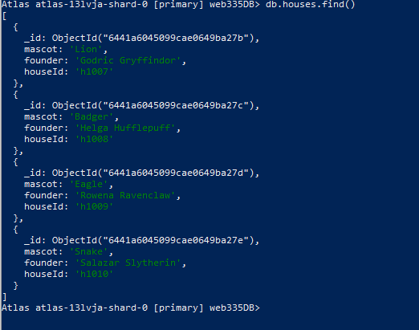

Query to show list of students.

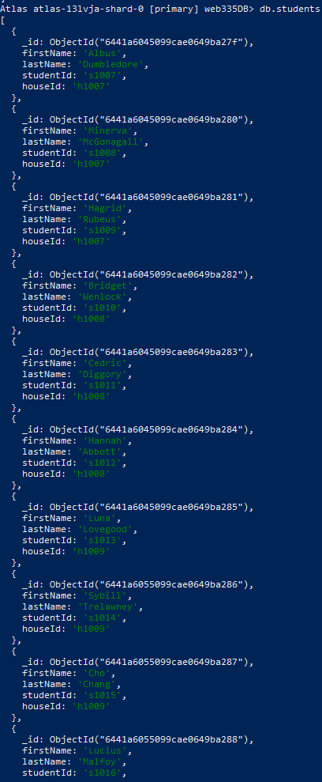

Adding student into collection

Proof it was added.

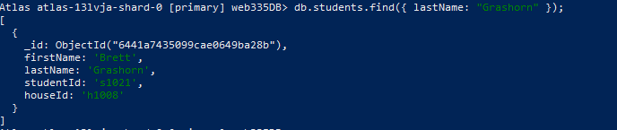

Deleting query that we made.



Proof deletion worked.



Query showing list of students by house.

