Topic Analysis:
Our task was to assign topic labels to the test dataset. This dataset consisted of reviews of either novels, movies, or restaurants.

Data Selection:
Initially, I attempted to train the BERT model on the 20 newsgroups text dataset, as we had seen in the lab. However, I quickly realized that this wouldn’t be an optimal solution due to the domain mismatch. The newsgroups data consists of news articles and classifies into topics such as, 'alt.atheism', 'comp.graphics', 'sci.med', and 'sci.space'. Meanwhile, we are testing the model’s performance against a dataset of reviews of novels, movies, and restaurants. So, training the model on news articles would not translate well in this scenario. Therefore, I am using the Amazon Multi-Domain Reviews Dataset (ACL) from huggingface.co via Johns Hopkins University. This dataset is composed of Amazon reviews of 4 products – books, DVDs, electronics, and kitchen. Although originally designed for sentiment analysis, those categories match our test categories rather well. So, rather than focusing on the sentiment of the reviews, I focused on the product which was being reviewed.
Data Structure and Processing:
The data was structured into 4 folders, 1 for each of the categories. Inside each of those 4 folders, there are 3 review files, of positive, negative, and unlabeled reviews represented as a bag-of-words. Next, I loaded in a label mapping to convert domain names to numerical values. The list is as follows: "books": 0, "dvd": 1, "kitchen": 2, "electronics": 3. The aim was that, in the test set, books would map to 0, movies would map to 1, and restaurants would map to 2. The dataset is relatively balanced between the 4 categories, but not entirely. There are 7945 reviews for kitchen products (label 2), 7681 for electronics (3), 6465 for books (0), and 5586 for DVDs. I applied minimal preprocessing to the training data, as it was already relatively well organized for our purposes. However, I did remove the embedded sentiment labels, "#label#:positive" and "#label#:negative", so the model did not cheat or find shortcuts using sentiment labels because this task was only concerned with topic classification. Then, I split the data into training and validation splits with 24909 data points for training and 2768 for validation (90% training, 10% validation), using a stratified split to ensure that the 4 topics are represented in a relatively balanced manner.
Methodology:
First, I decided to use a fine-tuned BERT model for a few reasons. Primarily, BERT has shown strong performance in topic identification across domains. So, this allows flexibility to work with various training and testing datasets. Next, using a supervised learning approach allows us control over the topics.
After selecting BERT, I had to make some decisions in the fine-tuning process. In “How to Fine-Tune BERT for Text Classification”, Sun et al discuss strategies for fine-tuning parameters. When fine-tuning BERT, I used the same learning rate given by an example in this paper, 2e-5. With a low learning rate like this, we avoid the catastrophic forgetting problem. If we had used a more aggressive learning rate, the model may fail to converge. Next, I chose to train the model on 3 epochs given that each epoch has 1557 steps. Many of the other fine-tuning parameters were taken from Lab 6.4.
In this graph of training and evaluation loss, we see both drop sharply and together. This indicates that the model learns well and converges. By the end of the training, there is a slight generalization gap, as evaluation loss is higher than training loss. Then, finally, training loss spikes above evaluation loss which could suggest slight overfitting.
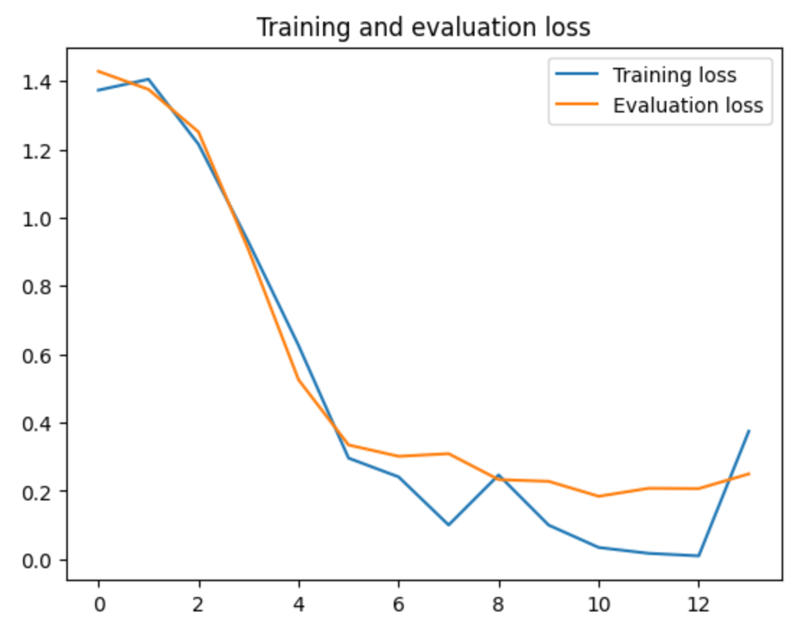

Results:
The model achieved an overall accuracy of 0.92 (0.93 precision 0.92 recall). The recall and precision scores for classes 0 and 2 (books and kitchen) are relatively balanced, but there is a bit of a discrepancy for classes 1 and 3 (DVDs and electronics). For DVDs, the precision of 0.96 and recall of 0.86 suggests that some true instances may be missed. Meanwhile, for electronics, the precision of 0.84 and recall of 0.97 tells us that there are very few false negatives, but more false positives. However, overall, the model scores very highly on the validation data.
As hoped, the model predicts movie reviews into the DVD topic and correctly identifies sentences about books. Furthermore, it correctly predicts 2 out of the 3 sentences about restaurants into the kitchen category, which we chose as our proxy for restaurants. One test sentence was misclassified, and that is a sentence about restaurants being classified into the movie category. A confusion matrix is listed below where we have substituted the labels of “DVD” with “movie” and “kitchen” with “restaurant” to allow for a match between the proxies in our training data and the true labels in the test data.

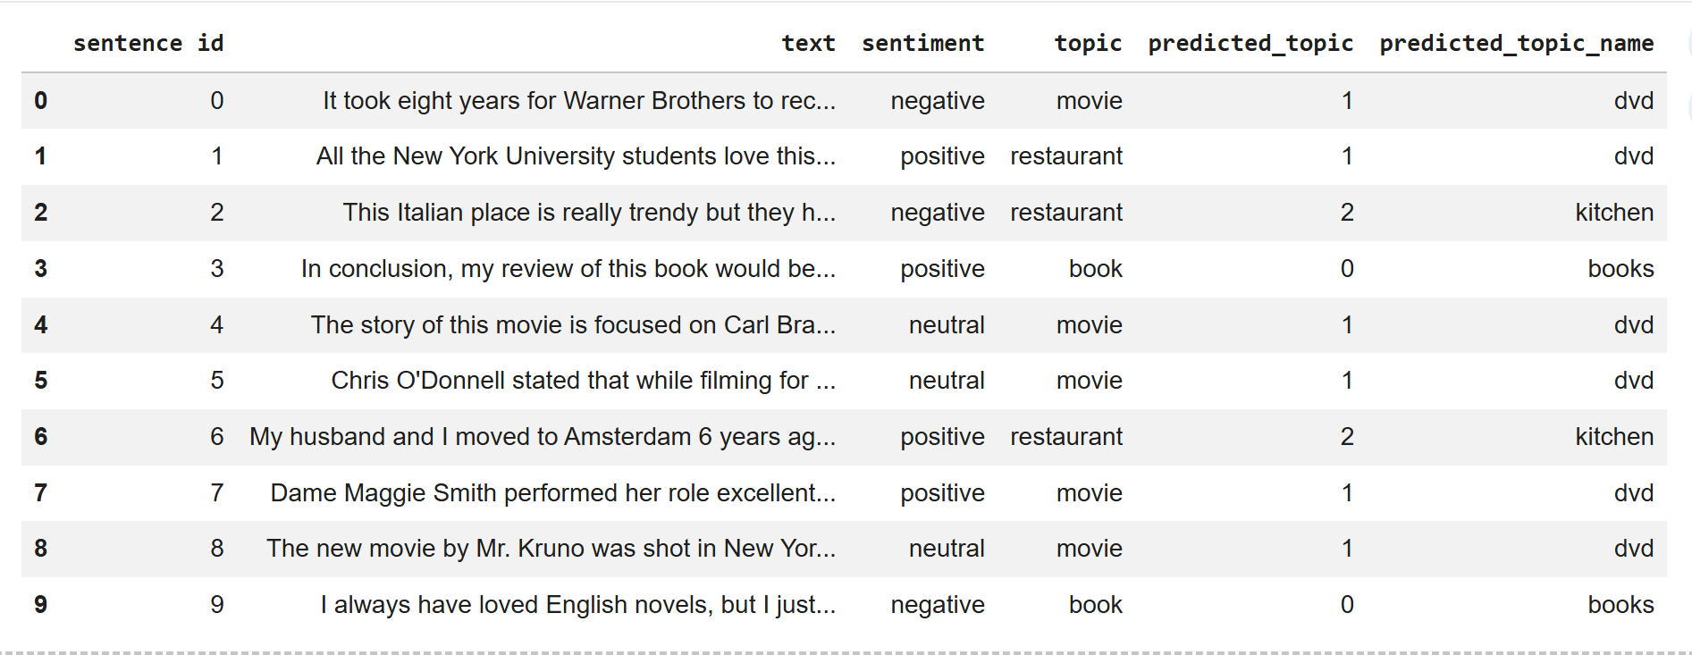

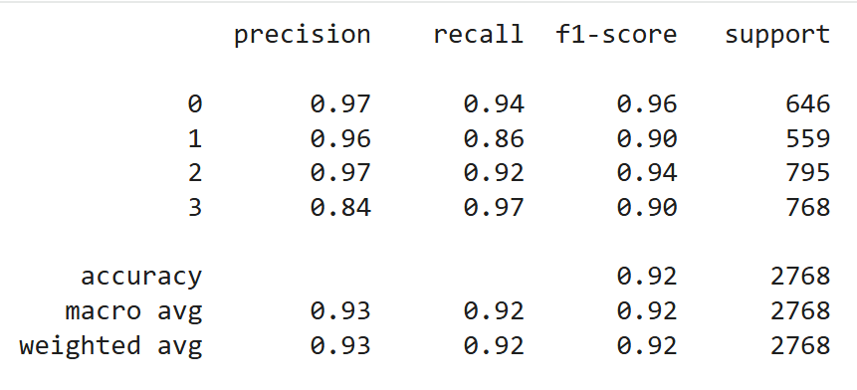

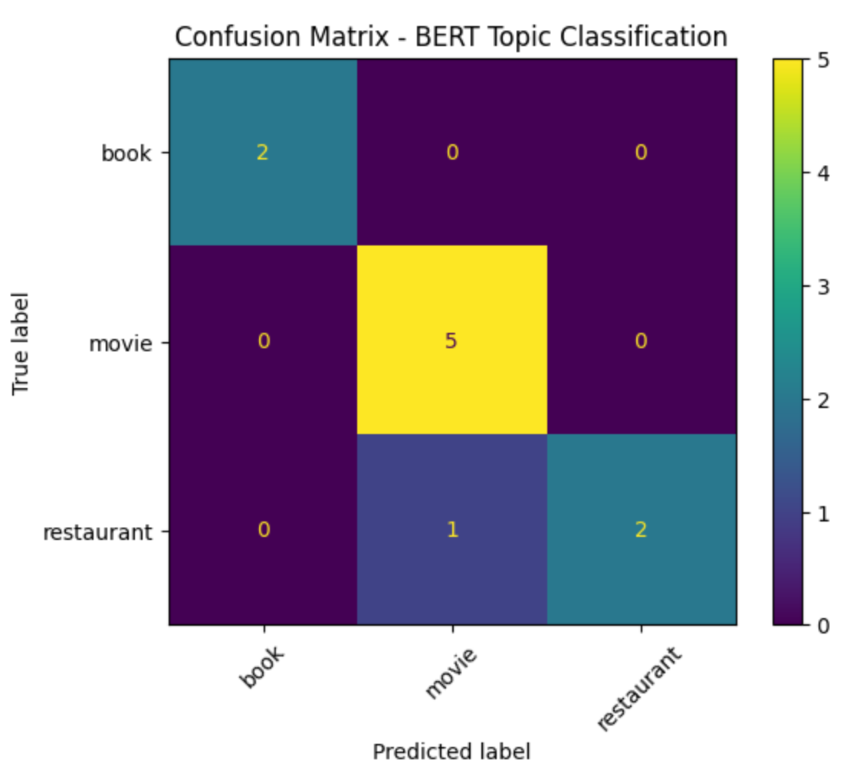

Conclusion:
In conclusion, the BERT model trained on the Amazon Multi-Domain Reviews Dataset performed well for this task. Although there was a slight mismatch in categories between the testing and training data, we effectively used “kitchen” as a proxy for “restaurant” and “DVD” as a proxy for “movie”. Nine out of the ten test sentences were predicted correctly. In the future, however, it could be beneficial to combine datasets to create a training set that more accurately matches the test categories. If we had used a training set that also included restaurant reviews, the one misclassified point would likely be correctly predicted. Finally, as Sun et al. mention, it could be beneficial to further pre-train BERT on in-domain data, such as movie, book, and restaurant reviews, rather than simply the general-domain corpus.

