Operation Room Triage model

A collaboration of Erasmus MC researchers

Report created: 17 juni, 2020, Last update model: 11/5/2020

## Warning: package 'pacman' was built under R version 3.6.3

# Goal of this research

The aim of this model is to support the triage for semi-elective operation within the Erasmus MC by identifying disease with the greatest potential loss by delaying surgery.

# How to read this report

The first sections gives a summary of the research and includes the most important conclussions and gives an overview of the model assumptions. In the second section we describe the model in more detail and provide an explanation of the files used to generate the results. All the code and data is provided in the appendix and can be used to replicate the results or modify the model for a different disease or surgery type. In the final section, section 3, all model results are included.

# Section 1: Summary of the research

### Model structure

To generate the data that helps surgery triage, we make use of a cohort state-transition model, also often called a Markov model, with three health states. These health states are a pre-operation health state, called *Preop*, a post-operation health state, caled *Postop*, and dead *Dead*. In the *Preop* health state patients patients in need for surgery are waiting for their surgery. While in this health state, they can die, in which case they transition to *Dead* or they can remain in the *Preop* health state to wait for surgery. The model structure specifies the time until surgery. After the time to waiting for surgery, all patients in the *Preop* health state get the surgery and transtion to *Postop*. Individual in the *Postop* health state might die or stay in the *Postop* health state. *Dead* is an absorbing state. The state-transition diagram is shown below.

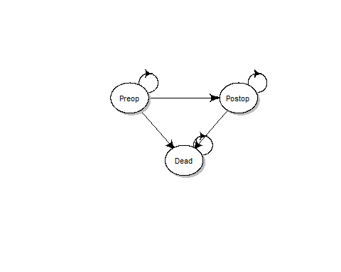

State-transition cohort model diagram.

## png   
## 2

We model a hypothetical cohort of representative patients over a lifetime horizon, up to a maximun age of 100 years, using weekly cycles. Since the average age per patient population is different, the total number of cycles is different per disease as the total number of cycles is defined by 100 years - average age in years of patients.

The cohort is modeled over several strategies. The first strategy is immediate surgery, defined as surgery within 2 weeks, vs delayed surgery modelled. Delayed surgery is model in intervals of 10 week delays after 2 weeks up to a maximum of 1 year. The main outcome of each modeled strategy is the expected quality adjusted life years (QALYs). These QALYs are calculated using a discount rate of 1.5% as recommended by the [Dutch guidelines] (<https://english.zorginstituutnederland.nl/publications/reports/2016/06/16/guideline-for-economic-evaluations-in-healthcare>).

## Important assumptions

**Model structure:**

* Comorbidities are not taken into account.
* We assume that all operations are succesful (e.g. reoperation is not taken into account).
* The SARS-Cov2 virus causing the pandemic situation is not modeled.
* All patients are assumed to be not infected by COVID-19.
* (Artifical) triangular distributions are used for parameter distribution, if the real distribution is not known.

**Related to Survival/treatment effect:**

* Before surgery the survival without surgery is applicable.
* After surgery the survival with surgery is applicable.
* Both survival with and without surgery is not age specific, unless specified.
* The survival after surgery is not affected by the delay of the surgery.
* The survival/effect of surgery is similar during an epidemic as compared to a normal setting (e.g. the difference of the health care system does not affect the patient outcomes).
* We do not include major complications (major bleeding etc.) of surgery because we assume that these complications are rare and equally distributed among the operations. As well as evenly likely to happen in situations of immediate surgery versus delayed surgery.
* The SARS-Cov-2 virus does not affect the survival.
* For transplantation surgery, we do not assume that patients on the waiting list can enter a “crisis state”, where transplantation becomes urgent (instead of semi-elective).

**Related to quality of life:**

* The QoL without surgery is constant. This means that surgery delay, which might causes extra stress, is not effecting the QoL.
* The QoL after the surgery is not influenced by the time until surgery.
* The QoL is not age specific.
* The disutiliy of recovery from a surgery is not modelled. The Qol l
* No disutility of the surgery and during the time to recover from is included.
* For interventions which only aim to improve survival, the quality of life is constant (preoperative vs post-operative).
* For some disease, surgery delay can cause an inreversable QoL decrease (e.g. getting blind, permanent function loss after fracture).
* *Add/check: Assumption we have with the QoL when they are equal /below/above*

# Section 2: The model

In this section we describe some of the steps that are done to get the results. We refer to several functions that help to run the model. These files can be found in the appendix of this report but are not shown in full detail. This reporst focusses mainly on the results. However, it is important to understand how the model is strucured and we enourage those interested to take a look at the code, replicate the results or modify the model for you own needs.

The main file to run the model is the file called main.R. To generate update results of the model and this report this file needs to be executed.

To get this results the following steps describe the proces conceptually:

1. **Prepair the R environment for the simulation**
2. **Load the literature data into the environment**

We load the literature data and mdify the data in order to be usded to model a cohort using weekly cycles.

1. **Model a cohort over time**

A model simulates a cohort of individuals up to an average age of 100 years while keeping track of the distribution of the cohort among hte different health states *Preop*, *Postop*, *Dead*. For example, for the senerio of immediate surgery, surgery within 2 weeks, the cohort is modeled for two weeks using the survival rate before surgery. In these first two weeks of the model the individuals are at risk of dying according to the weekly probability of dying before surgery. If this happens they transition to *Dead* otherwise they stay in *Preop*. After 2 weeks, those in the *Preop* all get the surgery, and they make the transition to *Postop*. For the remaining cycles, they are at risk of dying according based on the survival rates after surgery.

3.1 **Calculate the QALYs**

Based on the generated cohort trace, a matrix that described how the cohort is distributed among the three health states over time, the expected QALYs are calculated.

1. **Run all surgery senarios**

Repeat step 3 and 3.1 for a several times of delay for surgery. In our code we make use of a sequence of delay in steps op 10 weeks up to a maximum of 1 year. In other words, we run the model for a senareio of surgery after 2, 12, 22, 32, 42 and 52 weeks.

1. **Incorporate parameter uncertainty**

Using one parameter value for each model parameter in step 3 and 4 assumes we are certain about this values. However, this is not the case and our parameters come with some uncertainty. Some to this uncertainty is described by the literature, some is based on expert opinion. In order to capture parameter uncertainty on the model outcome we have to repeat steps 3 and 4 several times using different combinations of parameter values drawn from the distribtions. Therfore, we repeat stepts 3 and 4 100 times and calculate the average expected QALYS and the distibution around it.

1. **Repeat for all diseases**

Step 3, 4 and 5 are now repeated for all diseases of interest.

In the paragraphs below we describe how these steps are incorporated in the code.

## 01 Required packages

To run the model we make use of some packages which can be downloaded from CRAN as well as a package in development, called dampack, which we download from Github. But running the following lines of code one can prepare the computer to replicated the results. In order to install the package from GitHub. The uncommended code about the code p_load_gh("DARTH-git/dampack") should be used to load the package into the environment. This should only be done once.

if (!require('pacman')) install.packages('pacman'); library(pacman) # use this package to conveniently install other packages  
# load (install if required) packages from CRAN  
p_load("here", "dplyr", "devtools", "scales", "ellipse", "ggplot2", "lazyeval", "igraph", "ggraph", "reshape2", "knitr", "citr", "plyr", "stats", "diagram", "EnvStats")   
  
# load (install if required) packages from GitHub  
# install_github("DARTH-git/dampack", force = TRUE) #Uncomment if there is a newer version  
p_load_gh("DARTH-git/dampack")

## 02 Required functions

In this section we load the functions needed for the model. The functions are stored in the *R* folder. The file functions.R contains some generic functions often used in decision modeling and epidemiological research. Like a function to convert probabilities to rates and adjust a annual rate to a weekly rate as we have in our cycle. The functions in this file are mainly provided by the [DARTH workgroup](http://darthworkgroup.com).

The files model.R and functions_PSA.R includes functions specifically writen for this research. The aim of these functions is to efficiently program and to make our code easier to read and more transparent. In section XX we explain the model specific function in more detail, but we will first provide some informationabout the data used by these function.

source("../R/functions.R") # Load general functions useful for state-transition models   
# Model specific functions   
source("../R/model.R") # Code of the main model  
source("../R/functions_PSA.R") # Load the PSA function

## 03 Input model parameters

### 03.1 Load parameter data

We import the the parameters found in the literature for the different populations and different interventions. These parameters are stored in the Model parameters.xlsx file in the *data* folder and a list of reference can be found **ADD REFERENCE TO LITERATURE**

Moreover, we import the the age- and gender-specific mortality rates in 2018, downloaded from the [CBS](www.CBS.nl). Thes age-specific mortality rates are used to model the background mortality of individuals. The disease specific mortality is added to the age-specific mortality.

### 03.2 Data handling

This imported data requires some data handeling before it can be used in our model, like adjusting the survival rates and annual probabilities do die to weekly probabilities.

All model parameters have a mean estimate as well as a describtion. The data describes the type of distribution as well as the parameters required to reconstruct the distribution. As described in the data from the parameters, some of these distributions come from the literature, while others are (artefically) informed using expert opionon.

### 03.3 Prepare

#### 03.3.1 Make PSA datset

We make use of a probabilistic sensitivity analysis (PSA) to demonstrate the robustness of the model outcomes. In other words, how sensitive are our model outcomes due to the uncertainty of the input parameters. A PSA requires a dataset which contains a set of parameter values drawn from the distribution for each PSA iteration.

To generate this PSA dataset we use the function make_psa_df as described in the functions_PSA.R file in the *R* folder. Based on the model parameter values and their corresponding distribution the function generates a dataset with parameter values of each iteration of the PSA. This PSA dataset is called param_psa, which stands for parameters for the psa.

The following table shows the distributions of the parameters in the PSA for one disease. Appendix 1 gives a full overview of all parameters used in the model

The parameters with assumed distributions.

|  |  |  |  |  |  |
| --- | --- | --- | --- | --- | --- |
| Label | Param | Source | Estimate, 95%CI | Distribution | Units |
| ASD, repair | Surv_no_tx | Calculated from tx effect | 0.97 (0.92 - 0.99) | Calc_from_tx_eff | Probability per year |
| ASD, repair | Surv_tx | Nyboe C, Karunanithi Z, Nielsen-Kudsk J, et al. Eur Heart J. 2018;39(12):993-998 | 0.99 (0.99 - 0.99) | Triangle | Probability per year |
| ASD, repair | Tx_eff | Konstantinides S, Geibel An, Olschewski, M, et al. N Engl J Med 1995(333):469-473 | 0.30 (0.12 - 0.83) | Lognormal | OR/HR/RR |
| ASD, repair | QoL_no_tx | Experts | 0.79 (0.77 - 0.80) | Triangle | Utility |
| ASD, repair | QoL_tx | Experts | 0.97 (0.96 - 0.98) | Triangle | Utility |
| ASD, repair | Age | Nyboe C, Karunanithi Z, Nielsen-Kudsk J, et al. Eur Heart J. 2018;39(12):993-998 | 45.37 (44.79 - 46.09) | Normal | Years |

The following figures show the input parameters of all diseases in forest plots. 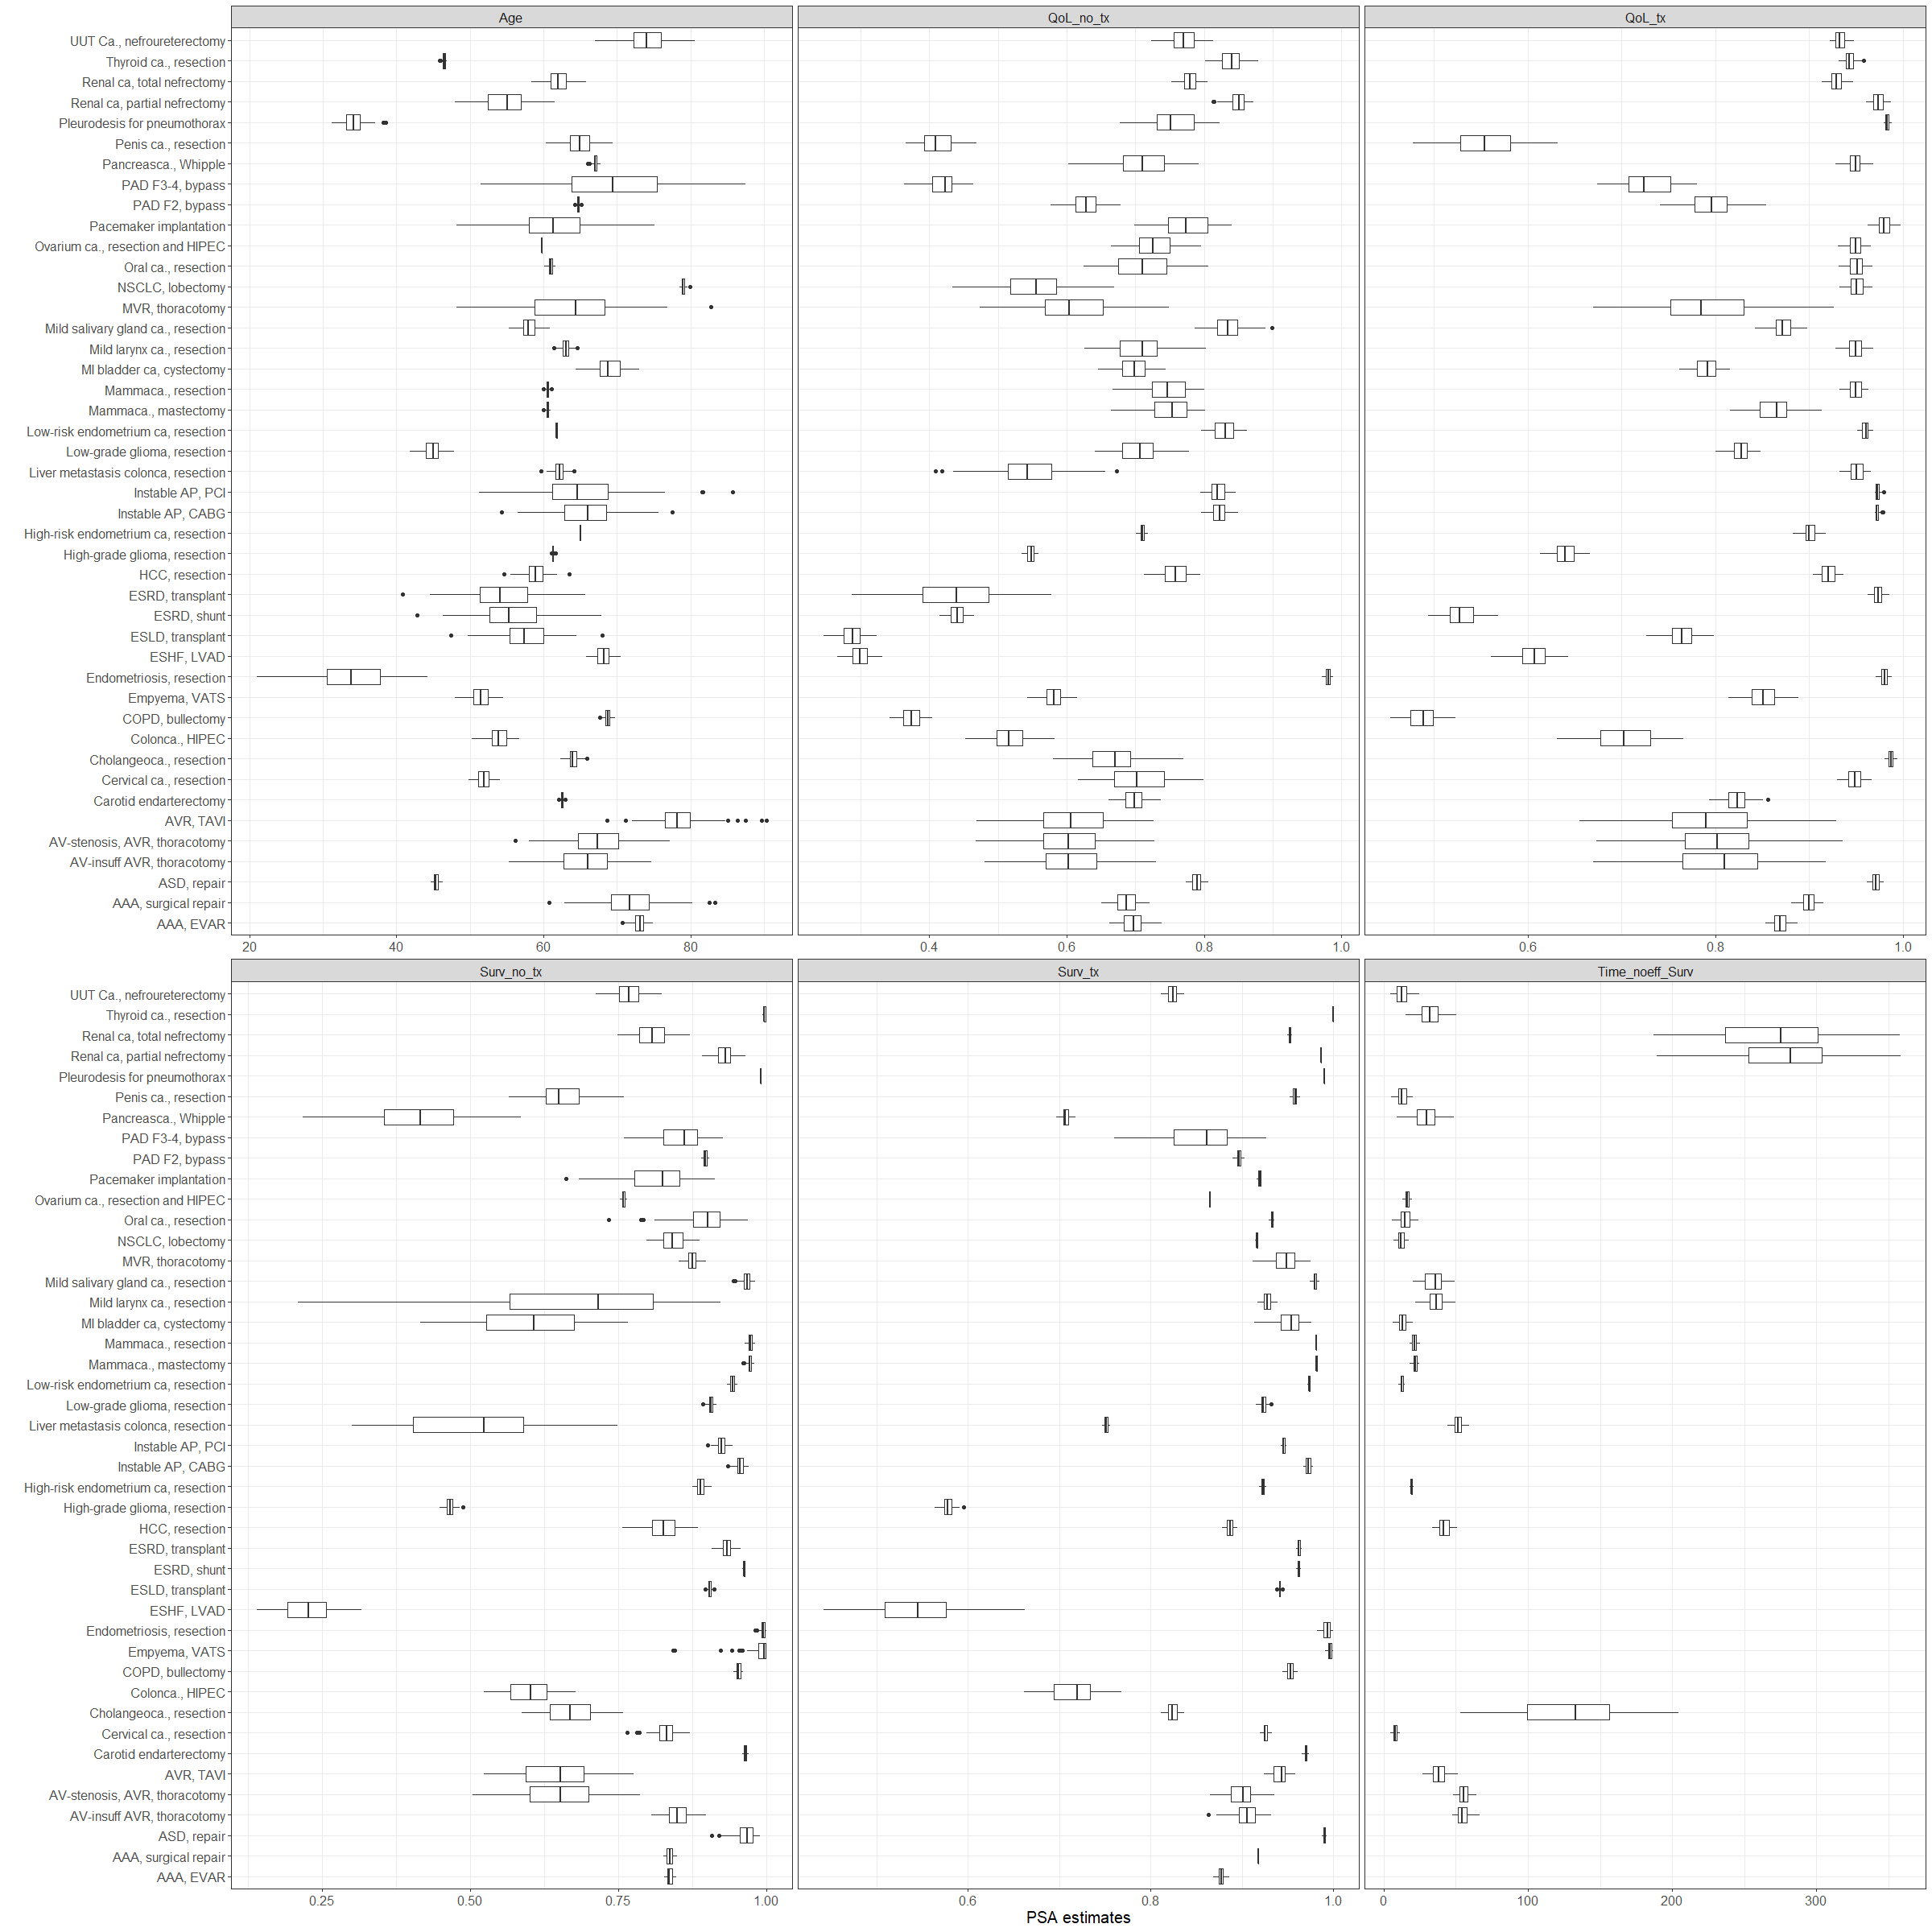

#### 03.3.2 Make the transition probability matrix

A key component of Markov model is a stucture called the transition probability matrix that described the probabilities of transitioning from one health state to another and to remain in a health state. The functions make_m_trans and trans_operation coded in the model.R file in the *R* folder generate this structure. The rows of the matrix describe the health state the individual in the cohort started from, while the colums describe where the individual transitions to. And example is shown below. In this unrealistic example, those in th *Preop* health state have a 20% change of dying every week and a 80% probability to stay in the *Preop* state, while after surgery, the group has a 5% change of dying every week.

## Preop Postop Dead  
## Preop 0.8 0.00 0.20  
## Postop 0.0 0.95 0.05  
## Dead 0.0 0.00 1.00

The transition probabilities in our model are depending on the cycle in which the cohort is in. For example, for the senario in which surgery is delayed to 12 weeks, the cohort can not transition from *Preop* to *Postop* therefore, the probabilty to transition from *Preop* to *Postop* until week 12 should be 0. At week 12, the cohort is at risk of dying and the remaining cohort will get the surgery and transition to the *Postop* health state. The “switching on and off” of the transition from *Preop* to *Postop* is done by the trans_operation function.

This means that the transition matrix is different at different cycles. Therefore, we make a transtion probabilty matrix for every cycles. In more technical terms, we add an extra dimension to the 3x3 matrix, a dimension of the number of cycles. This results in an array of transition probabilities. While running the model the transition probability matrix corresponding to the cycle is used to model what happends to the cohort.

In the make_m_trans.R - Describe how we deal with the tumor doubling reate & how the CBS data is used in addition to the disease specific data

## 04 Run the analysis

Based on the conceptual algorithm as described in the beginning of this paragraph and the function defined we run the model by excecuting the main.R file. Add the end of the file the results are stored in the *output* folder. These results are used to generate the figures as plotted in section 3.

The files are: - res_psa.Rdata: a dataframe including the results of the PSA

* psa_pooled.Rdata: a dataframe including a summary of hte PSA data
* input_psa.Rdata : The input data to make the PSA dataframe
* psa_parameters.RData : The parameter inputs for the PSA run

## 05 Calculate model outcomes

The main outcome of the model is are the expected QALYs at each time point of surgery. These values are informative, but it might be hard to interpret the effect of surgery delay. Therefore, we calculate the derivative at each time interval using thecalculateDerivative function from the model.R file. This function calculated how many QALYs on average are lost per week of surgery delay within the 10 weeks interval. The more QALYs are on average lost within a week of delay the more a patient can benefit from ealy surgery. This could be a patient population with indicaition for surgery that might need to get prioroty for surgery. While a value of zero indicate that waiting for 10 more weeks within that time interval does not result in an expected loss in QALYS. This indicates that this might be a population with surgery indication can wait a little longer. The function also creates figures of these results, which are stored in the *figures* folder

# Section 3: Disease specific results

In this section we describe the disease specific results in descending order of urgency.

## Main results

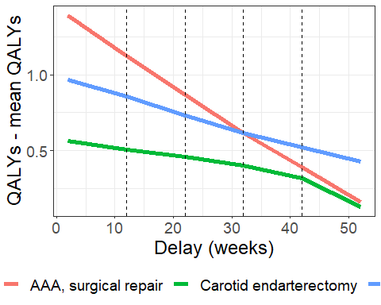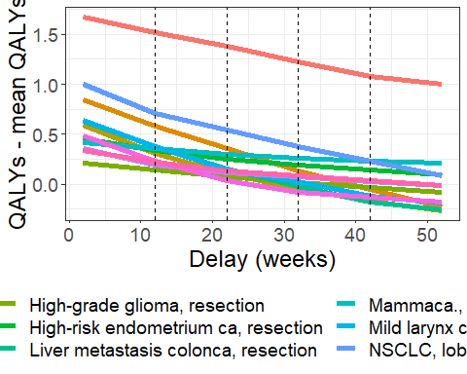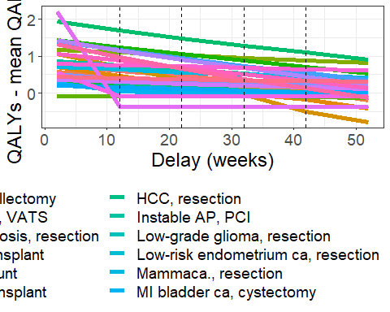

The following table presents the main results of the model. The results are ordered in descening urgency.

|  |  |  |  |  |  |  |  |  |
| --- | --- | --- | --- | --- | --- | --- | --- | --- |
|  | QALY, delay = 2 weeks | QALY, delay = 12 weeks | QALY, delay = 22 weeks | QALY, delay = 32 weeks | QALY, delay = 42 weeks | QALY, delay = 52 weeks | No surgery | QALY/month |
| PAD F3-4, bypass | 6.33 (4.04 - 9.62) | 3.75 (2.18 - 5.56) | 3.75 (2.18 - 5.57) | 3.75 (2.18 - 5.57) | 3.75 (2.18 - 5.57) | 3.75 (2.18 - 5.57) | 3.74 (2.17 - 5.59) | 0.23 (0.14 - 0.36) |
| AVR, TAVI | 4.83 (3.38 - 7.70) | 4.47 (3.00 - 7.22) | 4.12 (2.72 - 6.80) | 3.73 (2.38 - 6.23) | 3.26 (1.86 - 5.77) | 2.99 (1.82 - 5.09) | 2.99 (1.82 - 5.09) | 0.15 (0.09 - 0.24) |
| Renal ca, total nefrectomy | 9.03 (7.58 - 10.44) | 8.68 (7.29 - 10.20) | 8.38 (7.01 - 9.96) | 8.09 (6.74 - 9.74) | 7.85 (6.48 - 9.52) | 7.58 (6.22 - 9.32) | 4.43 (3.40 - 6.19) | 0.12 (0.09 - 0.15) |
| AAA, surgical repair | 11.56 (10.38 - 12.52) | 11.29 (10.14 - 12.20) | 11.04 (9.92 - 11.90) | 10.78 (9.70 - 11.61) | 10.56 (9.49 - 11.34) | 10.33 (9.28 - 11.08) | 5.62 (4.66 - 6.81) | 0.11 (0.09 - 0.13) |
| Pacemaker implantation | 11.04 (9.67 - 12.32) | 10.76 (9.26 - 12.05) | 10.51 (8.96 - 11.80) | 10.29 (8.62 - 11.63) | 10.05 (8.34 - 11.47) | 9.84 (7.98 - 11.31) | 4.81 (2.60 - 7.36) | 0.11 (0.04 - 0.22) |
| MVR, thoracotomy | 11.87 (8.18 - 15.39) | 11.65 (8.04 - 15.04) | 11.42 (7.92 - 14.71) | 11.21 (7.79 - 14.39) | 11.02 (7.67 - 14.08) | 10.83 (7.55 - 13.76) | 5.33 (3.83 - 6.76) | 0.09 (0.04 - 0.15) |
| AV-stenosis, AVR, thoracotomy | 3.64 (2.46 - 5.39) | 3.39 (2.24 - 5.13) | 3.15 (2.04 - 4.89) | 2.91 (1.86 - 4.66) | 2.74 (1.71 - 4.46) | 2.50 (1.39 - 4.32) | 2.13 (1.31 - 3.58) | 0.09 (0.06 - 0.17) |
| Cholangeoca., resection | 4.67 (3.89 - 5.39) | 4.41 (3.61 - 5.21) | 4.18 (3.35 - 5.05) | 3.96 (3.12 - 4.91) | 3.77 (2.92 - 4.78) | 3.60 (2.75 - 4.65) | 2.20 (1.70 - 3.20) | 0.09 (0.06 - 0.12) |
| ESRD, transplant | 15.58 (14.22 - 16.63) | 15.35 (14.06 - 16.42) | 15.13 (13.92 - 16.21) | 14.93 (13.76 - 15.99) | 14.74 (13.58 - 15.79) | 14.54 (13.40 - 15.61) | 5.25 (3.53 - 6.91) | 0.09 (0.06 - 0.12) |
| NSCLC, lobectomy | 9.38 (8.04 - 11.12) | 9.08 (7.67 - 10.89) | 8.92 (7.46 - 10.72) | 8.76 (7.29 - 10.56) | 8.61 (7.14 - 10.41) | 8.46 (6.99 - 10.27) | 5.44 (4.22 - 7.11) | 0.08 (0.06 - 0.10) |
| Liver metastasis colonca, resection | 2.43 (1.81 - 3.49) | 2.17 (1.48 - 3.34) | 1.95 (1.23 - 3.20) | 1.77 (1.04 - 3.07) | 1.62 (0.89 - 2.97) | 1.53 (0.78 - 2.87) | 1.09 (0.61 - 1.99) | 0.08 (0.05 - 0.10) |
| ESLD, transplant | 10.05 (9.15 - 10.96) | 9.87 (8.97 - 10.74) | 9.69 (8.80 - 10.54) | 9.51 (8.65 - 10.34) | 9.34 (8.50 - 10.14) | 9.16 (8.36 - 9.95) | 2.76 (2.28 - 3.24) | 0.08 (0.07 - 0.09) |
| Renal ca, partial nefrectomy | 14.29 (11.81 - 17.13) | 14.10 (11.58 - 17.00) | 13.92 (11.37 - 16.87) | 13.74 (11.16 - 16.75) | 13.56 (10.95 - 16.62) | 13.37 (10.75 - 16.49) | 9.64 (7.36 - 12.89) | 0.08 (0.05 - 0.10) |
| ESHF, LVAD | 1.45 (1.15 - 2.05) | 1.16 (0.90 - 1.60) | 0.96 (0.72 - 1.32) | 0.81 (0.59 - 1.11) | 0.69 (0.49 - 0.94) | 0.59 (0.43 - 0.81) | 0.33 (0.25 - 0.42) | 0.07 (0.05 - 0.11) |
| Mild larynx ca., resection | 4.27 (2.02 - 11.15) | 4.01 (1.68 - 11.06) | 3.78 (1.43 - 10.98) | 3.66 (1.24 - 10.89) | 3.51 (1.20 - 10.82) | 3.44 (1.17 - 10.76) | 2.77 (1.05 - 8.36) | 0.07 (0.04 - 0.10) |
| AV-insuff AVR, thoracotomy | 6.53 (5.13 - 8.65) | 6.40 (5.01 - 8.43) | 6.27 (4.89 - 8.22) | 6.15 (4.77 - 8.05) | 6.03 (4.64 - 7.89) | 5.78 (3.87 - 7.73) | 4.63 (3.52 - 6.52) | 0.06 (0.02 - 0.23) |
| AAA, EVAR | 9.03 (8.54 - 9.46) | 8.88 (8.43 - 9.30) | 8.75 (8.31 - 9.14) | 8.62 (8.19 - 9.00) | 8.49 (8.07 - 8.87) | 8.37 (7.96 - 8.74) | 5.89 (5.48 - 6.41) | 0.06 (0.05 - 0.07) |
| ASD, repair | 22.02 (21.06 - 22.77) | 21.86 (20.85 - 22.62) | 21.72 (20.67 - 22.50) | 21.57 (20.49 - 22.42) | 21.42 (20.31 - 22.35) | 21.34 (20.13 - 22.27) | 12.48 (7.31 - 17.06) | 0.06 (0.02 - 0.14) |
| Pancreasca., Whipple | 2.08 (1.56 - 2.56) | 1.83 (1.29 - 2.36) | 1.62 (1.12 - 2.21) | 1.51 (1.04 - 2.12) | 1.46 (1.00 - 2.07) | 1.42 (0.97 - 2.03) | 1.22 (0.86 - 1.76) | 0.05 (0.03 - 0.07) |
| Penis ca., resection | 1.97 (1.42 - 2.70) | 1.34 (1.00 - 1.98) | 1.34 (1.00 - 1.97) | 1.34 (1.00 - 1.97) | 1.34 (1.00 - 1.97) | 1.34 (1.00 - 1.97) | 1.34 (1.00 - 1.97) | 0.05 (0.03 - 0.08) |
| Instable AP, CABG | 18.38 (17.54 - 19.23) | 18.27 (17.42 - 19.12) | 18.14 (17.30 - 19.01) | 18.03 (17.19 - 18.91) | 17.94 (17.07 - 18.82) | 17.84 (16.96 - 18.73) | 13.30 (11.63 - 14.90) | 0.05 (0.03 - 0.07) |
| Instable AP, PCI | 14.42 (13.13 - 15.64) | 14.32 (13.04 - 15.50) | 14.21 (12.94 - 15.36) | 14.10 (12.84 - 15.21) | 13.97 (12.74 - 15.06) | 13.87 (12.63 - 14.95) | 10.11 (8.51 - 12.24) | 0.04 (0.02 - 0.06) |
| HCC, resection | 5.67 (4.69 - 7.54) | 5.55 (4.54 - 7.49) | 5.43 (4.39 - 7.43) | 5.32 (4.26 - 7.37) | 5.24 (4.15 - 7.31) | 5.20 (4.10 - 7.28) | 4.44 (3.50 - 6.12) | 0.04 (0.02 - 0.05) |
| Colonca., HIPEC | 2.25 (1.78 - 2.63) | 2.14 (1.67 - 2.48) | 2.04 (1.59 - 2.35) | 1.96 (1.51 - 2.26) | 1.87 (1.45 - 2.17) | 1.80 (1.39 - 2.11) | 1.09 (0.88 - 1.45) | 0.04 (0.02 - 0.06) |
| Ovarium ca., resection and HIPEC | 4.26 (4.14 - 4.36) | 4.10 (3.99 - 4.21) | 4.02 (3.91 - 4.12) | 3.98 (3.86 - 4.07) | 3.94 (3.80 - 4.03) | 3.89 (3.75 - 3.99) | 3.15 (2.91 - 3.44) | 0.03 (0.03 - 0.04) |
| Oral ca., resection | 9.45 (5.14 - 14.36) | 9.34 (4.93 - 14.37) | 9.28 (4.78 - 14.32) | 9.22 (4.73 - 14.27) | 9.17 (4.68 - 14.22) | 9.12 (4.63 - 14.17) | 7.12 (3.68 - 11.01) | 0.03 (0.02 - 0.04) |
| High-risk endometrium ca, resection | 8.81 (8.09 - 9.68) | 8.69 (7.96 - 9.59) | 8.60 (7.87 - 9.52) | 8.55 (7.82 - 9.47) | 8.50 (7.77 - 9.42) | 8.45 (7.73 - 9.37) | 6.88 (6.33 - 7.60) | 0.03 (0.03 - 0.03) |
| UUT Ca., nefroureterectomy | 6.08 (4.66 - 7.57) | 5.96 (4.56 - 7.44) | 5.88 (4.50 - 7.35) | 5.83 (4.46 - 7.28) | 5.78 (4.41 - 7.23) | 5.73 (4.38 - 7.17) | 4.95 (3.77 - 6.20) | 0.03 (0.02 - 0.04) |
| Mammaca., resection | 17.89 (16.09 - 19.05) | 17.81 (15.98 - 18.98) | 17.73 (15.88 - 18.92) | 17.69 (15.83 - 18.87) | 17.64 (15.77 - 18.81) | 17.60 (15.73 - 18.76) | 13.86 (12.40 - 15.38) | 0.03 (0.02 - 0.04) |
| MI bladder ca, cystectomy | 2.70 (1.75 - 4.56) | 2.49 (1.55 - 4.36) | 2.46 (1.53 - 4.30) | 2.43 (1.51 - 4.26) | 2.41 (1.49 - 4.23) | 2.39 (1.48 - 4.21) | 2.24 (1.40 - 3.78) | 0.03 (0.02 - 0.04) |
| Empyema, VATS | 21.40 (19.68 - 22.93) | 21.33 (19.55 - 22.86) | 21.26 (19.29 - 22.80) | 21.19 (19.11 - 22.74) | 21.11 (18.91 - 22.67) | 21.05 (18.64 - 22.61) | 14.30 (6.64 - 15.91) | 0.03 (0.02 - 0.12) |
| High-grade glioma, resection | 1.48 (1.41 - 1.55) | 1.41 (1.34 - 1.47) | 1.34 (1.28 - 1.40) | 1.28 (1.23 - 1.34) | 1.23 (1.19 - 1.28) | 1.19 (1.15 - 1.24) | 0.94 (0.90 - 0.97) | 0.03 (0.02 - 0.03) |
| Carotid endarterectomy | 15.05 (14.39 - 15.80) | 14.99 (14.35 - 15.74) | 14.94 (14.32 - 15.68) | 14.88 (13.53 - 15.63) | 14.80 (12.44 - 15.53) | 14.61 (12.37 - 15.44) | 12.11 (11.39 - 12.80) | 0.02 (0.02 - 0.24) |
| Cervical ca., resection | 5.04 (4.07 - 6.15) | 4.93 (3.97 - 6.07) | 4.88 (3.92 - 6.02) | 4.83 (3.86 - 5.97) | 4.78 (3.82 - 5.92) | 4.74 (3.77 - 5.88) | 3.79 (2.81 - 4.57) | 0.02 (0.02 - 0.03) |
| Low-grade glioma, resection | 7.81 (7.14 - 8.31) | 7.76 (7.10 - 8.27) | 7.71 (7.05 - 8.23) | 7.66 (7.01 - 8.19) | 7.61 (6.96 - 8.15) | 7.56 (6.92 - 8.11) | 5.66 (4.93 - 6.40) | 0.02 (0.01 - 0.03) |
| Low-risk endometrium ca, resection | 13.61 (12.67 - 14.38) | 13.51 (12.56 - 14.29) | 13.47 (12.52 - 14.26) | 13.44 (12.49 - 14.22) | 13.41 (12.45 - 14.19) | 13.38 (12.42 - 14.16) | 11.68 (10.75 - 12.54) | 0.02 (0.02 - 0.03) |
| PAD F2, bypass | 8.15 (7.56 - 8.81) | 8.11 (7.52 - 8.75) | 8.06 (7.49 - 8.69) | 8.01 (7.46 - 8.64) | 7.96 (7.43 - 8.58) | 7.91 (7.40 - 8.53) | 6.44 (5.86 - 6.96) | 0.02 (0.01 - 0.03) |
| Mammaca., mastectomy | 16.08 (14.59 - 17.18) | 16.02 (14.52 - 17.11) | 15.96 (14.47 - 17.04) | 15.93 (14.44 - 17.00) | 15.89 (14.42 - 16.96) | 15.87 (14.40 - 16.92) | 13.91 (12.29 - 15.34) | 0.02 (0.01 - 0.03) |
| COPD, bullectomy | 7.89 (7.24 - 8.54) | 7.85 (7.21 - 8.49) | 7.81 (7.18 - 8.45) | 7.78 (7.15 - 8.41) | 7.74 (7.11 - 8.37) | 7.71 (7.08 - 8.33) | 6.08 (5.43 - 6.57) | 0.02 (0.01 - 0.02) |
| Pleurodesis for pneumothorax | 21.40 (21.15 - 21.65) | 21.36 (21.12 - 21.62) | 21.33 (21.09 - 21.58) | 21.29 (21.05 - 21.54) | 21.26 (21.01 - 21.50) | 21.22 (20.98 - 21.47) | 16.38 (14.93 - 17.72) | 0.02 (0.01 - 0.02) |
| Mild salivary gland ca., resection | 15.28 (12.60 - 16.89) | 15.24 (12.52 - 16.87) | 15.20 (12.44 - 16.85) | 15.15 (12.36 - 16.82) | 15.12 (12.34 - 16.81) | 15.11 (12.33 - 16.81) | 14.51 (11.78 - 16.29) | 0.01 (0.01 - 0.03) |
| Thyroid ca., resection | 23.81 (22.49 - 24.94) | 23.78 (22.44 - 24.92) | 23.74 (22.40 - 24.90) | 23.72 (22.35 - 24.88) | 23.70 (22.32 - 24.86) | 23.68 (22.30 - 24.84) | 21.19 (19.70 - 22.74) | 0.01 (0.01 - 0.02) |
| ESRD, shunt | 8.55 (7.83 - 9.30) | 8.53 (7.81 - 9.28) | 8.51 (7.80 - 9.25) | 8.49 (7.78 - 9.22) | 8.48 (7.77 - 9.19) | 8.46 (7.75 - 9.17) | 7.09 (6.54 - 7.71) | 0.01 (0.00 - 0.01) |
| Endometriosis, resection | 22.68 (18.43 - 25.92) | 22.69 (18.46 - 25.90) | 22.71 (18.48 - 25.88) | 22.70 (18.50 - 25.85) | 22.66 (18.52 - 25.83) | 22.64 (18.55 - 25.81) | 23.32 (18.32 - 26.27) | -0.00 (-0.02 - 0.02) |

Since the table is quite large, we also summarized the main results in figures. The following figures shows the increase in QALYs attributable to the operation.

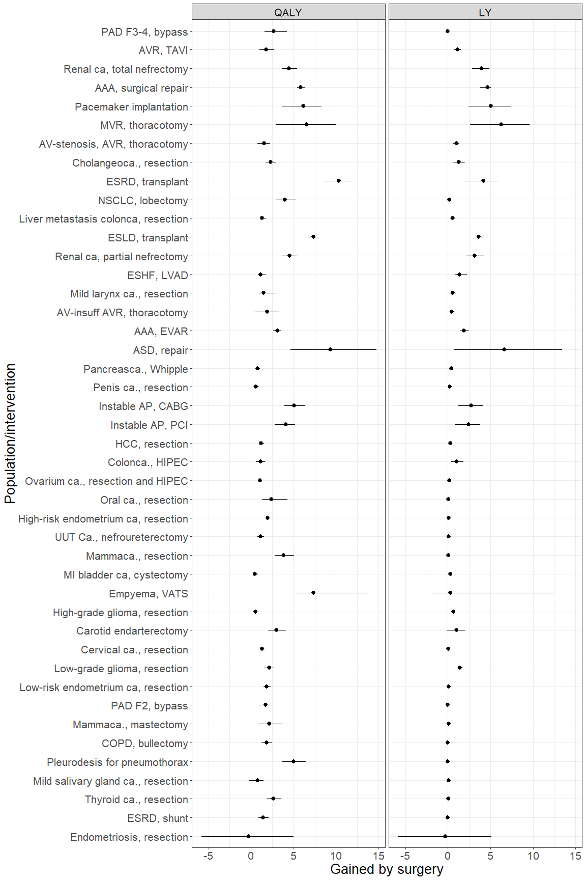

Jan van Busschbach recommended the following visualisation of the procedures:

bnft2 <- bnft  
bnft2$Label <- factor(bnft2$Label, levels = rev(order_populations))  
  
## part of QALY that is LY  
  
  
bnft2$Bnft[bnft2$type=="QALY"] <- -bnft2$Bnft[bnft2$type=="QALY"]  
bnft2$Bnft_lo[bnft2$type=="QALY"] <- -bnft2$Bnft_lo[bnft2$type=="QALY"]  
bnft2$Bnft_hi[bnft2$type=="QALY"] <- -bnft2$Bnft_hi[bnft2$type=="QALY"]  
  
bnft2[bnft2$type=="QALY",c("Bnft","Bnft_lo","Bnft_hi")][bnft2[bnft2$type=="QALY",c("Bnft","Bnft_lo","Bnft_hi")]>0] <- 0  
bnft2[bnft2$type=="LY",c("Bnft","Bnft_lo","Bnft_hi")][bnft2[bnft2$type=="LY",c("Bnft","Bnft_lo","Bnft_hi")]<0] <- 0  
  
breaks <- -15:15  
names(breaks) <- abs(breaks)  
bnft2$type <- factor(bnft2$type, levels=c("QALY","LY"))  
bnft_v2 <- ggplot(bnft2, aes(x = Label, y = Bnft, ymin=Bnft_lo, ymax=Bnft_hi)) +  
 geom_col(alpha=0.6) +  
 geom_linerange()+  
 geom_hline(yintercept = 0, colour = "black") +  
 facet_wrap_custom(~type, scales = "free_x", scale_overrides = list(  
 scale_override(1, scale_y_continuous(limits = c(-15,0),  
 breaks = seq(from = -15, to = 0,by = 1),  
 labels = seq(from = 15, to = 0,by = -1),   
 expand = c(0, 0))),  
 scale_override(2, scale_y_continuous(limits = c(0, 15),  
 breaks = seq(from = 0, to = 15,by = 1),  
 labels = seq(from = 0, to = 15,by = 1),   
 expand = c(0, 0)))  
 ))+  
 coord_flip()+  
 theme_bw() +  
 theme(panel.spacing.x = unit(0, "pt"),   
 strip.background = element_rect(colour = "black"),  
 text=element_text(size=18))+  
 labs(y="Associated with surgery",x="Surgery")  
  
bnft_v2

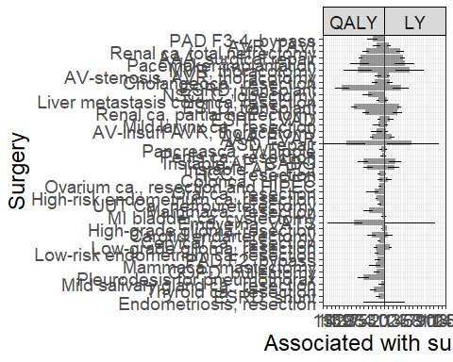

ggsave(bnft_v2,filename = "../figures/main_results/bnft_v2.png", width=15, height=10)

The following figure shows the loss of QALYs per week delay.

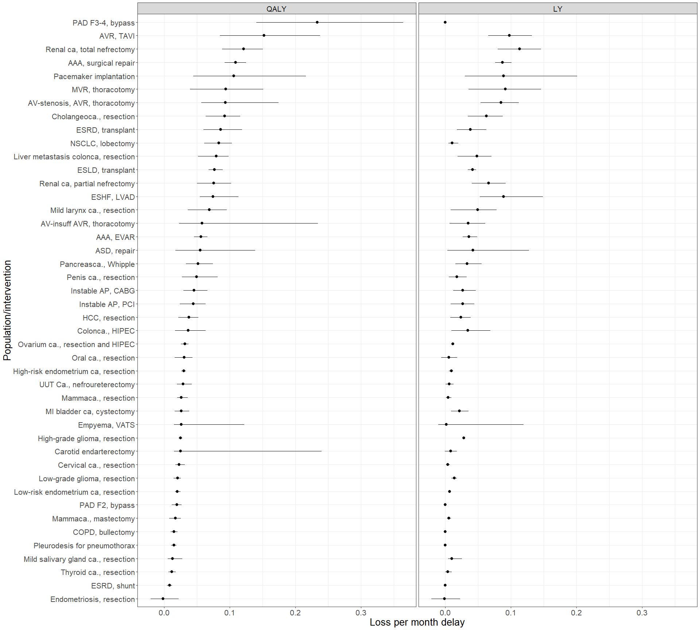

# Make an new urg df, which we can modify  
urg2 <- urg  
  
#Make sure the procedures are ordered in descending order  
urg2$Label <- factor(urg2$Label, levels = rev(order_populations))  
  
## QALYs are left, so need to be negative  
urg2$urg[urg2$type=="QALY"] <- -urg2$urg[urg2$type=="QALY"]  
urg2$urg_lo[urg2$type=="QALY"] <- -urg2$urg_lo[urg2$type=="QALY"]  
urg2$urg_hi[urg2$type=="QALY"] <- -urg2$urg_hi[urg2$type=="QALY"]  
  
## Do not allow negative values (make them 0)  
urg2[urg2$type=="QALY",c("urg","urg_lo","urg_hi")][urg2[urg2$type=="QALY",c("urg","urg_lo","urg_hi")]>0] <- 0  
urg2[urg2$type=="LY",c("urg","urg_lo","urg_hi")][urg2[urg2$type=="LY",c("urg","urg_lo","urg_hi")]<0] <- 0  
  
## To ensure that QALYs also have positive ticks (x-axis)  
breaks <- seq(-0.35,0.35, by=0.06)  
names(breaks) <- abs(breaks)  
  
## To ensure that QALY = Left, and LY = right  
urg2$type <- factor(urg2$type, levels=c("QALY","LY"))  
  
#Build plot  
urg_v2 <- ggplot(urg2, aes(x = Label, y = urg, ymin=urg_lo, ymax=urg_hi)) +  
 geom_col(alpha=0.6) +  
 geom_linerange()+  
 geom_hline(yintercept = 0, colour = "black") +  
   
 facet_wrap_custom(~type, scales = "free_x", scale_overrides = list(  
 scale_override(1, scale_y_continuous(limits = c(-0.35, 0),  
 breaks = seq(from = -0.35, to = 0,by = 0.05),  
 labels = seq(from = 0.35, to = 0,by = -0.05),   
 expand = c(0, 0))),  
 scale_override(2, scale_y_continuous(limits = c(0, 0.35),  
 breaks = seq(from = 0, to = 0.35,by = 0.05),  
 labels = seq(from = 0, to = 0.35,by = 0.05),   
 expand = c(0, 0)))  
 ))+  
 coord_flip() +  
 theme_bw() +  
 theme(panel.spacing.x = unit(0, "pt"),   
 strip.background = element_rect(colour = "black"),  
 text=element_text(size=18))+  
 labs(y="Loss per month",x="Surgery")  
  
urg_v2

## Warning: Removed 1 rows containing missing values (geom_linerange).

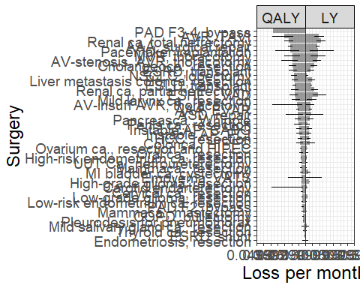

ggsave(urg_v2,filename = "../figures/main_results/urg_v2.png", width=15, height=10)

## Warning: Removed 1 rows containing missing values (geom_linerange).

The interventions are again ordered in descending urgency. The spread around the points are 95% confidence intervals. The estimates are given for the average loss of QALYs per week.

## In-depth results

Because we need to be able to check the input and output of the model simultaneously, we will present them here. In descending order of urgency, we will display the input parameters of the model, the impact on the remaining QALYs, and the QALYs lost per week during 1 year of delay.

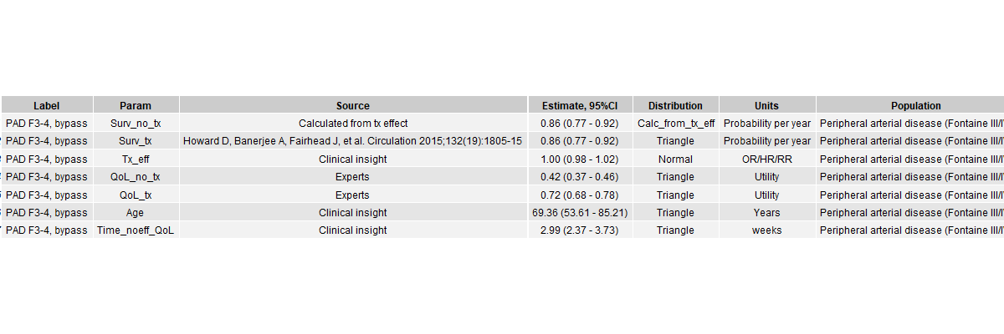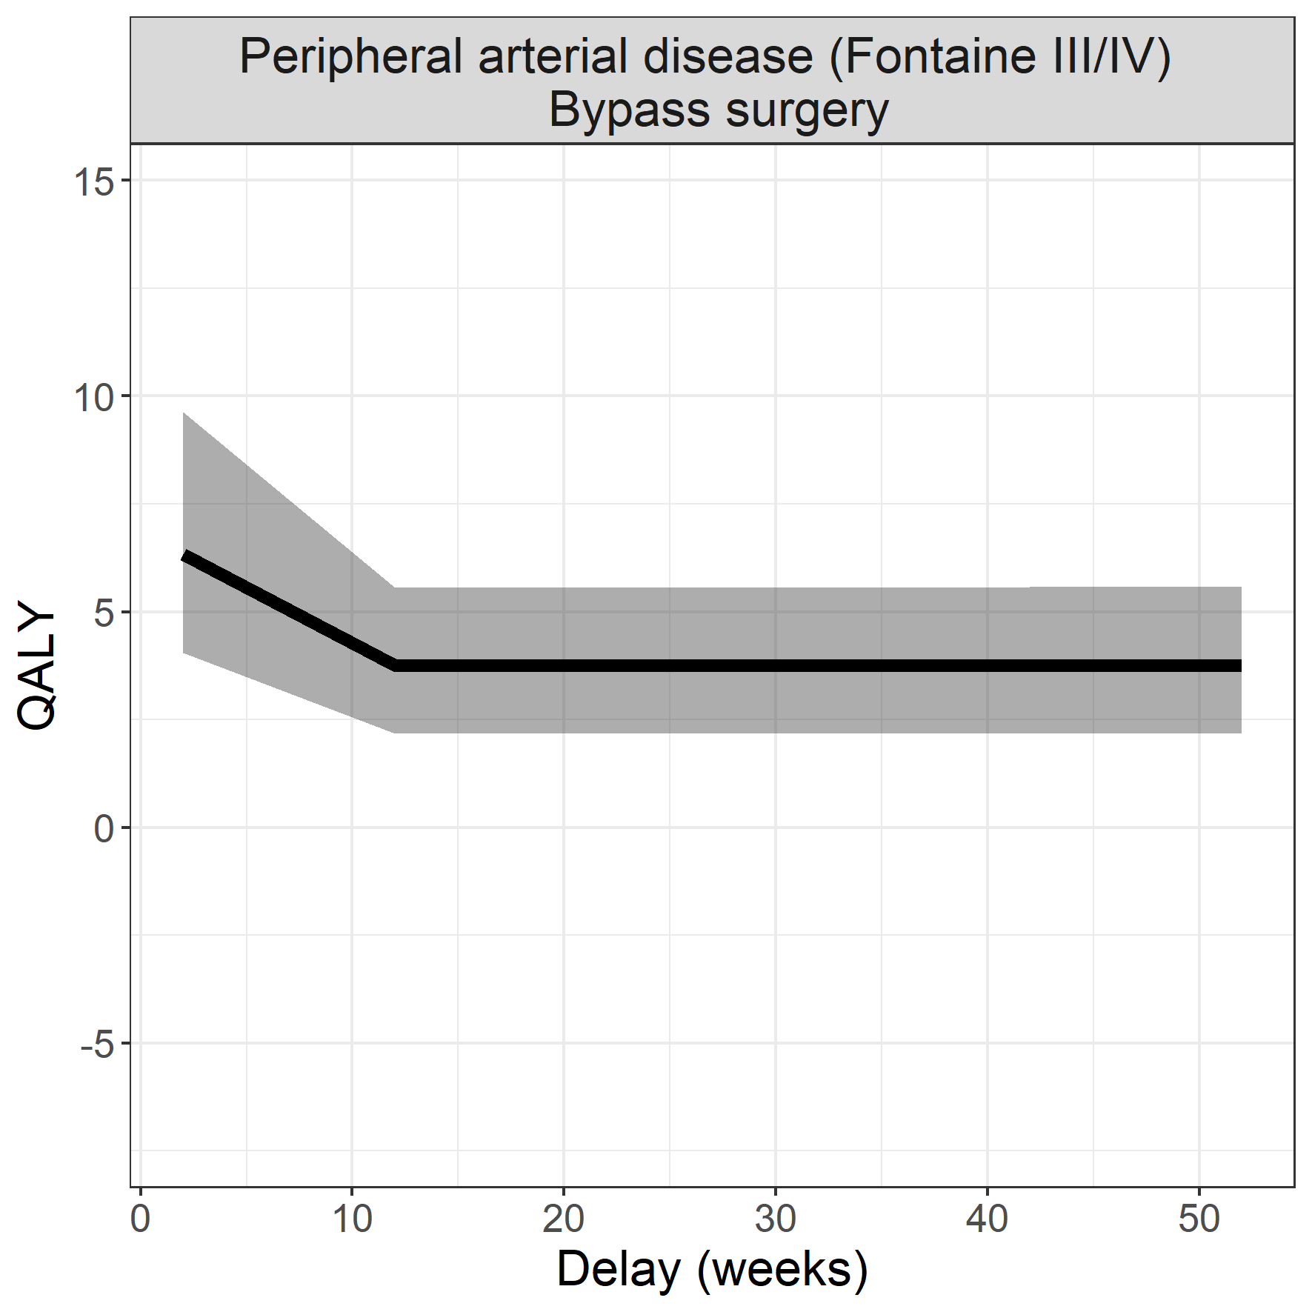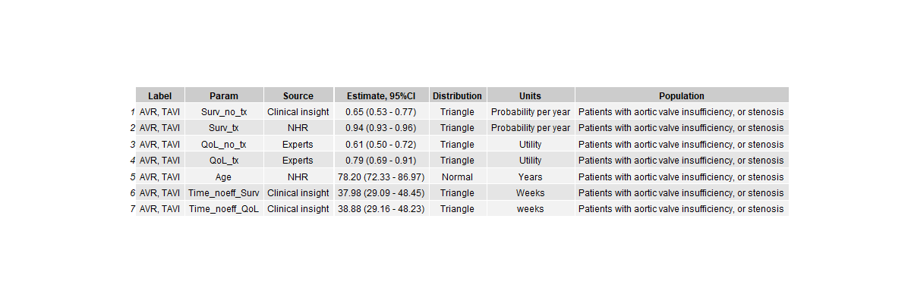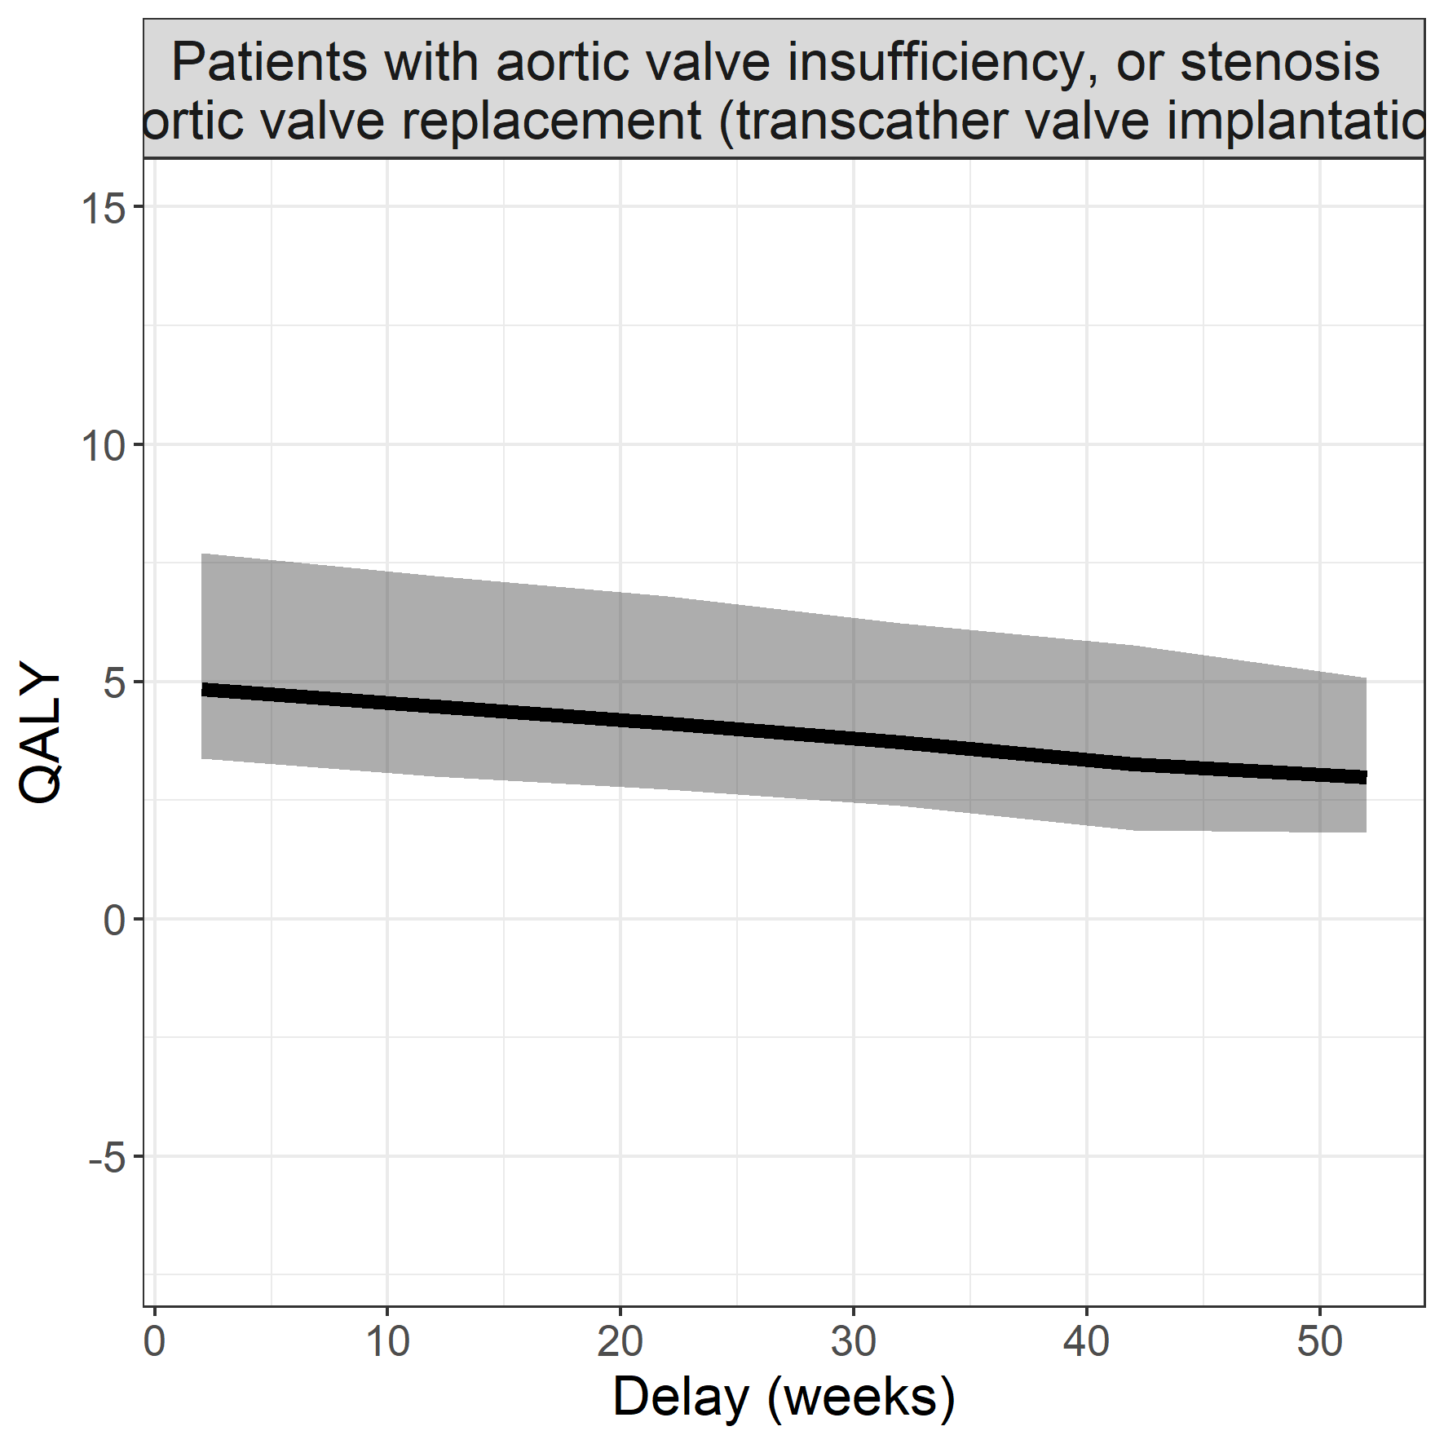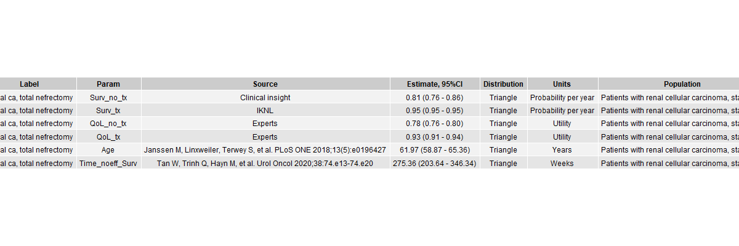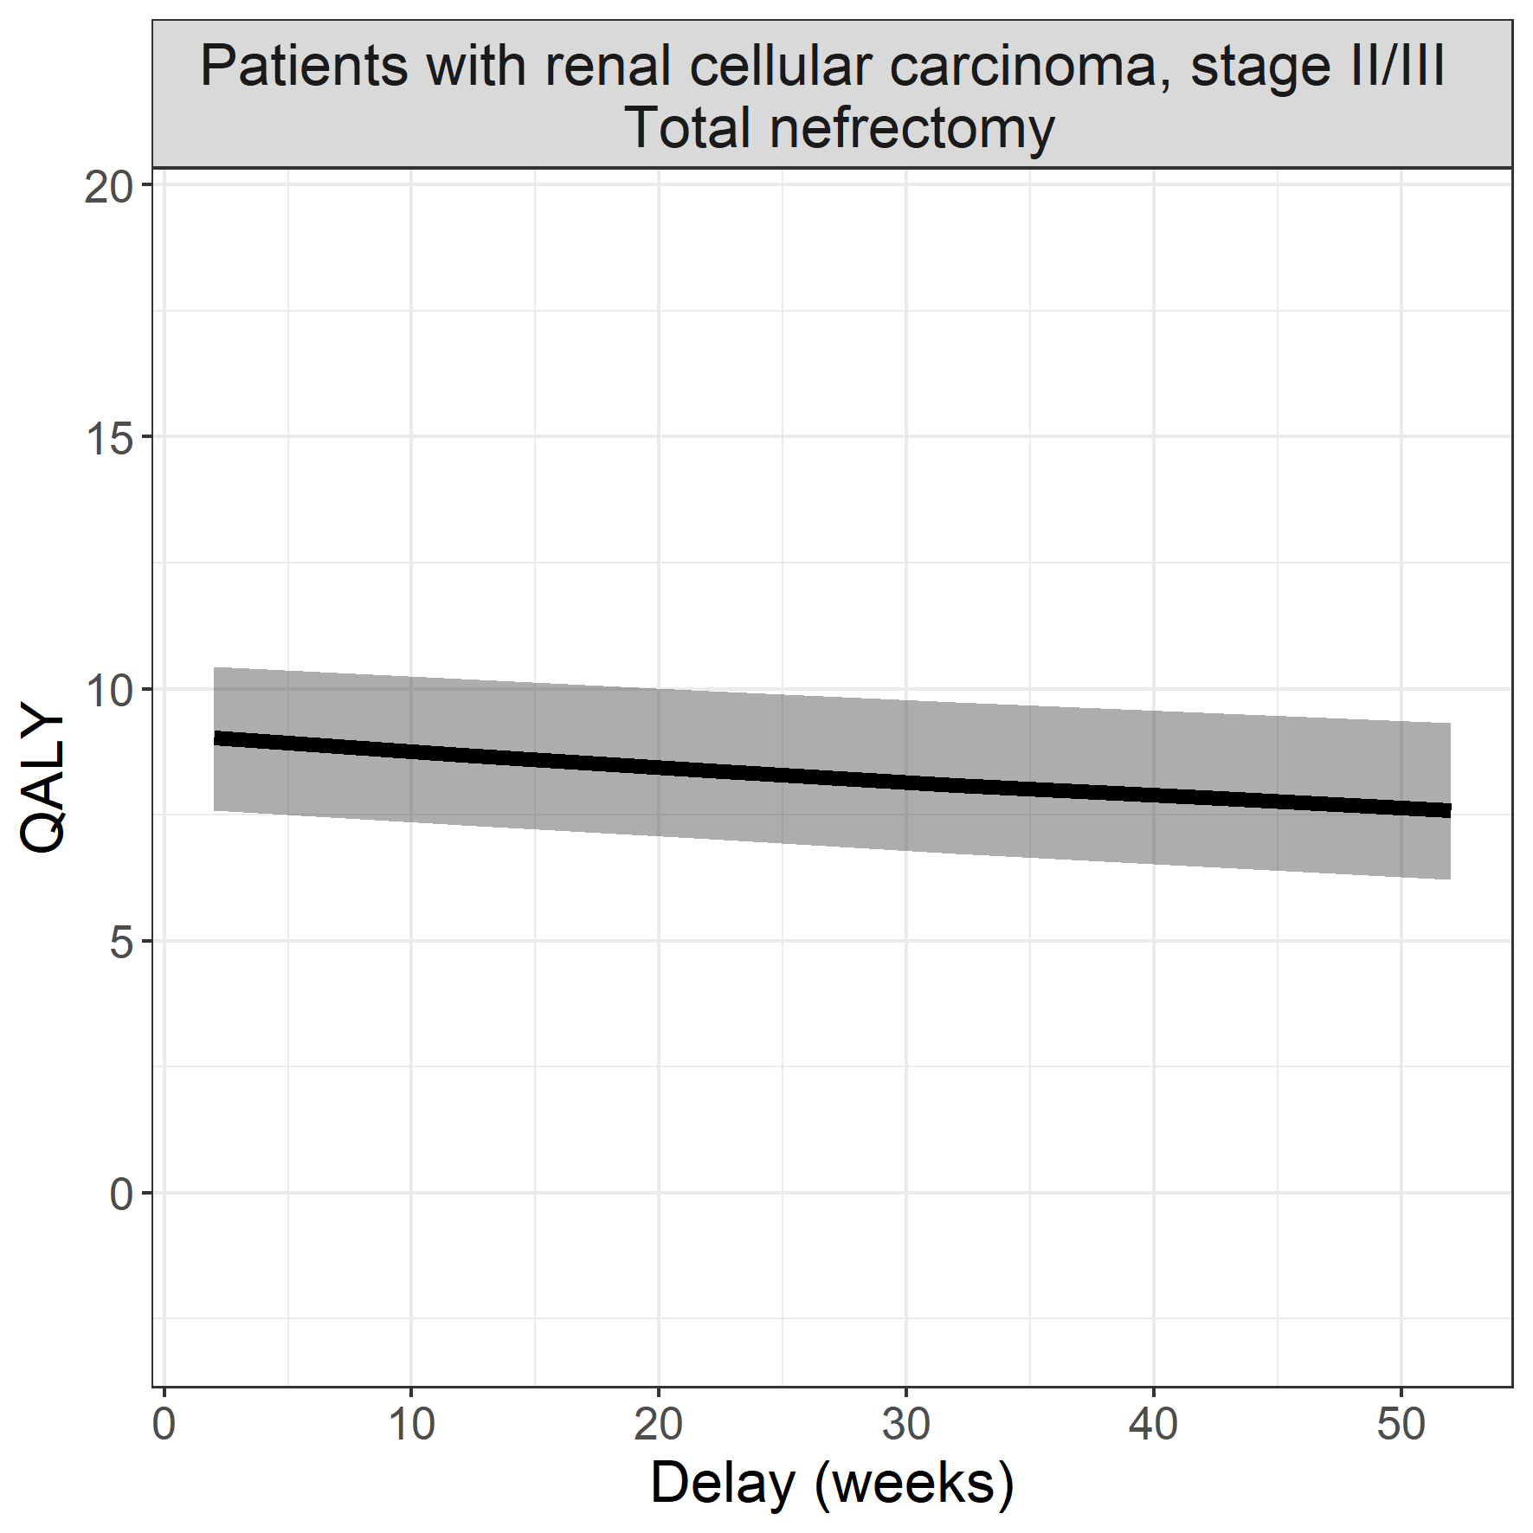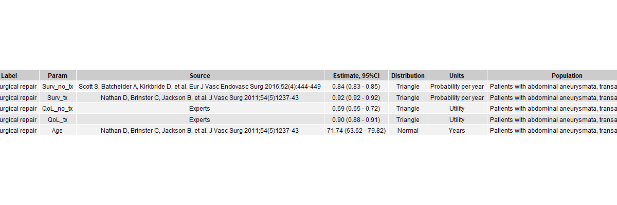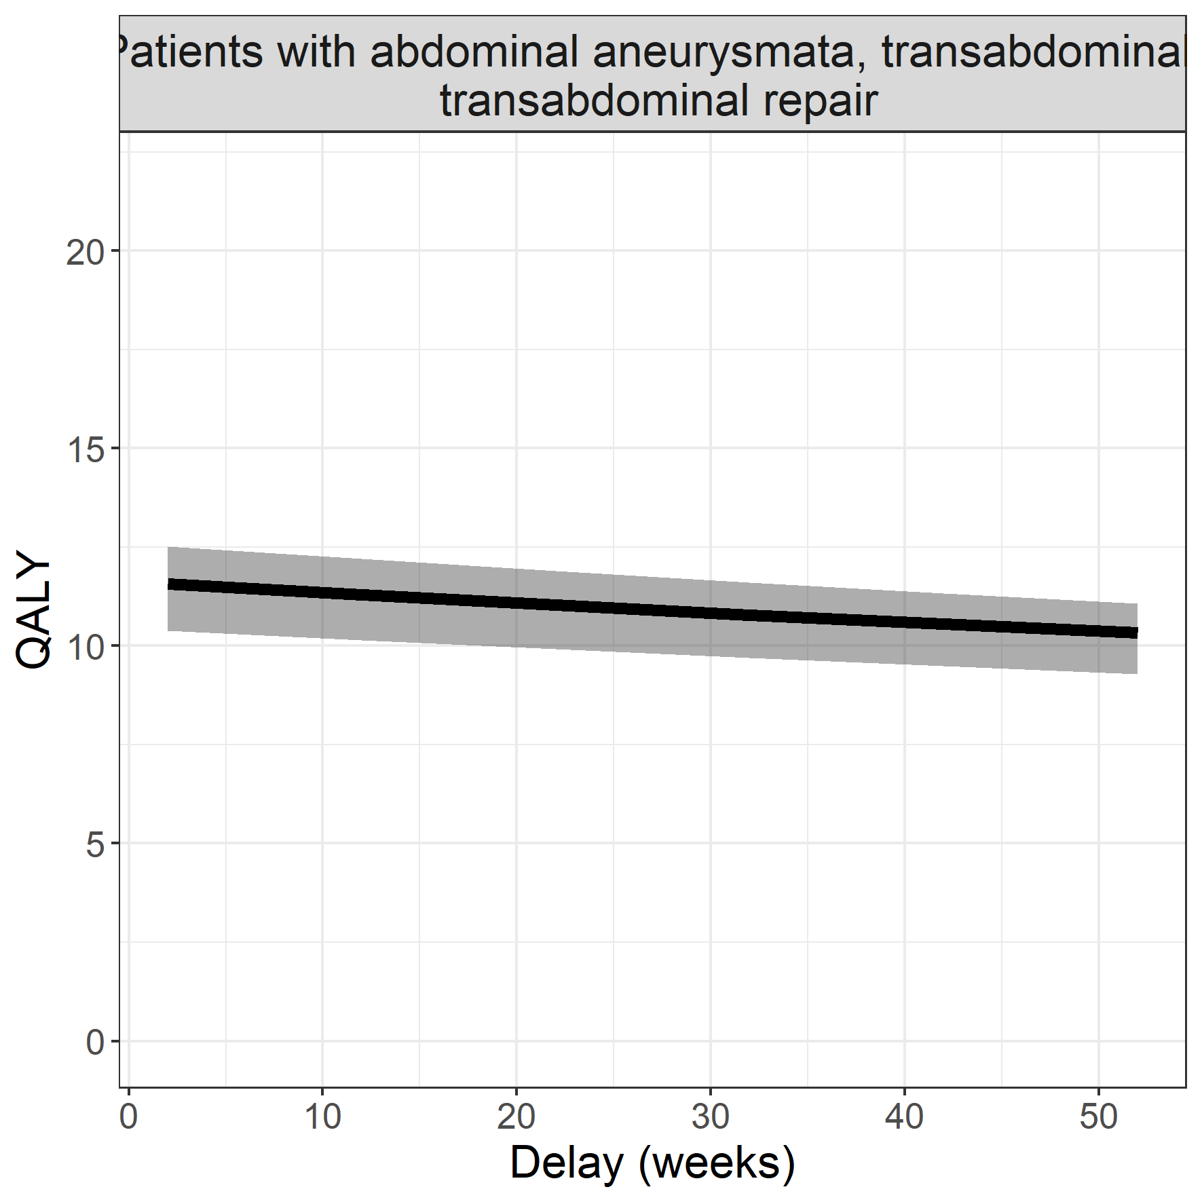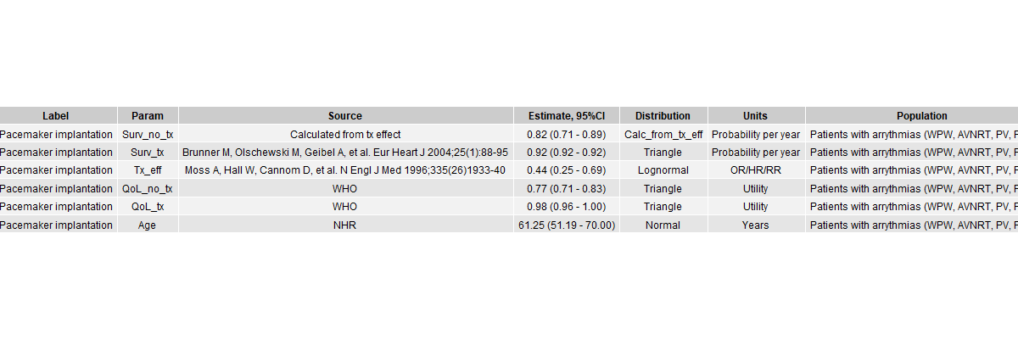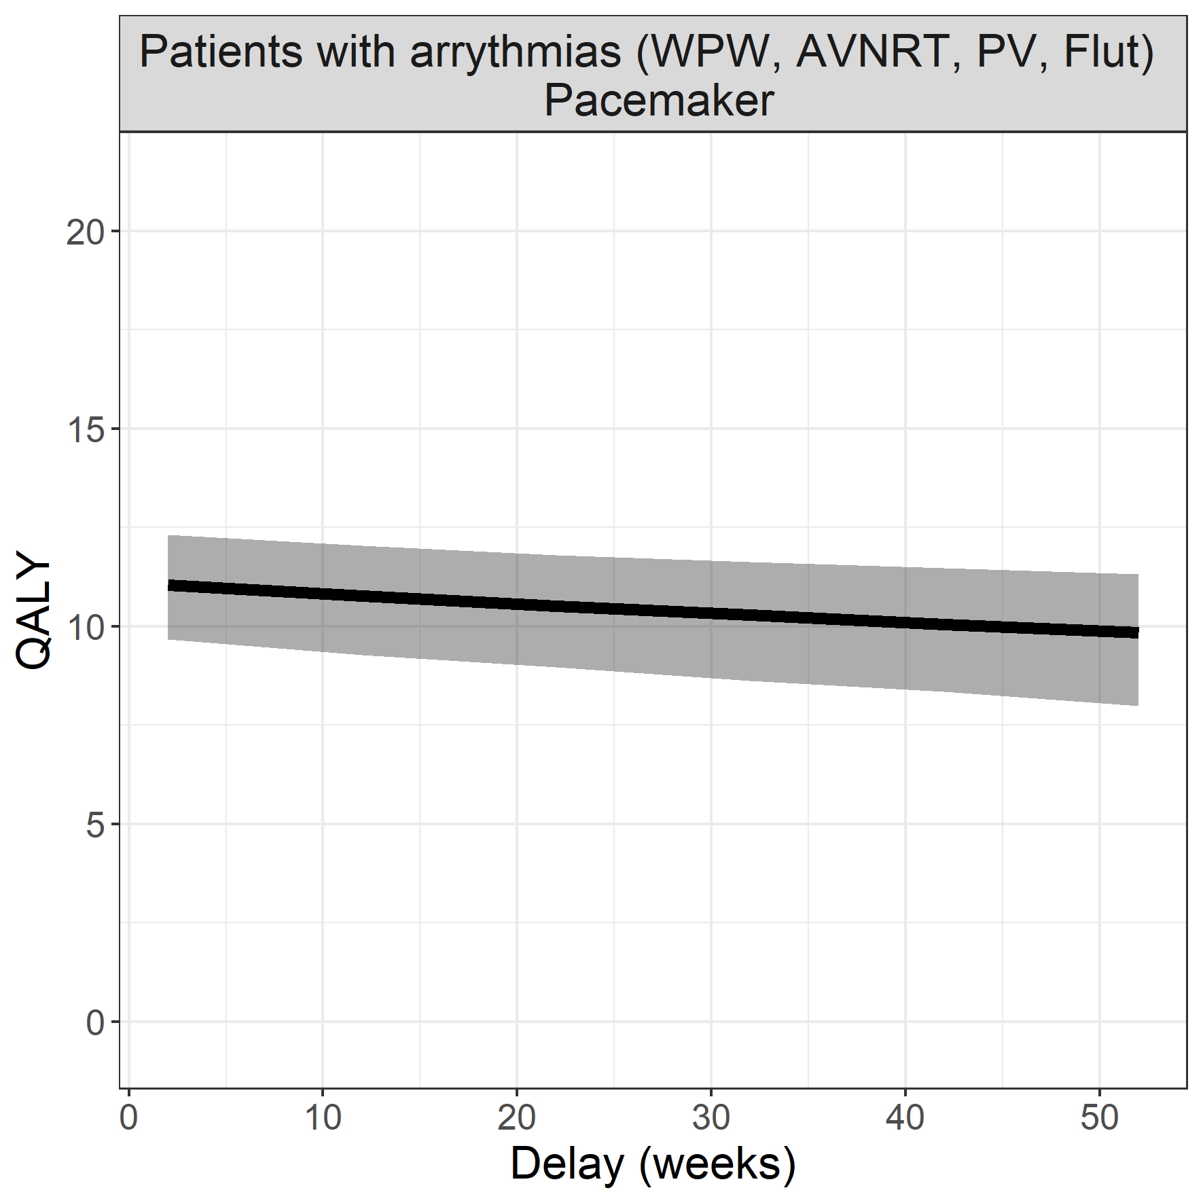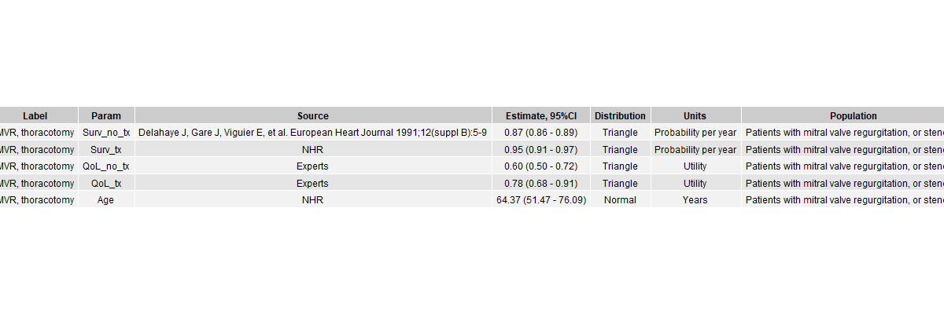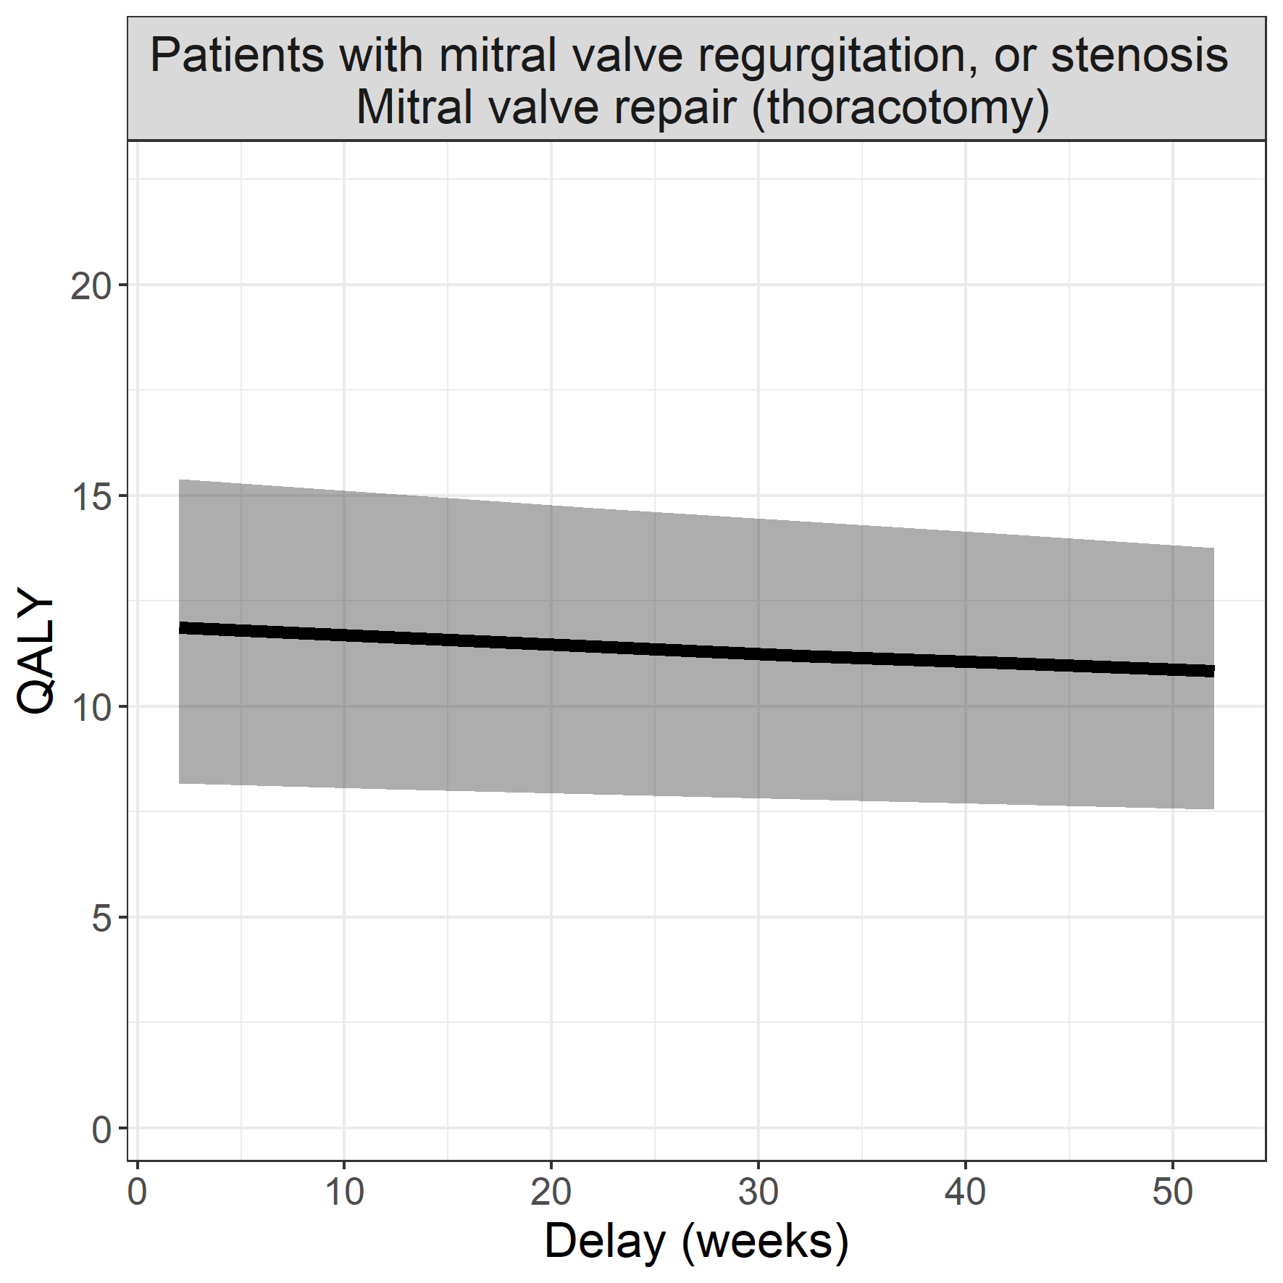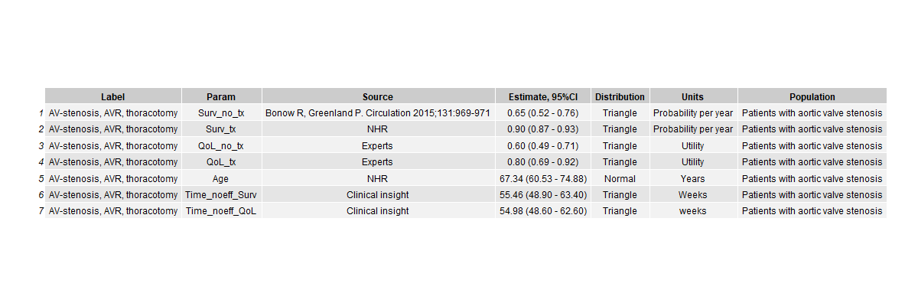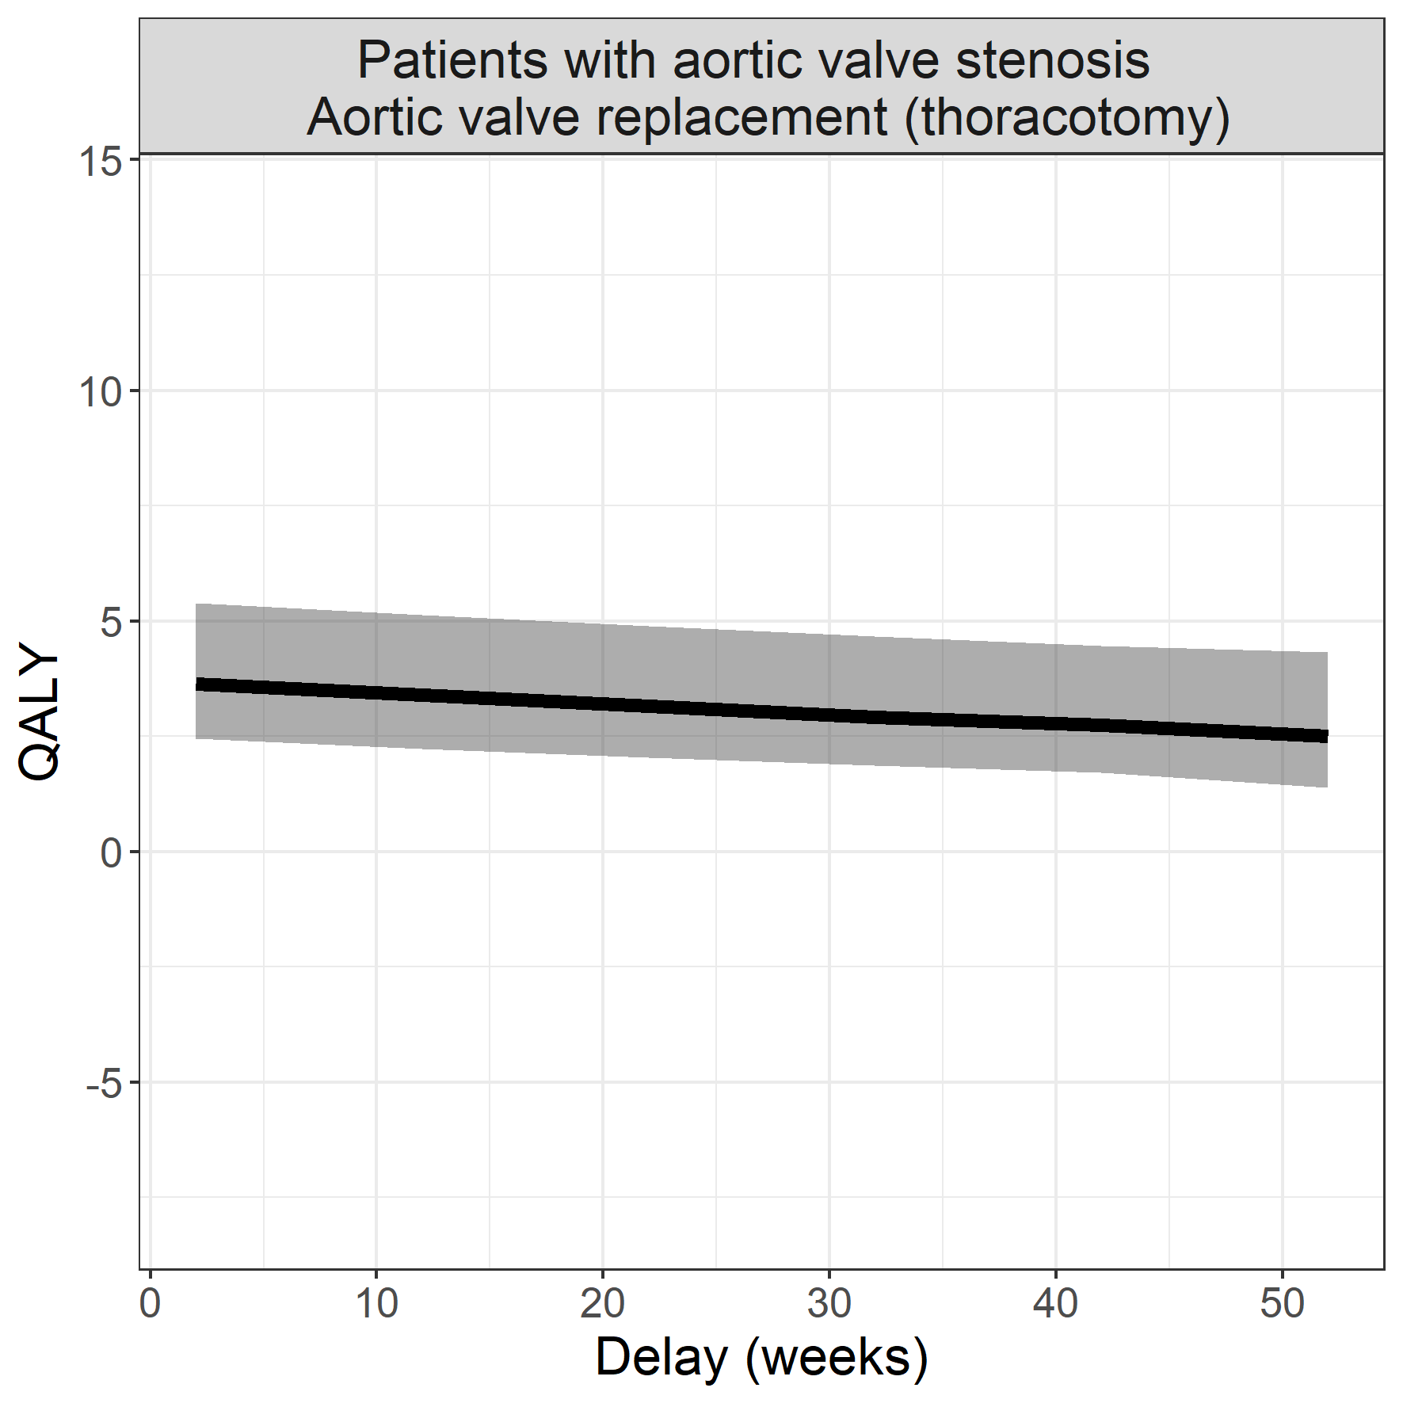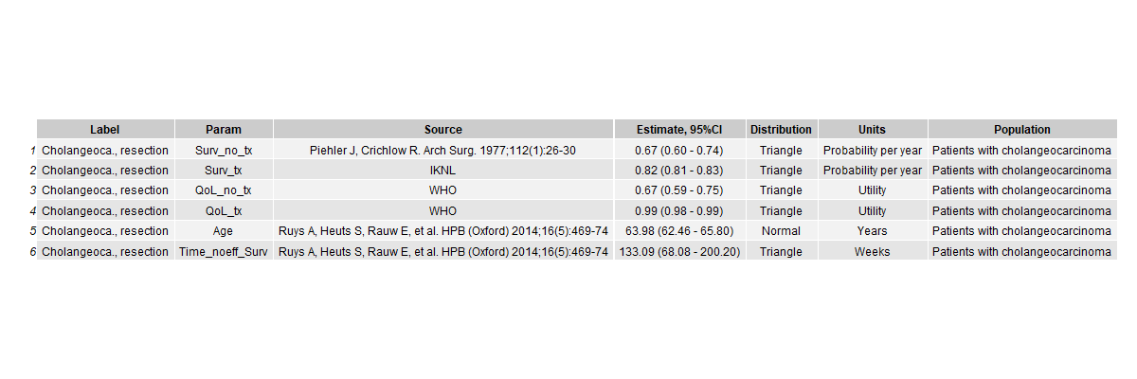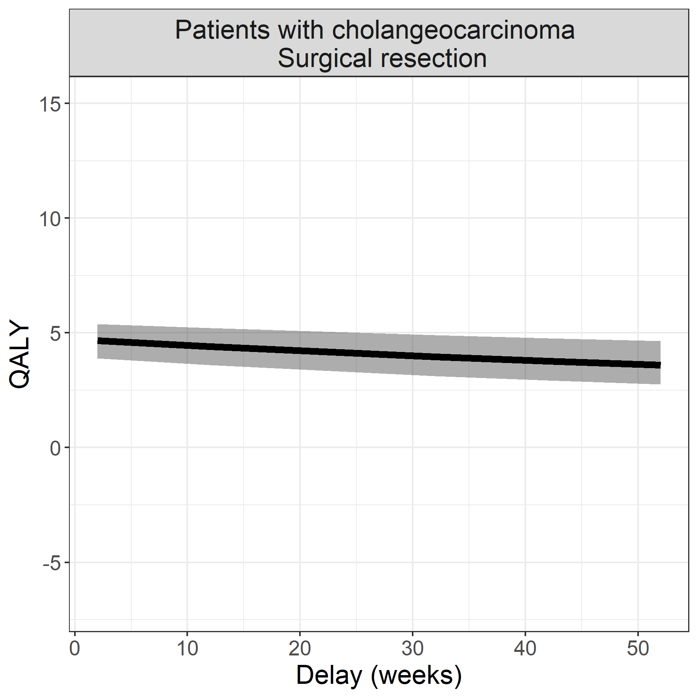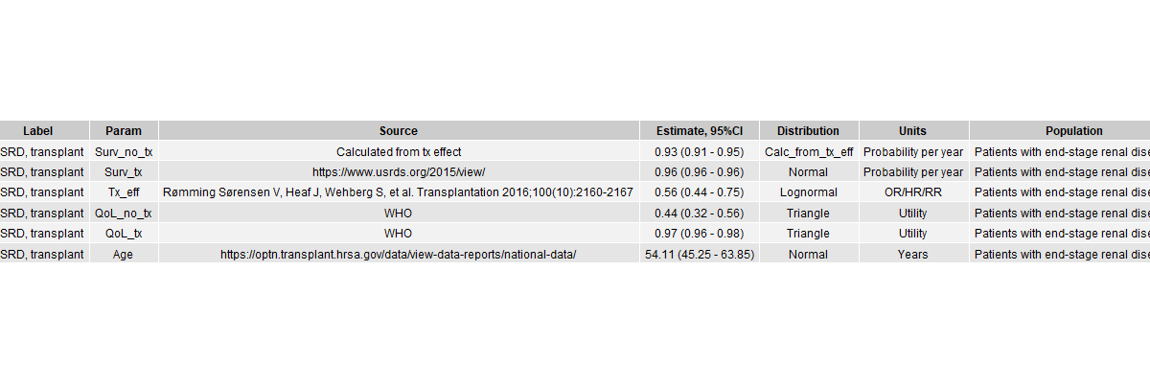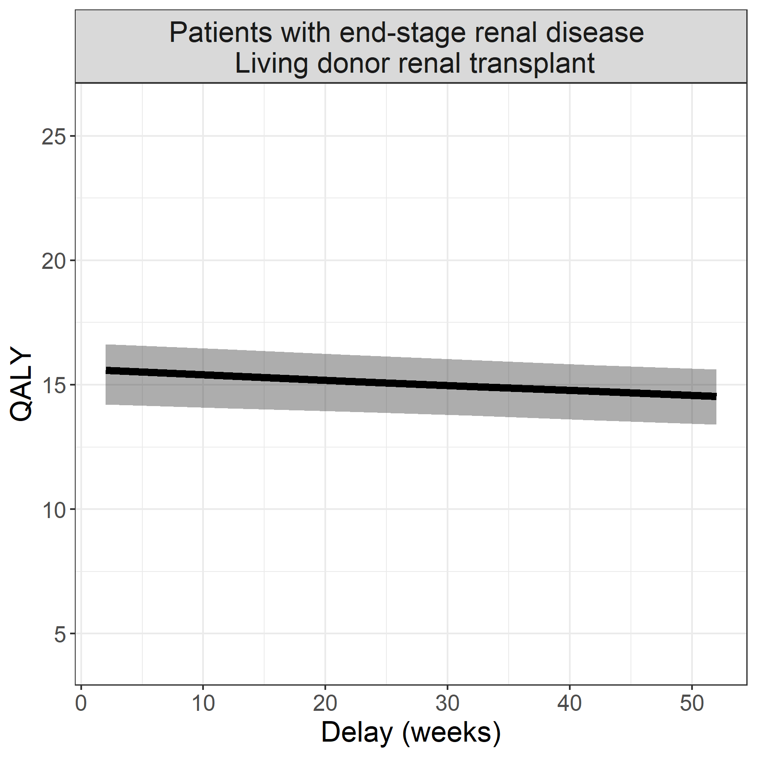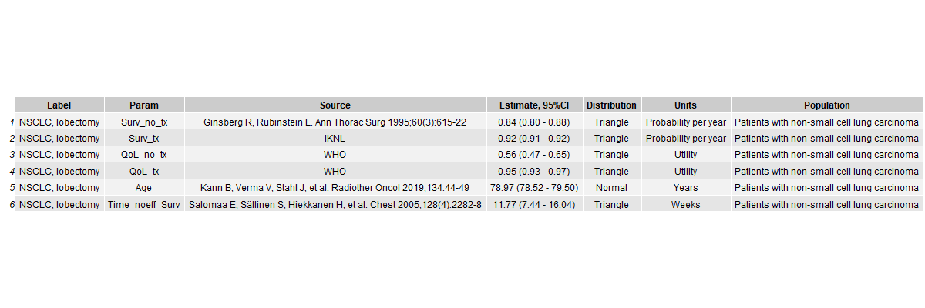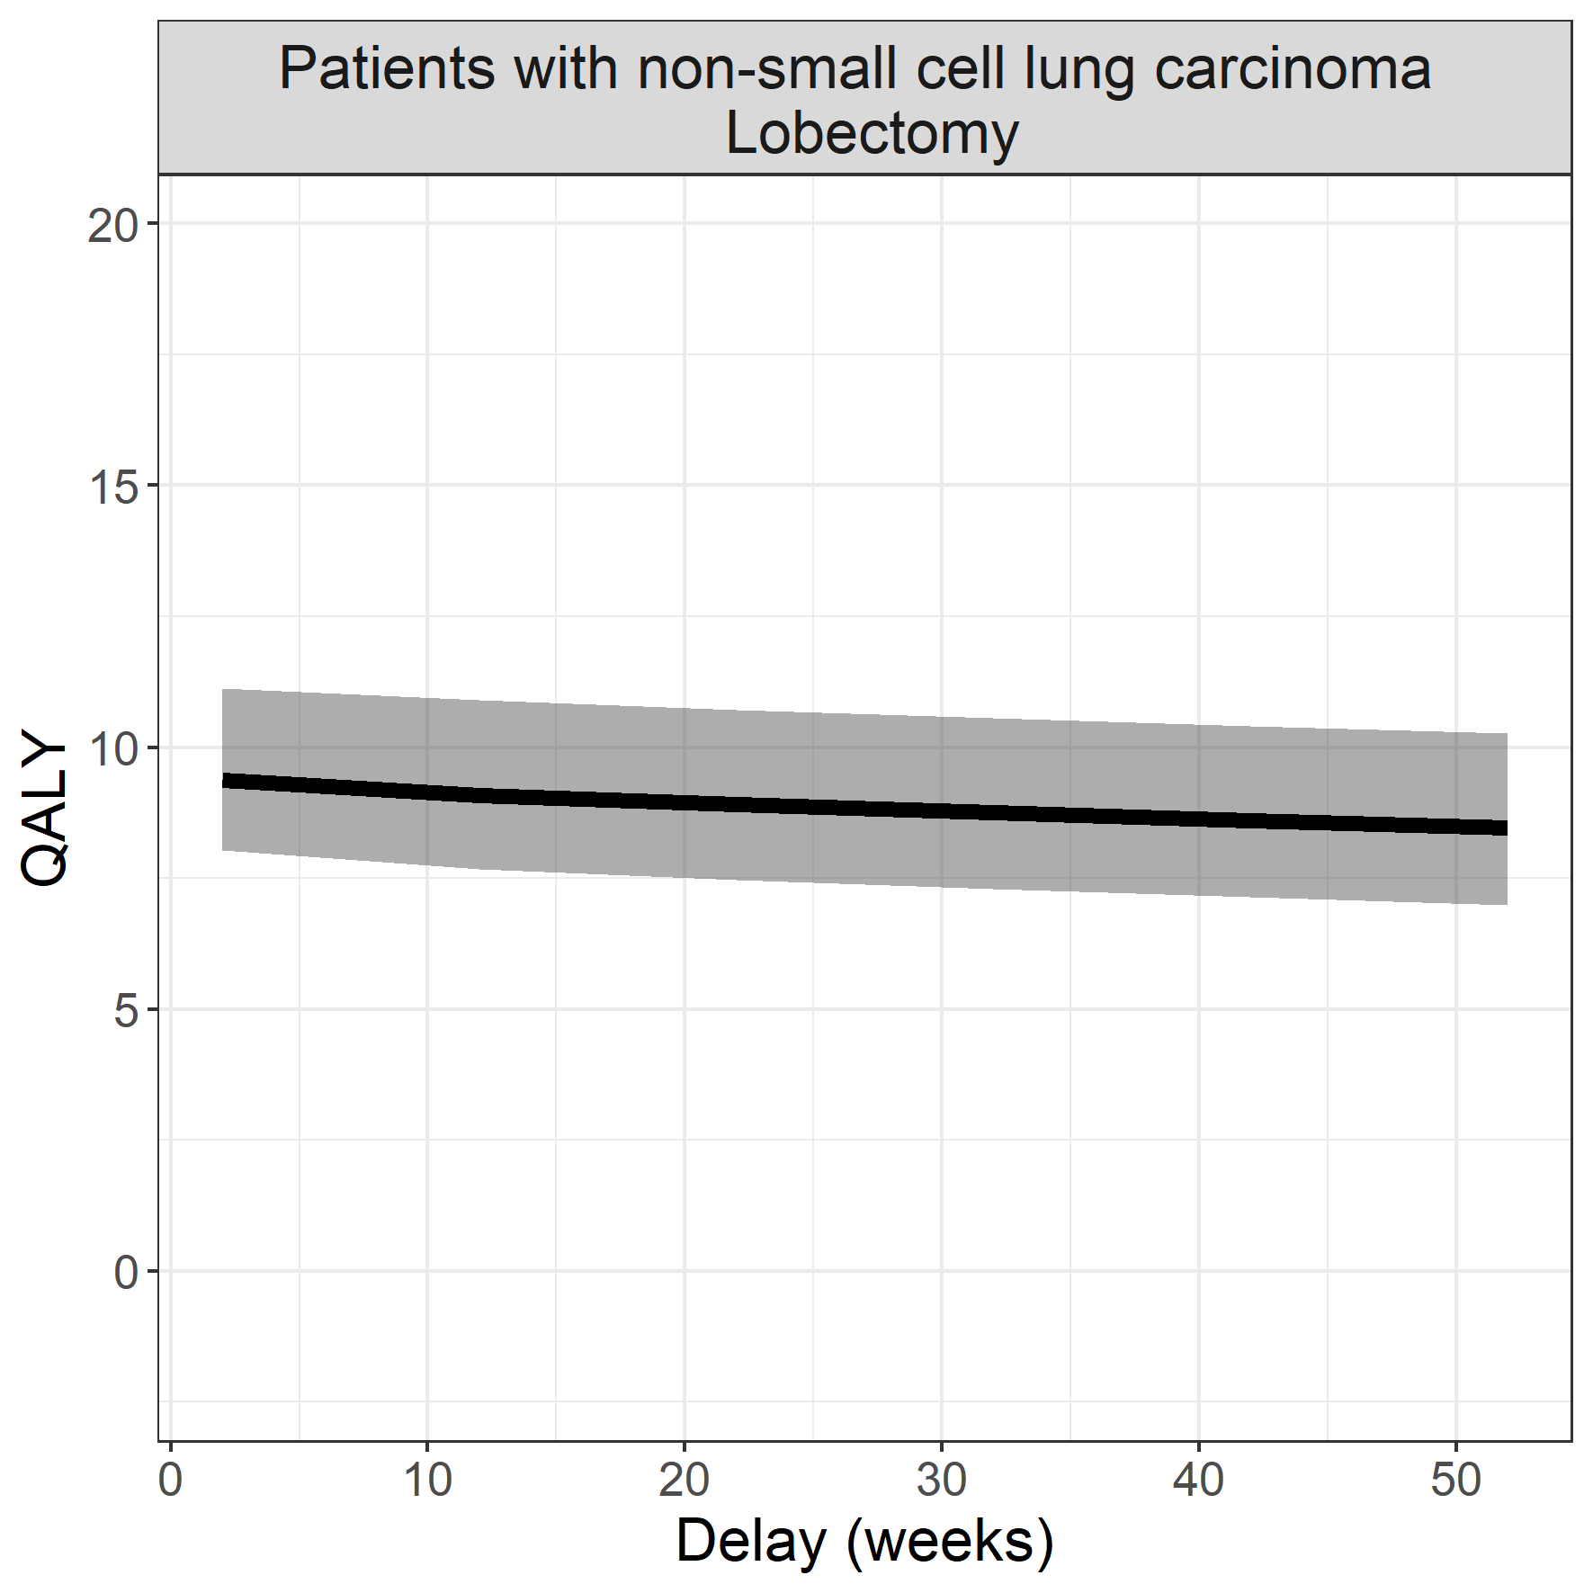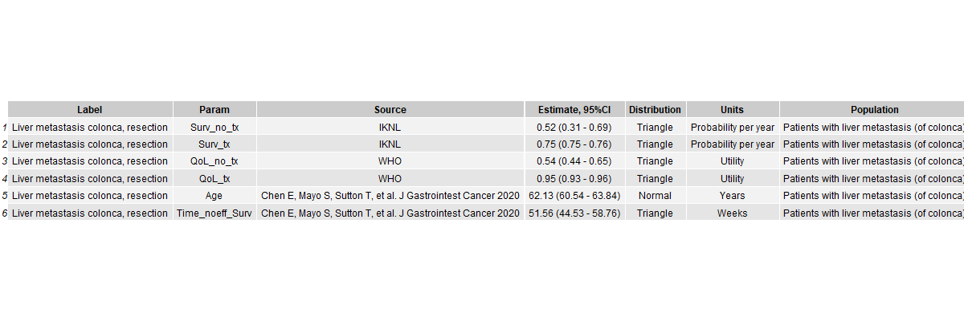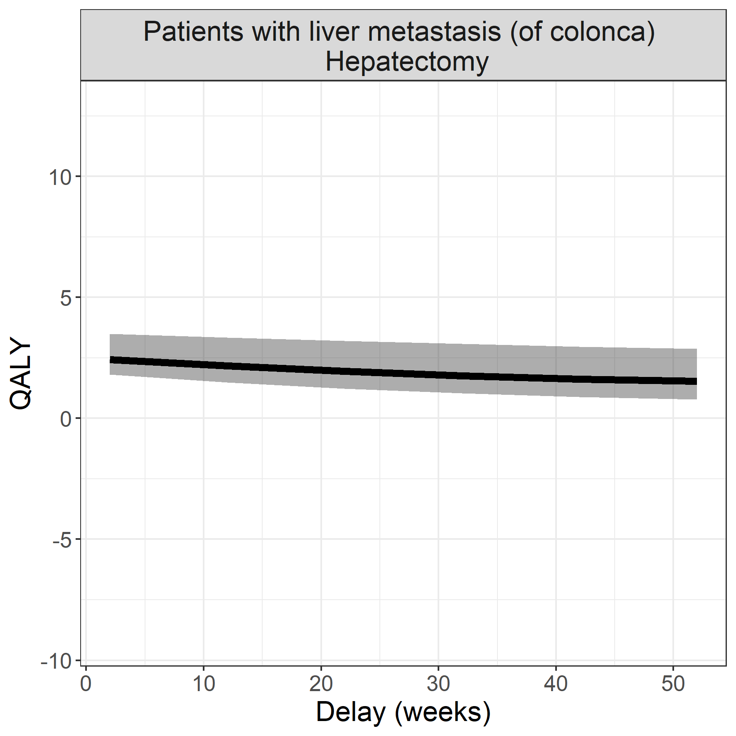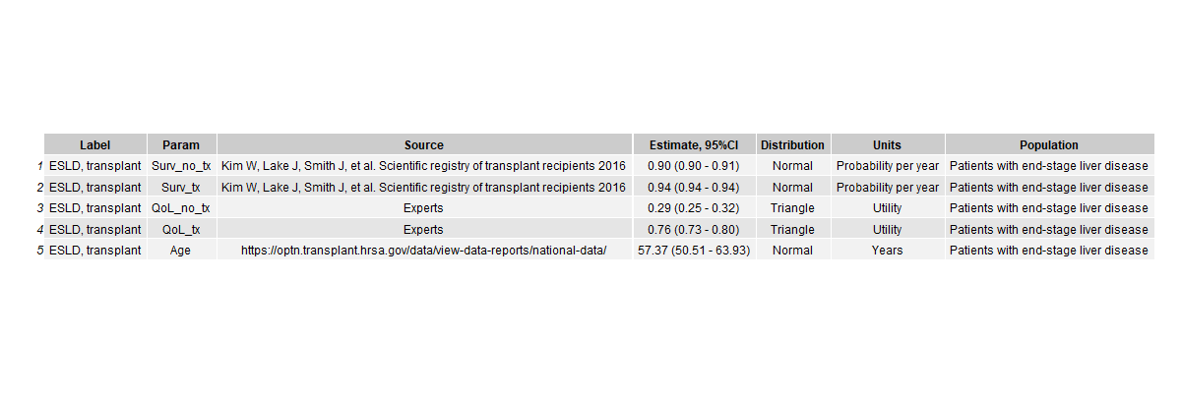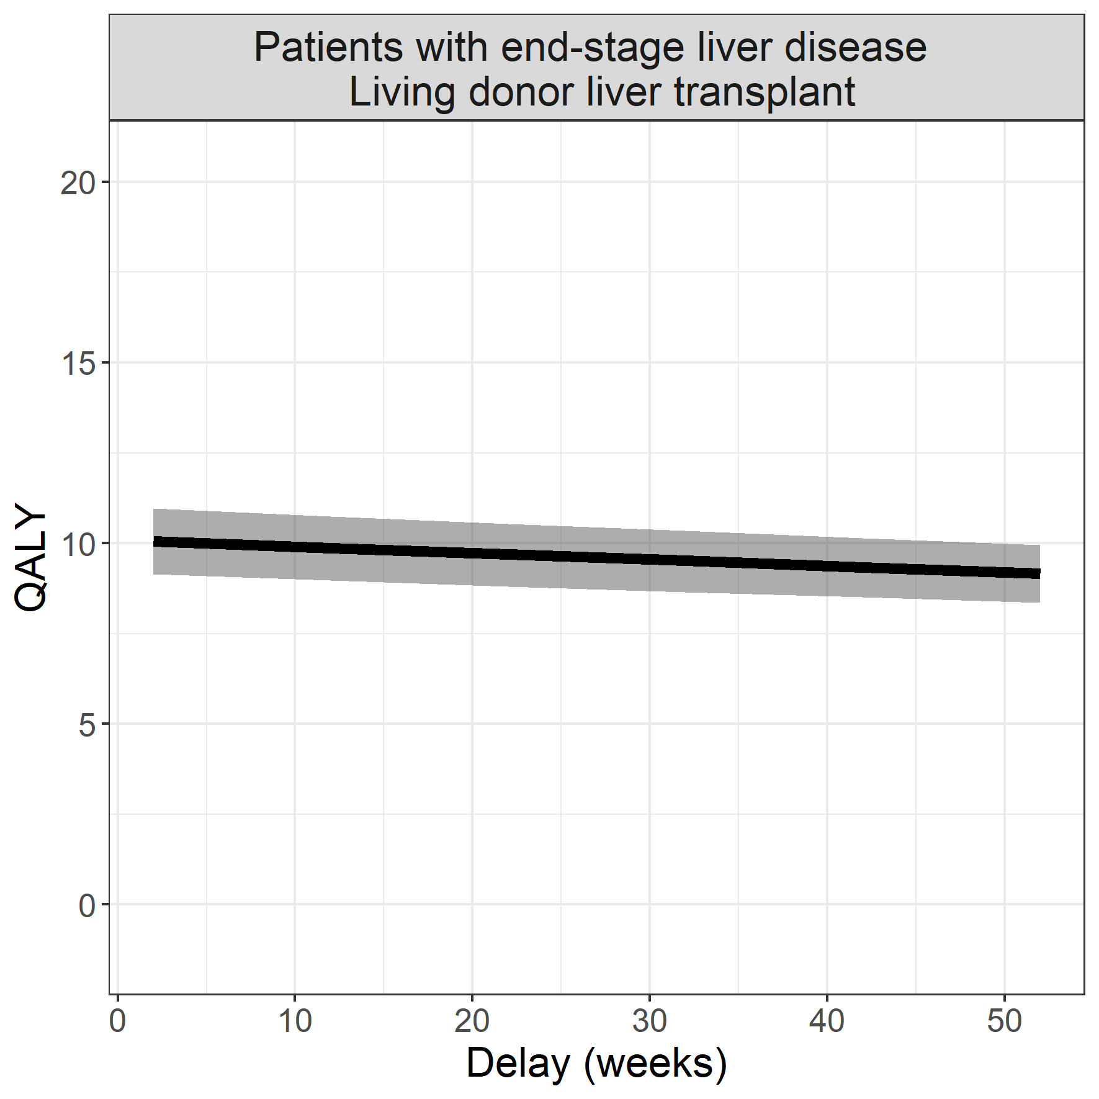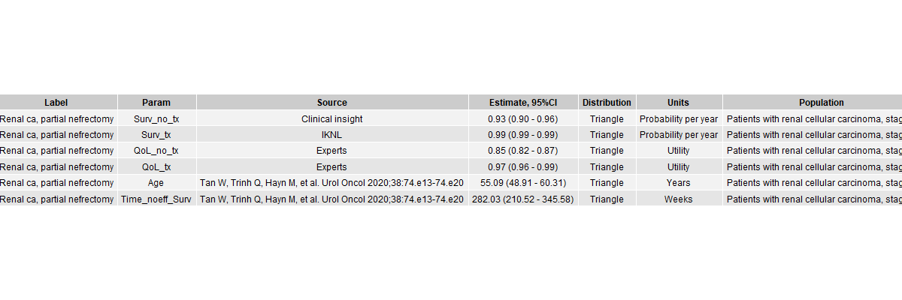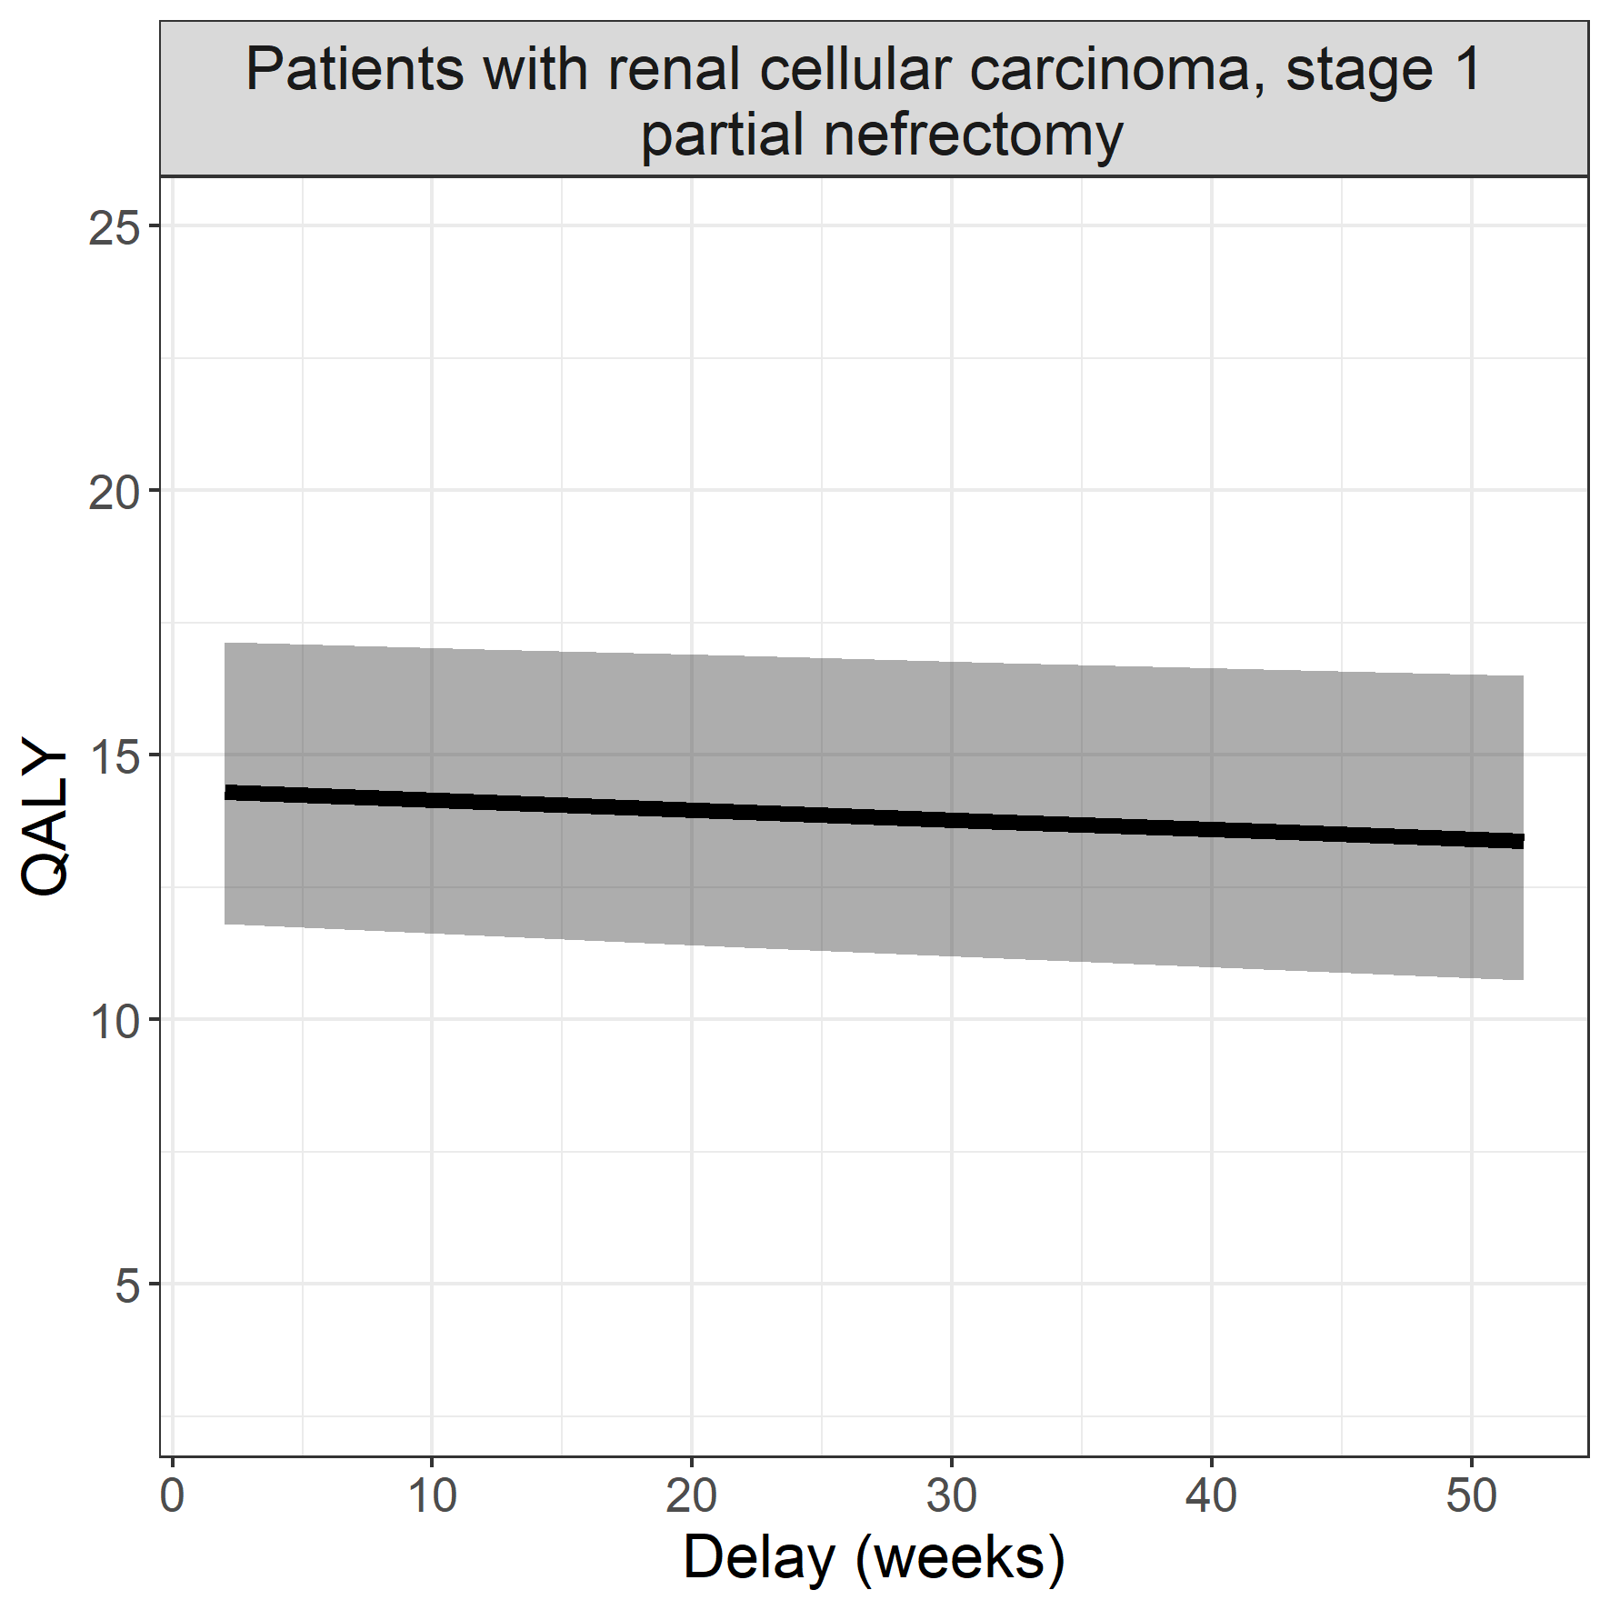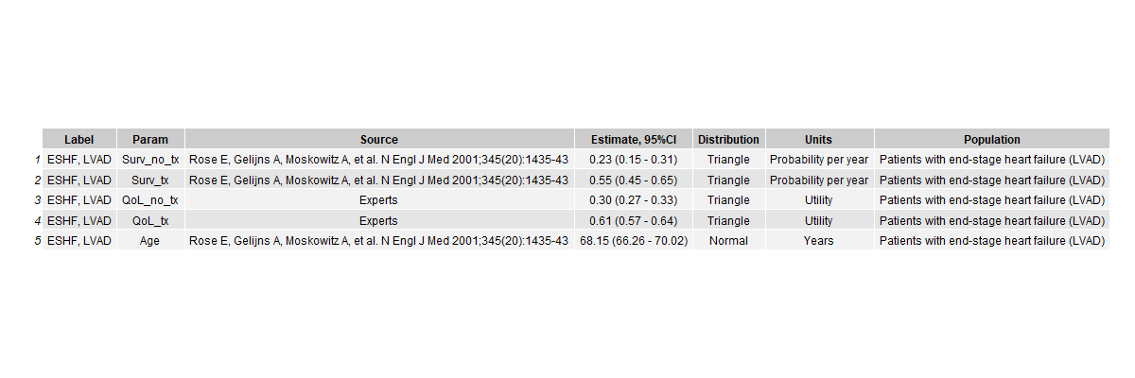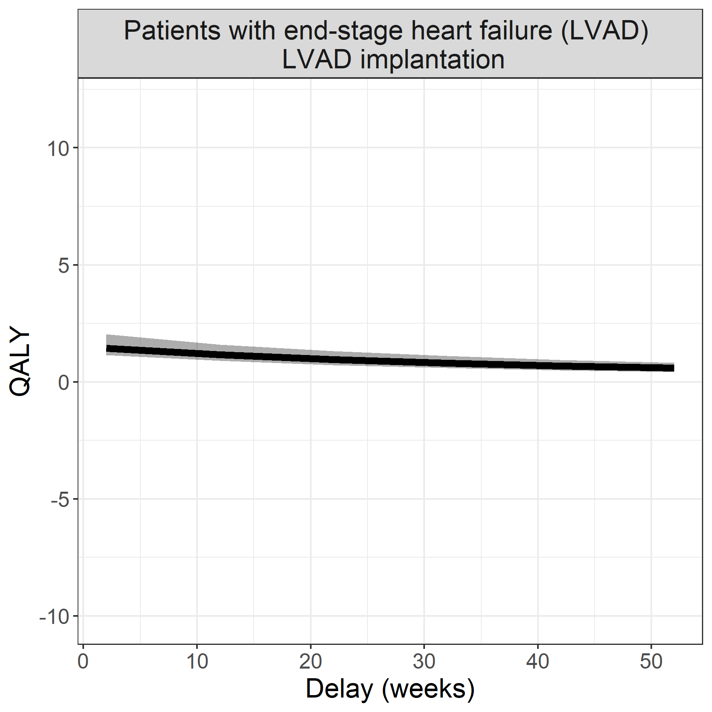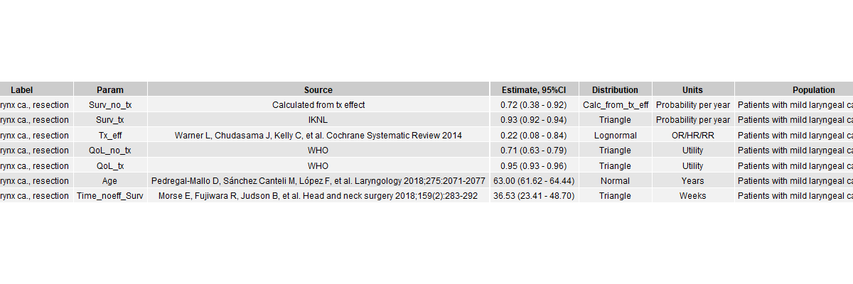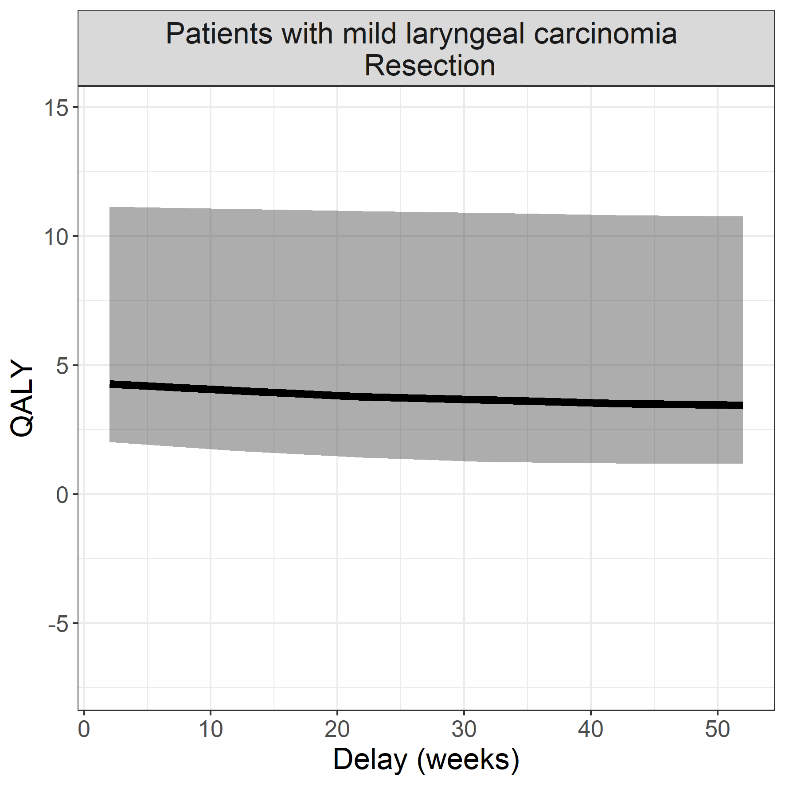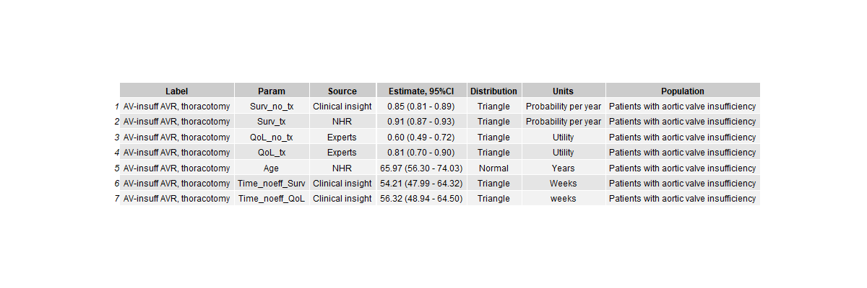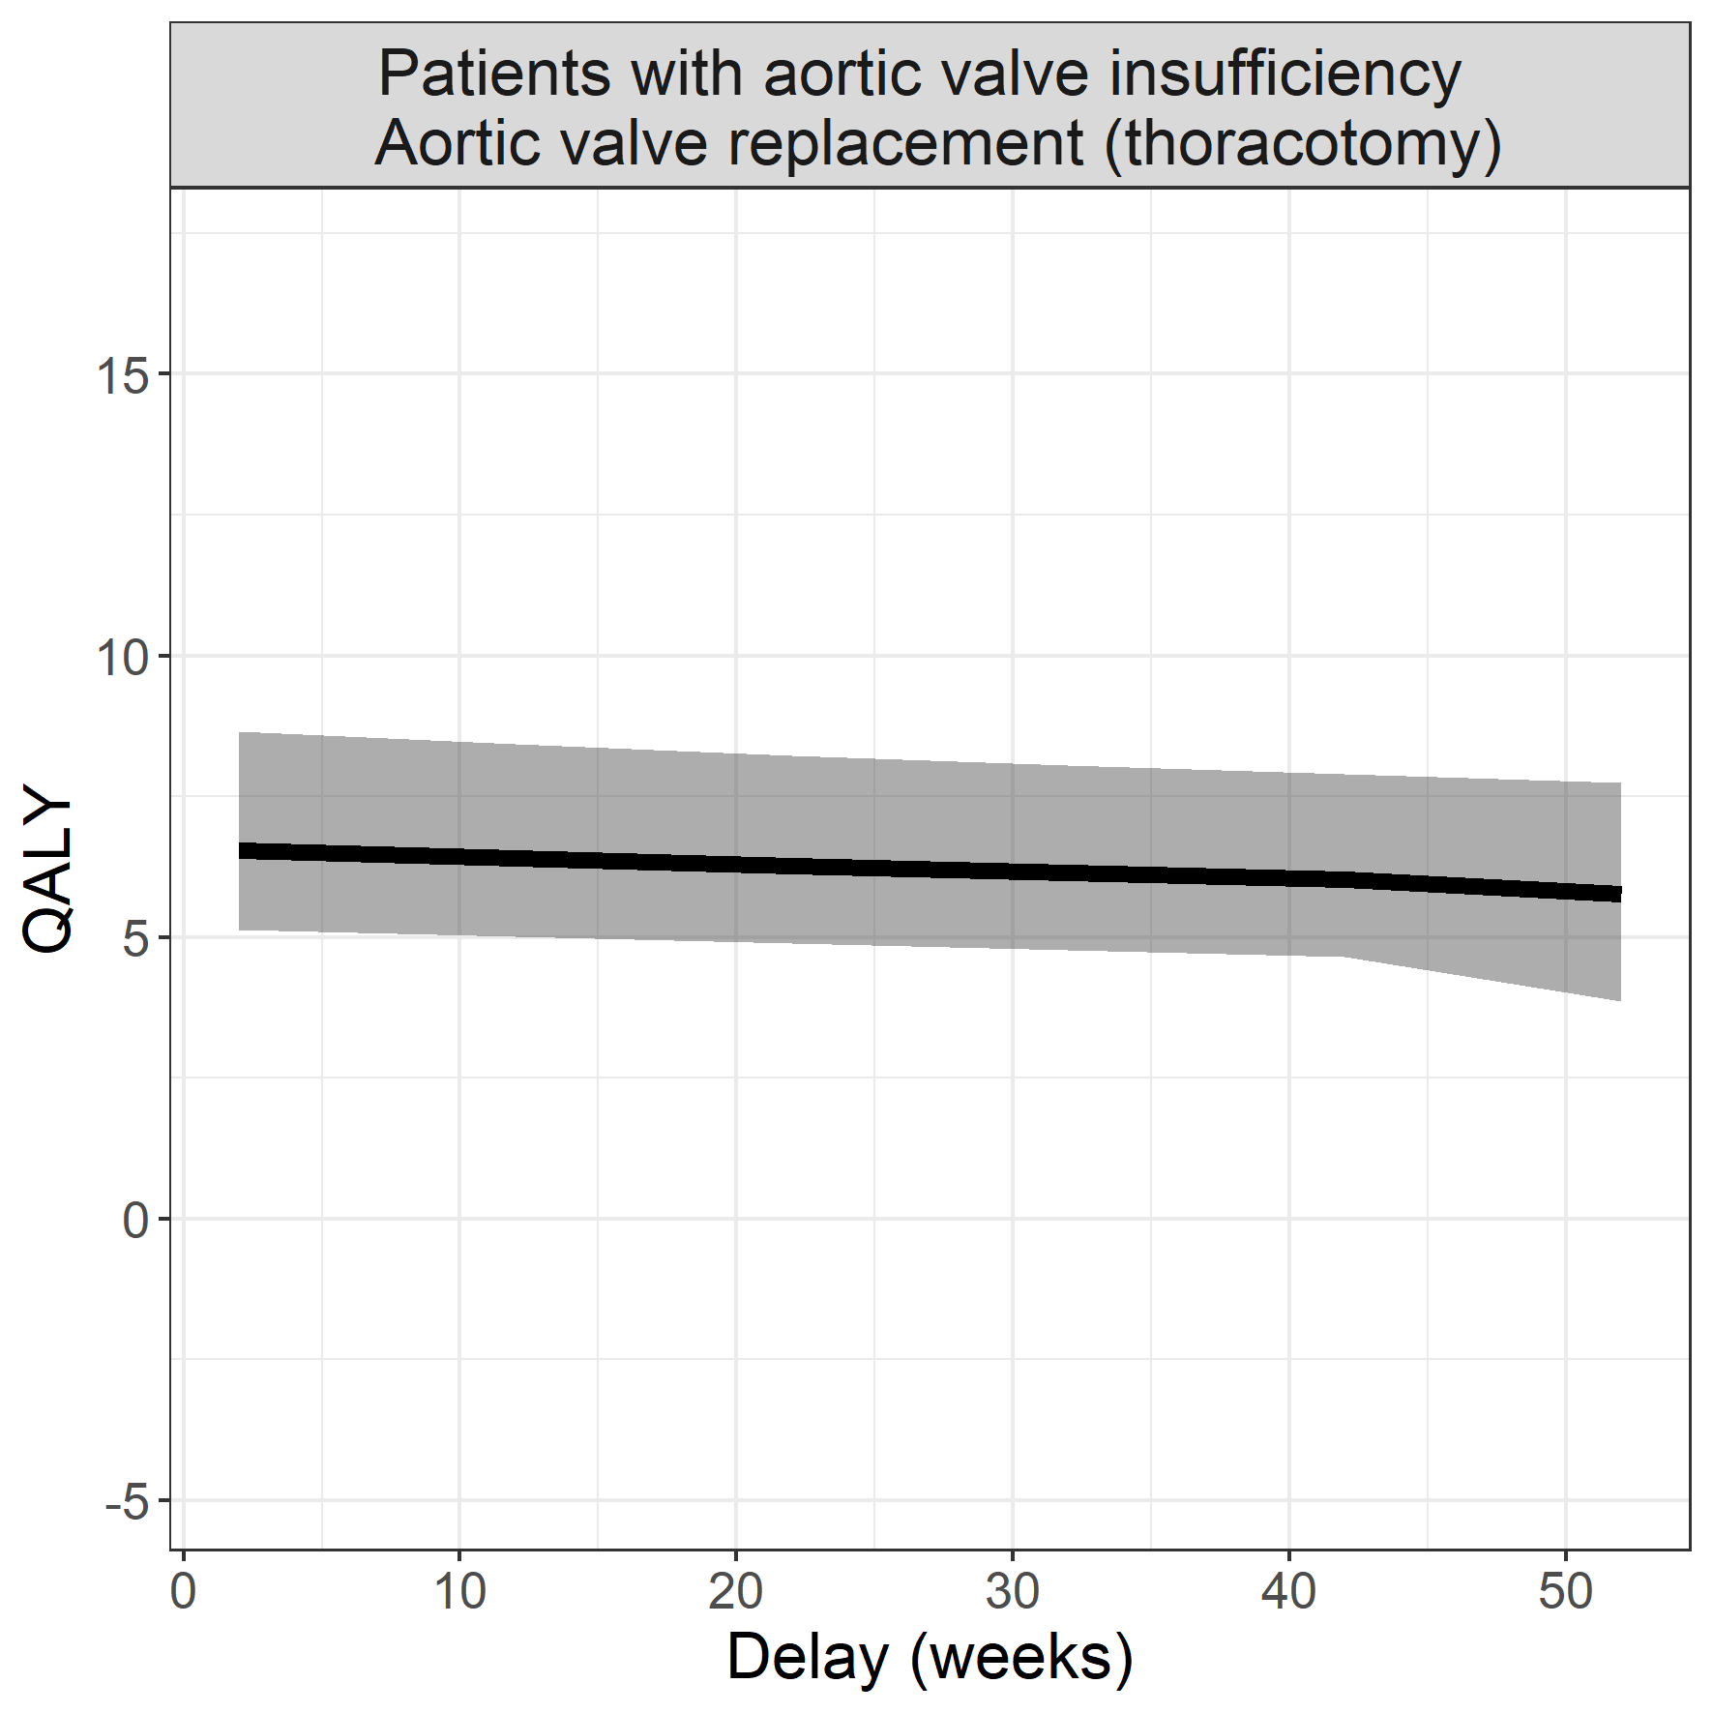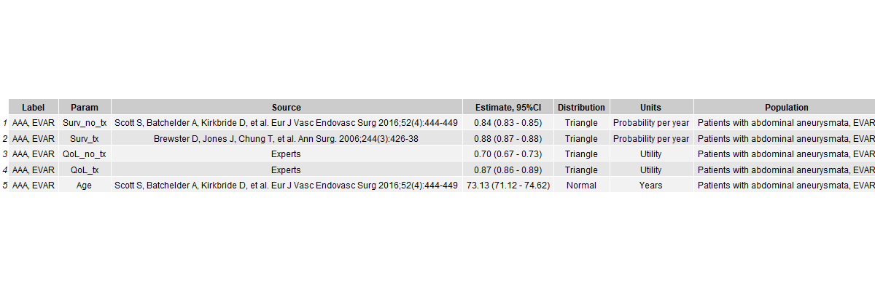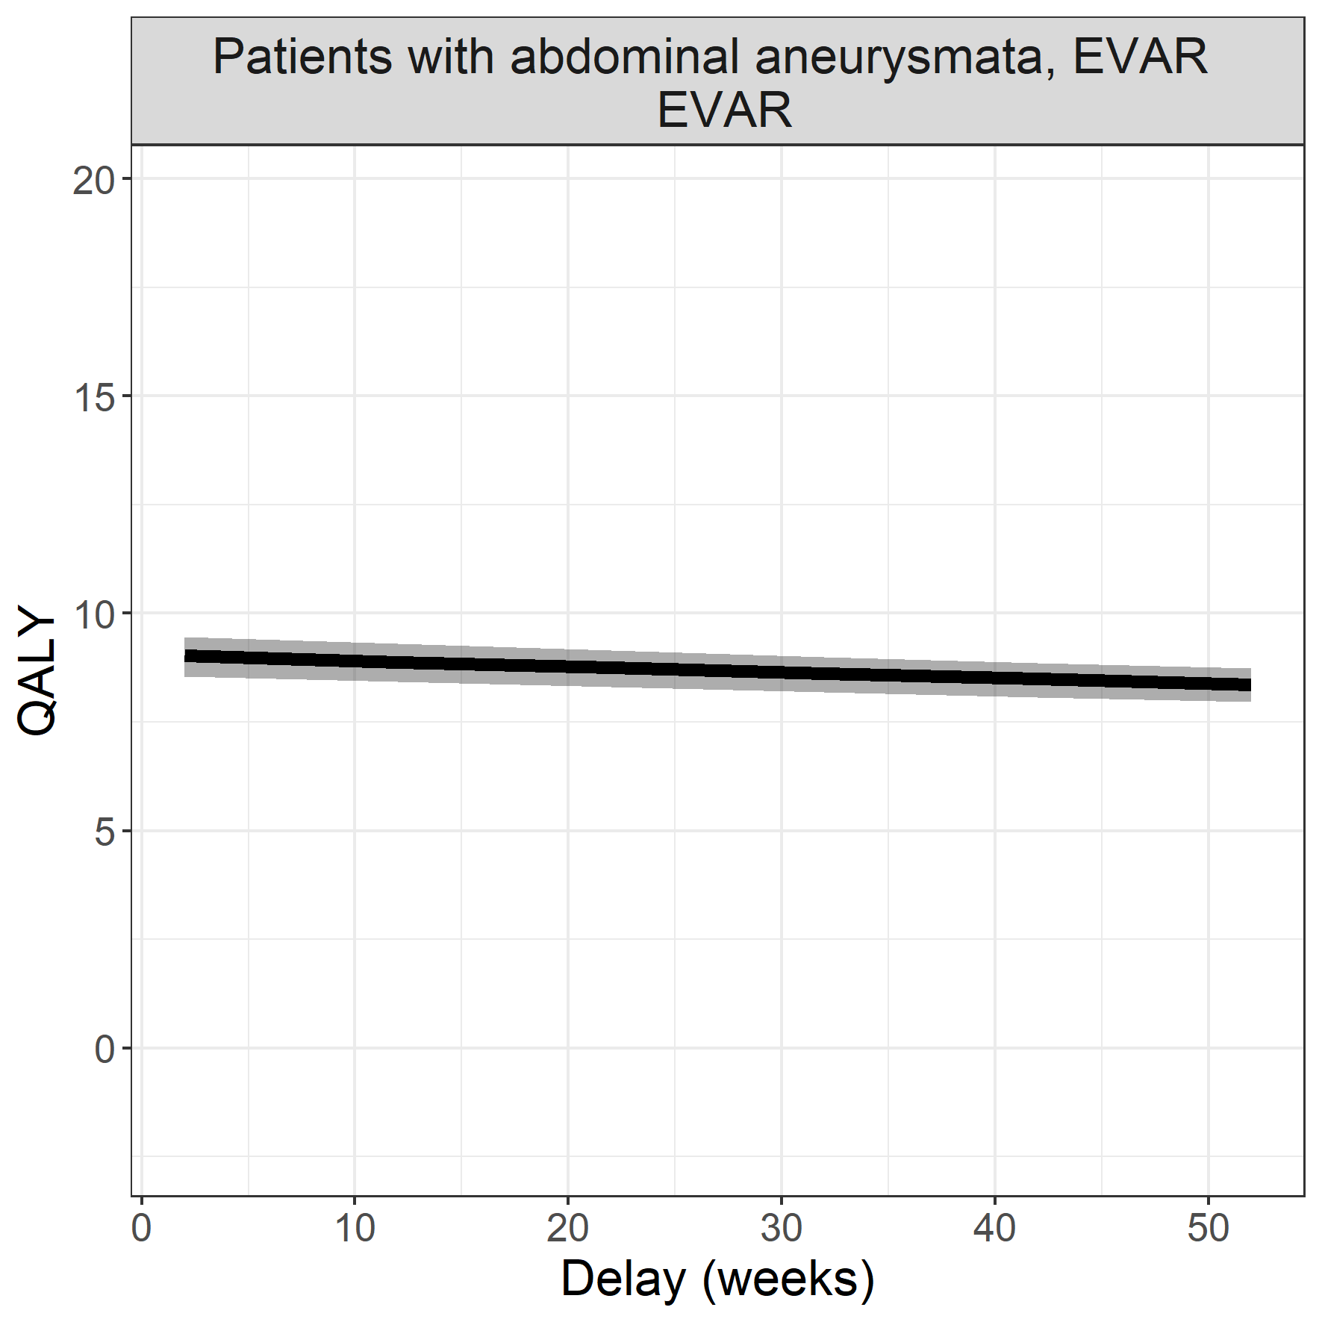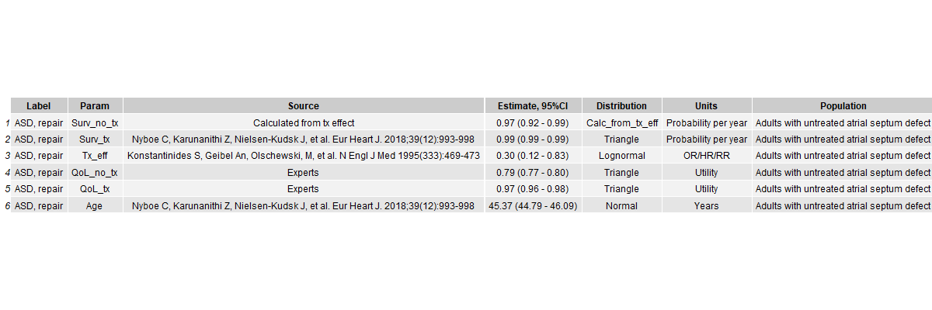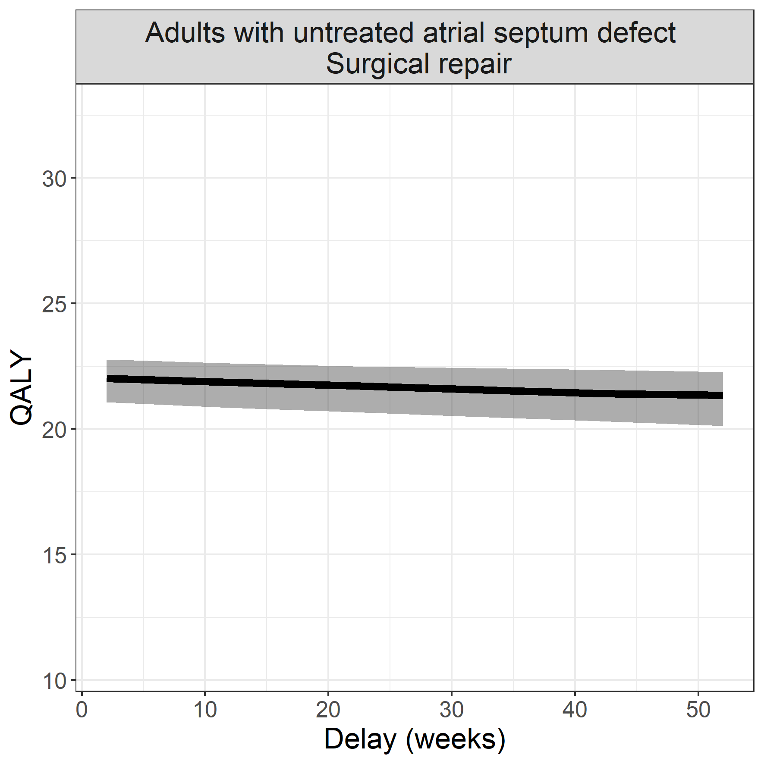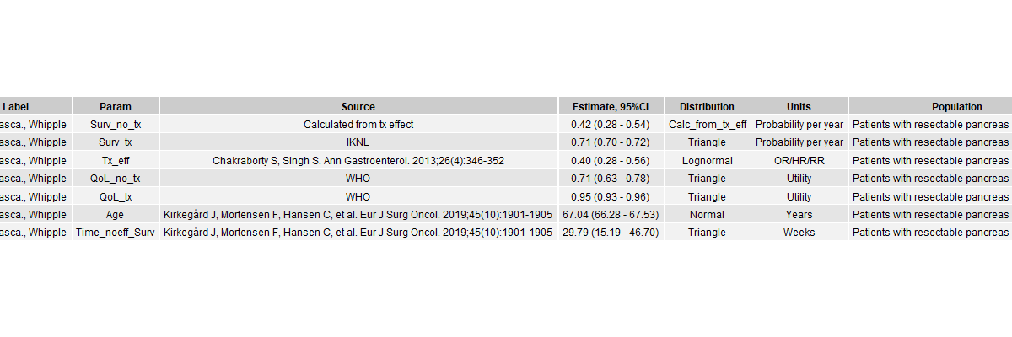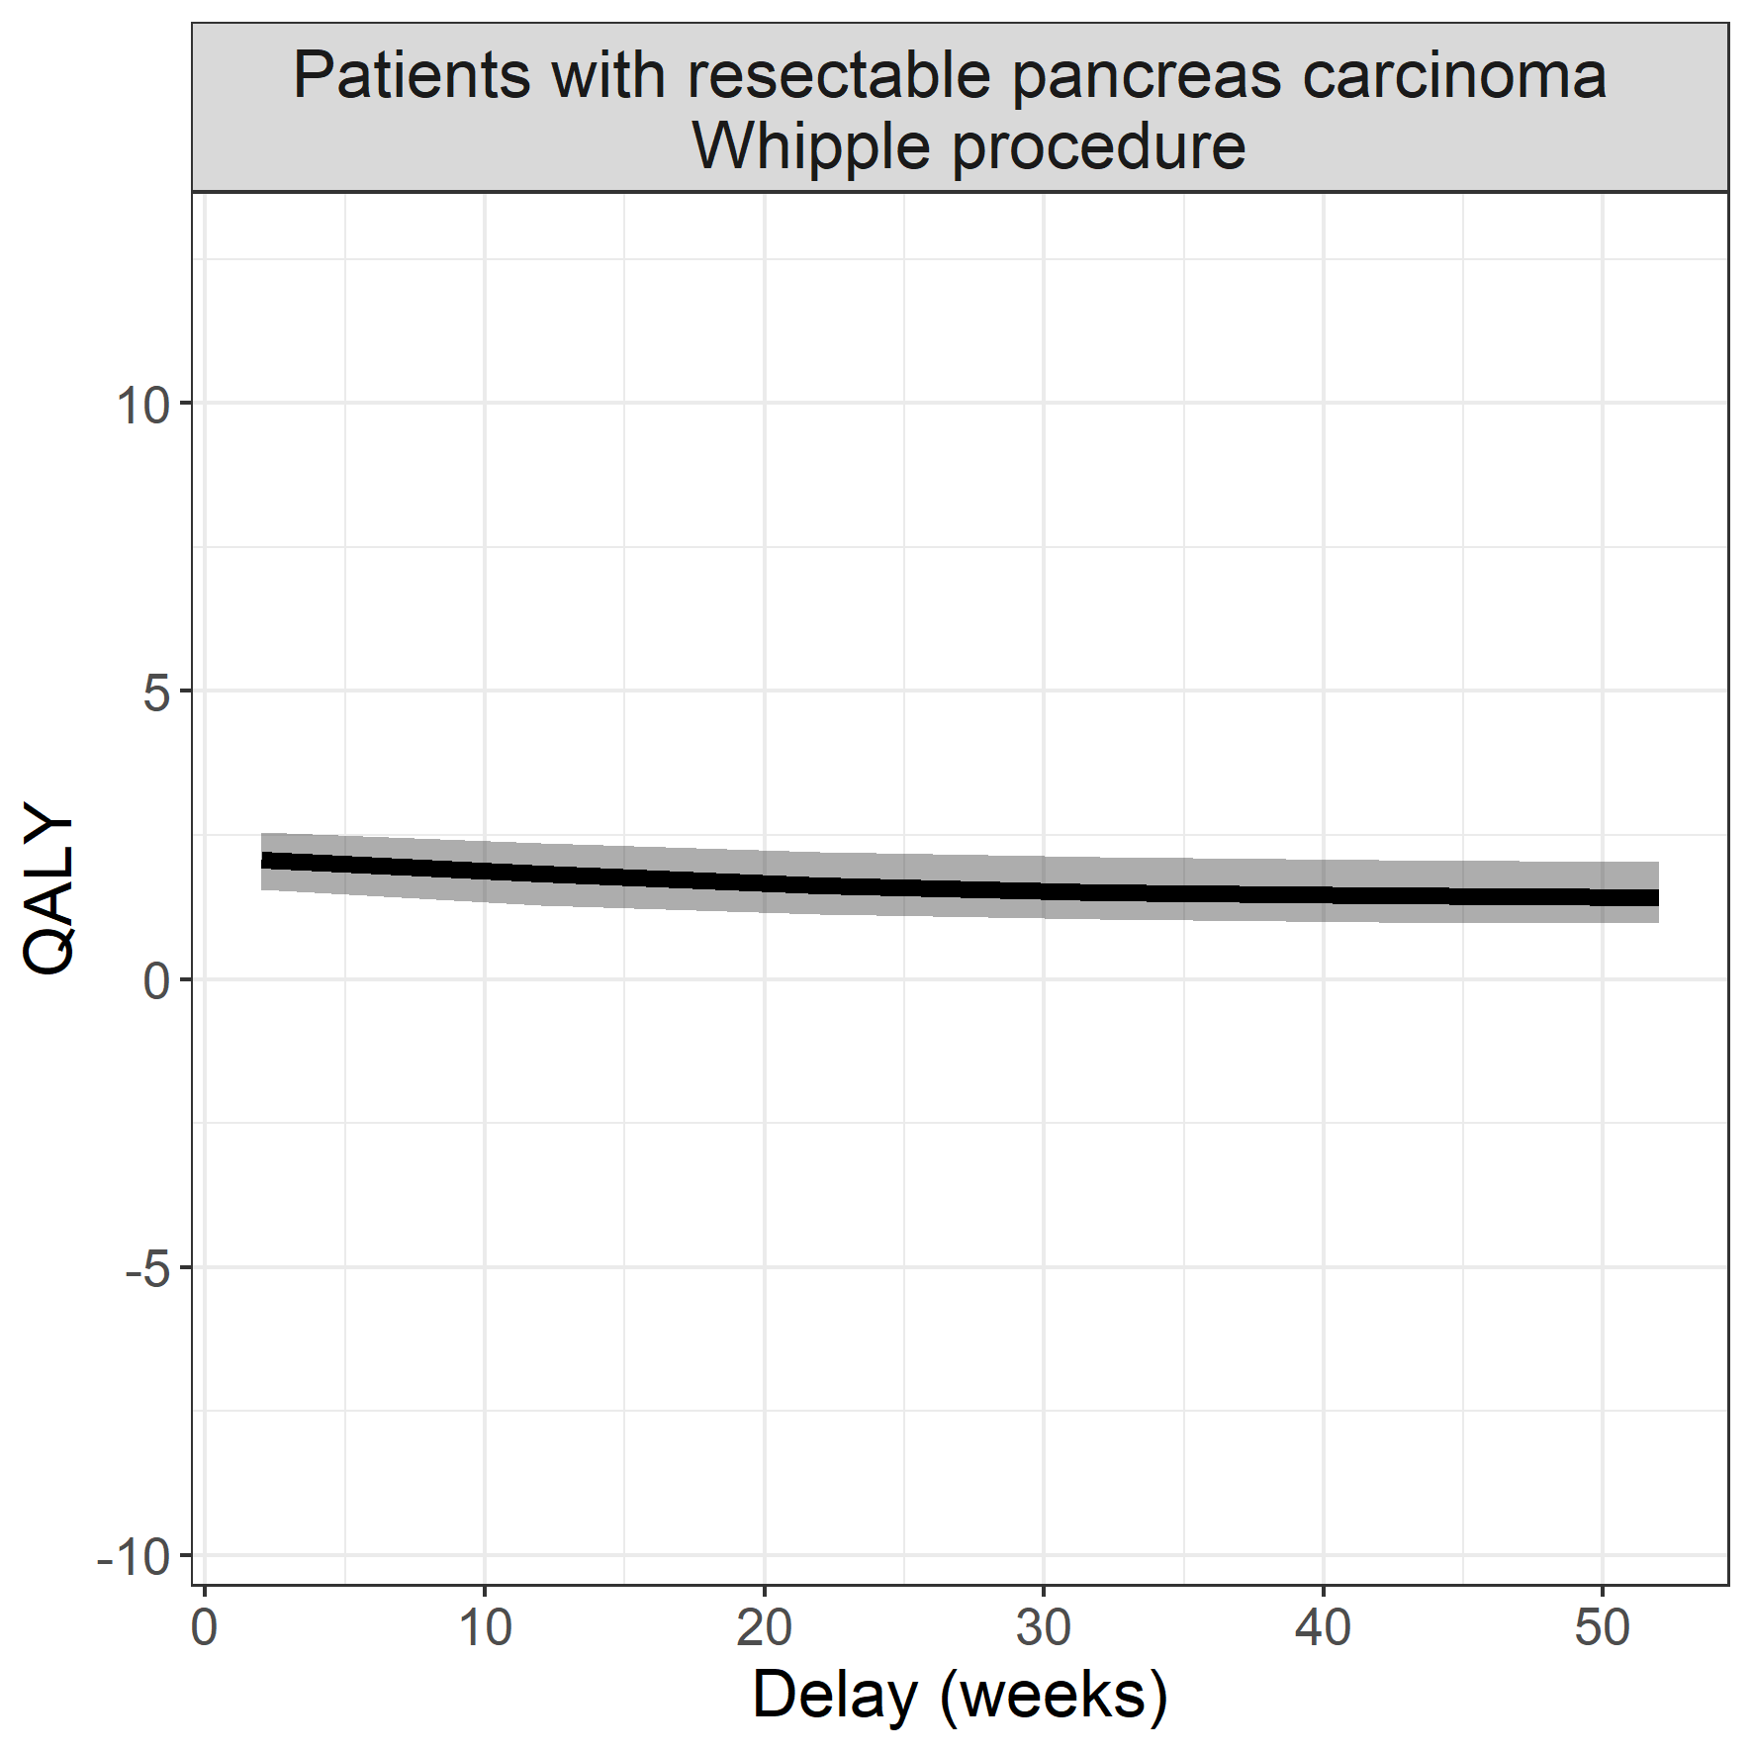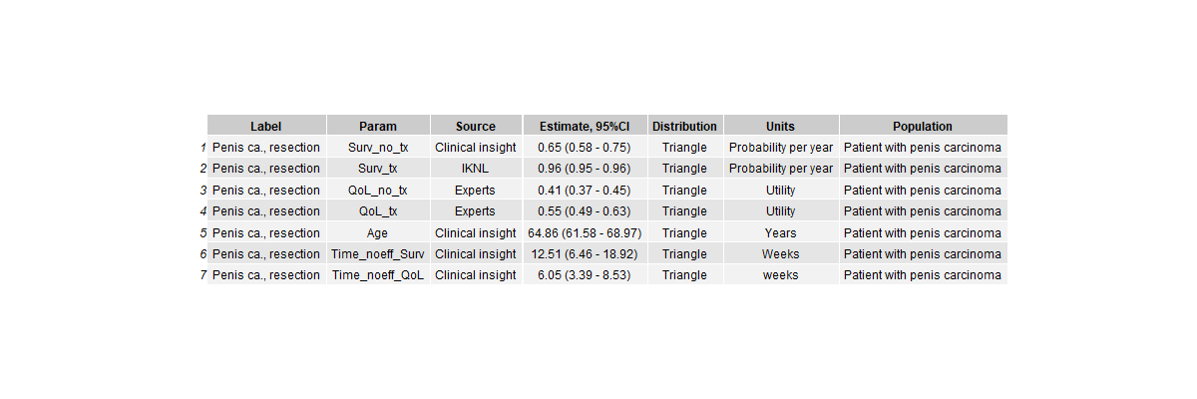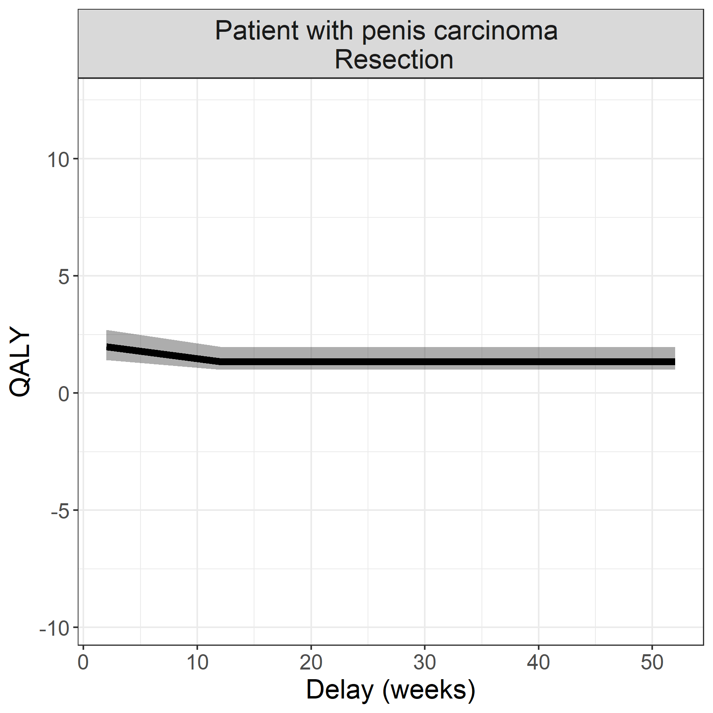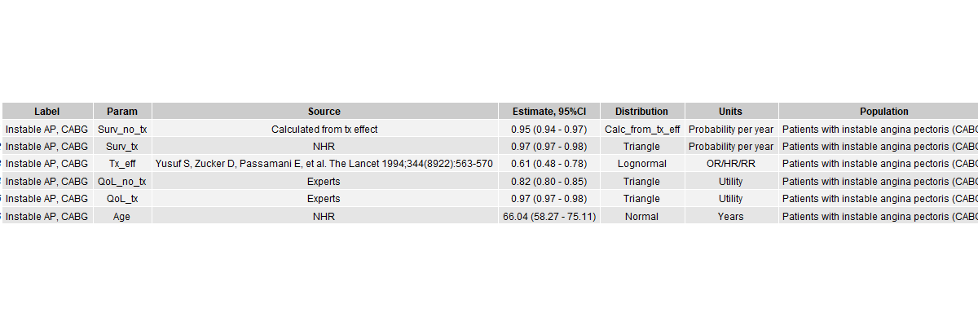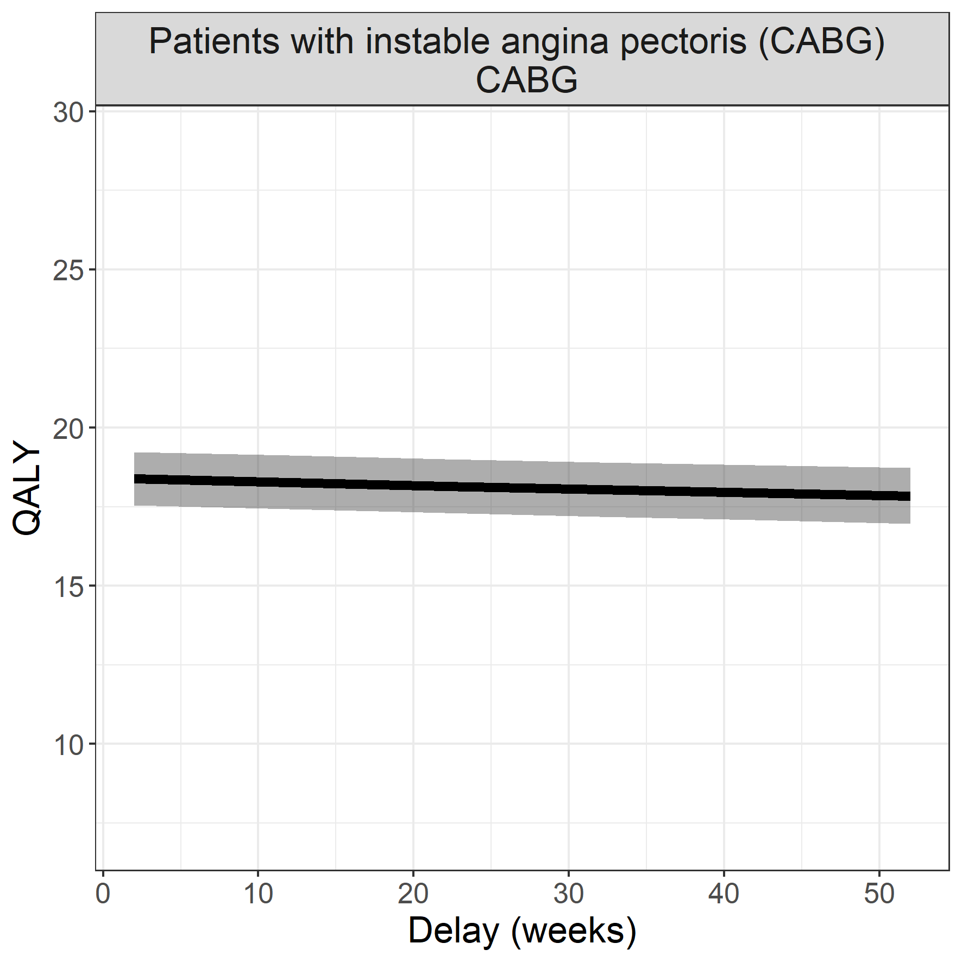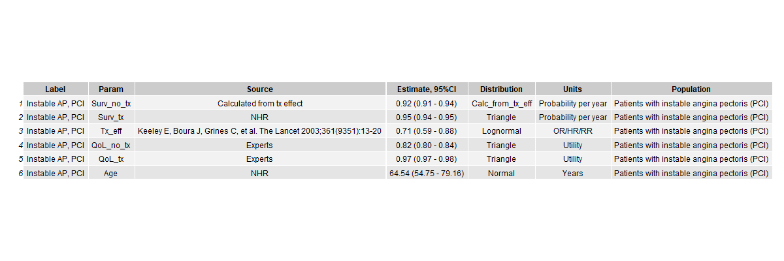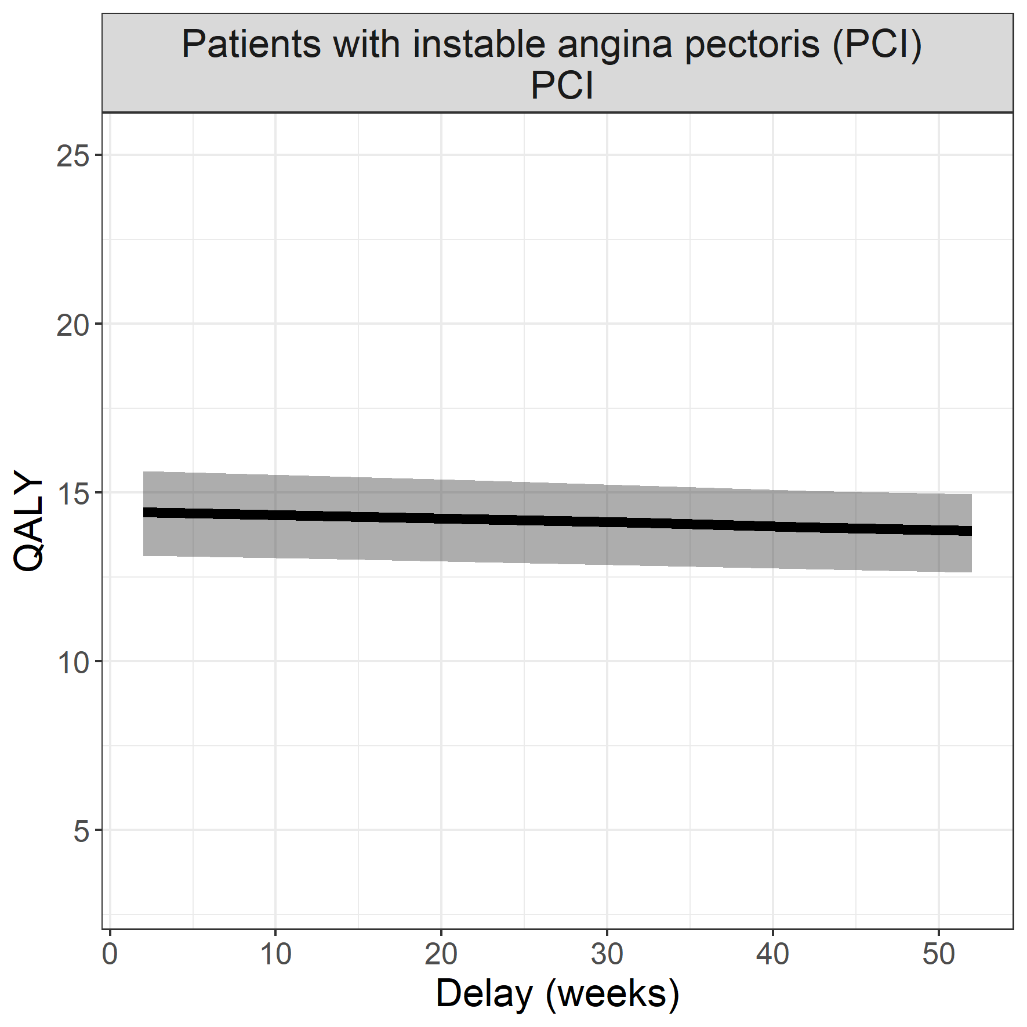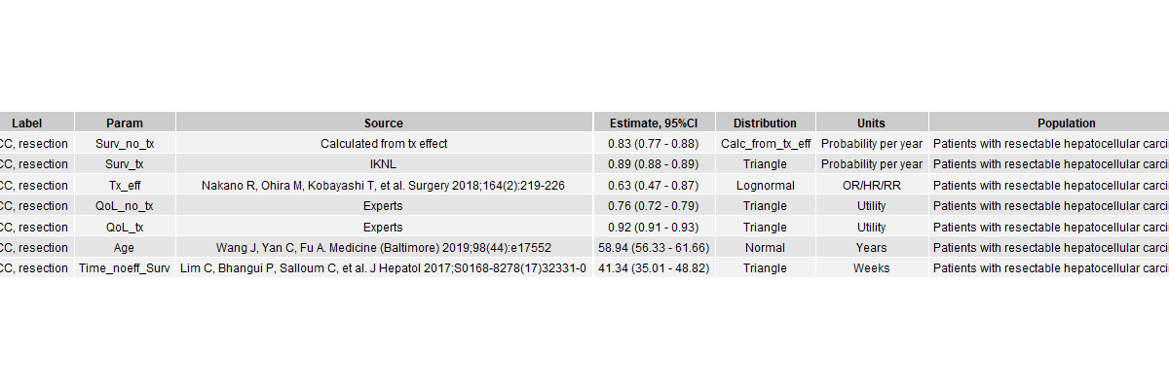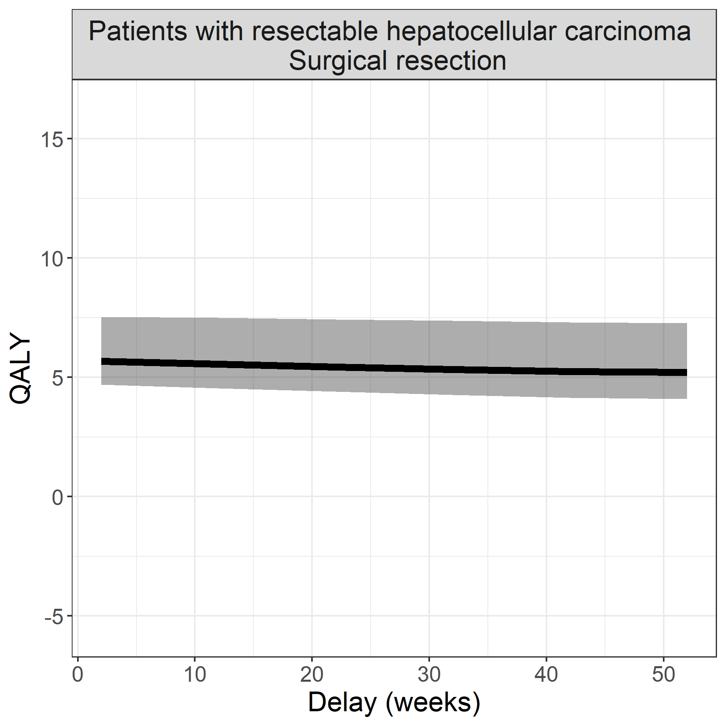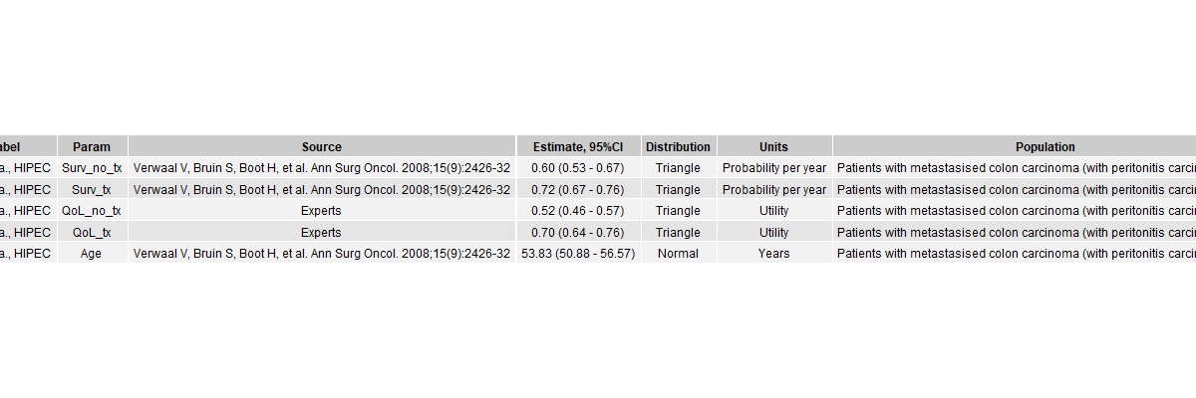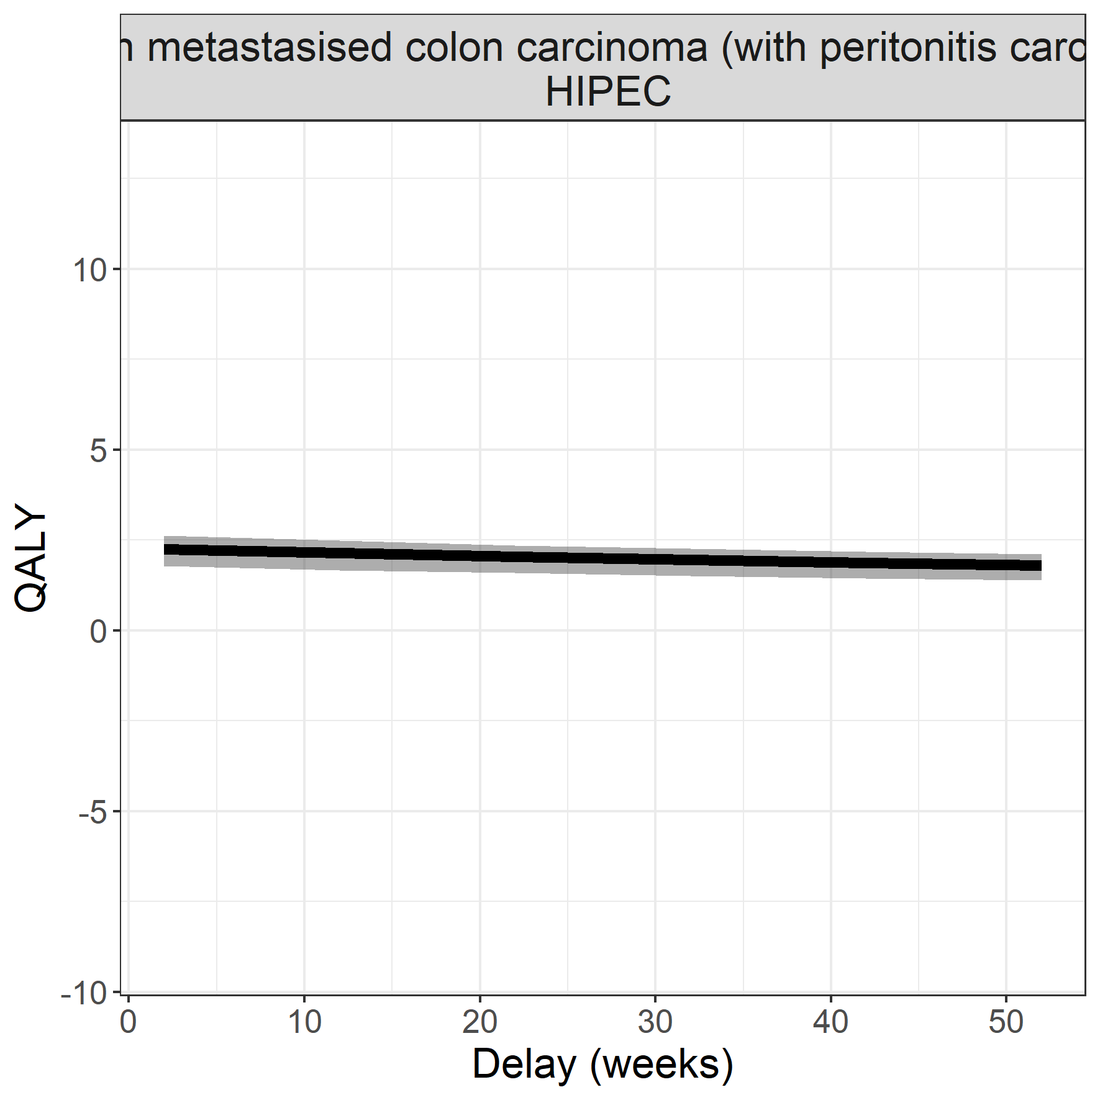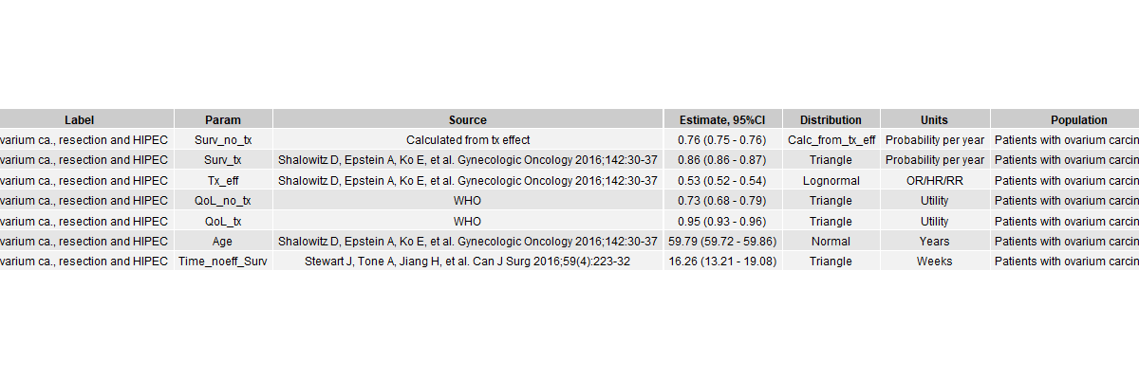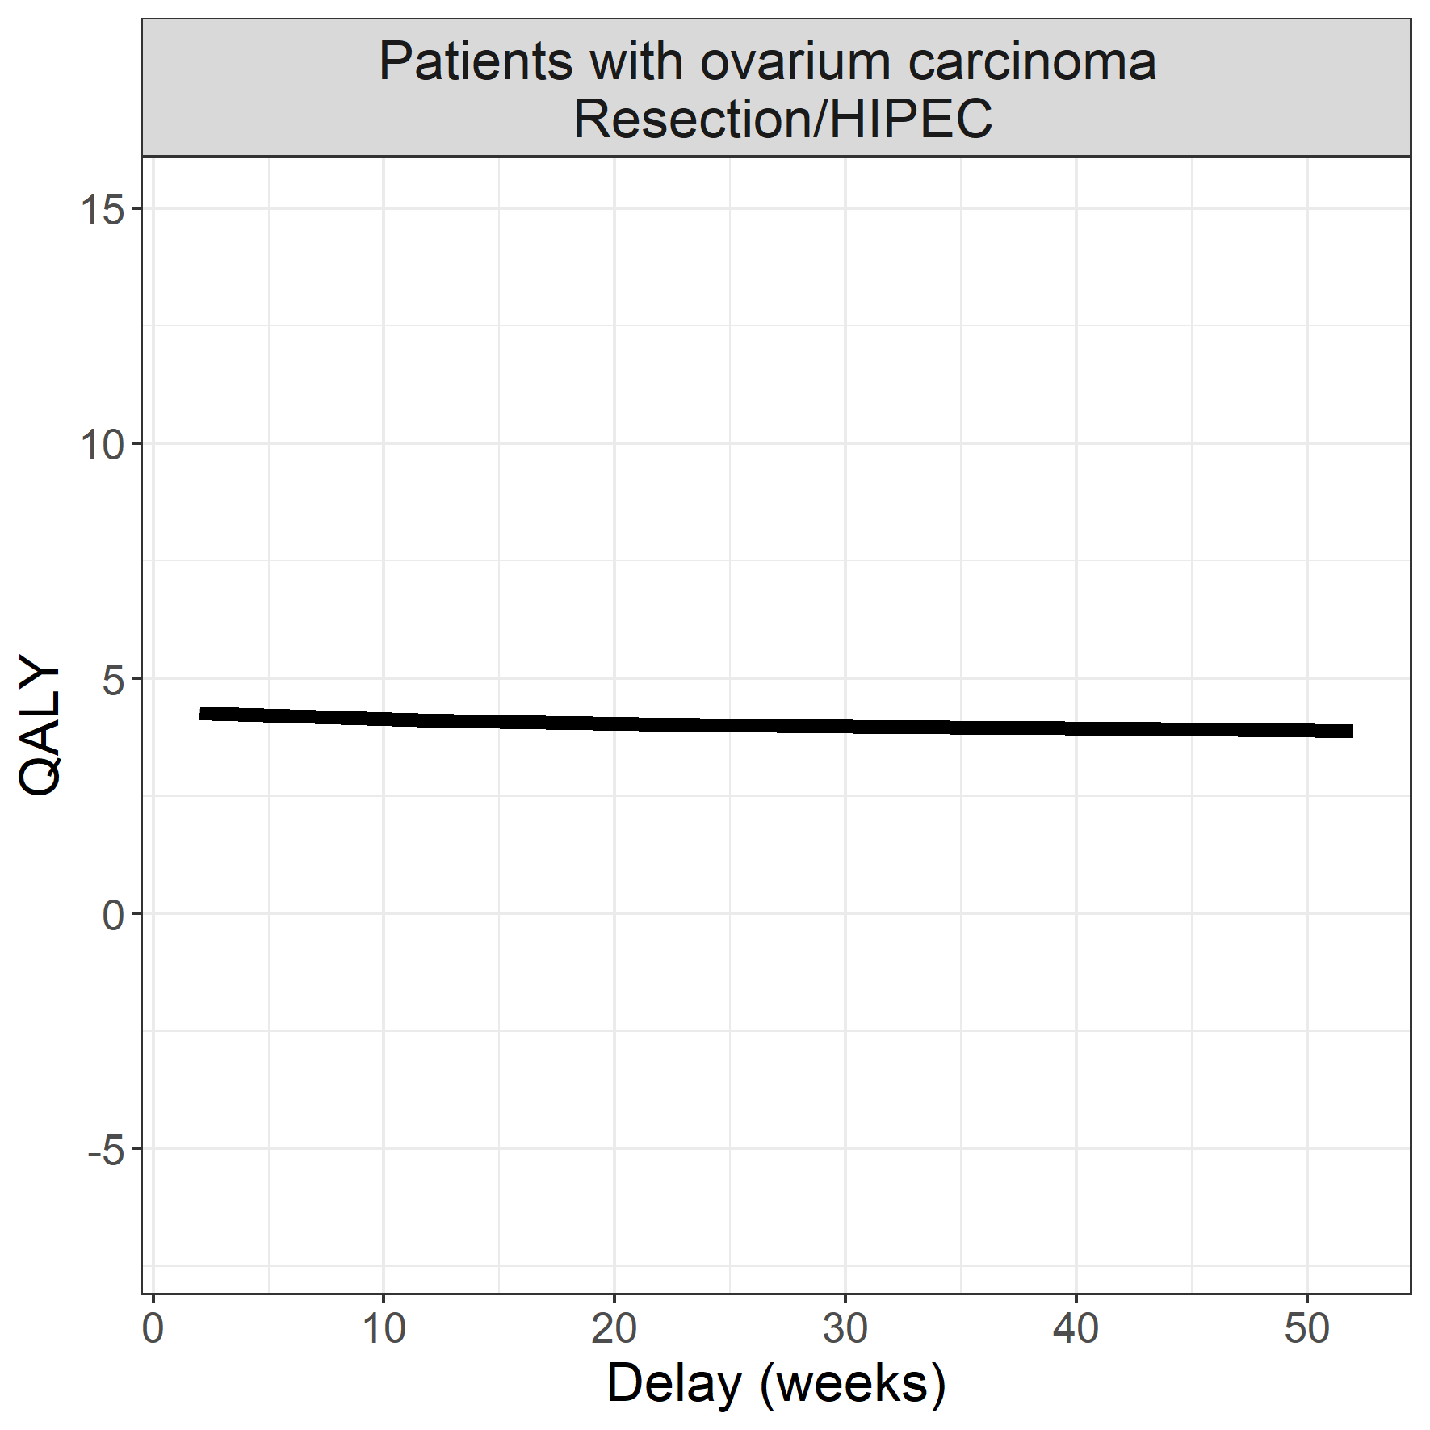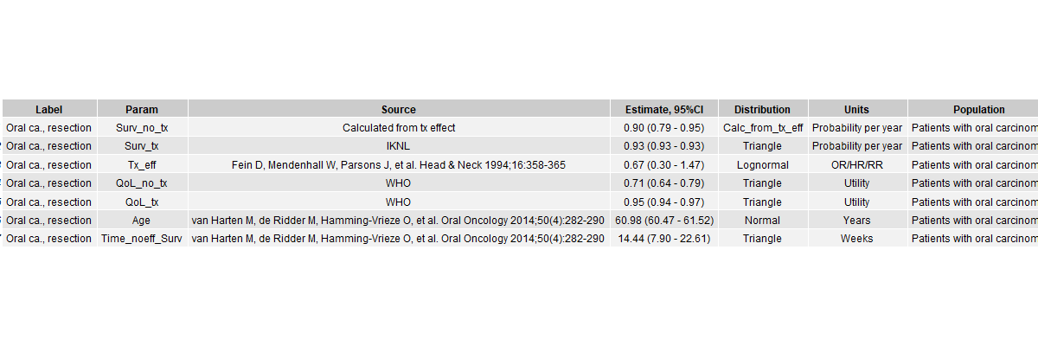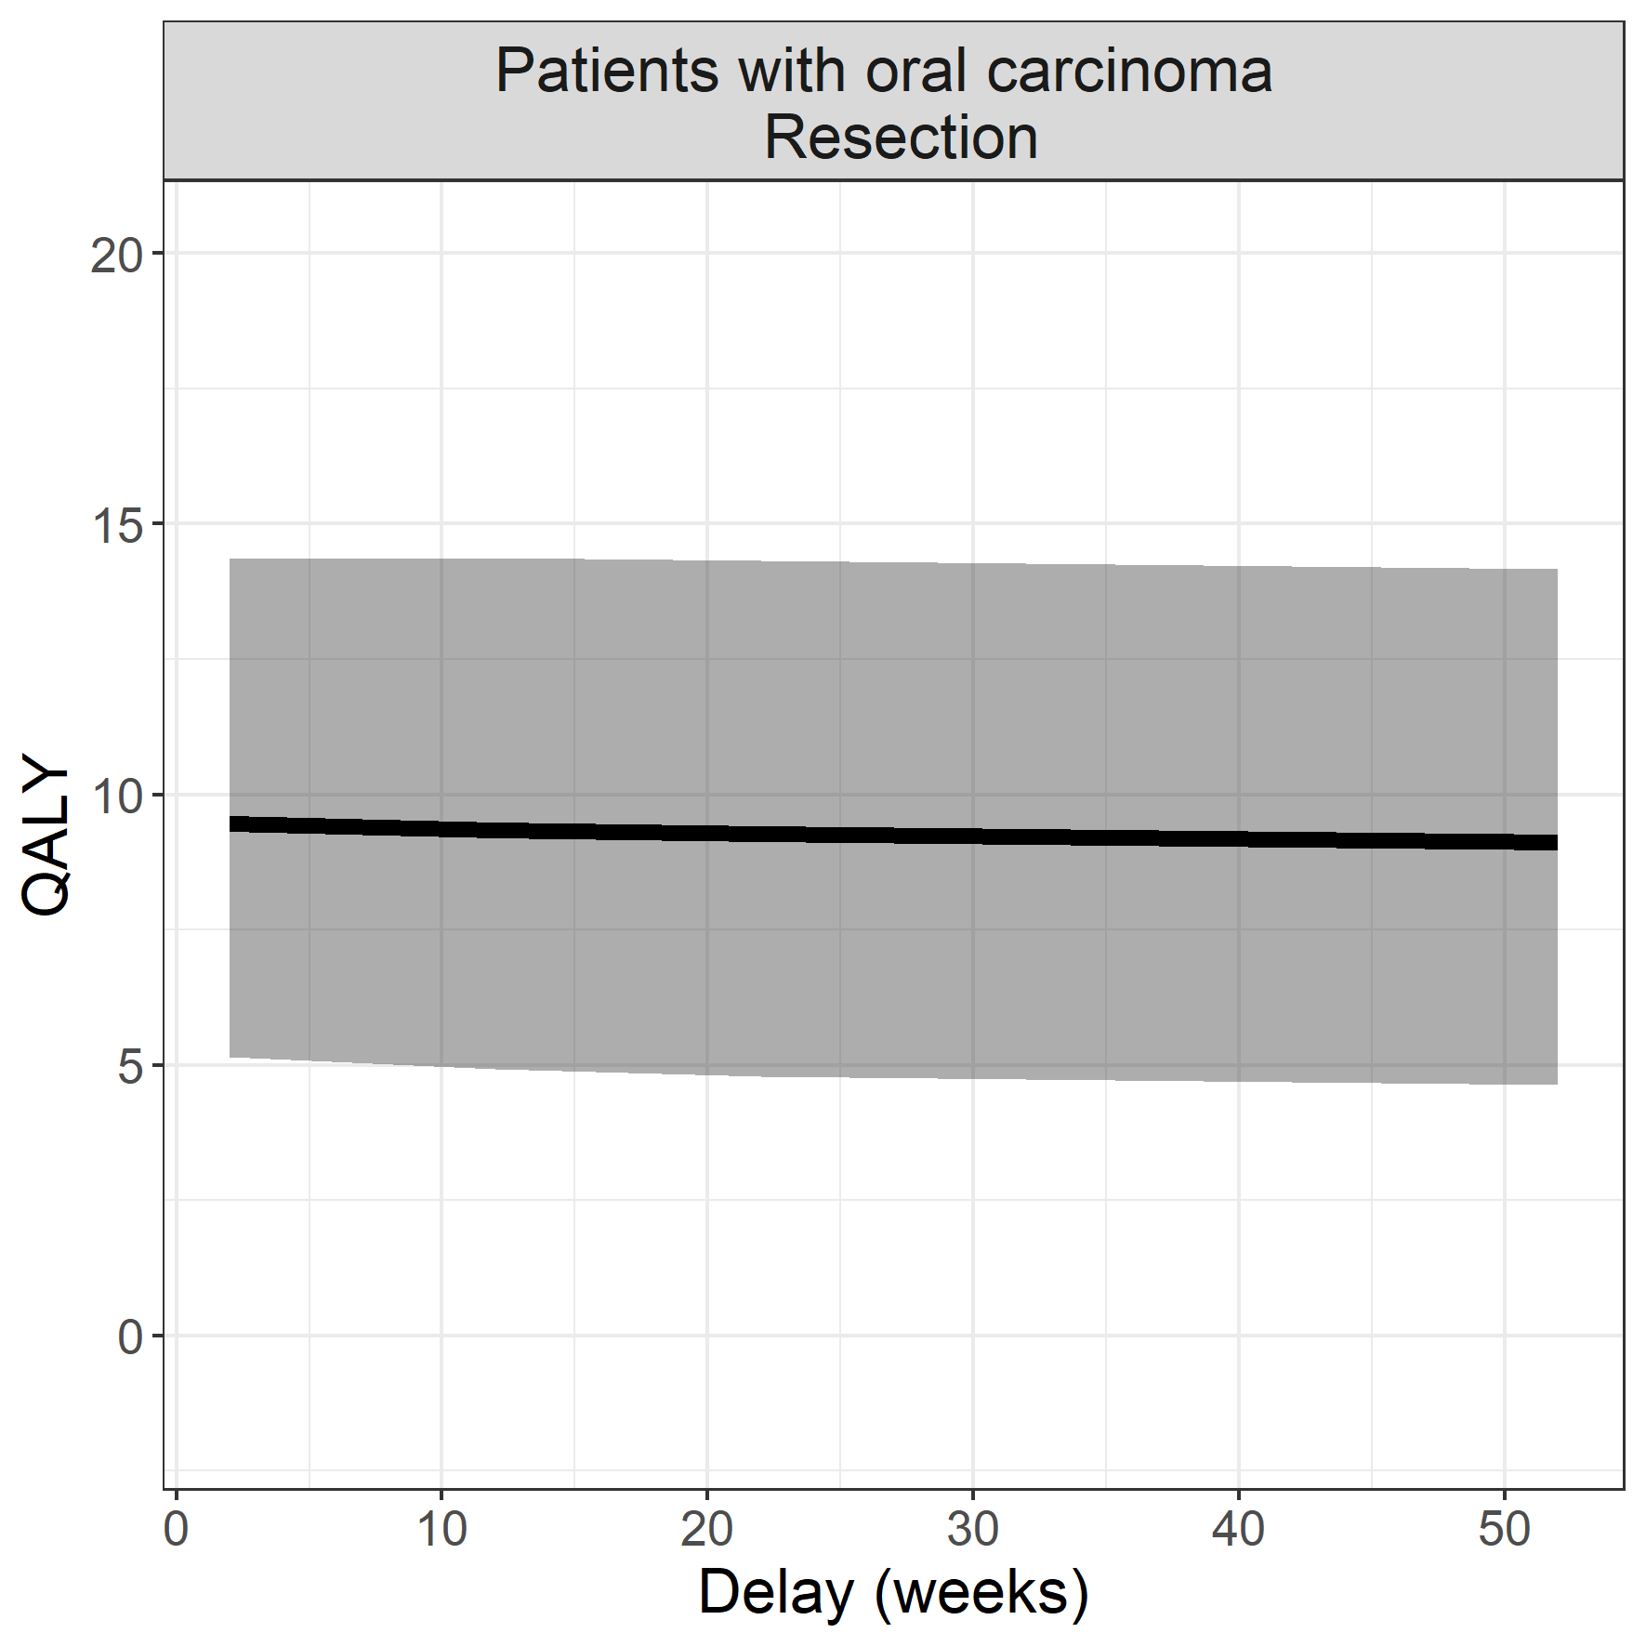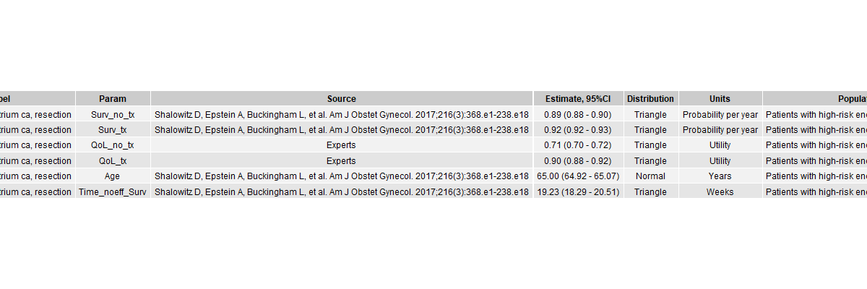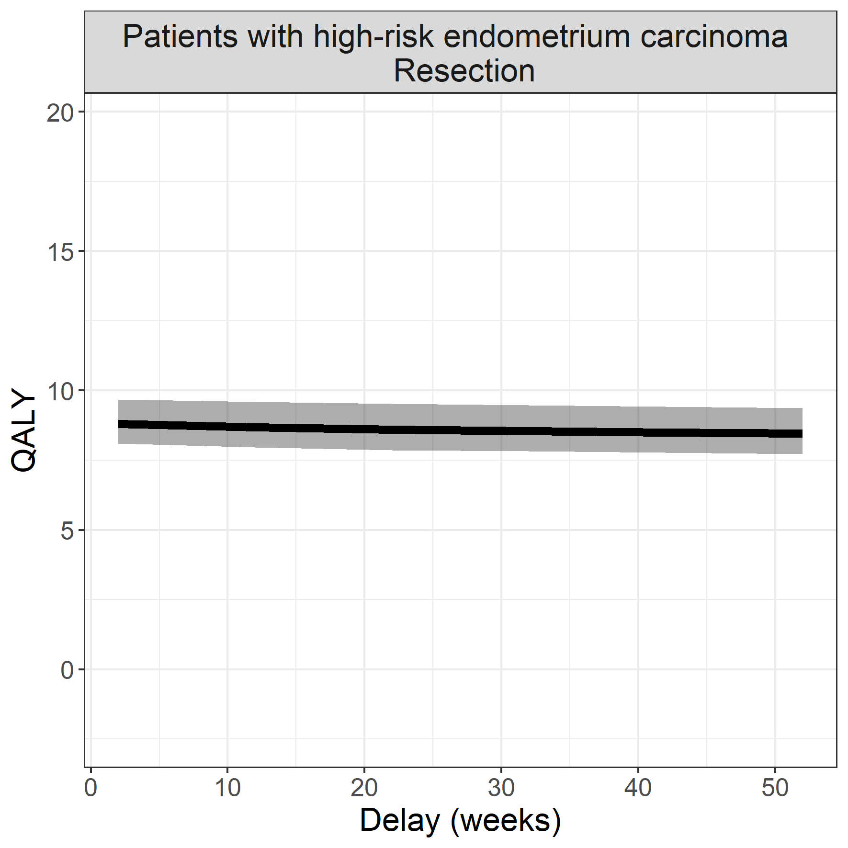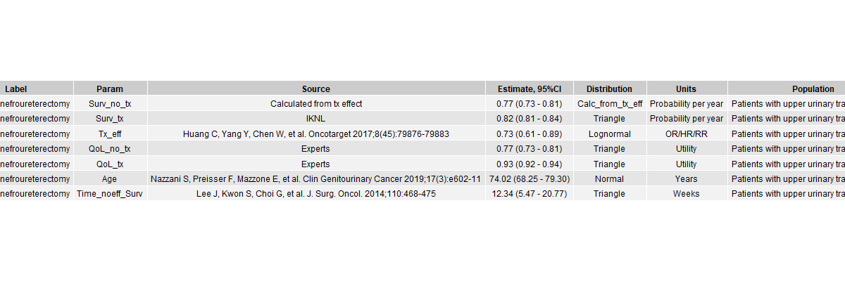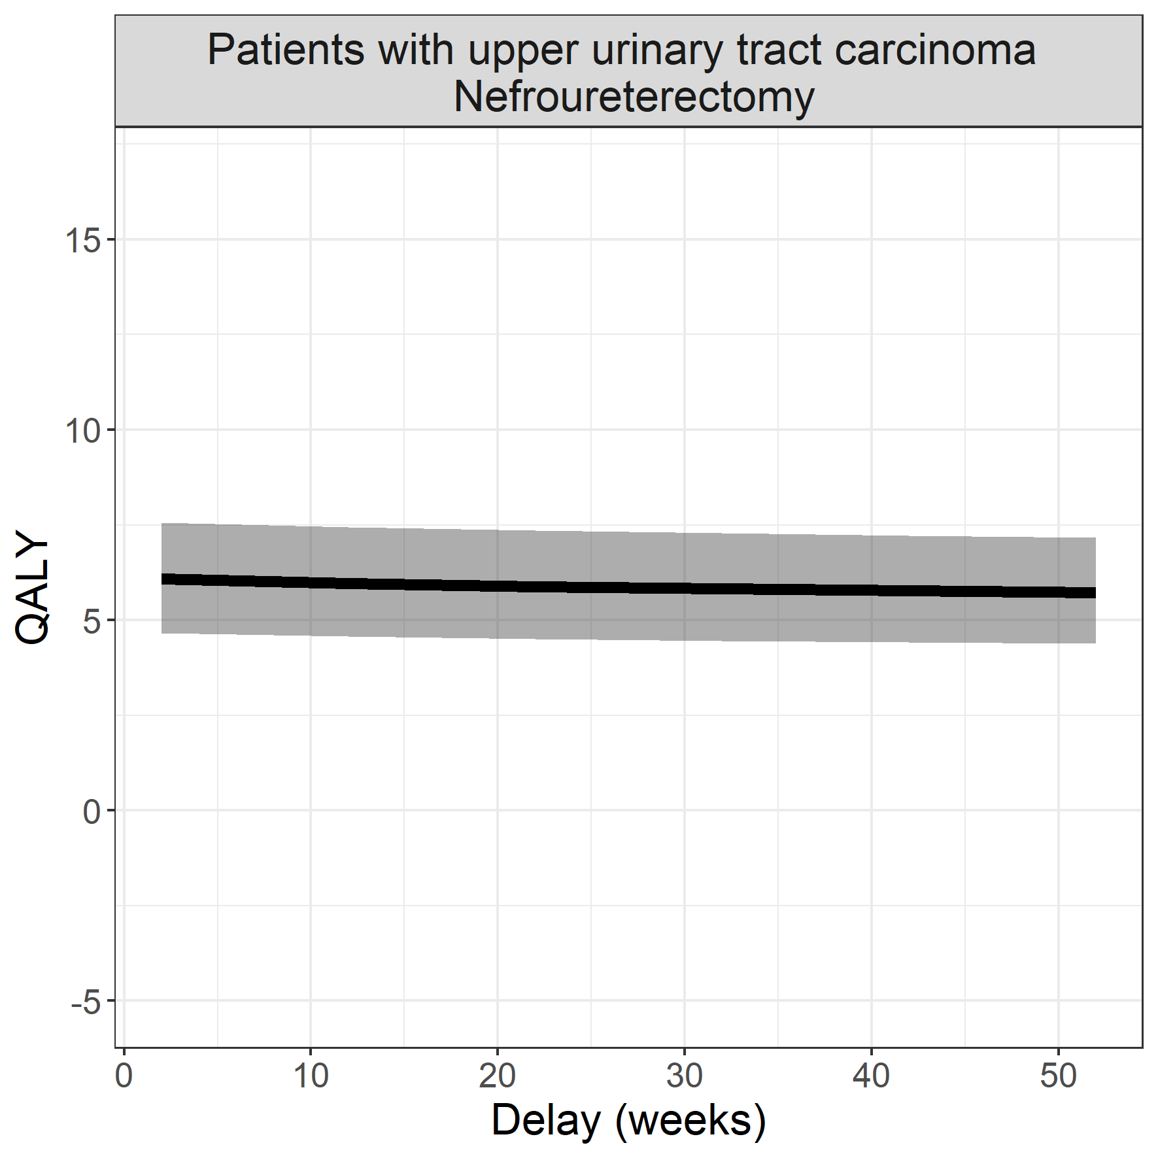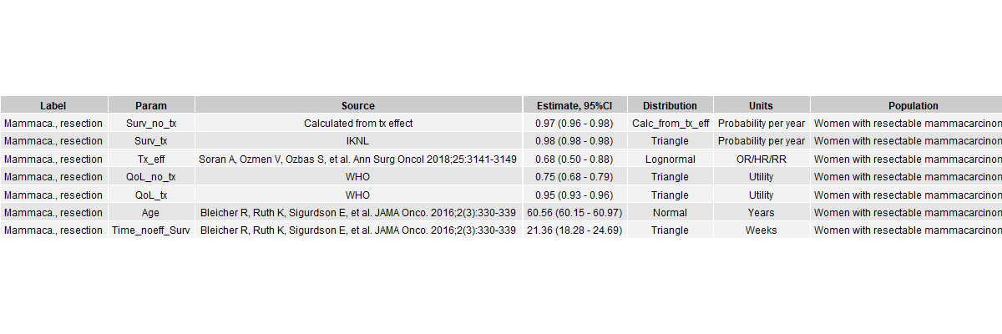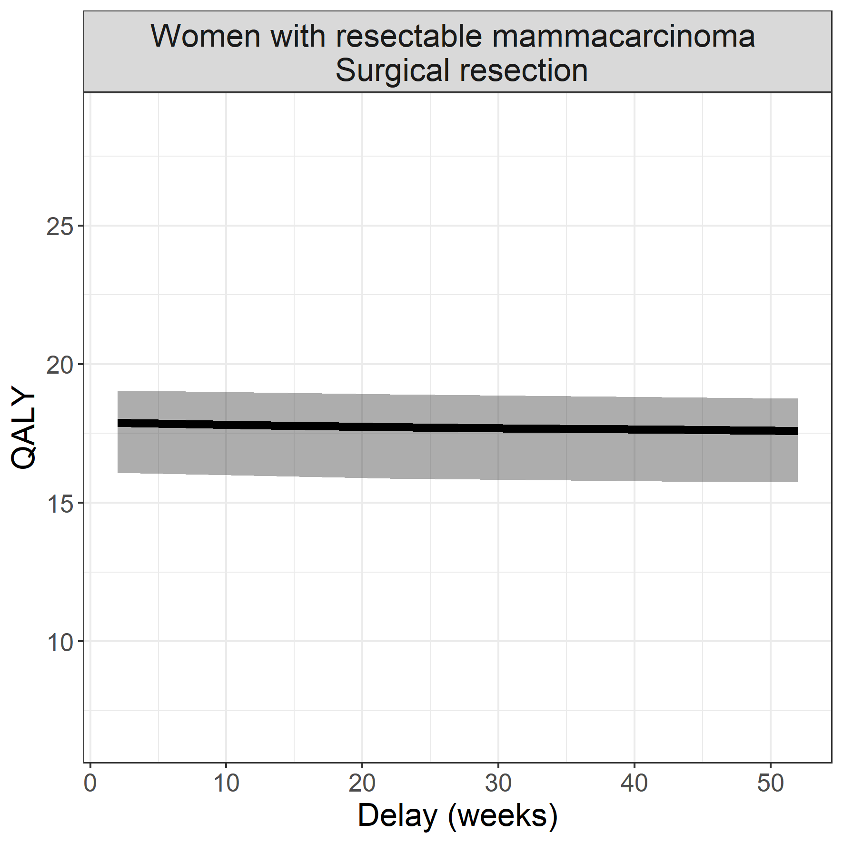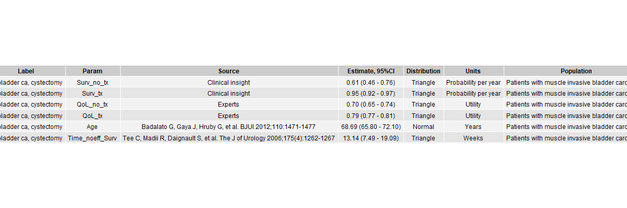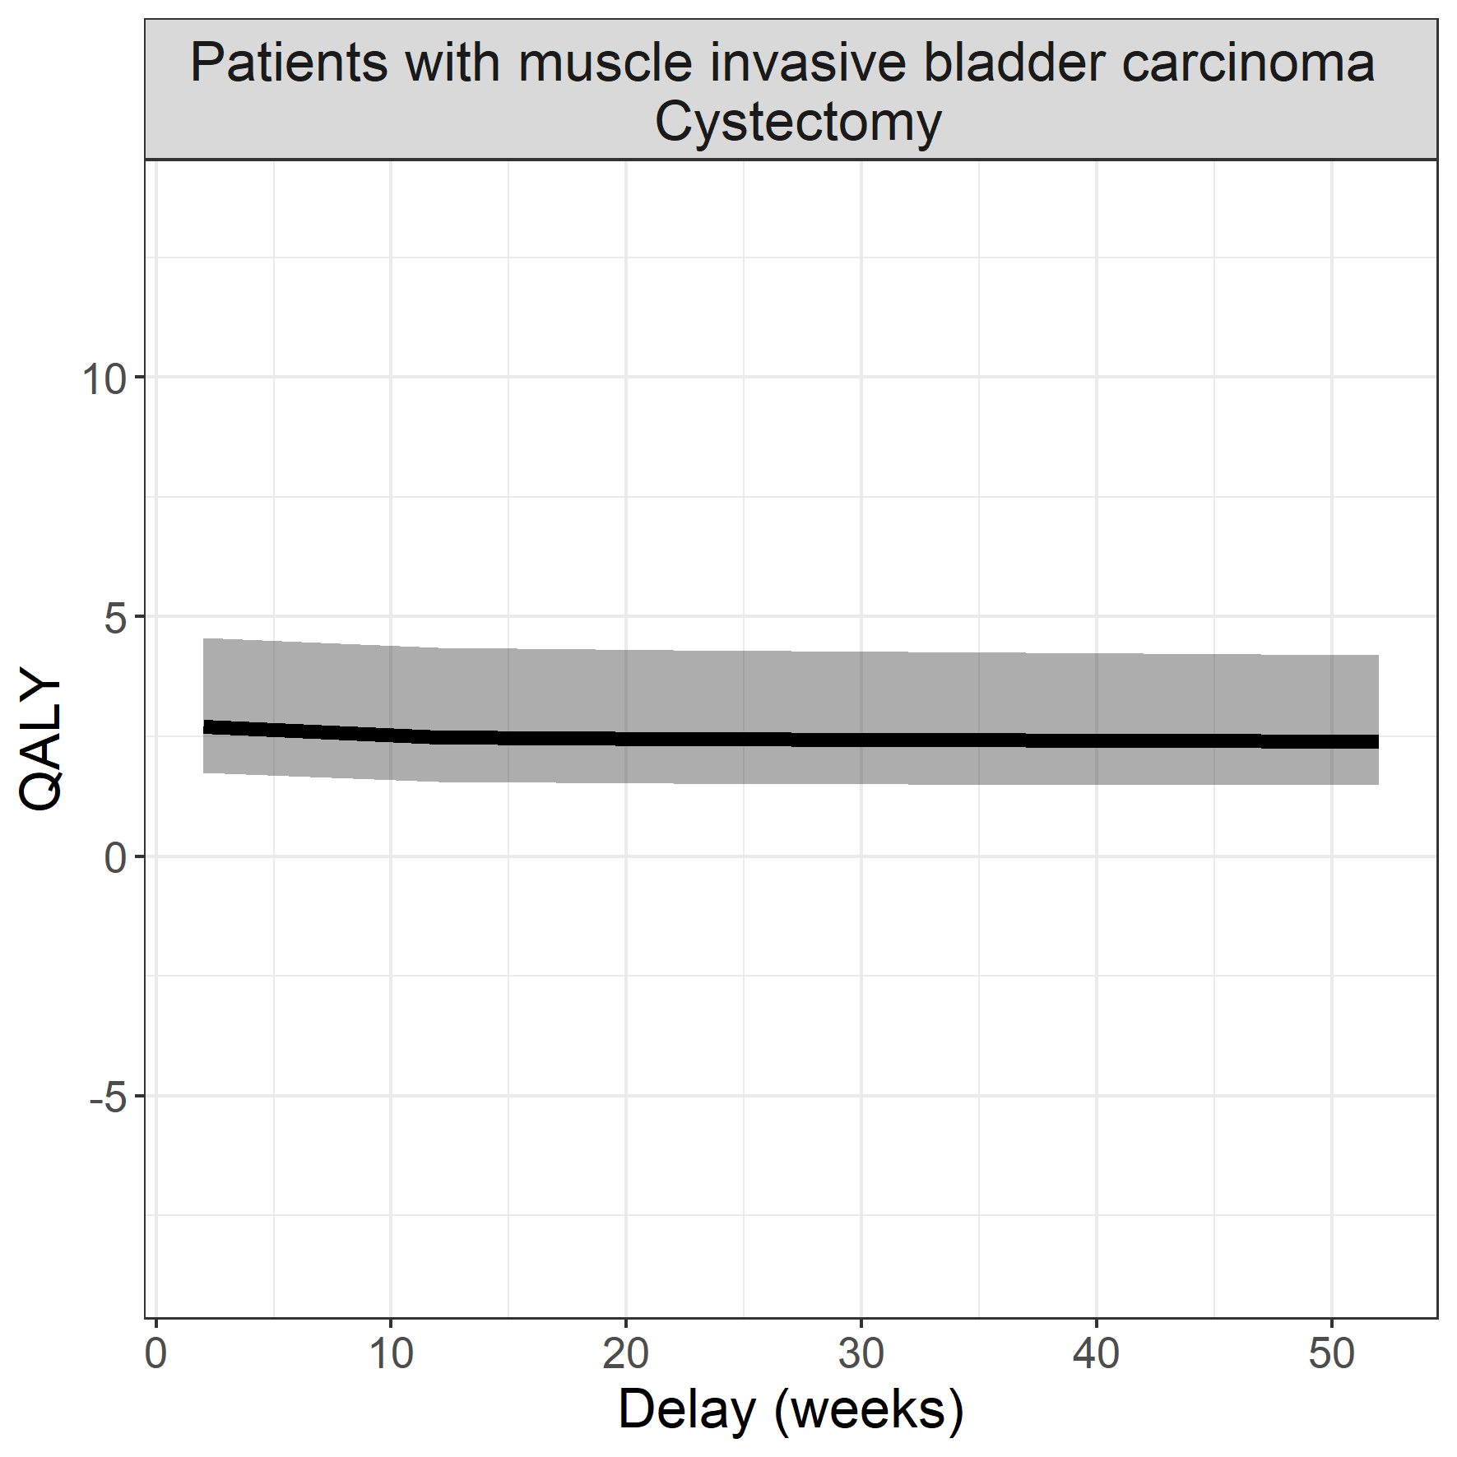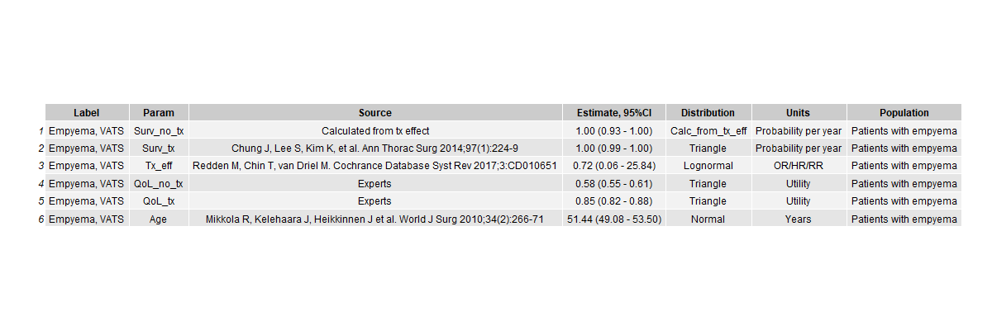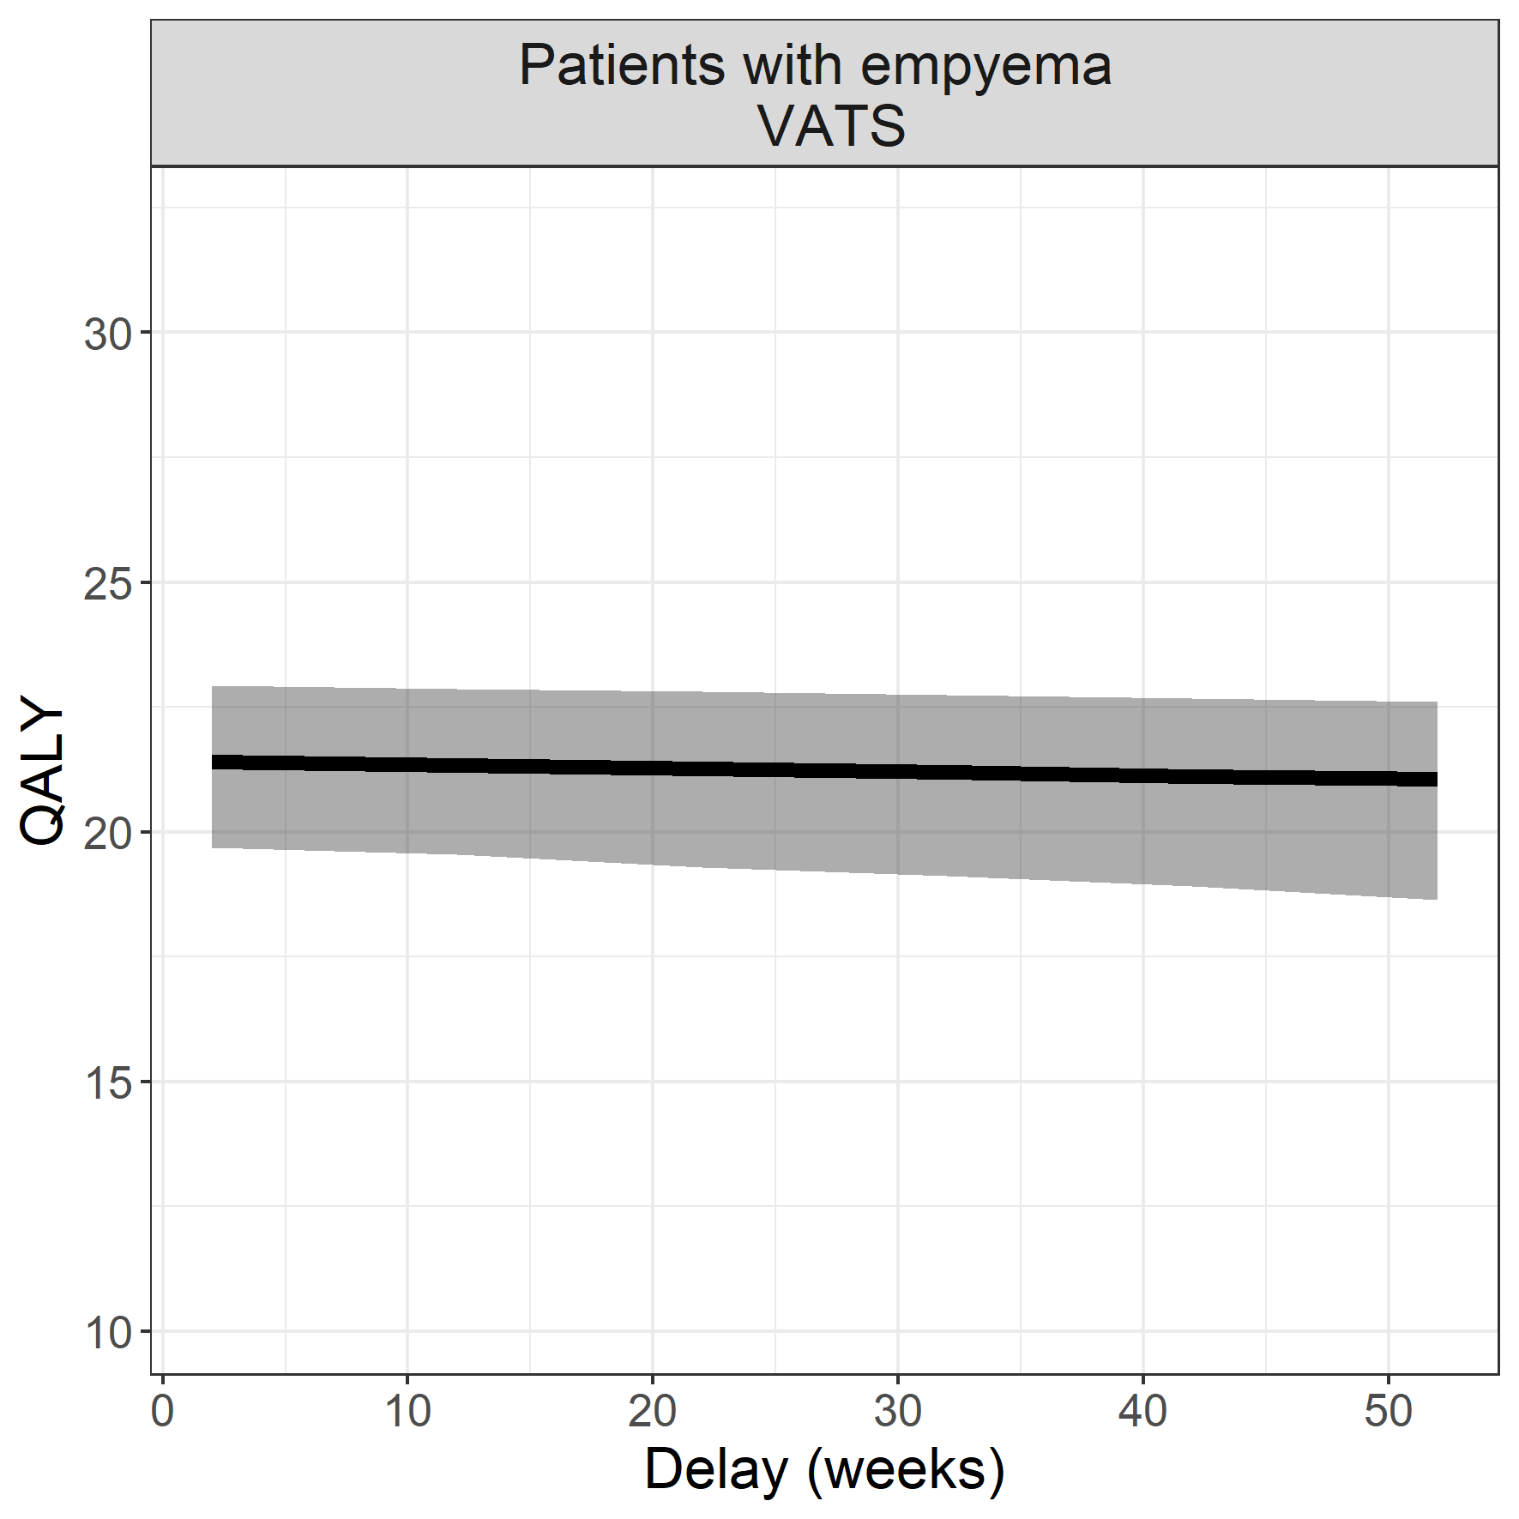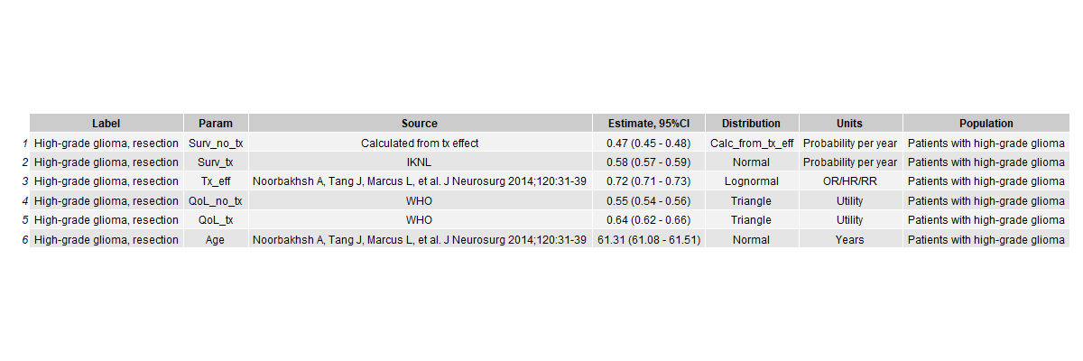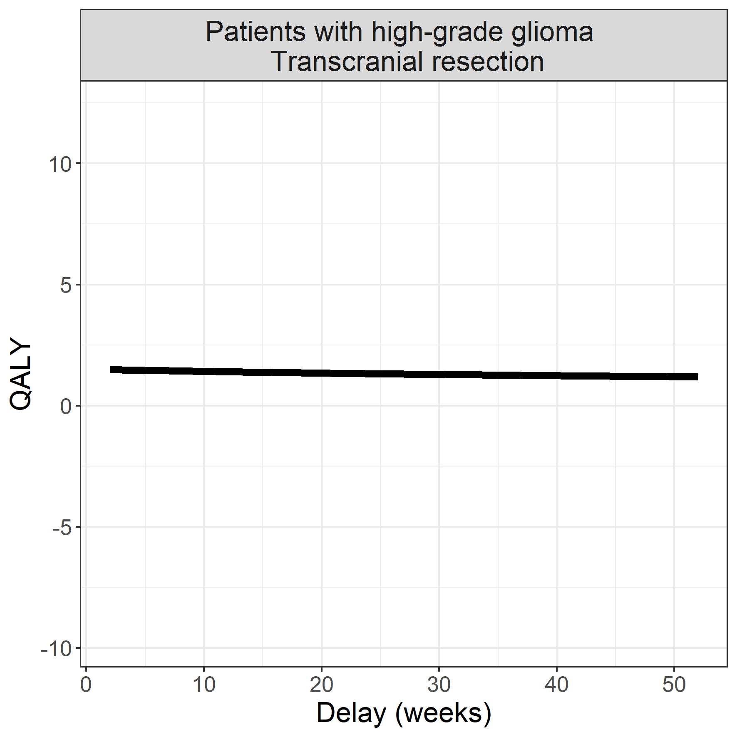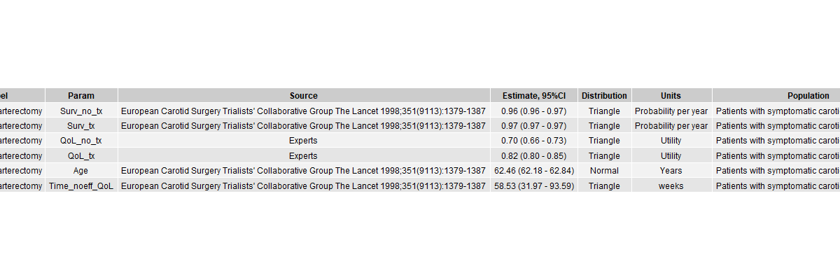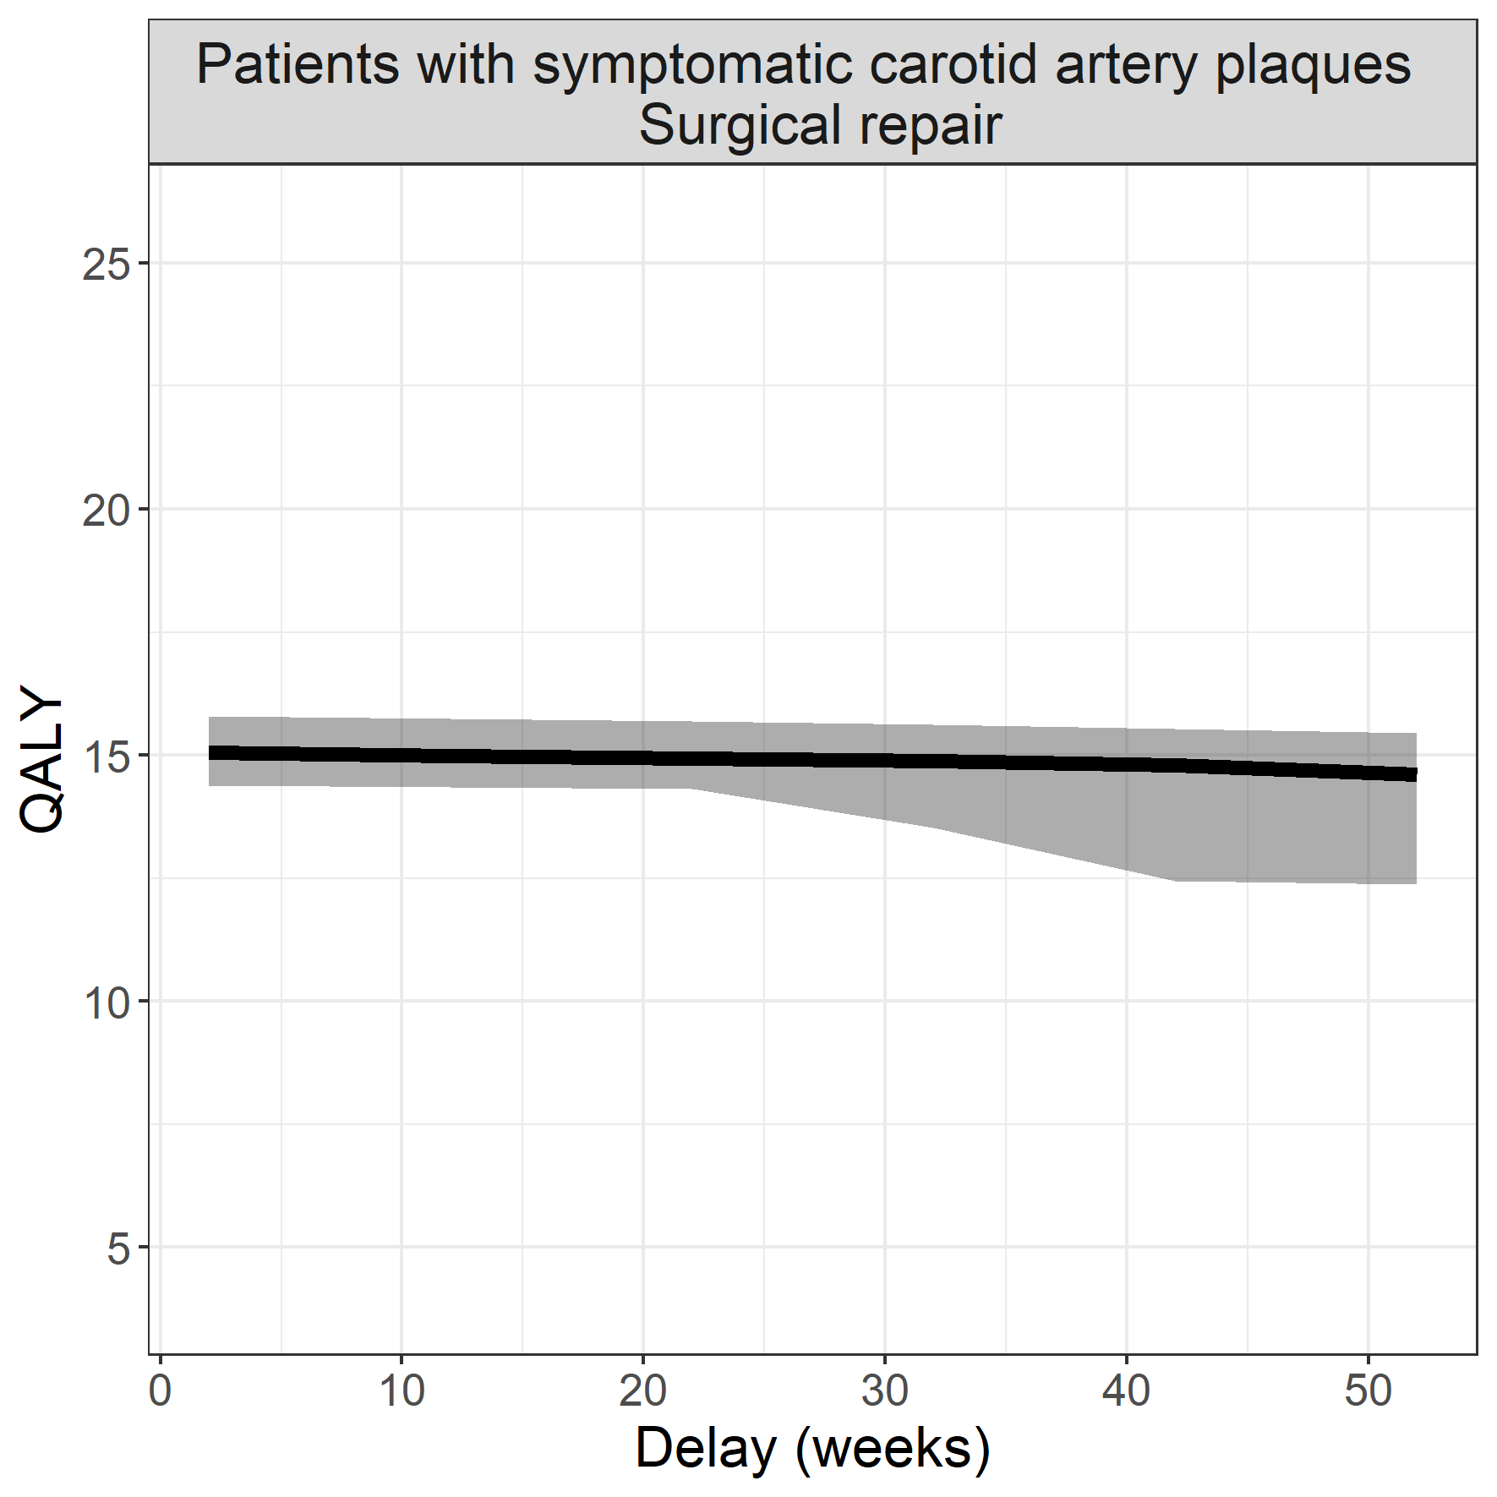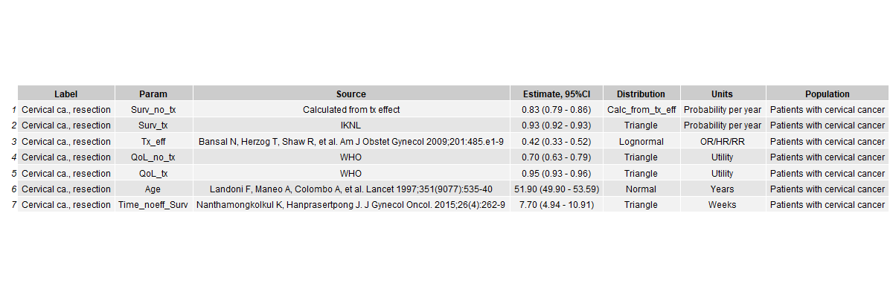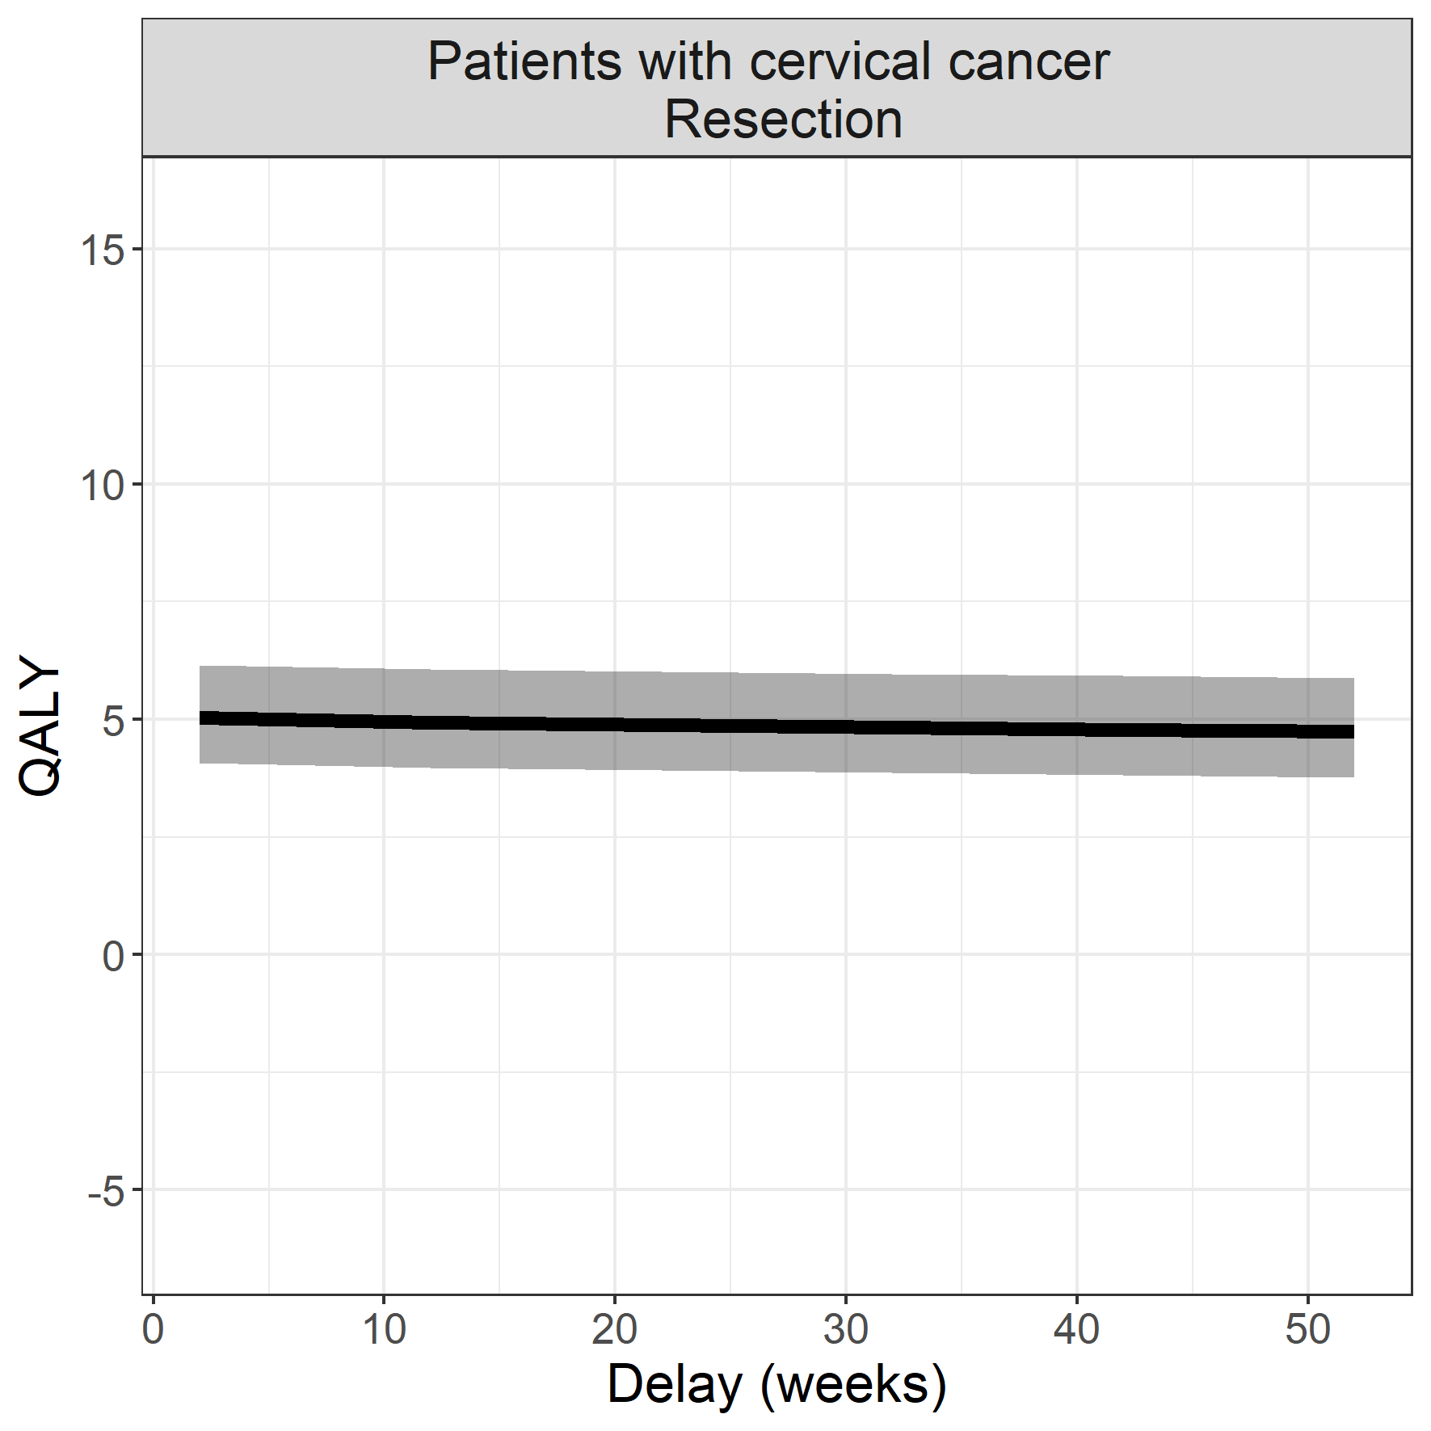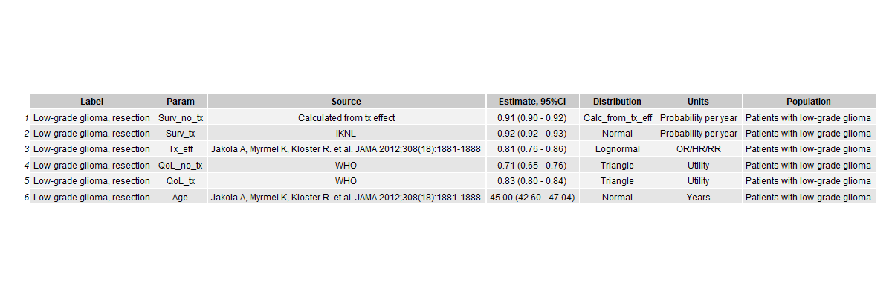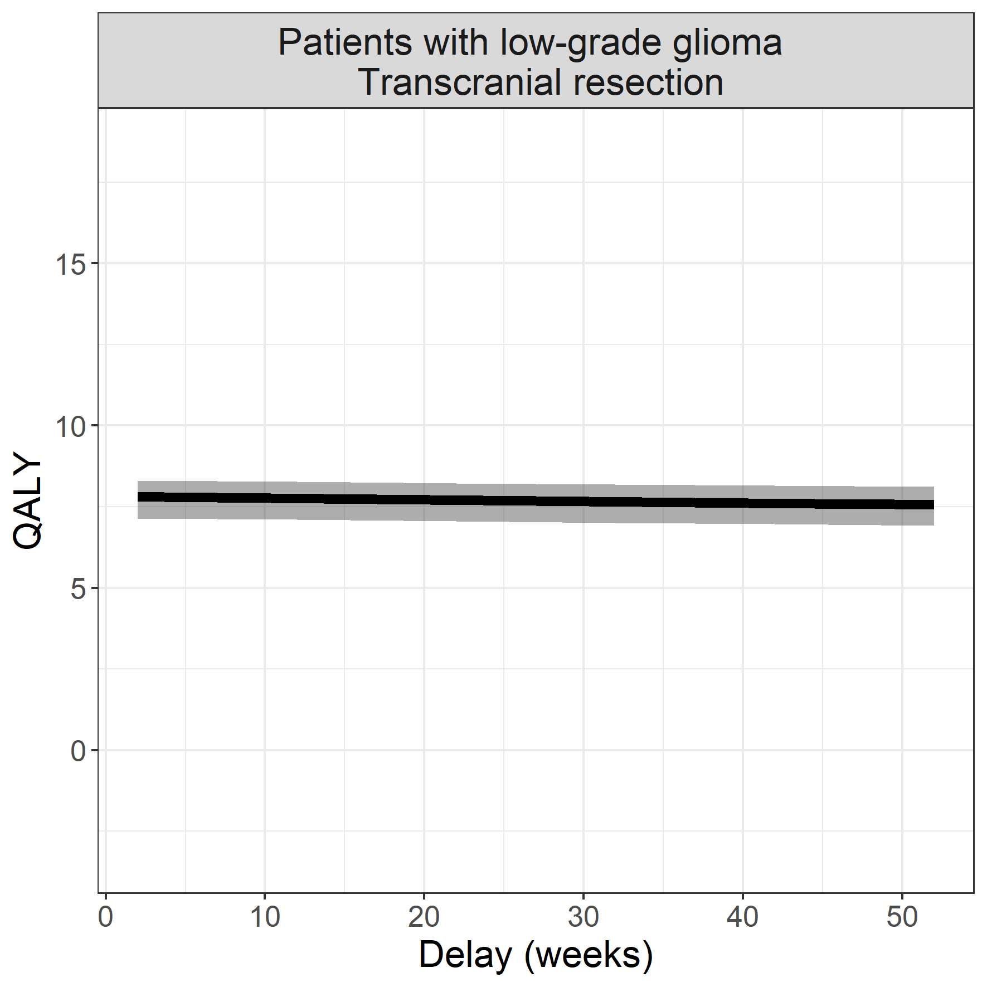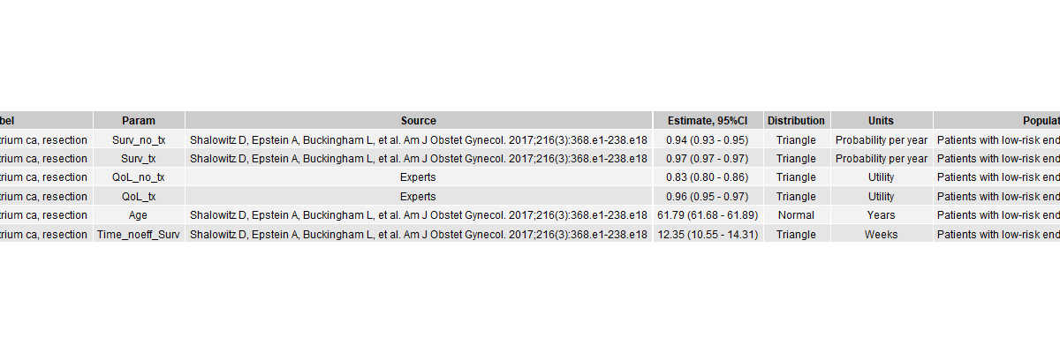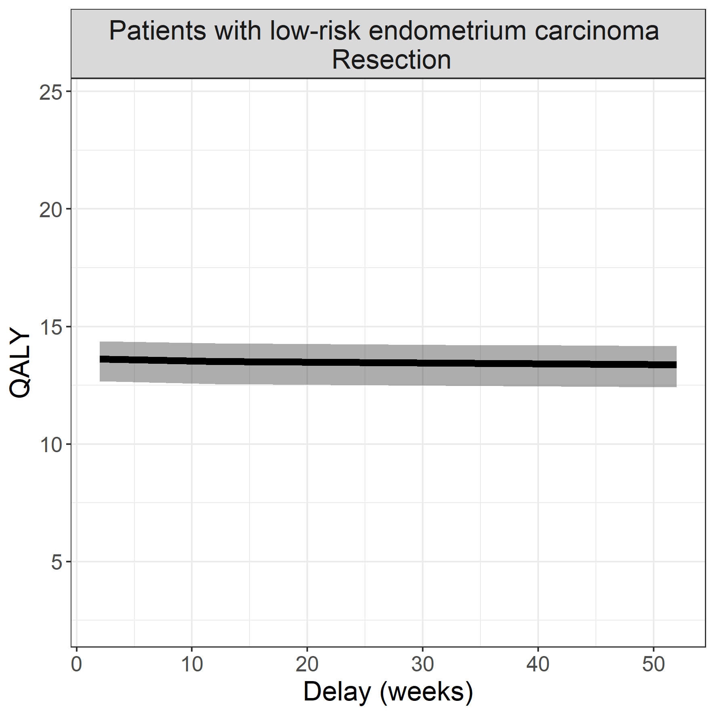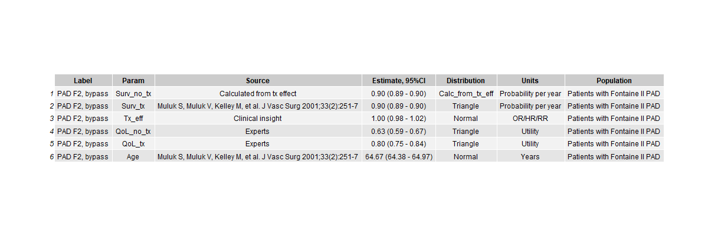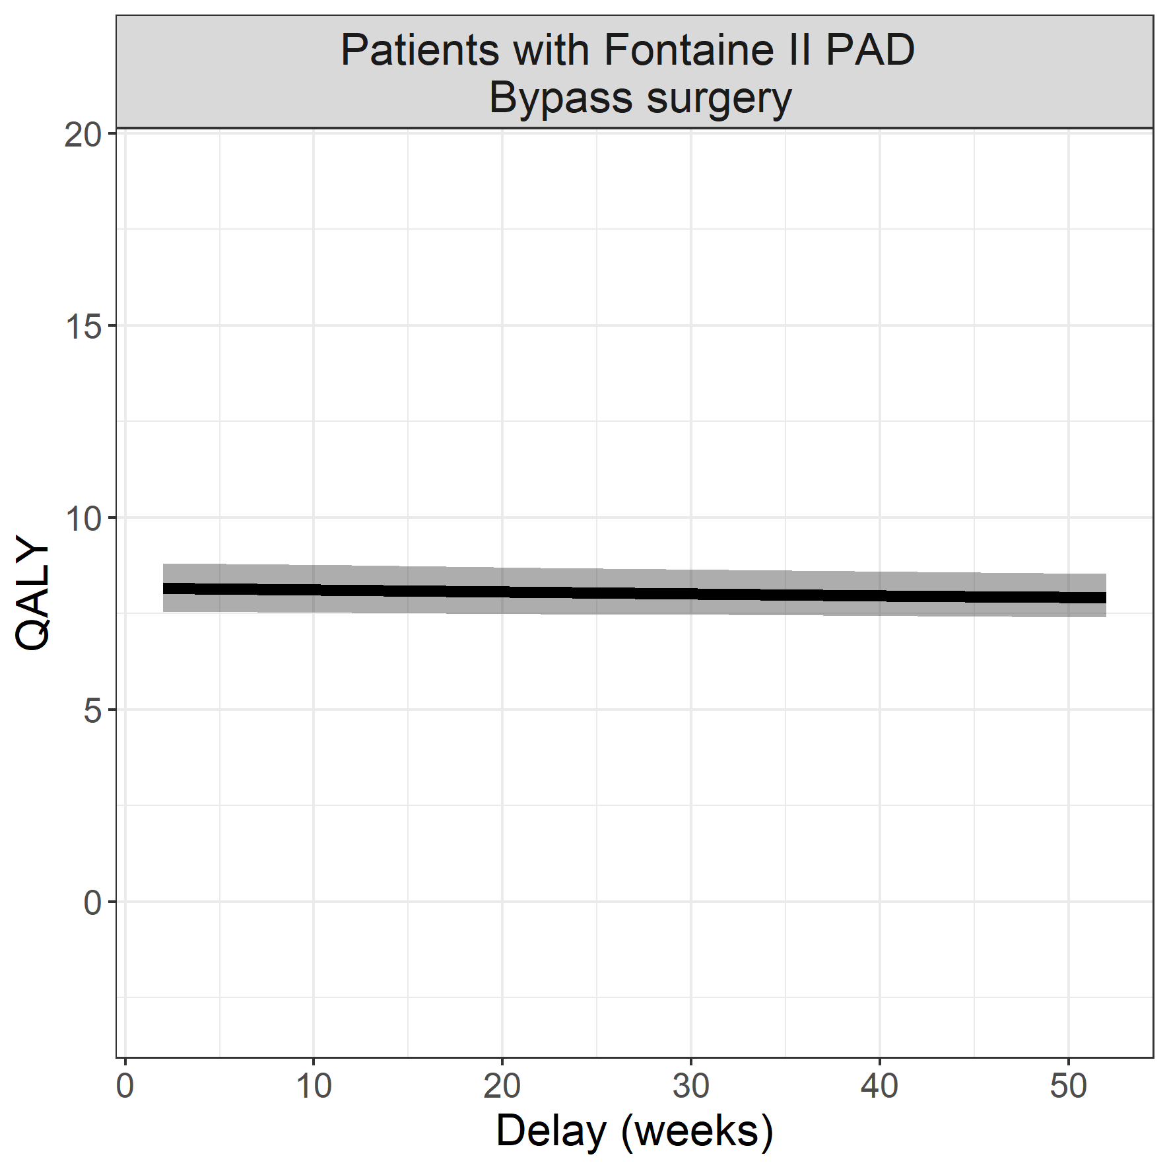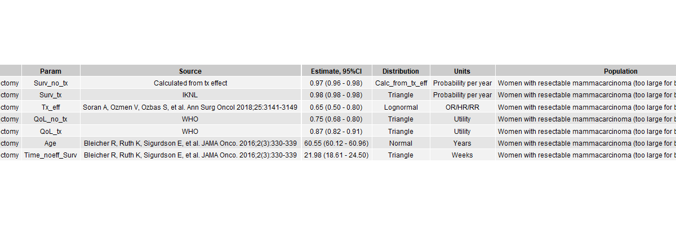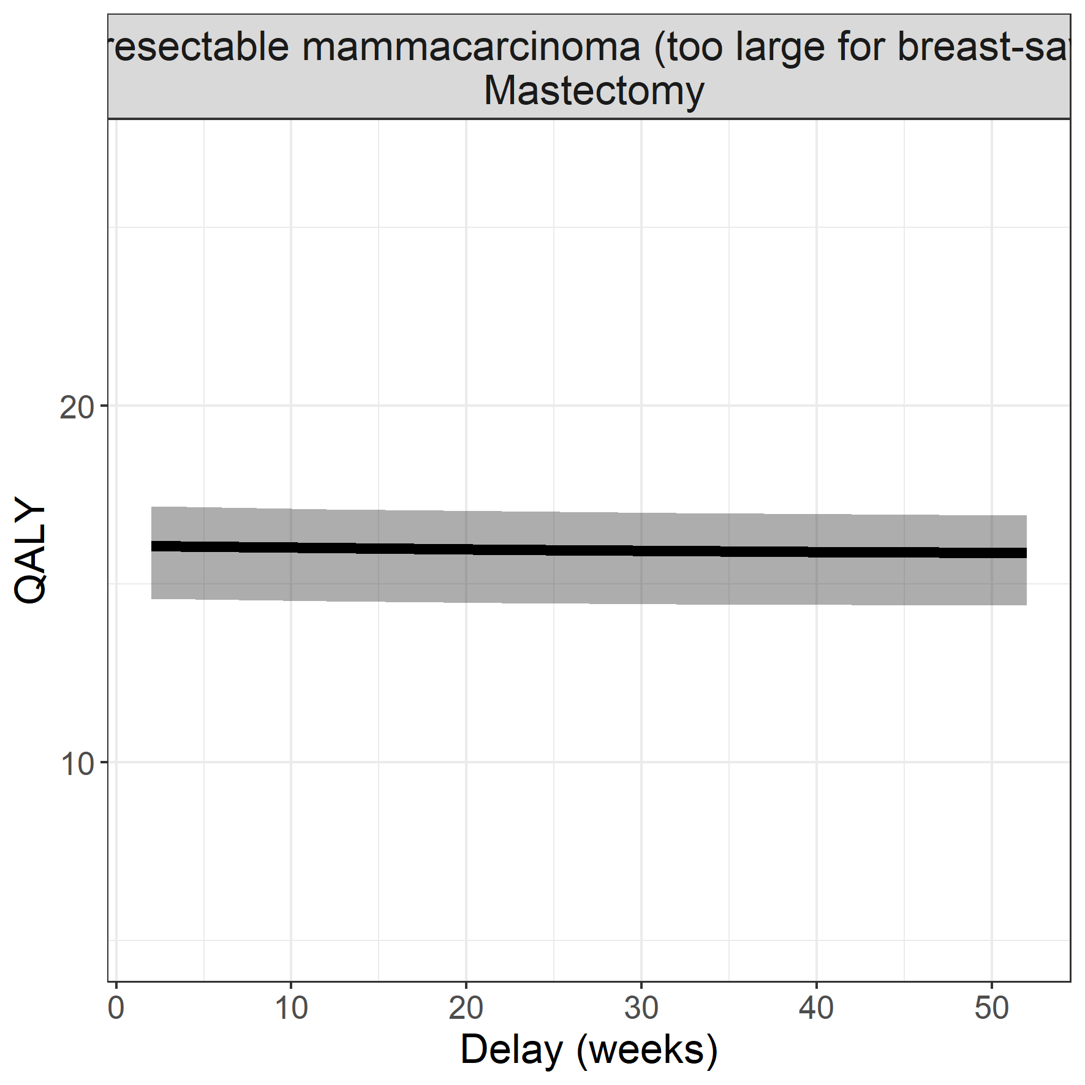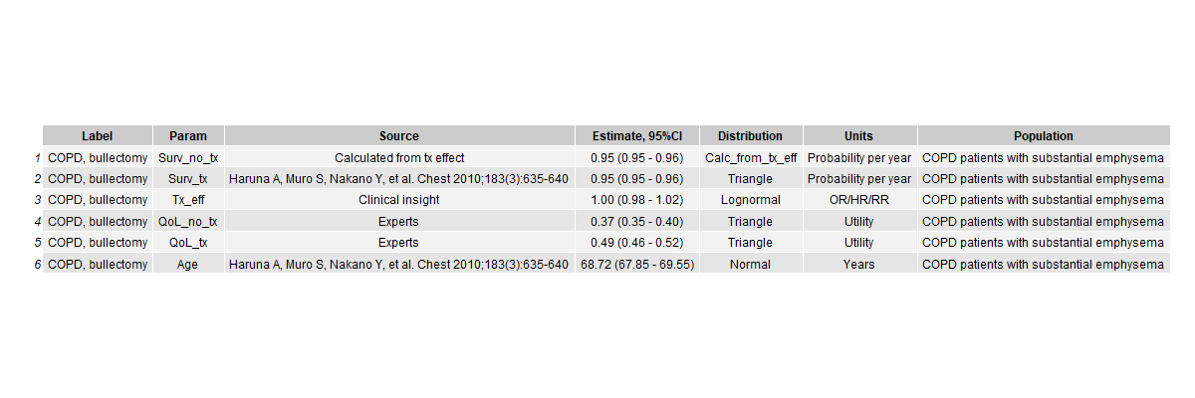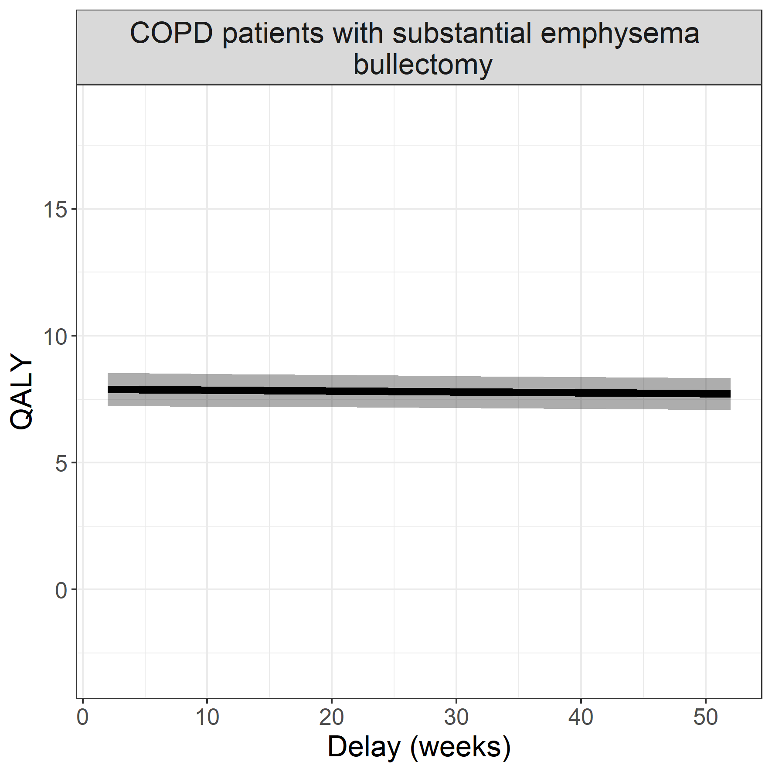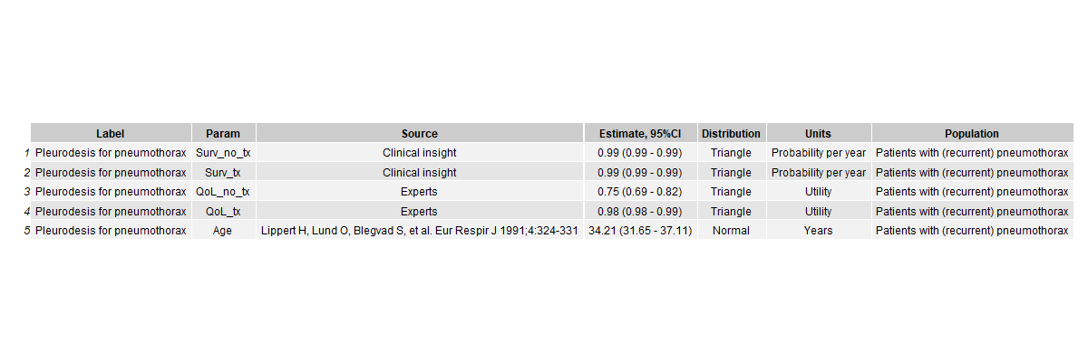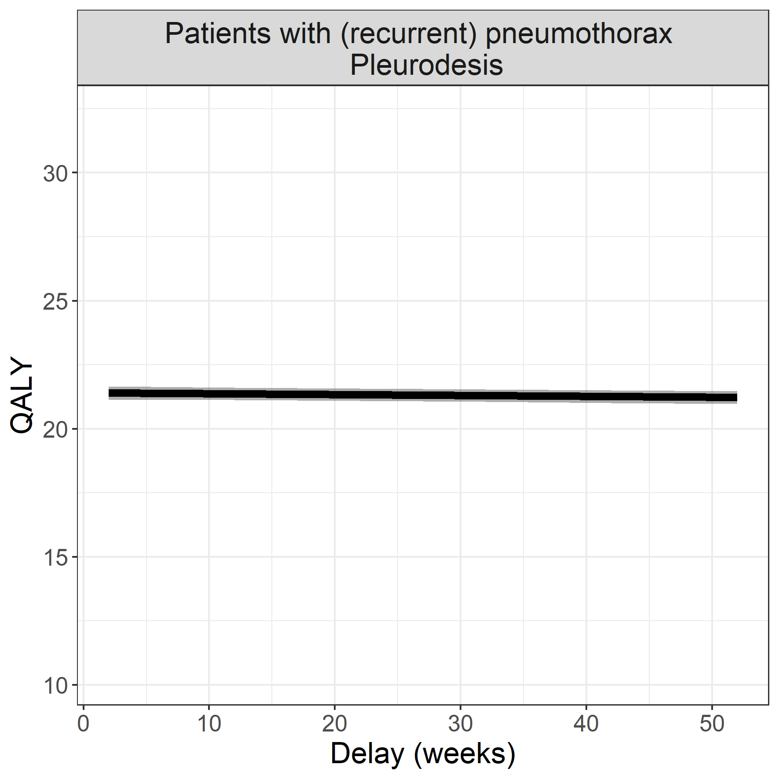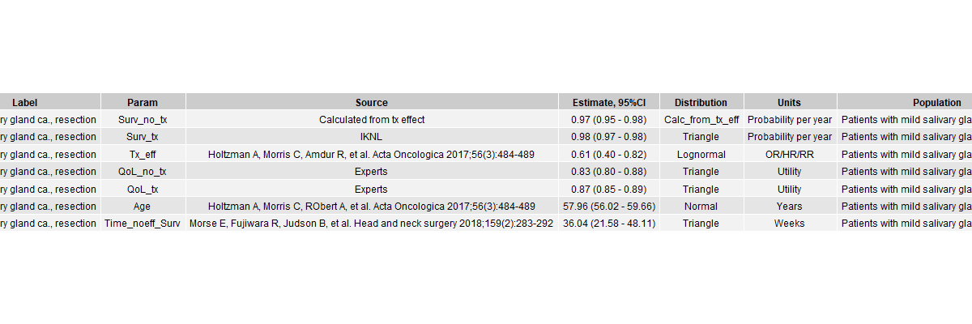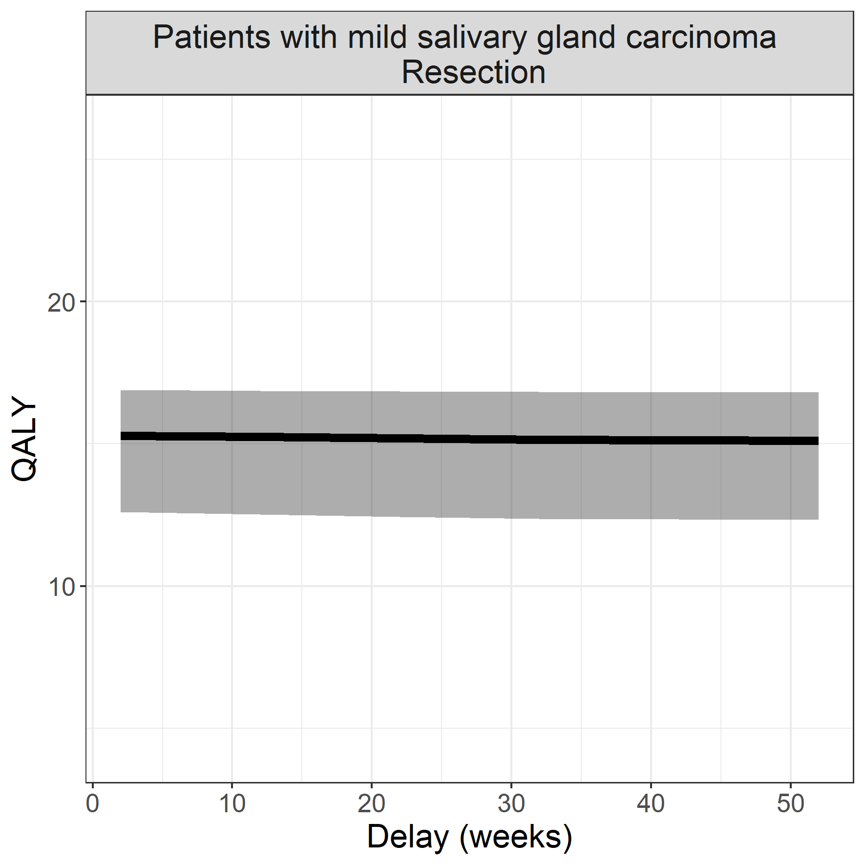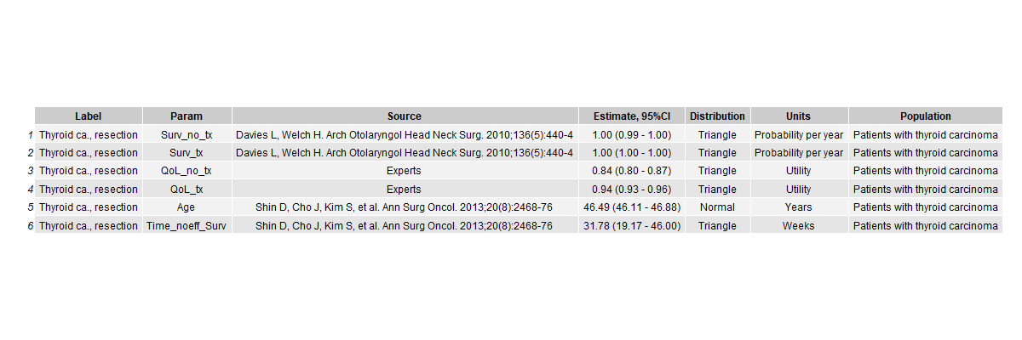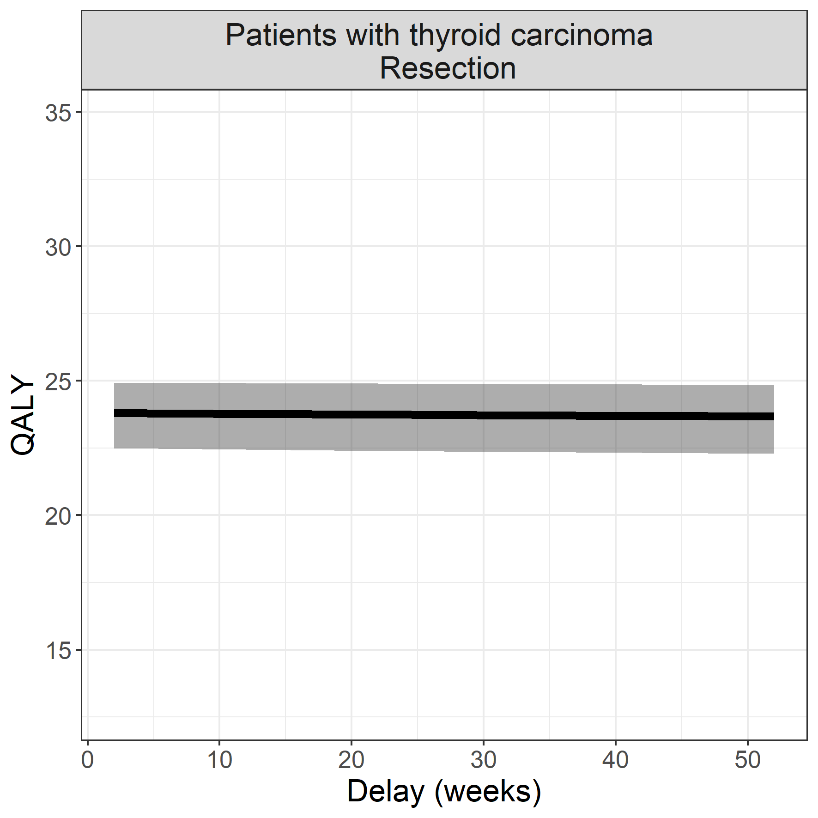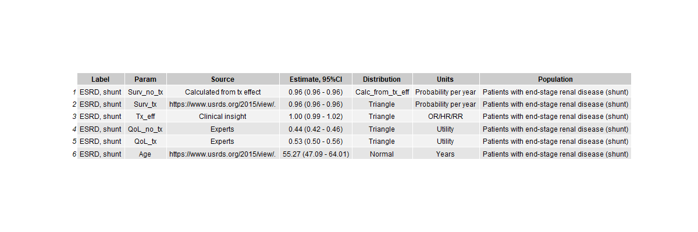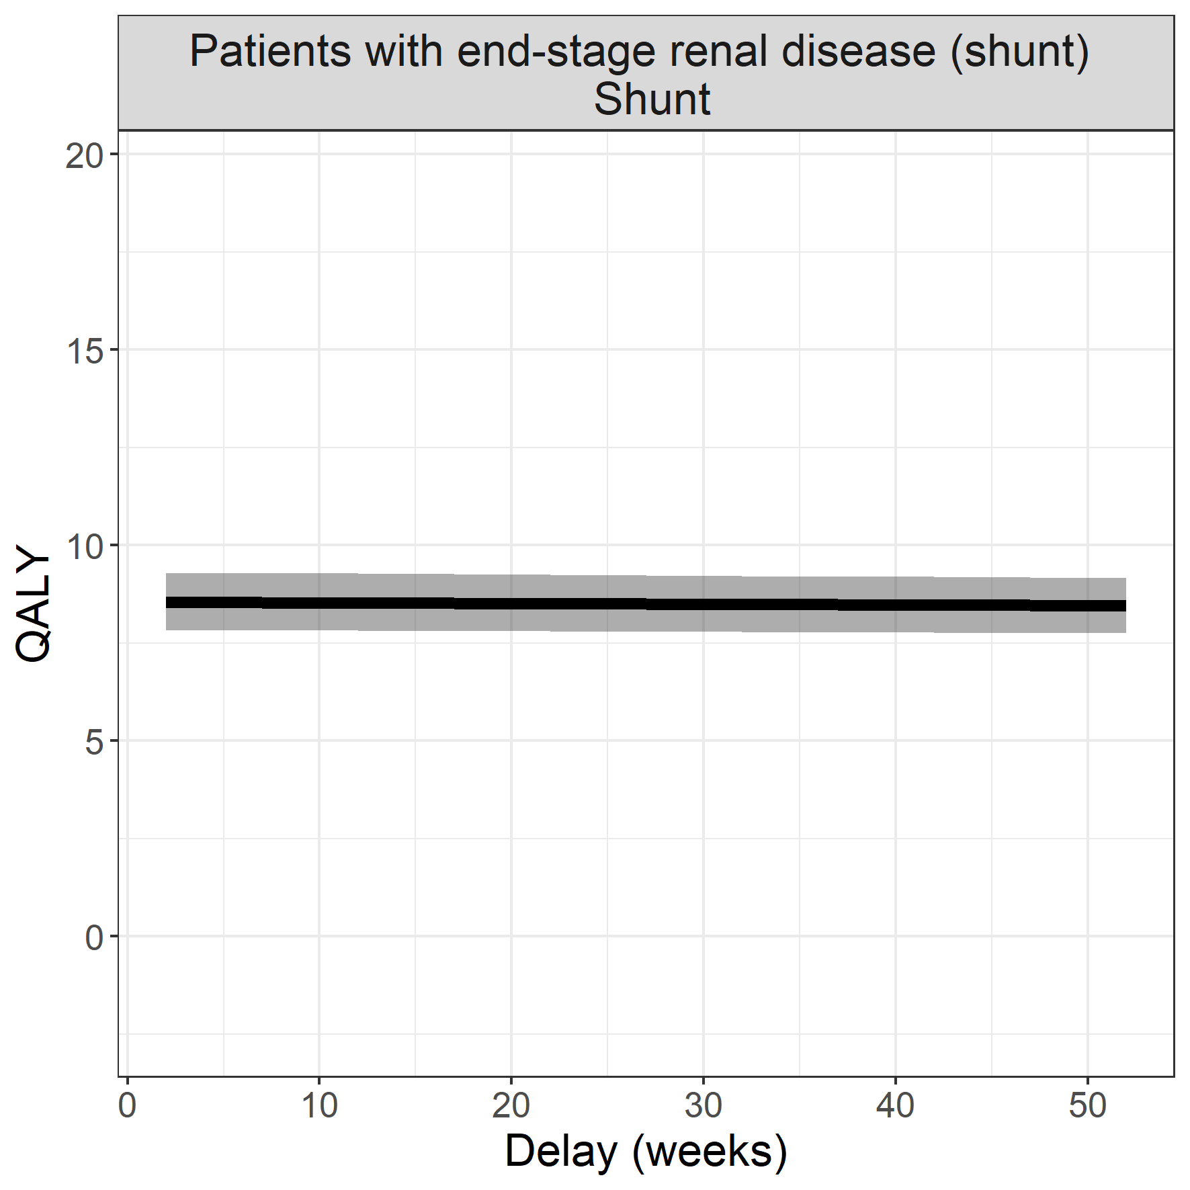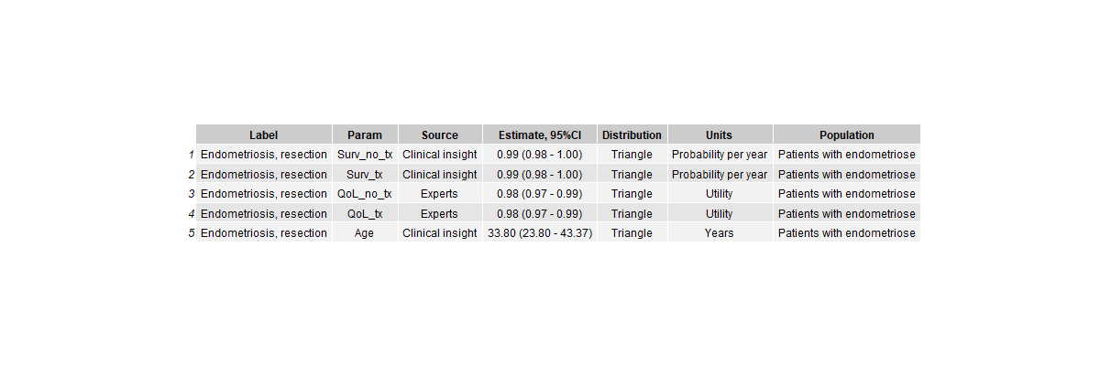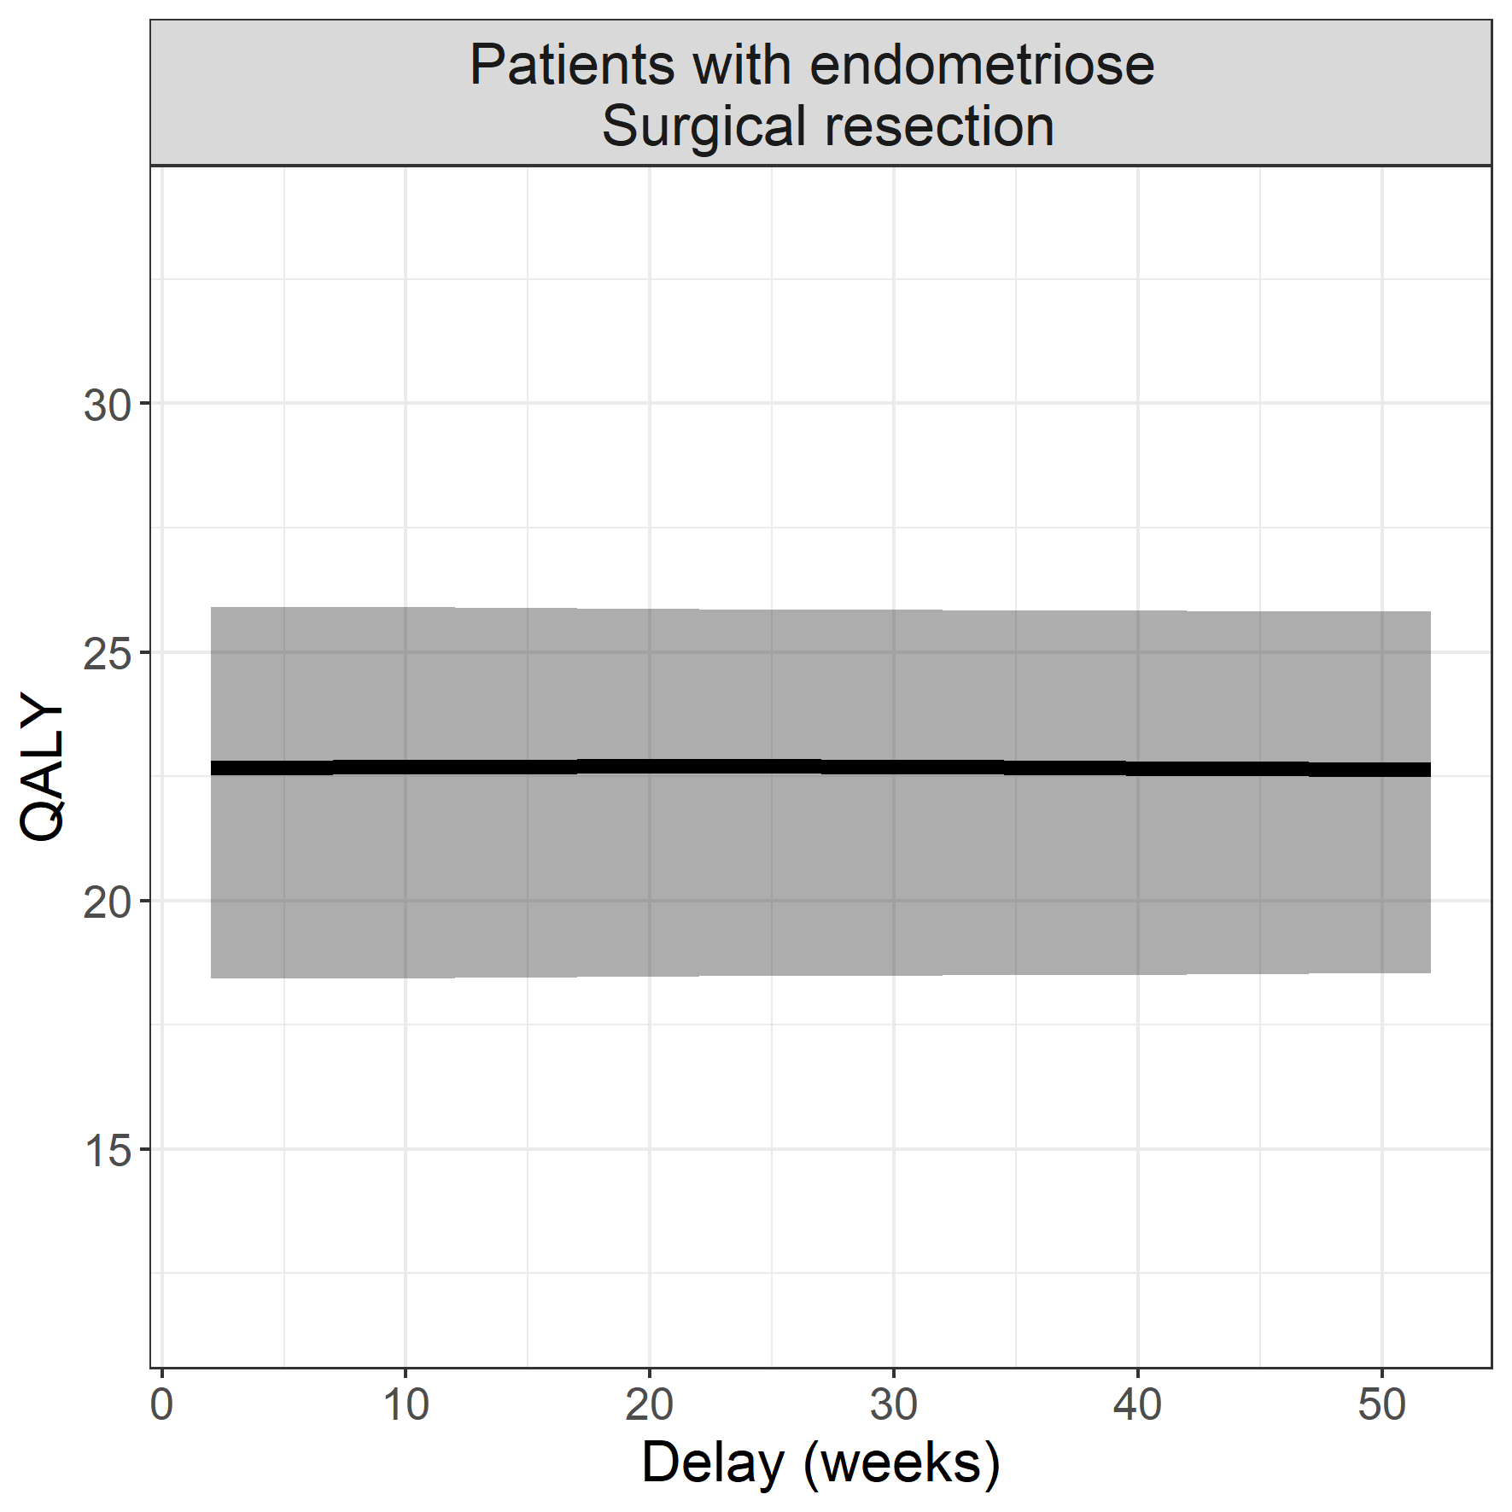

## Coupling with HIX data

The data which G. Geleijnse extracted from Hix, can be used to optimize OR time. For many of the diseases, the mean duration of the operation was found. We will first couple the HIX data to our own data.

cpcty_tbl <- df_res_main[df_res_main$type=="QALY",]  
cpcty_tbl$los_icu <- paste(cpcty_tbl$los_icu_med,  
 " (",  
 cpcty_tbl$los_icu_lo,  
 " - ",  
 cpcty_tbl$los_icu_hi,  
 ")", sep = "")  
cpcty_tbl$los_nonicu <- paste(cpcty_tbl$los_nonicu_med,  
 " (",  
 cpcty_tbl$los_nonicu_lo,  
 " - ",  
 cpcty_tbl$los_nonicu_hi,  
 ")", sep = "")  
cpcty_tbl$dur_or <- paste(cpcty_tbl$duration_or_med,  
 " (",  
 cpcty_tbl$duration_or_lo,  
 " - ",  
 cpcty_tbl$duration_or_hi,  
 ")", sep = "")  
  
  
knitr::kable(cpcty_tbl[,c("Label",  
 "count",  
 "dur_or",  
 "los_icu",  
 "los_nonicu")])

|  |  |  |  |  |  |
| --- | --- | --- | --- | --- | --- |
|  | Label | count | dur_or | los_icu | los_nonicu |
| 61 | PAD F3-4, bypass | 43 | 218 (163 - 269) | 0 (0 - 0) | 3.9 (2.9 - 5.1) |
| 72 | Renal ca, total nefrectomy | 105 | 228 (145 - 258) | 0 (0 - 0) | 1 (0.6 - 1.15) |
| 3 | AAA, surgical repair | 138 | 246 (166 - 305) | 0 (0 - 0.6) | 3.8 (2.2 - 7.1) |
| 57 | Pacemaker implantation | 273 | 115 (82 - 154) | 0 (0 - 0) | 1.4 (1.1 - 2.1) |
| 51 | MVR, thoracotomy | 713 | 99 (77 - 125) | 0 (0 - 0) | 3.1 (1.4 - 6.1) |
| 10 | AV-stenosis, AVR, thoracotomy | 713 | 99 (77 - 125) | 0 (0 - 0) | 3.1 (1.4 - 6.1) |
| 25 | ESRD, transplant | 346 | 291 (244 - 341) | 0 (0 - 0) | 11 (7.5 - 12.3) |
| 54 | NSCLC, lobectomy | 133 | 245 (213 - 294) | 0 (0 - 0) | 5.1 (3.9 - 8) |
| 36 | Liver metastasis colonca, resection | 355 | 230 (155 - 336) | 0 (0 - 0) | 6.2 (4.3 - 9.1) |
| 21 | ESLD, transplant | 81 | 875 (797 - 957) | 0.9 (0 - 2.3) | 9.5 (2 - 18.7) |
| 70 | Renal ca, partial nefrectomy | 105 | 228 (145 - 258) | 0 (0 - 0) | 1 (0.6 - 1.15) |
| 48 | Mild larynx ca., resection | 103 | 70 (38 - 109) | 0 (0 - 0) | 0.9 (0.2 - 1.3) |
| 7 | AV-insuff AVR, thoracotomy | 713 | 99 (77 - 125) | 0 (0 - 0) | 3.1 (1.4 - 6.1) |
| 1 | AAA, EVAR | 138 | 246 (166 - 305) | 0 (0 - 0.6) | 3.8 (2.2 - 7.1) |
| 5 | ASD, repair | 164 | 74 (56 - 132) | 0 (0 - 0) | 1.3 (0.6 - 1.95) |
| 64 | Pancreasca., Whipple | 413 | 268 (103 - 443) | 0 (0 - 0) | 7.15 (1 - 13.9) |
| 66 | Penis ca., resection | 29 | 92 (44 - 147) | 0 (0 - 0) | 1.75 (0.4 - 2.8) |
| 34 | Instable AP, CABG | 336 | 279 (244 - 314) | 0.6 (0.3 - 0.9) | 4.8 (3.8 - 6.3) |
| 27 | HCC, resection | 355 | 230 (155 - 336) | 0 (0 - 0) | 6.2 (4.3 - 9.1) |
| 14 | Colonca., HIPEC | 283 | 271 (75 - 405) | 0 (0 - 0) | 8.2 (0.4 - 12.1) |
| 55 | Oral ca., resection | 103 | 70 (38 - 109) | 0 (0 - 0) | 0.9 (0.2 - 1.3) |
| 31 | High-risk endometrium ca, resection | 83 | 244 (183 - 331) | 0 (0 - 0) | 5.2 (2.8 - 6.9) |
| 74 | UUT Ca., nefroureterectomy | 148 | 229 (188 - 268) | 0 (0 - 0) | 3.8 (2.6 - 6) |
| 44 | Mammaca., resection | 383 | 99 (71 - 148) | 0 (0 - 0) | 1.2 (0.4 - 2.1) |
| 45 | MI bladder ca, cystectomy | 426 | 72 (57 - 143) | 0 (0 - 0) | 1.7 (1.2 - 4.15) |
| 17 | Empyema, VATS | 55 | 174 (120 - 219) | 0 (0 - 0) | 4.1 (3.1 - 6.2) |
| 30 | High-grade glioma, resection | 329 | 228 (182 - 274) | 0 (0 - 0) | 4.1 (3.1 - 5.2) |
| 11 | Cervical ca., resection | 144 | 253 (68 - 384) | 0 (0 - 0) | 3 (0.45 - 5.1) |
| 37 | Low-grade glioma, resection | 329 | 228 (182 - 274) | 0 (0 - 0) | 4.1 (3.1 - 5.2) |
| 40 | Low-risk endometrium ca, resection | 83 | 244 (183 - 331) | 0 (0 - 0) | 5.2 (2.8 - 6.9) |
| 60 | PAD F2, bypass | 43 | 218 (163 - 269) | 0 (0 - 0) | 3.9 (2.9 - 5.1) |
| 41 | Mammaca., mastectomy | 383 | 99 (71 - 148) | 0 (0 - 0) | 1.2 (0.4 - 2.1) |
| 15 | COPD, bullectomy | 55 | 174 (120 - 219) | 0 (0 - 0) | 4.1 (3.1 - 6.2) |
| 68 | Pleurodesis for pneumothorax | 55 | 174 (120 - 219) | 0 (0 - 0) | 4.1 (3.1 - 6.2) |
| 49 | Mild salivary gland ca., resection | 100 | 108 (79 - 175) | 0 (0 - 0) | 1.2 (1 - 3.1) |
| 23 | ESRD, shunt | 190 | 72 (56 - 100) | 0 (0 - 0) | 1.1 (0.3 - 1.7) |
| 19 | Endometriosis, resection | 154 | 179 (122 - 238) | 0 (0 - 0) | 1.9 (1.2 - 2.7) |

write.csv2(cpcty_tbl[,c("Label",  
 "count",  
 "dur_or",  
 "los_icu",  
 "los_nonicu")],   
 file="../figures/main_results/hix_data.csv")

The table above shows the data for the investigated interventions for 3 years.

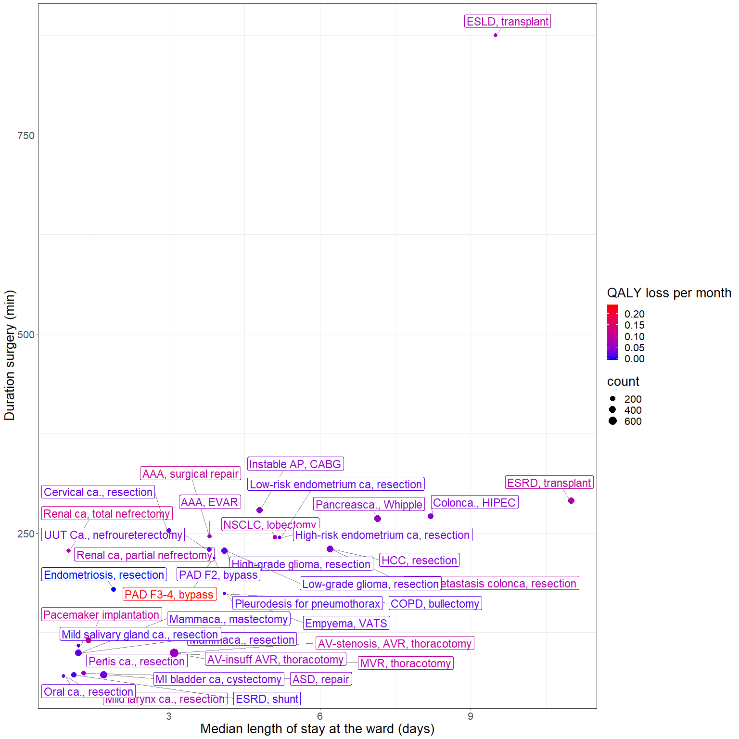

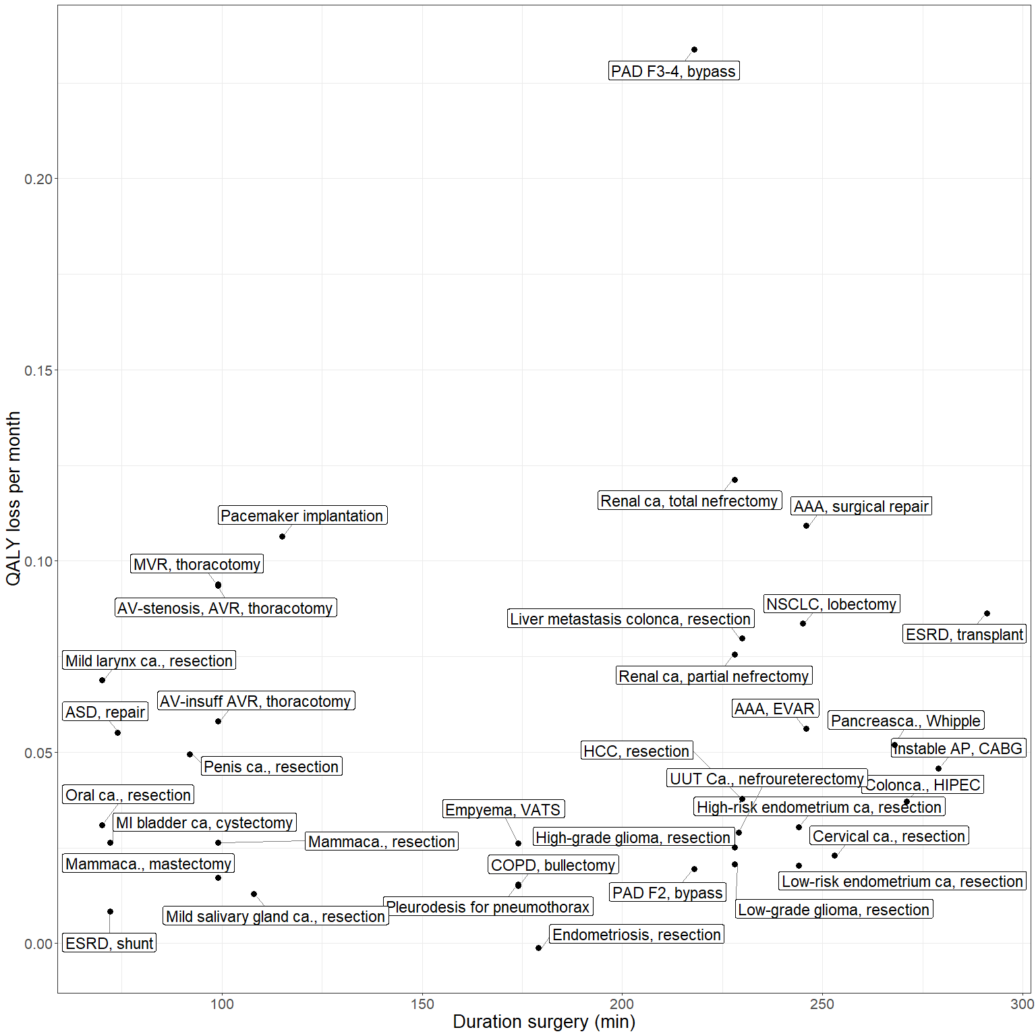

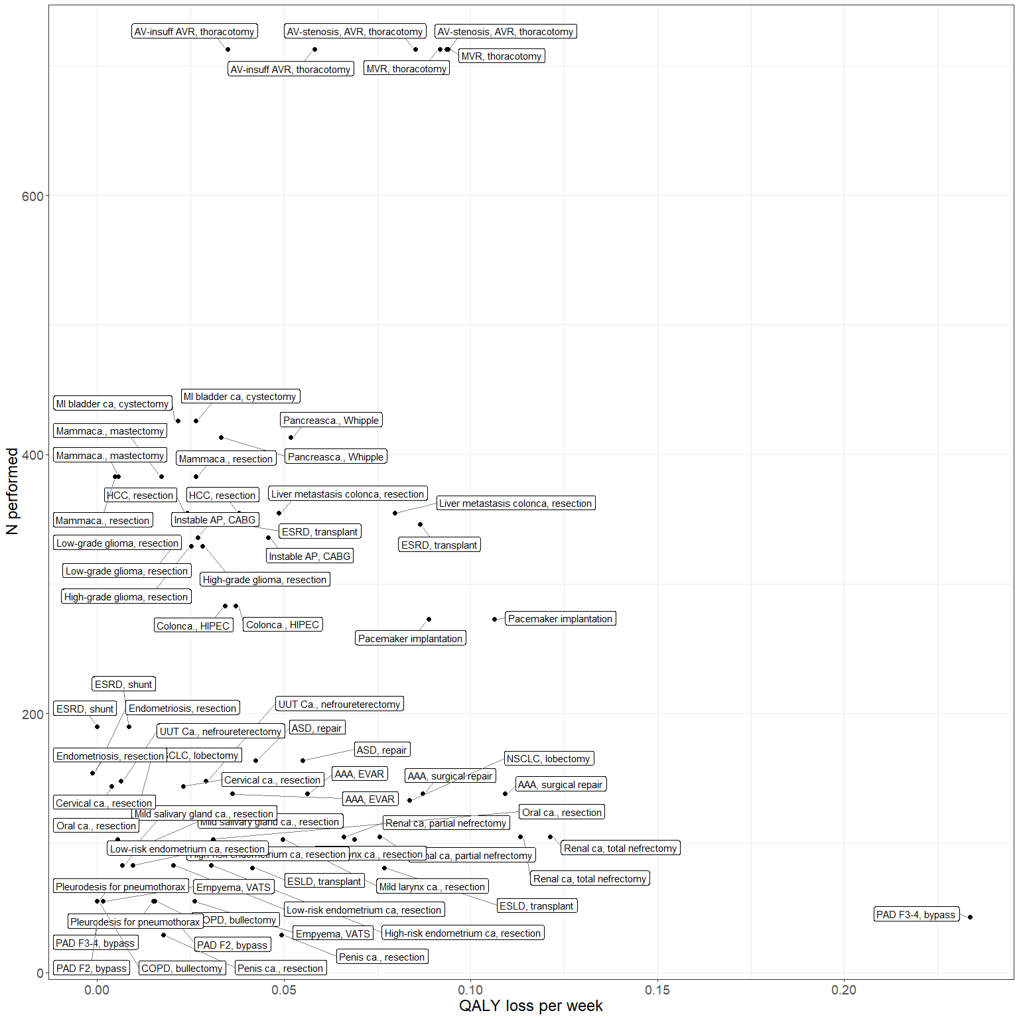

library(tableone)  
param <- readxl::read_excel("../data/Model parameters.xlsx", sheet="Complete")  
  
param <- data.table(param)  
param <- param[!is.na(param$Unit),]  
  
tbl_cls <- CreateTableOne(vars = c("Evidence_type","Evidence_class"),  
 strata = "Param",  
 data = param,   
 test = FALSE,  
 factorVars = c("Evidence_type","Evidence_class"))  
tbl_cls2 <- print(tbl_cls,printToggle=FALSE)   
   
  
kableone(tbl_cls)

|  |  |  |  |  |  |  |  |  |
| --- | --- | --- | --- | --- | --- | --- | --- | --- |
|  | Age | QoL_no_tx | QoL_tx | Surv_no_tx | Surv_tx | Time_noeff_QoL | Time_noeff_Surv | Tx_eff |
| n | 44 | 44 | 44 | 44 | 44 | 6 | 23 | 22 |
| Evidence_type (%) |  |  |  |  |  |  |  |  |
| Before-after study | 0 ( 0.0) | 0 ( 0.0) | 0 ( 0.0) | 0 ( 0.0) | 0 ( 0.0) | 0 ( 0.0) | 0 ( 0.0) | 1 ( 4.5) |
| Expert opinion | 3 ( 6.8) | 0 ( 0.0) | 0 ( 0.0) | 9 (20.5) | 3 ( 6.8) | 5 (83.3) | 4 (17.4) | 4 (18.2) |
| Expert panel | 0 ( 0.0) | 30 ( 68.2) | 30 ( 68.2) | 0 ( 0.0) | 0 ( 0.0) | 0 ( 0.0) | 0 ( 0.0) | 0 ( 0.0) |
| Expert panel (WHO) | 0 ( 0.0) | 14 ( 31.8) | 14 ( 31.8) | 0 ( 0.0) | 0 ( 0.0) | 0 ( 0.0) | 0 ( 0.0) | 0 ( 0.0) |
| National registry | 21 (47.7) | 0 ( 0.0) | 0 ( 0.0) | 12 (27.3) | 31 (70.5) | 0 ( 0.0) | 9 (39.1) | 6 (27.3) |
| Observational, prospective | 5 (11.4) | 0 ( 0.0) | 0 ( 0.0) | 4 ( 9.1) | 3 ( 6.8) | 0 ( 0.0) | 3 (13.0) | 1 ( 4.5) |
| Observational, retrospective | 10 (22.7) | 0 ( 0.0) | 0 ( 0.0) | 9 (20.5) | 4 ( 9.1) | 0 ( 0.0) | 7 (30.4) | 3 (13.6) |
| RCT | 5 (11.4) | 0 ( 0.0) | 0 ( 0.0) | 10 (22.7) | 3 ( 6.8) | 1 (16.7) | 0 ( 0.0) | 7 (31.8) |
| Evidence_class (%) |  |  |  |  |  |  |  |  |
| I | 5 (11.4) | 0 ( 0.0) | 0 ( 0.0) | 10 (22.7) | 3 ( 6.8) | 1 (16.7) | 0 ( 0.0) | 7 (31.8) |
| IIa | 5 (11.4) | 0 ( 0.0) | 0 ( 0.0) | 4 ( 9.1) | 3 ( 6.8) | 0 ( 0.0) | 3 (13.0) | 2 ( 9.1) |
| IIb | 31 (70.5) | 44 (100.0) | 44 (100.0) | 21 (47.7) | 35 (79.5) | 0 ( 0.0) | 16 (69.6) | 9 (40.9) |
| III | 3 ( 6.8) | 0 ( 0.0) | 0 ( 0.0) | 9 (20.5) | 3 ( 6.8) | 5 (83.3) | 4 (17.4) | 4 (18.2) |

write.csv2(tbl_cls2, file = "../figures/main_results/evidence_tbl.csv")

# Acknowledgement

# @BG and @EK, we have to check if the list is complete

The team: - The principal investigators of this projects are: R.J. Baatenburg de Jong and H.F. Lingsma - The research team: I.R.A. Retel Helmrich, E. van Veen, H.F. Lingsma, C.L. van Lint, S.M. Bruinsma, R.J. Baatenburg de Jong, B.Y. Gravesteijn, E.M. Krijkamp - The code is written by: B.Y. Gravesteijn and E.M. Krijkamp - For the methods and materials used for the collection of the quality of life values we like to thank J.J. van Busschbach.

We would like to acknowledge C. Verhoef, C.H. Bangma, C.M.F. Dirven, E.M. Roes, G. Geleijnse, G. Jansen van Rosendaal, H.A. Polinder - Bos, J.A. Goudzwaard, J.J.M. Takkenberg, J.L.C.M. van Saase, M.G. van Vledder, P.J.E. Bindels,S. Sleijfer, T.W. Galema for active participation in this research. A special thanks goes to H. Karreman and C. Van der Velden - van der Graaf for the incredable amount of work they have done to proces the data.

We would like to acknowledge XXX and XXX for the survival data

XXX other names of people that helped with this research (and are not authors of the document).

For this research we made use of the template developed by the Decision Analysis in R for Technologies in Health (DARTH) workgroup: <http://darthworkgroup.com>.

The notation of our code is based on the following provided framework and coding convention: Alarid-Escudero, F., Krijkamp, E.M., Pechlivanoglou, P. et al. A Need for Change! A Coding Framework for Improving Transparency in Decision Modeling. PharmacoEconomics 37, 1329–1339 (2019). <https://doi.org/10.1007/s40273-019-00837-x>.

There was no funding for this research.

CONFLICTS OF INTEREST?

All errors in the code are the responsibility of the authors.