BANA 7041 Module II Applied Linear Regression
Prof. Yan Yu
Homework #1
Computational Part (Type and submit in WORD only).
Please make sure that you include a cover page.

 | You can make a difference …  http://www.law.uc.edu/alumni

- Alumni donations are an important source of revenue for colleges and universities. If administrators could determine the factors that influence increases in the percentage of alumni who make a donation, they might be able to implement policies that could lead to increased revenues. Research shows that students who are more satisfied with their contact with teachers are more likely to graduate. As a result, one might suspect that smaller class sizes and lower student-faculty ratios might lead to a higher percentage of satisfied graduates, which in turn might lead to increases in the percentage of alumni who make a donation. The attached data alumni.xls shows data for 48 national universities (America’s Best Colleges, Year 2000 Edition). The column labeled % of Classes Under 20 shows the percentage of classes offered with fewer than 20 students. The column labeled Student/Faculty Ratio is the number of students enrolled divided by the total number of faculty. Finally, the column labeled Alumni Giving Rate is the percentage of alumni that made a donation to the university.

Use R or SAS to analyze the given data and answer the following questions. Consider the alumni giving rate as the response variable Y and the percentage of classes with fewer than 20 students as the predictor variable X.

- Start with exploratory data analysis. Show summary statistics of the response variable and predictor variable.
- What is the nature of variables X and Y? Are there outliers? What is the correlation coefficient? Draw a scatter plot. Any major comments about the data?
iii) Fit a simple linear regression on the data. What is your estimated regression equation?
iv) Interpret your results.
Write a brief report up to two pages. Please clearly label your figures and tables. No raw outputs please.

- A Simulation Study (Simple Linear Regression).
Assume mean function E(Y|X)= 10 + 5 * X
- Generate data with X~N(2, .1²), sample size n=100, and error term
ε~N(0, σ ²), where σ ²=.25.
- Show summary statistics of the response variable and predictor variable. Are there outliers? What is the correlation coefficient? Draw a scatter plot.
- Fit a simple linear regression. What is the estimated model? Report the estimated coefficients. What is the model mean squared error (MSE)?
- What are the sample mean of x and y? Plot the fitted regression line and point 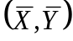. What do you find?
Write a brief summary in two pages.

Mathematics Part (Please feel free to type or handwrite):

- Ordinary Least Squares (OLS) are usually used to fit a simple linear regression by minimizing 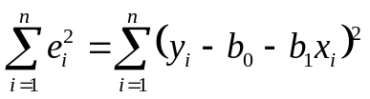.
- how about minimizing 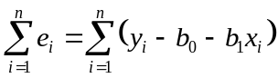?
- how about 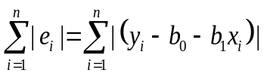 ?
- Why is the OLS most popular approach for linear regression?

4. Establish the following relationships. (Some are trivial to show.)
1) The fitted line goes through the point .

2) 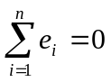

3) 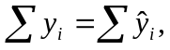

4)  That is, the sum of the weighted residuals is zero when the residual in the i-th trial is weighted by the level of the predictor variable in the i-th trial.

5) . The sum of the weighted residuals is zero when the residual in the i-th trial is weighted by the fitted value of the response variable in the i-th trial.

6) 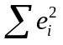is minimized.

