Lab 19 Book Keeping

Bradley Grose

# Problem

This code must take in information on a book and using the call number determine the type of book it is, construct it, and sort it into a library using a 2d array to store the book. It also must be able to remove books from the library and print out the library.

# Solution

Using the pre made Front end and the book types given by the lab, I created an interface book that has the following methods. The methods are getName which returns a string, getAuthor which returns a string, getCallNumber which returns a double, setName(String) which returns nothing, setAuthor(String) which returns nothing, setCallNumber(double), equals(Book) which returns a Boolean, and toString which returns a string. This is then implemented into SimpleBook which builds the book using a constructor for author, name, and call number, the accessors and mutators check for valid values. It also checks to make sure the book equals as well as creating a string for the book. There is also a class for Library which has a 2d array to store book. The constructor builds a 10x100 sized array. It also has methods that sorts the book into an index using integer division, there is also a method called add book that uses that index to create the specific type of book it is and store it into the correct spot in the array. The removed book function searches for the book and removes it from the array if needed. There is also printBooks which will print out all of the books in the array.

# Implementation Problems Encountered

No Problems were encountered in this lab.

# Lab Report Questions

1.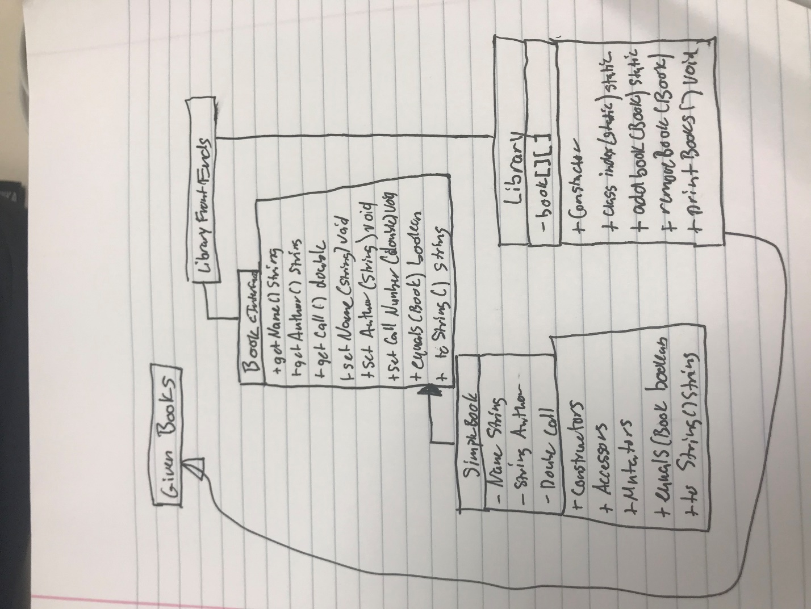

2. Class to interface- inherits

Class to class- extends

Interface to interface- inherits