Lab 18 ARPS

Bradley Grose

# Problem

In this lab we must make a program that simulates a game of rock paper and scissors. Using the primary driver, the code will have a player that makes a gesture and keeps track of the score. There is a human player that gives what their moves are. There is also a computer player that randomly generates a move that the computer will execute.

# Solution

For my solution, I first used the premade driver for the code. I then made an interface that has the methods getPoints() which returns a int, getGesture which returns a string, setPoints which takrs in a integer and returns nothing, setGesture which takes in a string and returns nothing, and chooseGestrure which takes in nothing and returns nothing. This is then implemented into RPSBasicPlayer, which creates the instance variable of gesture, keeps track of the points using the int. It has a default constructor for the start of the game that sets the basics. The it has accessor and mutators to check for valid gestures and point values. Finally, it sets a default gesture of rock. This is then inherited by RPSHumanPlayer and RPSComputer. Both of these are similar but different. RPSHuman will use the keyboard as a scanner and construct the gesture based on what the user inputs in the driver. This overrides the preset. RPSComputer will generate a random number and use that to create a randomized gesture which overrides the setGesture function.

# Implementation Problems Encountered

No Problems were encountered in this lab.

# Lab Report Questions

1.

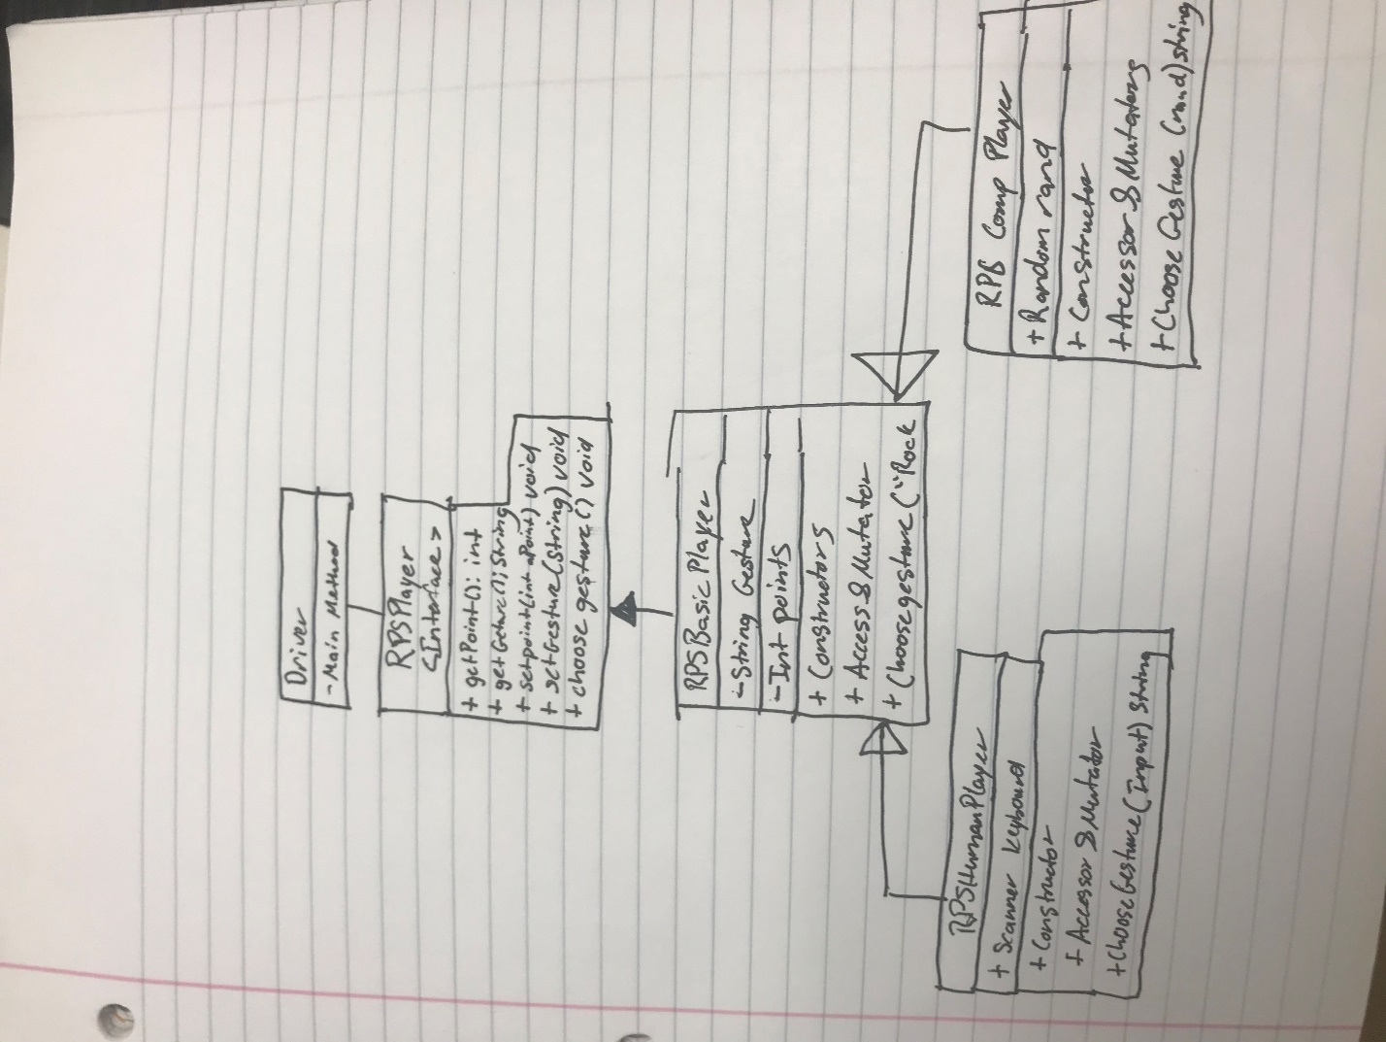

2. No it is not possible