Lab 07 Dice Roller

Bradley Grose

# Problem

In this code, we must ask the user how many dices rolls they want to run. Once they answer, the code must run that many dice rolls using random numbers, displaying which each result is. Finally, it must total up how many of each rolls there was and display at the end.

# Solution

First, I collected the number of rolls the user wanted and stored that as an integer value. Then, using a do…while loop, I had the code generate a random number. The loop will run until the count variable, which starts at 0, is equal to that of the number of times requested.

Also inside the while loop, the number is generated that must be between 0-5, and then I add 1 to make the range between 1-6. Then, using if and else if statements, I look for the value so I can add to the count to make a running total of how many of that number was rolled. Finally, I increase the overall count by 1 and the while loop runs until the condition is not met anymore.

Then, after the do while loop ends, the output is given for how many times each dice was rolled, using the counts created by the if functions.

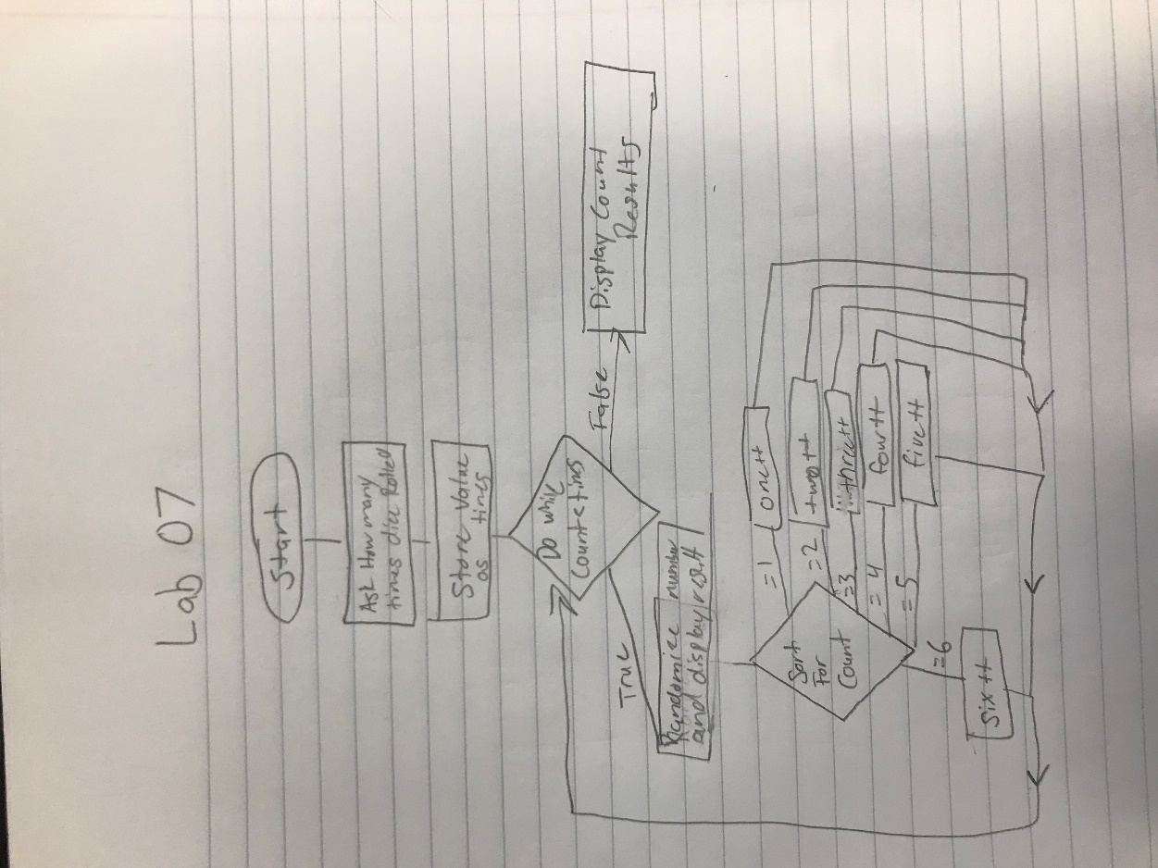

# Implementation Problems Encountered

There were no problems that I encountered in the code.

# Lab Report Questions

1. Included in section
2. A while loop does not have to be run any amount of times in a code. However, a do…while loop must be run at least once in code in order for the code to continue. Therefore, the Boolean expression must be true at least once.
3. When the Boolean expression is never false, it creates an infinite loop that will keep going and never end. This means that the code will never progress past this point.