Lab 10 Matrix Addition

Bradley Grose

# Problem

In this programming lab, we must make an application that first collects the size of the matrix the user wants. Then a matrix will be made using what the user wants. The user will then fill the values of the matrix. Then the user will create a second matrix. If the size is not the same as the first, the code must display invalid dimensions. Once the two matrixes are filled, the code will add the matrix together, adding spot 0,0 to 0,0 and so on. This will then be displayed

# Solution

For my solution, I first prompted the user for two integers. Then using those integers, I made a 2d array or matrix. Then using 2 nested for loops, I run through each position in that first matrix and prompt the user for a value to fill it with. Then, the code will ask for the size of the second matrix. Then if the 2d array is not the same size as array1, it will say “Invalid Dimensions”. If it is the same size, then the same process will be used to fill array2 with the values. Then, the two matrix will be displayed using nested for loops to print out each number with spaces and new lines. Finally, there is a nested for loop that will add up the values in the same position of each matrix and does matrix addition to add up the values, using for values of I and J to print it out.

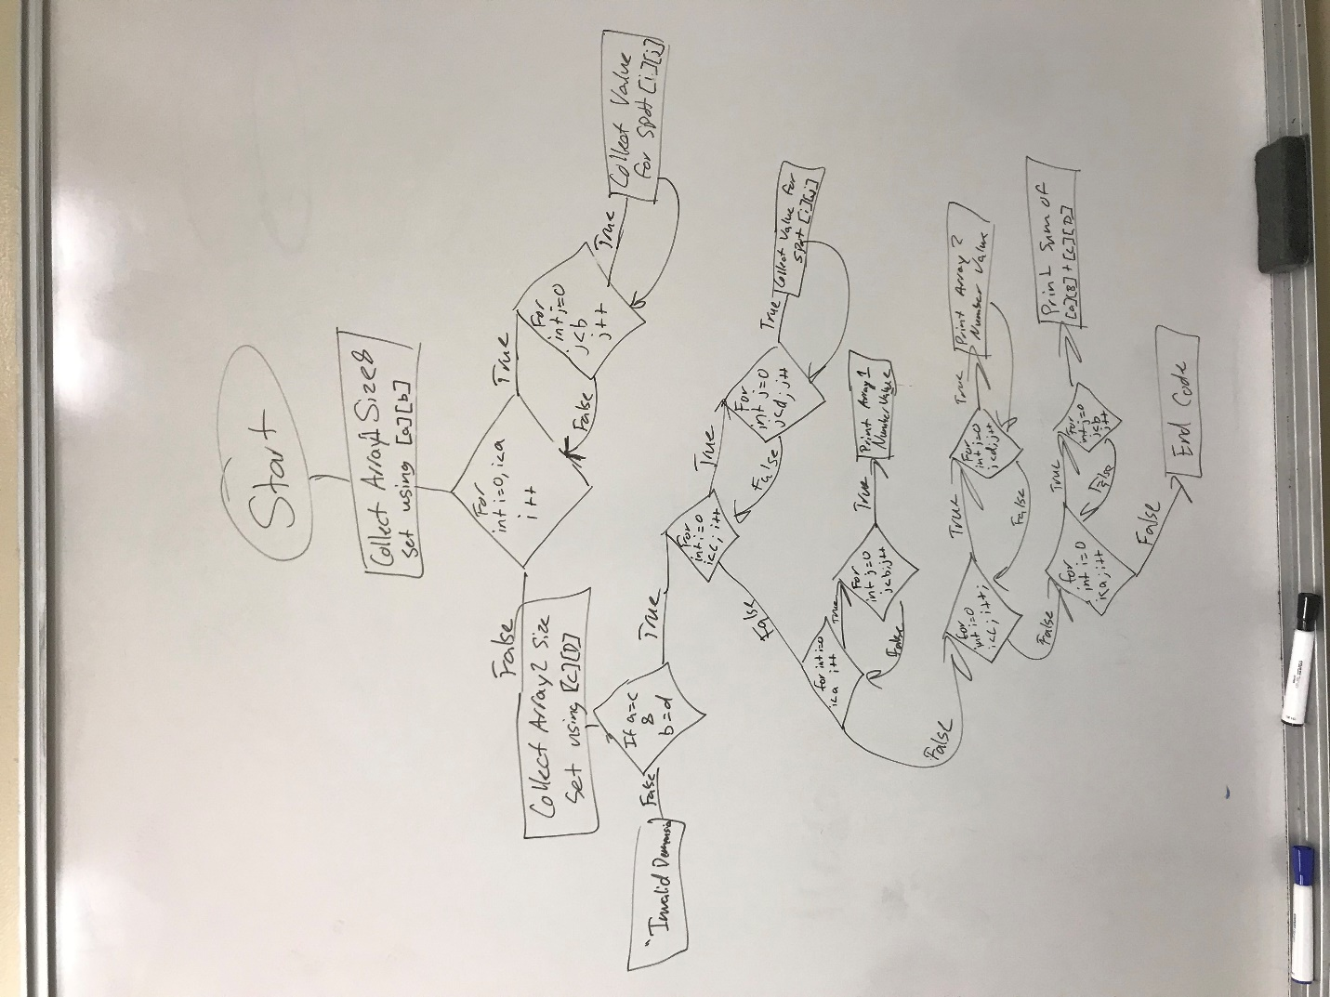

# Implementation Problems Encountered

There were no problems that I encountered in the code.

# Lab Report Questions

1. Included in section
2. Yes, it is possible but it takes many more lines to define it to make the jagged matrix

3)

**int**[] a = {1,2,3,4,5,6,7,8,9};

**int**[][] b = **new** **int**[3][3];

**for**(**int** i=0;i<a.length;i++)

{

for(int j = 0; j<3; j++)

{

for(int k = 0; k<b.length; k++)

{

b[j][k] = a[i];

}

}

}