Lab 09 Temperature Average

Bradley Grose

# Problem

In this programming lab, we must make an application that collects the temperatures of 10 days from the user and store it in an array. Then the code must calculate out an average temperature for the week. Once it displays that, it must determine the days that were below the average temperature and display that to the user.

# Solution

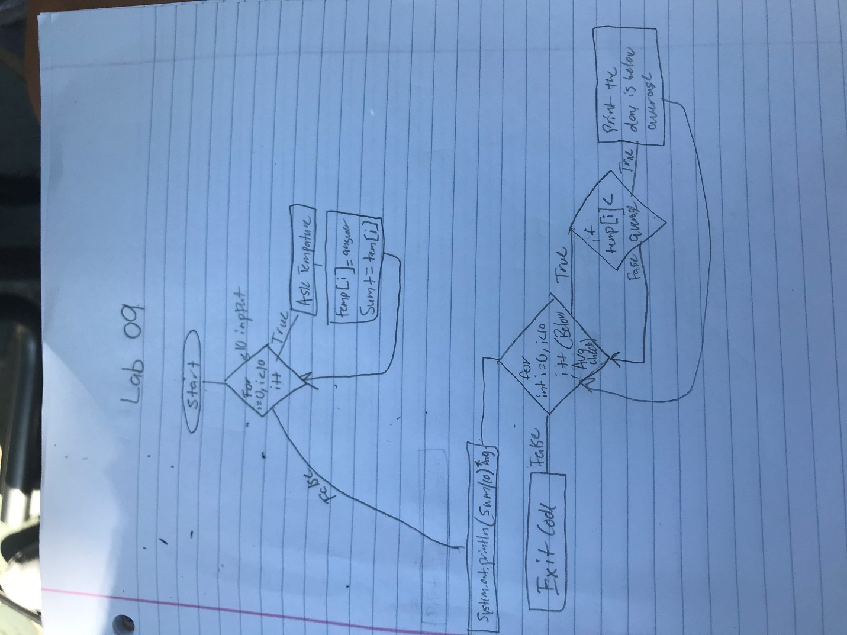

For my solution, I first start using a for loop with a 10 counter. This will allow for 10 user inputs for the temperature. After each input, I save it to an array position and add to the sum to find the average. Once that for loop is done, it will calculate the average and print it out. Then, another for loop using a 10 counter is run to find the dates with temperatures below average. That is displayed at the end using If statements nested in the for loop.

# Implementation Problems Encountered

There were no problems that I encountered in the code.

# Lab Report Questions

1. Included in section
2. No, once they are set, they cannot be changed.
3. The last valid index is 1 minus the array size. So if it is a size of 10, the last index is a 9.