Lab 08, Triangle Maker

Bradley Grose

# Problem

In this lab we must have the user input a desired size for the triangle as the make size that it can be. Following that, using *, we must create that triangle, and have it print out for the user. After the triangle is made the code must display “DONE”

# Solution

For my solution, I had the user first input the number of the size they wanted the triangle to be. Then, I check to make sure it is a valid size greater than 0, displaying an error message if it is not. Then I will start to run the main for loop, using a counter that must be less than double the size, as to make a triangle it will take double the size – 1 worth of lines. Then using a Boolean, I check for the direction, so I can add or subtract a * if needed to create the shape. If i=size-1, then it will switch the Boolean value to mark it counting down now. Then I have a nested for loop that runs the number of stars needed, using a counter and a star value count. Once it exits the loop, using the Boolean value a star will be added or subtracted from the star counts. This will run until the triangle has fully been printed. Once that is done, the code will display “DONE”.

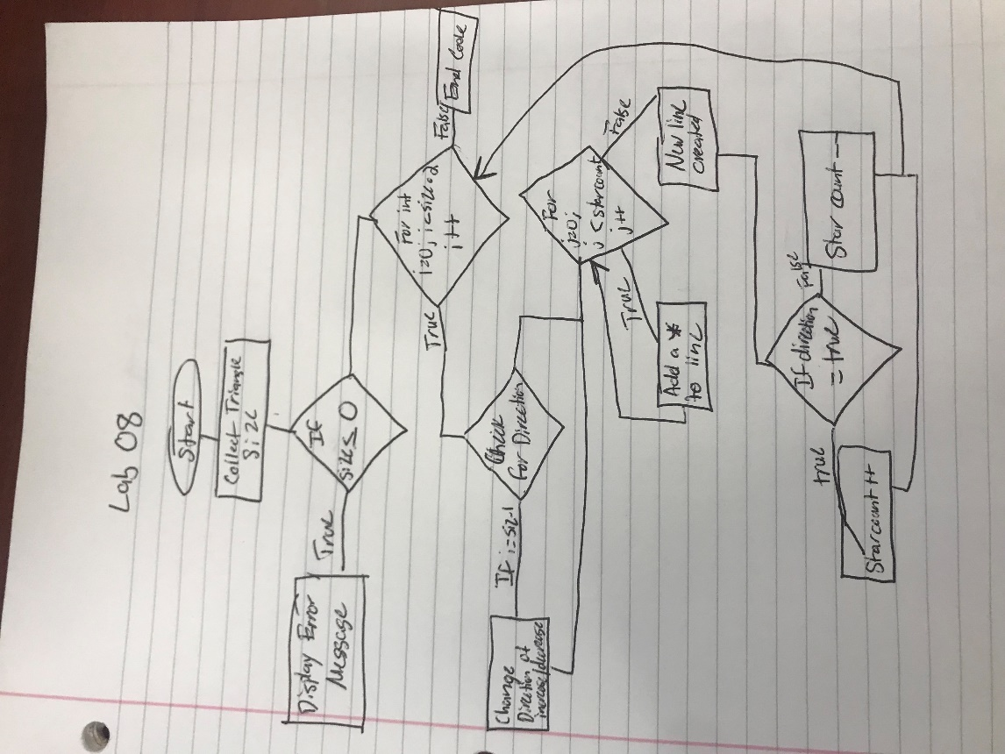

# Implementation Problems Encountered

There were no problems that I encountered in the code.

# Lab Report Questions

1. Included in section
2. It is more appropriate to run a for loop when there is a set number of times that it will be ran. Using a for loop with a counter helps ease up the process of a while, as it runs the same functions, it was designed for when there is a set amount of times.
3. int counter = 100;

while(counter>0)

{

System.out.println(counter);

counter-=10;

}